Name: Ndibe ARIZE emeka
Matric Number: 17/ENG06/056
Department: MECHANICAL ENGINEERING
ENG 382 ASSIGNMENT V
Simulation File
commandwindow
clearvars
clc
format short g
syms t kp td tp
v = kp*(1-exp(-((t-td)/tp)));
mdata = xlsread(' 1587203818odevbesdata', 'data1');
t1 = mdata(:,1);
v = mdata(:,2);
V1 = round(mdata(900,2),1)
t0 = ones(length(v),1)
t = [t0 t1]
[mcoeff, mcoeffint, mresid, mresidint, manova] = regress(v,t);
% mcoeff
% rsquaredvalue=mcoeff(1)
plot(t,v);
xlabel('Time (min)')
ylabel('Volume (m^3)')
grid on
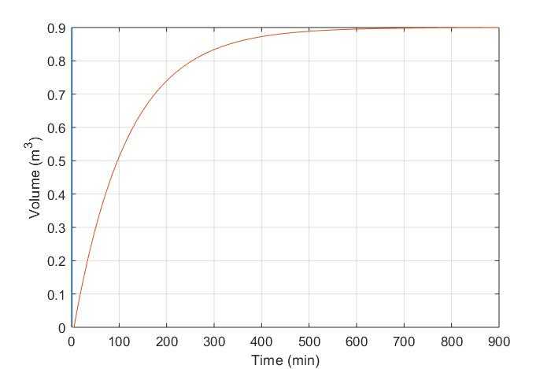

G

commandwindow
clearvars
clc
format short g
syms t kp td tp
v = kp*(1-exp(-((t-td)/tp)));
mdata = xlsread(' 1587203818odevbesdata', 'data1');
t1 = mdata(:,1);
v = mdata(:,2);
V1 = round(mdata(900,2),1)
t0 = ones(length(v),1)
t = [t0 t1]
[mcoeff, mcoeffint, mresid, mresidint, manova] = regress(v,t);
% mcoeff
% rsquaredvalue=mcoeff(1)
plot(t,v(:,1), 'g-0', 'Marketindices',([1:40::length(t)]);
xlabel('Time (min)')
ylabel('Volume (m^3)')
grid on

sir with this coding i got this graph
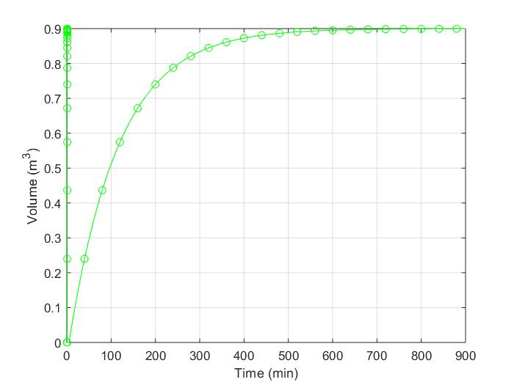
RAPH

