ADEUJI FAVOUR D.
15/ENG04/003

Question 1
(i) With the aid of a well labelled architectural diagram, provide detailed explain on the
working principle of 3G, 4G and 5G networks
(ii) Outline the advantage and disadvantages of 3G, 4G and 5G

3G ARCHITECTURE
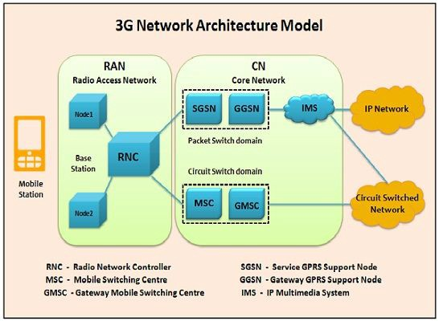
UMTS (Universal Mobile Telecommunications System)
UMTS, short for Universal Mobile Telecommunications System, is a 3G networking standard used throughout much of the world as an upgrade to existing GSM module.
- UMTS makes use of WCDMA, a technology that shares much with CDMA networks used throughout the world, though it is not compatible with them.
- Base level UMTS networks are generally capable of downlink speeds as 384 kbps.
- The UMTS architecture takes advantage of the existing GSM and GPRS networks which serve as a core network in UMTS infrastructure.
The UMTS is made up of 3 main components:
a) User Equipment:
It is assigned to a single user and contains all the functions needed to access UMTS services. It contains: – Mobile Equipment (ME) : It is a radio terminal which is used to connect the UMTS subscriber with the fixed part of UMTS system via the radio interface Uu.
– UMTS Subscriber Identity Module (USIM): A smartcard which contains the subscriber identity, authentication algorithms, encryption keys etc.
b) UMTS Terrestrial Radio Access Network (UTRAN):
It handles cell-level mobility. It is a system of base station and controller handling function related to mobility. It contains:
i) Nodes B (Base Stations):
• It converts the data between Uu radio interface and the Iub interface connecting a Node B with the RNC.
• It performs physical level processing such as channel coding, data interleaving, rate matching, modulation etc.
ii) Radio Network Controllers (RNC):
• RNC’s controls and manages radio resources to Node B.
• RNC performs the data-link layer processing and participates in handover operations. • RNC is considered a single access point of UTRAN for the core network.
• It’s connected to a single MSC/VLR to route circuit-switched traffic and to a single SGSN to route packet switched traffic.
c) Core Network (CN):
The core network is shared with GSM and GPRS. The CN contains functions for intersystem handover, gateways to other networks and performs location management. It contains:
- Home Location Register (HLR)
- Mobile Station Controller / Visitor Location Register (MSC/VLR).
- Gateway MSC: Connect UMTS to external circuit switch n/w (e.g PSTN)
- Serving GPRS Support Node (SGSN): It serves the Packet-switched traffic.
- Gateway GPRS Support Node (GGSN): Connects UMTS to external packet switched. (e.g. Internet)

Advantages of 3G :
- Faster data rates.
- Support multimedia applications such as video and photography.
- Value added services like mobile television, GPS, video call and video conference.
- High speed mobile internet access.
- Increased capacity.

Disadvantages of 3G :
- Requires 3G compatible handsets.
- The cost of upgrading to 3G device is expensive.
- Power consumption is high.
- 3G requires closer base stations which is expensive.

4G ARCHITECTURE
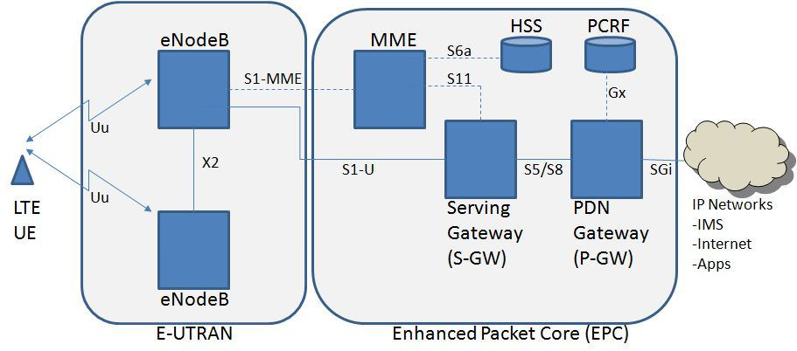
- 4G stands for fourth generation cellular system.
- 4G is evaluation of 3G to meet the forecasted rising demand.
- It is an integration of various technologies including GSM,CDMA,GPRS,IMT-2000 ,Wireless LAN.
- Data rate in 4G system will range from 20 to 100 Mbps.
- Figure shows Generic Mobile Communication architecture.
- 4 G network is an integration of all heterogeneous wireless access networks such as Ad-hoc, cellular, hotspot and satellite radio component.
- Technologies used in 4 G are smart antennas for multiple input and multiple output (MIMO), IPv6, VoIP, OFDM and Software defined radio (SDR) System.
Features:
- Fully IP based Mobile System.
- It supports interactive multimedia, voice, streaming video, internet and other broadband service.
- It has better spectrum efficiency.
- It supports Ad-hoc and multi hop network.

Smart Antennas:
- Smart Antennas are Transmitting and receiving antennas.
- It does not require increase power and additional frequency.
IPV6 Technology:
- 4G uses IPV6 Technology in order to support a large number of wireless enable devices.
- It enables a number of application with better multicast, security and route optimization capabilities.
VoIP:
- It stands for Voice over IP.
- It allows only packet to be transferred eliminating complexity of 2 protocols over the same circuit.
OFDM:
- OFDM stands for Orthogonal Frequency Division Multiplexing.
- It is currently used as WiMax and WiFi.
SDR:
- SDR stands for Software Defined Radio.
- It is the form of open wireless architecture.
Advantages:
- It provides better spectral efficiency.
- It has high speed, high capacity and low cost per bit.
Disadvantage:
- Battery usage is more.
- Hard to implement.

MME- Mobility Management Entity
It is used for Paging ,Authentication, Handover and Selection of Serving Gateway
SGW- Serving gateway
It is used to Routing and Forwarding user data packet.
PDN-GW Packet Data Network Gateway
It is used for user equipment (UE) IP allocation
HSS -Home Subscriber Server
It is a user Database used for service subscriber, user identification and addressing
PCRF -Policy and Charging Rule Function
It provide quality of service and charging
eNode B-evolved Node B
It is used as radio resources management and radio bearer control.

Advantages of 4G:
- Quickly download files over a wireless network
- Extremely high voice quality
- Easily access Internet, IM, social networks, streaming media, video calling
- Higher bandwidth
- 4G is 10 times faster than 3G
Disadvantages of 4G:
- New frequencies means new components in cell towers.
- Higher data prices for consumers
- Consumer is forced to buy a new device to support the 4G
- It is impossible to make your current equipment compatible with the 4G network

5G ARCHITECTURE

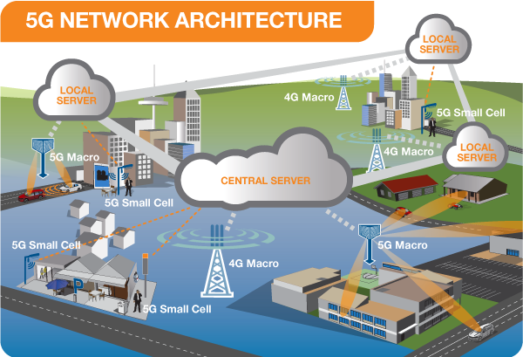

FIG; 5G network architecture illustrating 5G and 4G working together, with central and local servers providing faster content to users and low latency applications.
A mobile network has two main components, the ‘Radio Access Network’ and the ‘Core Network’.
The Radio Access Network - consists of various types of facilities including small cells, towers, masts and dedicated in-building and home systems that connect mobile users and wireless devices to the main core network.
Small cells will be a major feature of 5G networks particularly at the new millimeter wave (mmWave) frequencies where the connection range is very short. To provide a continuous connection, small cells will be distributed in clusters depending on where users require connection which will complement the macro network that provides wide-area coverage.
5G Macro Cells will use MIMO (multiple input, multiple output) antennas that have multiple elements or connections to send and receive more data simultaneously. The benefit to users is that more people can simultaneously connect to the network and maintain high throughput. Where MIMO antennas use very large numbers of antenna elements they are often referred to as ‘massive MIMO’, however, the physical size is similar to existing 3G and 4G base station antennas.
The Core Network - is the mobile exchange and data network that manages all of the mobile voice, data and internet connections. For 5G, the ‘core network’ is being redesigned to better integrate with the internet and cloud based services and also includes distributed servers across the network improving response times (reducing latency).
Many of the advanced features of 5G including network function virtualization and network slicing for different applications and services, will be managed in the core. The following illustration shows examples of local cloud servers providing faster content to users (movie streaming) and low latency applications for vehicle collision avoidance systems.

Technology Response time (millisec)
4G- LTE systems 20 – 30 ms
5G – enhanced mobile broadband 4 – 5 ms
5G – URLLC (Ultra Reliable Low Latency Communication) systems 1 ms

ADVANTAGES OF 5G
- High resolution and bi-directional large bandwidth shaping.
- Technology to gather all networks on one platform.
- More effective and efficient.
- Technology to facilitate subscriber supervision tools for the quick action.

DISADVANTAGES OF 5G
- 5G is more costly compared to other Mobile Network Technology because many technical/ official engineers are required to install and maintain it.
- The risk of overcrowding the frequency range of the 5G wireless spectrum is greater as more devices are connected to one channel.
- 5G network Technology will take more time for security and privacy issues.
- Coverage indoor distance up to 2 meters and 300 meters outdoors can be achieved due to greater losses at higher frequencies as 5Gmm wave influences from such losses (rain losses, attenuation due to rain, etc.).

Question 2
In tabular form, establish adequate differences between 2G, 3G, 4G and 5G

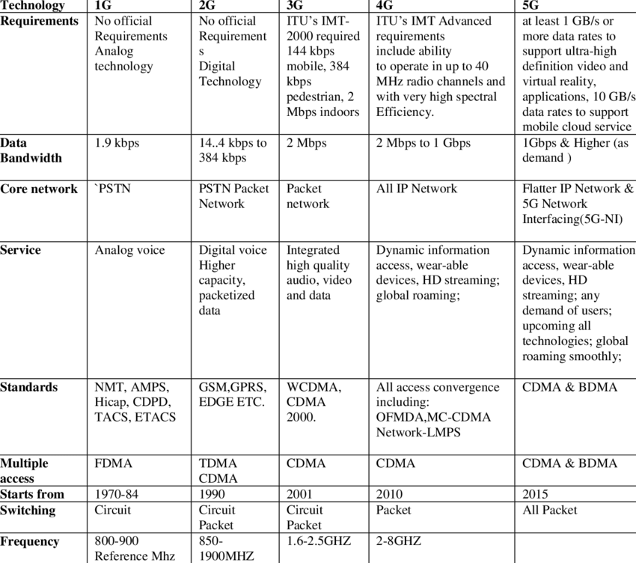

QUESTION 3
Recently in Nigerian there has been a widespread of opinion that the advent of 5G
evolution will aid the spread of the corona virus which has become a pandemic all over the
world.
(i) Is there any correlation between 5G and Corona virus
(ii) Do you support the state, if yes or No, in not more than 500 words Justify your answer to
(i) and (ii)

  - No
  - No
JUSTIFICATION FOR (i) and (ii)

5G and human health
5G, or fifth-generation wireless technology, is a new global wireless standard being deployed around the world now. While previous mobile network generations relied on lower frequency wavelengths being transmitted across wider areas, the standard 5G spectrum is about a factor of 10 — an order of magnitude — higher than the previous four generations of cell networks. That increased information flow, coupled with more accurate antenna connectivity and decreased latency, makes a range of new real-time operations possible over the network.
Ted Rappapot, an electrical engineer and professor at New York school of Engineerind and School of Medcine said that, "The frequencies of 5G waves are so much lower in power and still four orders of magnitude, or 10,000 times less, than ionizing waves, which are known to possibly be carcinogenic in large doses.
“It’s important for people to realize that the ultraviolet waves from the sun are many thousand times higher frequency than 5G. People should be more concerned about wearing sunscreen outside than using their 5G cellphones,” "Nothing has been scientifically demonstrated that links electromagnetic radiation and virus proliferation," Richard Kuhn, a professor of virology at Purdue University, told USA TODAY. "This is true not only for COVID-19 but also for other known human viruses."
“A worldwide online conspiracy theory has attempted to link 5G cellphone technology as being one of the causes of the coronavirus. Many cell towers outside of the U.S. have been set on fire as a result. 5G technology does NOT cause coronavirus,” the Federal Emergency Management Agency and Federal Communication Commission jointly emphasize on an "Coronavirus Rumor Control" page of FEMA's website.
The World Health Organization issued a similar statement dispelling myths that 5G is caused by the coronavirus. “Viruses cannot travel on radio waves/mobile networks. COVID-19 is spreading in many countries that do not have 5G mobile networks,” the WHO said on its website.
“COVID-19 is spread through respiratory droplets when an infected person coughs, sneezes or speaks. People can also be infected by touching a contaminated surface and then their eyes, mouth or nose.”
Standard 5G frequencies were also ruled safe by the International Commission on Non‐Ionizing Radiation Protection, an organization of scientists that reviews the health risks posed by lower frequency electromagnetic waves.
“We know parts of the community are concerned about the safety of 5G, and we hope the updated guidelines will help put people at ease,” ICNIRP Chairman Dr. Eric van Rongen said of the group’s new standards, which identify the millimeter-wavelengths to be used for 5G as safe.
“The technologies and frequencies that are being used in 5G are not things that we haven’t seen before,” Muriel Médard, a professor of electrical engineering at the Massachusetts Institute of Technology said.
“Since there is no bioeffects or health effects research on 5G, I personally think it is irresponsible to publicize these theories during a pandemic when many people are highly anxious and conspiracy theories are rampant,” he continued. “People are spreading this virus. If there is a link with the pandemic, it would be disruption of the immune system caused by exposure to various types of nonionizing electromagnetic fields, not just 5G radiation.”

