NAME: CHIEZE CHINOMSO FAITH

MATRIC: 18/ENG01/006

DEPT: AEROSPACE ENGINEERING

FOOD AND PRODUCTION

FAITH’S FISH FARM

FAITH’S FISH FARM

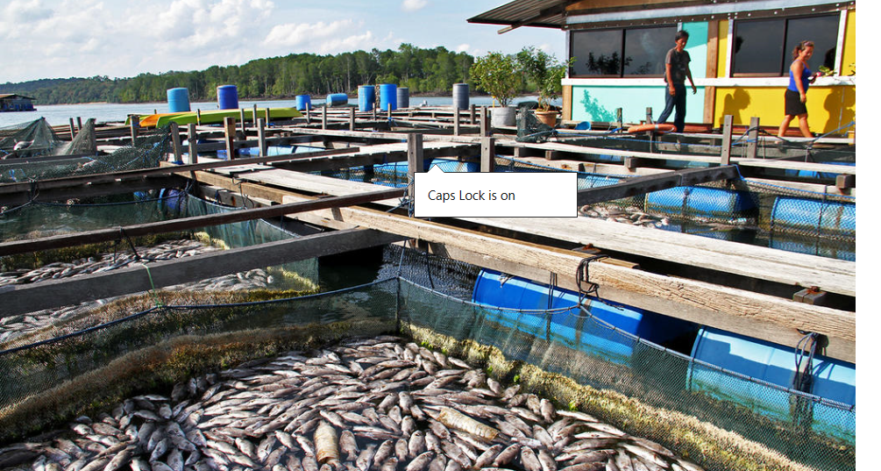

THE PROJECT CYCLE INVOLVES:
- IDENTIFICATION/SELECTION
- PREPARATION AND ANALYSIS
- APPRAISAL
- IMPLEMENTAION AND MONITORING
- EVALUATION

FISH FARMING PROJECT
Fish farming or pisciculture involves raising fish commercially in tanks or enclosures such as fish ponds, usually for food. It is the principal form of aquaculture, while other methods may fall under mariculture.

HOW TO START A FISH FARM
- Get a good location for your farm.
You need to first decide whether you are starting your fish business on a small scale or you are going big.
If you are starting a small scale fish farm, you may decide to start at your backyard with tank but if you are going big, you may need to buy or rent one or few fish ponds (earthen or concrete ponds) outside your home
- Get a good source of water.
The size of your intending fish farm determines the quantity of water needed, if you are starting a small scale fish business, you may be comfortable with a nearby well or borehole and water storage tank.
- Choose the right fish pond for your fish.
My fish needs a comfortable place to live. The more natural and comfortable the fish pond is the better for them. So a pond or a well might be a good idea.
- Decide the right species of fish to farm.
This means that I have to decide which species to choose as I am starting my own fish farming business
- Get healthy Juveniles.
These are the little fishes I would need to grow to table-size, E.g. Fingerling, yearling, etc.
- Choose the right fish feeds
Fish need:
- Natural fish feed
- Supplementary fish feed
- Complete feed as their source of food.
- Be business minded.
I have to approach my fish farm as a serious business
- Think about a mentor and fish farming training.
I have to look for a mentor in the fish farm business to look up to so I can be consistent.

FEASIBILITY STUDY
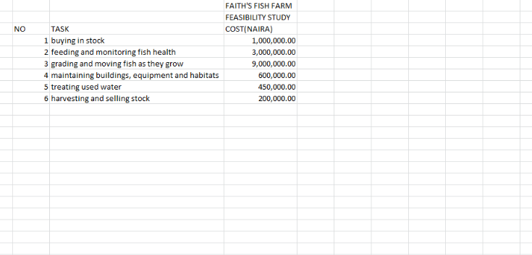
Total= 14,250,000
If after the 2 month period, there are three batches of fish produced. Our farm should be able to produce up to dozens offices. A dozen of fish in today’s market is 30,000.00 naira. Hence 12 X 30,000 = 360,000,000. At the end of the year if we subtract the gain from the capital we get 14,250,000 – 120,000 = 14,130,000. That’s a 71% gain.

EXECUTIVE SUMMARY/ PROJECT DESCRIPTION
We have purchased 3 boreholes and 6 wells in the southern part of Kaduna. The number of our fish will be one thousand and they would be able to reproduce triple of them after every four months in our first year.
SPONSORSHIP
The farm’s primary sponsor will be the founder
MANAGEMENT
It is going to be governed by the founder.
Eng. Frank Chieze Faith and her family.
TECHNICAL ASSISTANCE
All our equipment will be gotten from Chinedu and sons enterprise.
MARKETING AND SALES
Market orientation: domestic: South West, Nigeria.
Market Share: 7% niche market in South West Nigeria
USER OF PRODUCTS: Restaurant owners, fish sellers, Sardine companies, etc.
PROJECT TIMELINE
Different species of fish will go out to the various users of the products every one month and it goes for the price of 30, 00.00 depending on the amount of fish needed.
CONCLUSION
The project is technically feasible and commercially viable. It is therefore recommended for funding.

APPRAISAL
In the phase of the project, the project planning the optimal use of scarce resources by the proposed project will be appraised by using the Cost Benefit Analysis Method.
MARKET ANALYSIS
ABARES has been conducting surveys of agricultural industries sin​ce the 1940s. Farm surveys conducted by ABARES provide a wide range of information on the current and historical economic performance of farm business units in the rural se​ctor. This information is used for research and analysis on a range of industry issues of concern to gove​rnment and industry.​
An overview of results for Australian br​oadacre and dairy farms is released at the ABARES OUTLOOK Conference each March. This includes analysis of farm costs, receipts, income, profit, rates of return, performance by state and performance by industry (defined by ANZSIC). Farms are classified to ANZSIC-based industries based on the relative contribution of farm outputs to total​ output. This method allows analysis to focus on relatively homogeneous groups of farms.
Subsequent analyses of farm performance are published for beef, lamb, grain and dairy farms. These industries are classified more broadly than those published at OUTLOOK to provide a more complete picture of trends and variation in performance across farms by type of co​mmodity produced, size and region.​​
WHO IS OUR TARGET MARKET
The target market is informed about the uniqueness of the fish product, and an important health benefit or otherwise of the fish products highlighted. Therefore, Faith’s fish farm is targeting many people as possible including hoetels, restaurants, etc.
OUR COMPETITIVE ADVANTAGE
We offer clients better and greater value. Advertising our fishes with lower prices or bigger fishes piques the interest of consumers.
WHAT IS OUR SALES STRATEGY
We are quite aware that in order to expand our market scope, we should go beyond reaching other people. In view of that, we decided to set up smaller fish farms in other states to help us maximize our profits.
Our employees will be groomed every month and be frequently updated on the latest trends. Below are the steps we need to take:
- Introduce our business by sending introductory letters alongside our brochure to stake holders in the agriculture industry, other fish farmers, hotels, etc.
- Advertise our business in fish on food related websites and magazines
- List our type of fishes on yellow pages’ ads
- Engage in direct marketing,
Equipment needed
- Net and traps
- Pumps
- Harvesting tools
- Tools for digging up the pond
- Equipment for measuring out the pond
- Equipment for weighing fish
- Equipment for stocking
- Taking care of fish farming equipment
- Water pump

IMPLEMENTATION/MONITORING
The future of the business lies in the numbers of loyal customers that they have the capacity and competence of the employees, their investment strategy and the business structure. If all these factors are missing from a business, then it won’t be too long before the business close shop. One of the major goals of starting Faith’s fish farm is to build a business that will survive off its own cash flow without the need for injecting finance from external sources once the business is officially running.
We know that one of the ways of gaining approval and winning customers over is to sell our farm produce (processed and well- packaged) a little bit cheaper than what is obtainable in the market and we are well prepared to survive on lower profit margin for a while.

EVALUATION
Business name: completed
Business incorporation: completed
Opening of bank accounts in various states: in process
Getting Tax payer’s ID: competed
Getting all form of insurance from the bank: in process
Conducting Feasibility Studies: completed
Start – up Capital generation: completed
Writing of business plan: completed
Drafting of Employee’s Handbook: completed
Design of Company’s logo: completed
Buying of ponds: completed
Gathering of fingerlings: in the process
Purchase of tools for cleaning: completed
Raising and purchase of earthworms: completed
Drainage and water supply system: completed
Segregation of fish: completed
Partnering with restaurants: completed
purchase of industrial freezer: completed
Processing into Titus: in process
Fractional distillation of oil: in process
Recruitment of employees: in process
Creating official website for the company: in process

