NAME: OSENI-BAKO NAOMI OCHUWA.

MATRIC NO: 18/SMS09/079.

LEVEL: 200 LEVEL.

SEMESTER: SECOND SEMESTER.

COLLEGE: SOCIAL AND MANAGEMENT SCIENCES. (SMS).

DEPARTMENT: INTERNATIONAL RELATIONS AND DIPLOMACY. (IRD).

COURSE CODE: AFE 202

COURSETITLE: FOOD PRODUCTION AND HEALTH AWARENESS.
QUESTION; PREPARE A BUSINESS PLAN ON A CHOSEN AGRICUTURAL ENTERPRISE FOLLOWING THE GUIDELINE IN THE NOTE. MINIMUM OF FIVE PAGES, TIMES NEW ROMAN SIZE 12 WITH DOUBLE SPACING.

NAOMI Z FARM LIMITED POULTRY FARMING BUSINESS PLAN

Company Name & Logo:

NAOMI Z FARM LIMITED

NAOMI Z FARM LIMITED

Headline:
What is a poultry?
A poultry can be defined as domestic fowls, including chickens, turkeys, geese and ducks, raised for the production of meat or eggs and the word is also used for the flesh of these birds used as food.
There are 3 basic types poultries;
- Domestic land fowl; they are domesticated birds that belong to the scientific order of galliformes. The most common variety is chicken.
- Domestic waterfowl; they include waterborne birds. Duck is one of the most common varieties of domestic waterfowl.
- Game birds; undomesticated varieties of fowl that are hunted for food. Many game birds are wild versions of their domestic counterparts such as wild turkey, wild duck, wild goose, etc. they have a more intense flavor than domesticated fowl.

EXECUTIVE SUMMARY OF THE BUSINESS.
Naomi Z Farm Limited is a full service poultry farming business setup to provide quality and affordable poultry products to the millions of Nigerians earning less than the minimum wage. This will be achieved through our unique and proprietary methods of raising poultry gained from over 10 years of experience in the poultry farming industry.
Naomi Z Farm is established in Lagos, which was once the capital of Nigeria, the main office is located there, and it has other branches in Abuja, port Harcourt, edo, and even outside of the country Nigeria.

Problem(s) we will solve:

Naomi Z Farm Limited intends to address the following problems/pain points in the market:
- Making poultry products affordable to low-earning workers who only/mostly eat poultry on special occasions (Christmas, birthdays etc.)
- Ensuring that poultry products are well packed and prepared hygienically

Naomi Z Farm Limited’s solution(s):
Rayfield Poultry Farms Ltd will make poultry affordable to the masses by
- Drastically reducing the cost of raising poultry by using new feeding methods, practices and feed materials
- Eliminate the middle men in product distribution by supplying directly to the consumers through use of e-commerce and community per sales outlets

Naomi Z Farm Limited’s target market:
population can be seen below
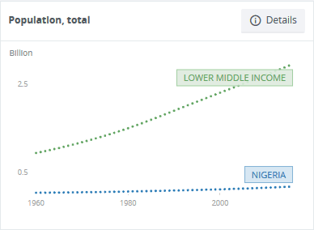
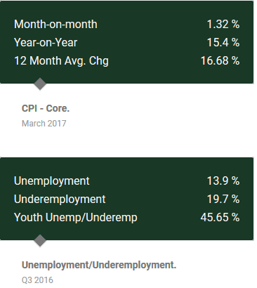

Naomi Z Farm Limited’s competitive landscape
The competitive landscape for our poultry farming is listed below:
Direct Competitors
Roostter | Better packaging, More variety
ChoFarms | Cheaper price, More variety
Zamo | Cheaper price, Better packaging
Fiesta | Cheaper price, Better packaging

Indirect Competitors
Pork meat | Mass appeal
Meat sellers | Better hygiene
Fish sellers | Tastier, Better hygiene, Better packaging
Canned Products | Healthier, Fresher

Naomi Z Farm Limited’s Funding needs
Naomi Z Farms Ltd intends to raise N160,200,000 which would be spent as shown below:
- Processing Equipment and Machinery— N105,000,000
- Staff & Personnel— N4,800,000
- Birds— N5,400,000
- Feeding Material— N45,000,000
Naomi Z Farm Limited’s sales channels
Naomi Z Farms Ltd intends to get her poultry products directly to her customers through the following sales channels:
- Online store: where customers can order directly to their homes
- Community peer channels: we will setup clusters of peer sales outlets in densely populated areas where customers can buy poultry products from
- Farm sale shops
Marketing activities
- Facebook marketing campaign
- Twitter marketing campaign
- Product flyers and banners
- Radio advert
- Instagram promotion
- Google adword campaign

. Naomi Z Farm Limited’s Financial Forecast:

We will be selling eggs and poultry parts and computing all the financial data for our business plan, the following are the financial projections we arrived at:
Naomi Z Farm Limited is a full service poultry farming business setup to provide quality and affordable poultry products to the millions of Nigerians earning less than the minimum wage. This will be achieved through our unique and proprietary methods of raising poultry gained from over 10 years of experience in the poultry farming industry.
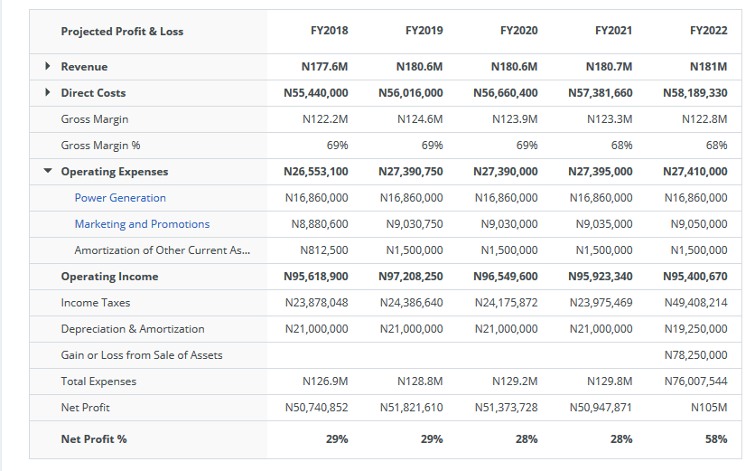

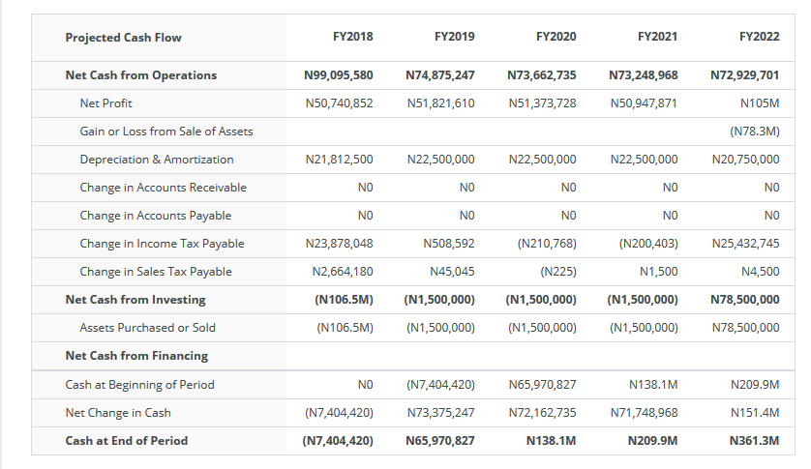Name & Logo

