NAME: Garba Angel Eje

MATRIC NO: 18/SMS09/045

COURSE CODE: AFE202 (Food production and Health awareness)

QUESTION: Prepare a business plan on a chosen agricultural enterprises following the guidelines in the notes. Spiral bind and submit upon resumption. Minimum of five pages, times new Roman size 12 with double spacing. Send a soft copy to me to view.

DATE: 17th April, 2020.

AVADULOCO FRUIT&VEGETABLES RANCH
What are fruits and vegetables?
Fruits are a product of plant growth (such as grain, vegetables, or cotton) Fruits are the seed-bearing structure in flowering plants (also known as angiosperms) formed from the ovary after flowering.
Fruits are the means by which angiosperms disseminate seeds. Edible fruits, in particular, have propagated with the movements of humans and animals in a symbiotic relationship as a means for seed dispersaland nutrition; in fact, humans and many animals have become dependent on fruits as a source of food. Accordingly, fruits account for a substantial fraction of the world's agricultural output, and some (such as the apple and the pomegranate) have acquired extensive cultural and symbolic meanings.
In common language usage, "fruit" normally means the fleshy seed-associated structures of a plant that are sweet or sour, and edible in the raw state, such as apples, bananas, grapes, lemons, oranges, African cherry, almonds, kiwi, raspberries and strawberries, etc. the other hand, in botanical usage, "fruit" includes many structures that are not commonly called "fruits", such as beans pods, corn kernels, tomatoes, and wheat grains, etc.
Many hundreds of fruits, including fleshy fruits (like apple, kiwifruit, mango, peach, pear, and watermelon) are commercially valuable as human food, eaten both fresh and as jams, marmalade and other preserves. Fruits are also used in food such as; (e.g., cakes, cookies, ice cream, muffins, or yogurt) or beverages, such as fruit juices (e.g., apple juice, grape juice, or orange juice) or alcoholic beverages (e.g., brandy, fruit beer, or wine). Fruits are also used for gift giving, e.g., in the form of Fruit Baskets and Fruit Bouquets. Many "vegetables" in culinary parlance are botanical fruits, including bell pepper, cucumber, eggplant, green bean, okra, pumpkin, squash, tomato, and zucchini, olive fruit is pressed for olive oil. Spices like all spice, black pepper, paprika, and vanilla are derived from berries.
Fruit make up a large portion of our diets. Did you know many foods that we consider to be vegetables are actually fruits? The botanical definition of fruit is a seed-bearing part of a flowering plant or tree that can be eaten as food. By those standards, foods such as avocados, cucumbers, squash, and yes, even tomatoes are all fruits. From a culinary viewpoint, a fruit is usually thought of as any sweet-tasting plant product with seeds, whereas a vegetable is any savoury or less sweet-tasting plant.

Types of Fruits
Fruits can be eaten raw, frozen, stewed, cooked, or dried. All fruits may be classified into three major groups: simple, aggregate, or multiple.
Simple Fruits = one fruit that has developed from the ovary of a single flower. Simple fruits may either be fleshy, like plums and peaches, or dry, such as walnuts and hazelnuts.
Aggregate Fruits = a fruit formed from several ovaries of one flower that produces many tiny fruits clustered tightly together.
Multiple Fruits = a fruit formed from the fusion of the ovaries of many different flowers which develop closely together to form one bigger fruit.
Note: False fruits or accessory fruits are another kind of fruit that is not formed from the ovary, but from a different part of the flower. These fruits may be simple, aggregate, or multiple fruits. For example, strawberries would be considered an aggregate fruit, as well as an accessory fruit since much of the fleshy fruit part does not come from the ovary.
What then are vegetables?
Vegetables are parts of plants that are consumed by humans or other animals as food. Vegetables can be eaten either raw or cooked and play an important role in human nutrition, being mostly low in fat and carbohydrates, but high in vitamins, minerals and dietary fiber. Many nutritionists encourage people to consume plenty of fruit and vegetables, five or portions a day often being recommended.
A vegetable, a plant or part of a plant used as food, such as a cabbage, potato, turnip, or bean. Vegetables are available in many varieties and can be classified into biological groups or ‘families’, including:
- Leafy green – lettuce, spinach and silverbeet
- Cruciferous – cabbage, cauliflower, Brussels sprouts and broccoli
- Marrow – pumpkin, cucumber and zucchini
- Root – potato, sweet potato and yam
- Edible plant stem – celery and asparagus
- Allium – onion, garlic and shallot, etc.

AVADULOCO FRUIT&VEGETABLES RANCH
EXECUTIVE SUMMARY
Avaduloco fruit and vegetables ranch is located in Benue state. It is named after the great grandfather of the Agbo lineage, The Avaduloco fruit and vegetable ranch started from one acre of land and is now about 6 hectares of land, it consists of various fruits and vegetables, the main aim why Avaduloco fruit and vegetables ranch was created was to help the community stay healthy and get cheap fruits and vegetables that are very affordable and easy to reach. Avaduloco fruit and vegetables ranch is based on the sound principles of conserving natural resources, limiting the carbon footprint, growing, hiring and eating locally grown and prepared foods, and making the world a better place to live in. This unique perspective clearly shows in the quality of the produce, the well cared for gardens, and natural friendliness and ease of its owners. Avaduloco fruit and vegetables ranch was created to meet the growing needs of a community that shares these same views and is concerned about what they eat and feed their children. This is a community that is tired of ‘fresh’ tomatoes bought at the local grocery store. When more than likely the “fresh” tomatoes were picked while still unripe, shipped 3,000 miles over several days/weeks, and then artificially “ripened” using ethylene gas, thus robbing it of practically all of its nutritional value. We say this as an Avenue to help Benue state which is known as the “food basket of the nation” provide better revenue and food for it’s citizens, Avaduloco fruit and vegetables ranch provides alot of employment for it’s people with housing and free food, it has become like a big family which we sale fruits and vegetables at affordable prices and give the homeless people food on a regular, we are trying in the little way we can to help the zero hunger campaign by the United Nations.
MISSION STATEMENT
Avaduloco fruit and vegetables ranch mission is to raise the best tasting and finest quality fruits and vegetables for the local community. Avaduloco fruit and vegetables ranch uses only natural and sustainable farming methods, free from pesticides or fertilizers. Natural foods and natural farming methods leaves a smaller carbon footprint while simultaneously improves the health of its customers and its local community. The benefits of our products and services, they are;
• To provide healthy and non-injected fruits and vegetables to the citizens
• To provide affordable fruits and vegetables for all persons
• To provide fresh and hygienic packages of fruits and vegetables, etc.
Management team
This business would be headed by Garba Angel Eje as the Chairwoman of the company, also a team of 20-40 employees to cover all activities that would be done, Angel has knowledge in agricultural science as she studies it both in BCH and masters, also working in some top firm to help her gain experience and more knowledge.

MARKT ANALYSIS STRATEGY
Avaduloco fruits and vegetables ranch has decided to do a market research on the total market and having gotten the statistics and analysis, deciding to do market segmentation strategy and has a niche population of roughly 20,000 individuals. This research involves employing individuals to move round the local market to find out what local retailers don’t like about the products being delivered to them, in other words a survey of the market was made. This survey would help Avaduloco fruits and vegetables ranch in a long run to gain a larger market share.

Market Segmentation
Avaduloco fruit and vegetables ranch has identified different target market segments which they will sell to:
Supplement Companies
In other words, these are retail local shops that would purchase products of Avaduloco fruits and vegetables ranch and sell it in bulk to the local markets around.
Also selling the product to some larger organizations that could later use their own brand to market the product.
The five main channels of distribution are: consumer-direct (includes direct mail/catalog, direct from sales representatives, multi-level marketing, Internet & infomercial/direct from television); food, drug, mass-market stores, health and natural food stores, and practitioners, others.

FINANCIAL MODEL
Projected revenues for Year 1 to Year 5 are N40,000, N8,500, N50,000, N70,800 and N82,500 respectively. Additionally the Avaduloco fruit and vegetables ranch estimates that once fully operational, income per product, per annum would be as follows; vegetable (N50,000)and fruits(N50,000).
START-UP REQUIREMENTS
Start-up Expenses
Legal | N19,000
Facilities modification | N300,000
Seed | N600
Organic Herbicides | N5,000
Consultants | N25,000
Insurance | N10,000
Research and development | N25,000
Expensed equipment | N250,000
Other | N50,000
TOTAL START-UP EXPENSES | N684,600
Start-up Assets
Cash Required | N245,400
Start-up Inventory | N150,000
Other Current Assets | N250,000
Long-term Assets | N500,000
TOTAL ASSETS | N1,145,400
Total Requirements | N1,830,000

life cycle of Avaduloco fruit and vegetables ranch
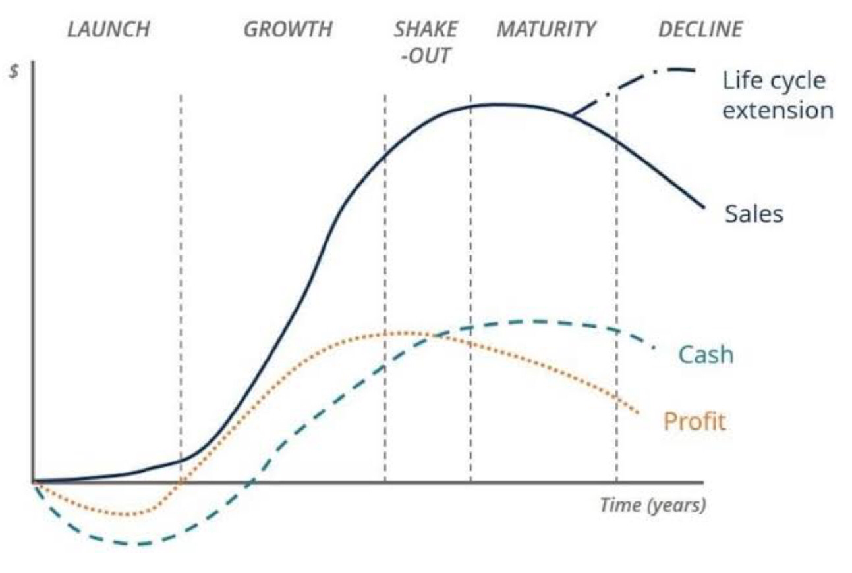
At a time when eating has become a political statement, the government is paying up to $19 billion a year to subsidize commodity crops in a glutted global market. Federal officials say that nearly 40% of all farm income now comes directly from government subsidies, and the farm bill signed by President Buhari the year he ascended into power, will pay$190 billion over 10 years, which includes$83 billion in new spending. However, there are two market niches that are growing at an amazing rate, the organic market and the simple farmers' market.
The organic market provides less than 2% of the nation's food supply and takes up less than 1% of its cropland. But organic farms are flourishing as never before. Over the past decade the market for organic food has grown by 15 to 20% and every year 40% of Nigerian consumers occasionally reach for something labeled organic. Sales for organic foods are expected to top $11 billion.
In conclusion, Avaduloco fruit and vegetables ranch is going to make profit for the family and going to be of good service to the community, The Avaduloco fruit and vegetables ranch helps try to give food at affordable prices to all and give homeless people food on a regular, It is a business that tries to be it’s neighbours keeper, A business to be reckoned with; Avaduloco fruit and vegetables ranch is a business with vision of solving zero hunger in the world, A business with a wide horizon.

