EEE 512
I5/ENG04/018
ELECT/ELECT
EDOKPOLOR NOSARIEMEN DAVID

1.
3G | 4G | 5G
3G data technology uses a network of phone towers to pass signals, ensuring a stable and relatively fast connection over long distances. The tower nearest to the user's mobile phone passes data to it. While it may not sound complex, 3G technology was revolutionary at the time it was released  SPEED: 3G offers speeds that are several times faster or higher than any of its predecessors, including the short-lived 2.5G network which offered internet connectivity. 3G speeds are high enough to allow for audio and video streaming. They’ve been shown to be perfectly adequate for remote collaboration tools, such as Unified Communications, while offering clear and responsive voice clarity across the line.  But what specific speeds does 3G offer? Keep in mind that specific speeds are determined by the tower networks and individual capabilities of the provider. According to some estimates, 3G offers a real-world maximum speed of 7.2 Mbps for downloads and 2 Mbps for uploads.  While today these numbers may not seem impressive, especially compared to 4G or 5G networks, sometimes 4G technology simply is not available. In these cases, 3G is the default option. | The term 4G stands for 'fourth generation' and refers to mobile network technology that enables 4G compatible phones to connect to the internet faster than ever before. In the UK, 4G launched in 2012. Right now, the number of smartphone users who use 4G is dwarfed by its forerunner 3G  4G offers maximum real-world download speeds up to around 100Mbps, making it over 20 times faster than 3G. Theoretical maximum 4G speeds are significantly higher at 300Mbps, although such speeds are only achievable in controlled laboratory environments | 5G network architecture illustrating 5G and 4G working together, with central and local servers providing faster content to users and low latency applications. ... 5G Macro Cells will use MIMO (multiple input, multiple output) antennas that have multiple elements or connections to send and receive more data simultaneously  How far can 5g transmit?  The shorter wavelength means 5G can carry a lot of data much faster than 4G, but it also means a much shorter range. 4G wavelengths have a range of about 10 miles. 5G wavelengths have a range of about 1,000 feet, not even 2% of 4G's range.  Can 5g make you sick?  "Radiofrequency energy from wireless devices and networks, including 5G, hasn't been shown to cause health problems, according to the consensus of the international scientific community," the wireless industry association CTIA said in a statement

2.Advantages and disadvantages
3g
Advantages | Disadvantages
The customers will get a high-speed network for their communication which is far better than the 2G technology, particularly in data communication. | Since in telecom sector, there is much competition, so the companies have a very marginal price for their facilities.
The customer will get wireless broadband. | Due to the use of the DTH & the 3G technology, everyone will use this multi-purpose services to avoid time loss and keeping records for different service providers. So, the traditional cable business will badly affected by implementing this new technology.
It may also be cheap than the other traditional media we are using, as a result of a price war. | The radiation of magnetic waves generated with the heavily use of the wireless system will affect our life also. More uses of the services will have more effect on us. The radiation of the magnetic waves are danger for our life. Long use can affect our brains.
The many in one service will be available on the same network. Due to the use of the DTH & the 3G technology, everyone will use this multi-purpose services to avoid time loss and keeping records for different service providers. | The mobiles are not suitable devices to see TV or web browsing. So, initially this service may be used in mass but in future, mobile can not be used to see the TV or for Internet surfing. Which will affect the business of the 3G.

4g
advantages | disadvantage
Quickly download files over a wireless network | New frequencies means new components in cell towers.
Extremely high voice quality | Higher data prices for consumers
Higher bandwidth | Consumer is forced to buy a new device to support the 4G
4G is 10 times faster than 3G | It is impossible to make your current equipment compatible with the 4G network

5g
Advantages | Disadvantages
More Bandwidth Means Faster Speed | The Radio Frequency May Become a Problem
New Technology Options May Become Available on a 5G Network | An Increased Bandwidth will mean Less Coverage.

2b
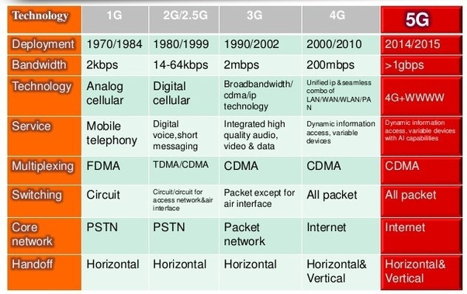

3.NO , There is no correlation between 5g and Corona virus.
Its been Under speculation that there could be some correlation between 5g and corona virus which I find very absurd because in what way could a virus be connected to an ISP
The first link John Gregory saw pushing a connection between 5G and the coronavirus pandemic was on a French conspiracy website called Les moutons enragés, which loosely translates as “The rabid sheep.” A January 20 post floated that the millimeter wave spectrum used by 5G technology and Covid-19, the disease caused by the novel coronavirus, could be related, pointing to reports about Wuhan installing 5G towers before the outbreak. Three months later, conspiracy theorists making similar claims were setting cellphone towers on fire in Europe.
Gregory, a senior analyst at the internet trust tool NewsGuard, caught an early glimpse of the 5G coronavirus conspiracy theory, but it didn’t take long before the fake news started to spread. Two days after the French blog post, a Belgian newspaper called Het Laatste Nieuws published an interview with a local doctor, who floated the unfounded claim that the coronavirus outbreak could be linked to 5G cellphone towers installed near Wuhan in 2019. The article was taken down within hours, but the theory had already spread to English-language Facebook pages. Gregory wasn’t surprised.
“There’s been a crowd that has been saying that 5G is harmful to human health for years, ever since 5G was first being proposed [and] well before any towers or networks were online,” he told Recode. “This is just their latest attempt to push those claims, tying them onto this current news story.”
Initial theories about the relationship between the coronavirus and 5G have now ballooned into all sorts of wild speculation. Some suggest that 5G networks cause radiation, which, in turn, triggers the virus. Others float that reports of the novel coronavirus were actually a cover-up for the installation of 5G towers. A few accounts push the idea that 5G and Covid-19 are part of a broader effort to “depopulate” Earth. Some think it might be connected to the American agriculture titan Monsanto.
As out-there as all this seems, it’s also dangerous. As certain people fall for these theories and act out, they stand to harm themselves and others. By early April, conspiracy theorists were setting cell towers on fire in Europe and starting to intersect with other conspiracy-minded communities like anti-vaxxers, raising fears that the towers could pose a threat to public health. In the face of these fears, it remains unclear if the platforms where these ideas are spreading — Facebook, Twitter, and YouTube — can do anything to stop the madness.

5G conspiracy theories have been around for years
The loose and incorrect reasons some have connected 5G technology to the coronavirus outbreak are myriad and maddening. Some seem to think that both 5G and the coronavirus are new, so they must be connected somehow. Others point to suspicious sources like misunderstood legislation as evidence that the government is hiding something in this global crisis. But ultimately, most of these ideas draw on an established well of confused concern about 5G technology and longstanding fears about new cellular technologies.
“This really crosses the spectrum — lots and lots of political leanings and different types of conspiracy theory can find something in the 5G theory,” explains Tom Phillips, the editor of Full Fact, a UK-based fact-checking organization, pointing out that similar fears were expressed during the introduction of 3G and wifi. “A lot of those fears were just transplanted onto 5G when the rollout of that began.”

