NAME: AMAINO SAMUEL
DEPARTMENT: BIOMEDICAL ENGINEERING
MATRIC NO: 18/ENG08/026
COURSE: BME316

ANSWERS

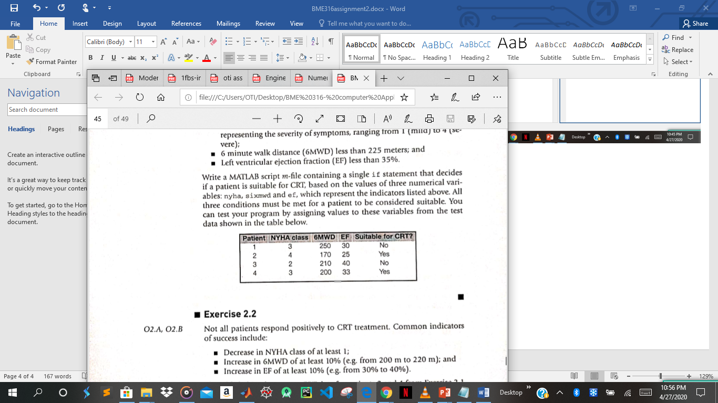

2.1
1a)
%CRT qualification test
commandwindow
clc
clear all
syms nyha sixmd ef
a = CRTqualification(3, 250, 30)
function [a]=CRTqualification(nyha, sixmwd,ef)
if (nyha >=3 & nyha <= 4)& (sixmwd<225) & (ef < 35)
a = "yes"
else
a = "no"
end
end

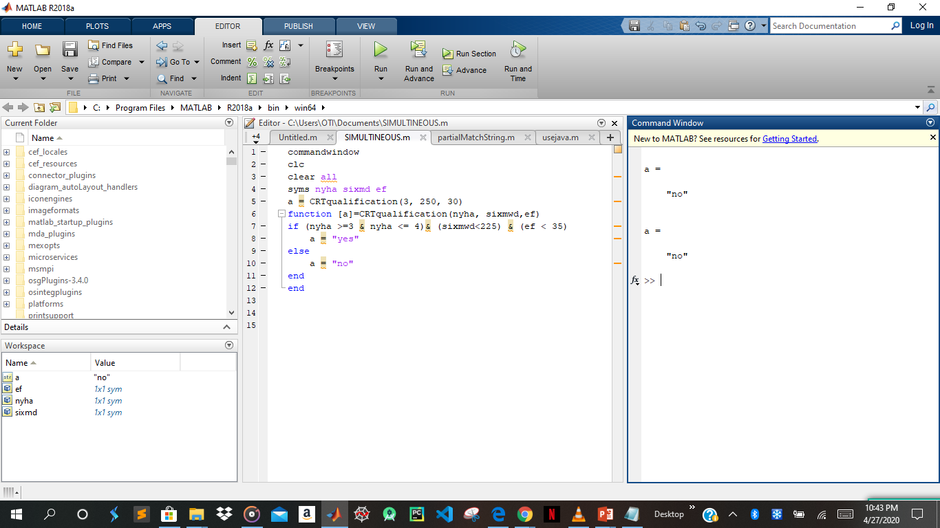

b)
commandwindow
clc
clear all
syms nyha sixmd ef
a = CRTqualification(4, 170, 25)
function [a]=CRTqualification(nyha, sixmwd,ef)
if (nyha >=3 & nyha <= 4)& (sixmwd<225) & (ef < 35)
a = "yes"
else
a = "no"
end
end

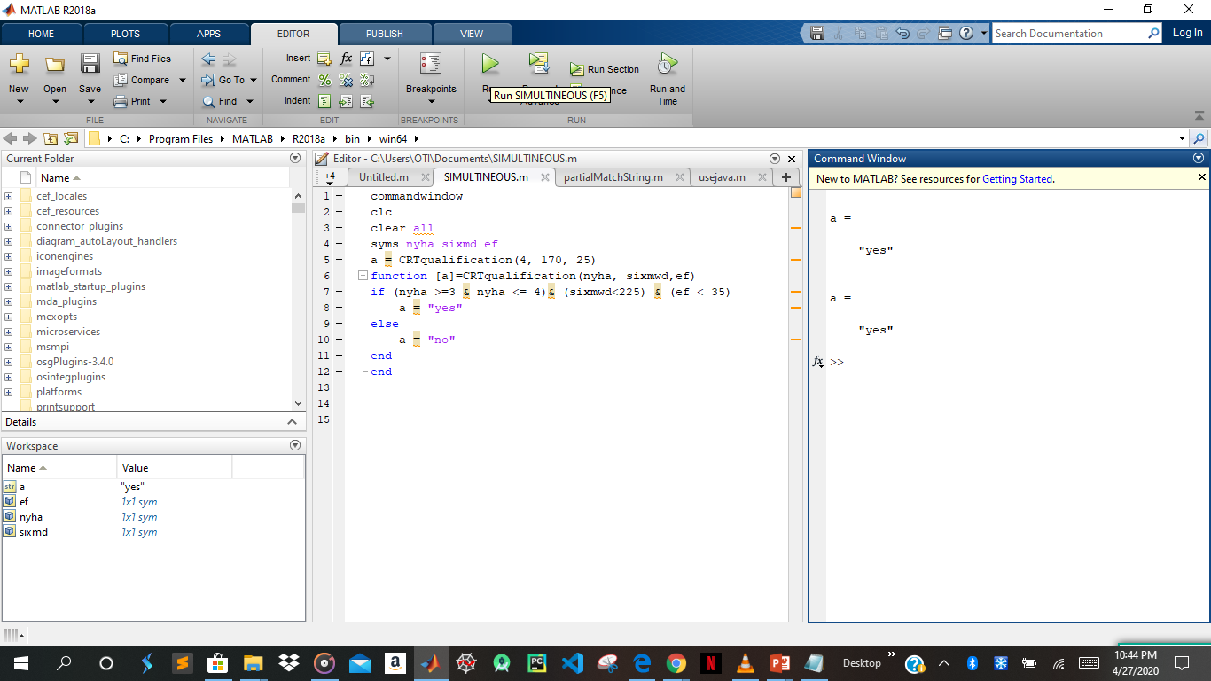

c)
commandwindow
clc
clear all
syms nyha sixmd ef
a = CRTqualification(2, 210, 40)
function [a]=CRTqualification(nyha, sixmwd,ef)
if (nyha >=3 & nyha <= 4)& (sixmwd<225) & (ef < 35)
a = "yes"
else
a = "no"
end
end

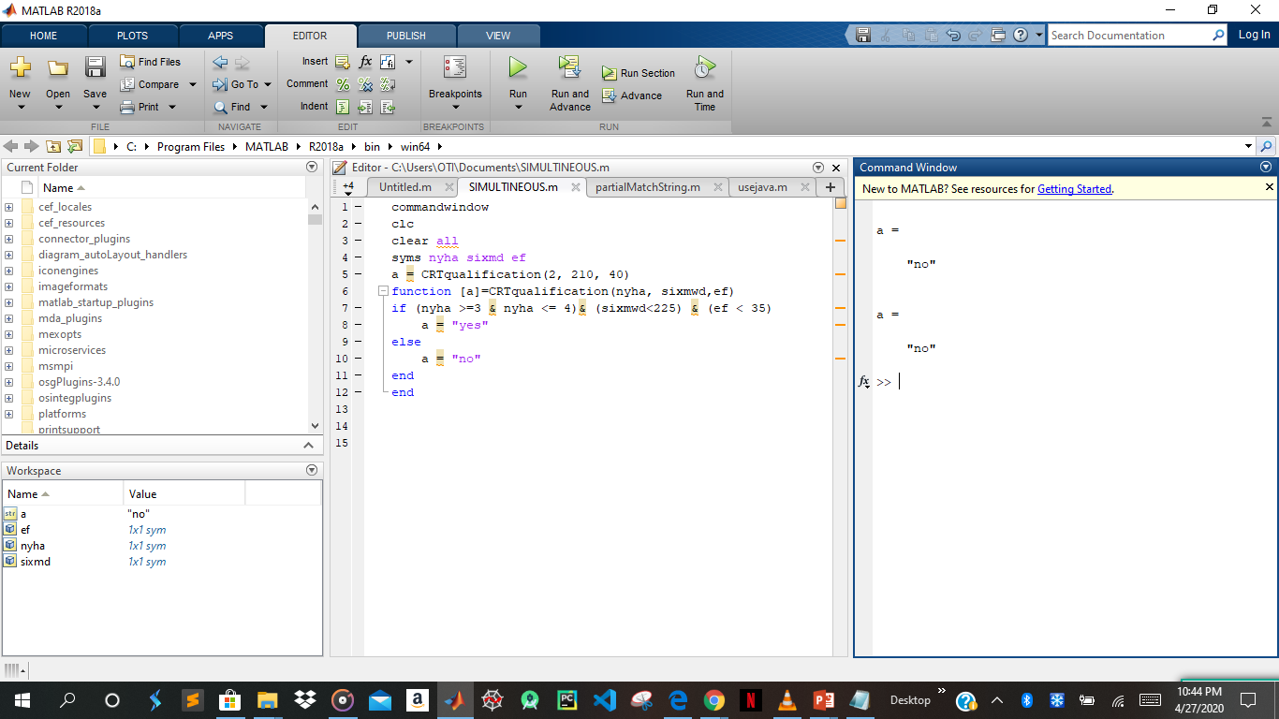

4)
commandwindow
clc
clear all
syms nyha sixmd ef
a = CRTqualification(3, 200, 33)
function [a]=CRTqualification(nyha, sixmwd,ef)
if (nyha >=3 & nyha <= 4)& (sixmwd<225) & (ef < 35)
a = "yes"
else
a = "no"
end
end

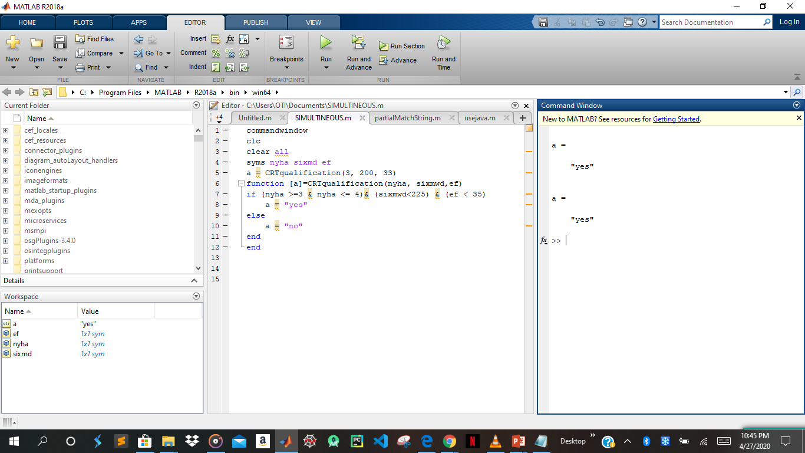

2.3
commandwindow
clc
clear all

number = input('insert a number from(0-9): ');
character = input('insert character: ');
switch number
case {1,2,3,4,5,6,7,8,9,0}
disp('numbers')
end
switch characters
case {'+', '-', '/','*'}
disp('characters')
end

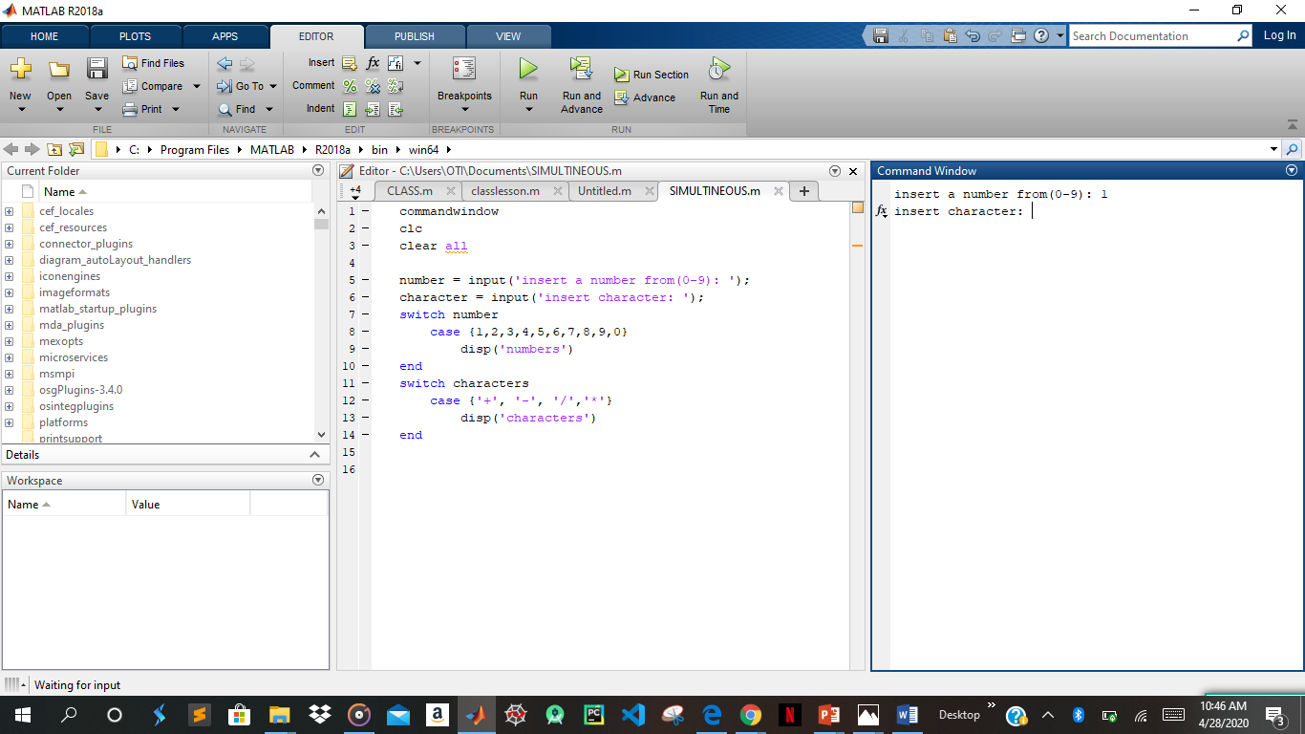

2.4

commandwindow
clear all
clc

systolic_diastolic_value = input('input values from 70-140: ');
switch systolic_diastolic_value
case {130,140,150}
disp('pre high')
case {100,110,120}
disp('ideal')
case {70,80,90}
disp('low')
end
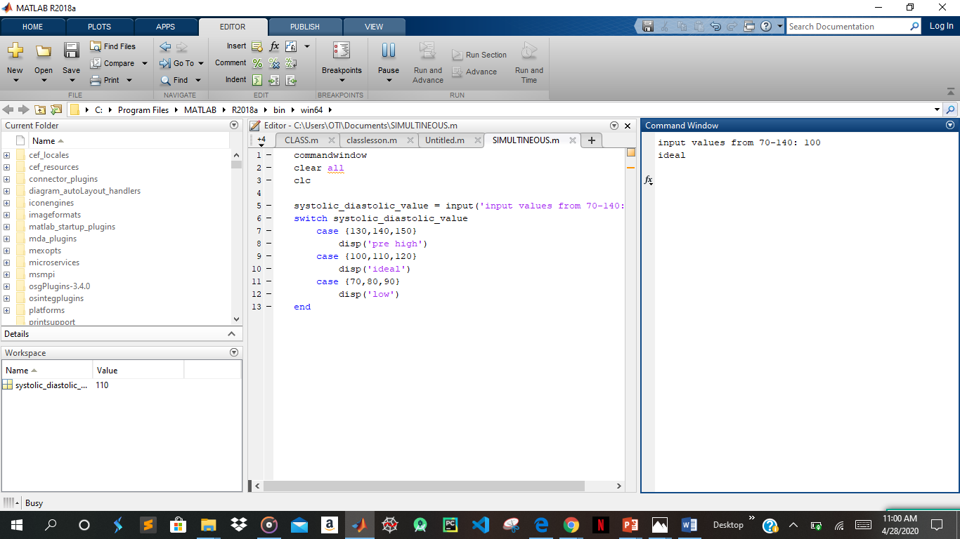

2.5
commandwindow
clc
clear all

grade = input('input a value from 0-100: ');

switch grade
case {70,80,90,100}
disp('EXCELLENT')
case 60
disp('GOOD')
case 50
disp('OK')
case 40
disp('BELOW AVERAGE')
otherwise
disp('FAIL')
end

