ELISHA ZABRINA
18/LAW01/088
FOOD PRODUCTION AND HEALTH AWARENESS
200LEVEL
LAW
Introduction
This research enterprise chosen is the kereksuk rice located in Nigeria. Furthermore, a business plan would be written on how the enterprise can succeed and grow in the market without declining or pushed away by competitors. The farm currently in on 45 hectares, and employees over 600 people.

Before going in-depth, the definition of strategic analysis and strategy development would first be explained. Strategic analysis is defined as researching the business environment or industry in which a firm is established, and this is, however, a process that is essential for the firm and can help the firm in the smooth running of the organization (Bhat, n.d.). While strategic development helps the firm in creating an objective and goals which are essential for the firm and how these goals can be achieved.
In improving the organization's standards and growth, an organization should conduct a research analysis consecutively. This measure can, however, make a firm know its area of concentration and areas that need improvement. Also, areas that are working efficiently, finally, if a firm wants to be at the top position, it is required for the firm to eliminate all negative boundaries and adhere to positive changes.
The majority of people wonder how some firms such as amazon, apple, Coca-Cola, Samsung are progressing. However, little do they know its continuous business development and planning at different stages that make most leading firm at the top position. Moreover, the main question asked is, what should a firm consider while making a strategic analysis, the answer is that firms should know their competitors and implement strategic planning that can give their organization an edge over competitors (Bhat, n.d.).

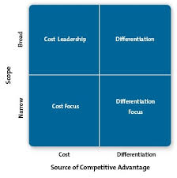

This image shows the four generics of the porter strategies which helps a firm gain a competitive advantage/
- According to (Riley, 2020) The porter strategic is used by a firm to gain its competitive stand among other competitors in the business industry. It consists of four strategies a firm can use to gain a competitive advantage. The four competitive models are explained below

- Cost leadership: a firm running on a cost leadership scale should have a cost advantage, which depends on the structure of the industry. Firms operating on this kind of competitive advantage find different kinds of cost advantage, and most of them have access to raw materials and other vital factors. With this kind of strategy, the firm can attract more customers and have an edge over its competitors.

- Differentiation: firms operating using this kind of strategy produces a unique product. Such a firm position itself to be unique and produces a product that is valued by customers. Its product is different from others. However, it is essential for a firm operating on this kind of strategy to have different kind of customer wants and needs, which its competitors does not have. An example is compelling selling marketing, ability to deliver qualified sales.

- The focus strategy: this type of strategy focuses its attention on a unique market. Firms using this strategy understand the market very well, and they build a closer relationship with their customers. This strategy is about offering something different from competitors; an example is reducing the cost of the product or creating differentiation with the relationship built from customers (Riley, 2020).

, what is a competitive analysis? A competitive analysis (White n.d.) is research that is made by a firm to understand competitors and know the strength of the competitors that surrounds his organization. It merely about knowing the competitors, researching their product, how does the competitor product differ from a shareholder organization, knowing the in and out of competitors is suitable for a firm because a strategy can be formulated to achieve higher success than the competitors surrounding a firm.
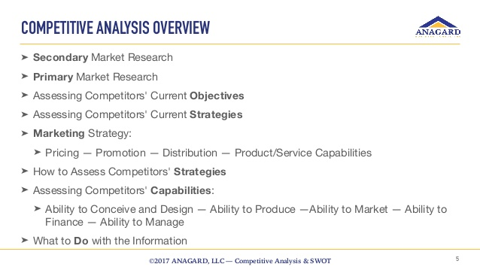

The image below gives a brief explanation of the research topic and various steps of competitive analysis.

However, there are different steps on how an organization can conduct a competitive analysis, according to (White, n.d.).
- It is essential to determine who the competitors are. A firm should figure out the main competitors, then compare the data and statistics together; however, not all that works for a particular firm would work for another person firm. So it is best to divide the competitors into two, direct competitors and indirect competitors, direct competitors, offer similar product which can serve as a substitute and is sold in the same location. Moreover, indirect does not provide the same product, but they are liable to satisfy the want and needs of customers.

- It is good to determine the kind of product competitors offer. It is suitable for a firm to make a research on the kind of product his competitors are offering to the customers. Are they a low-cost kind of firm, or are they selling a unique kind of product? Knowing their pricing and the discount rate that is given to their customers is also vital to know.

- It is good to know the competitors’ sales tactics and results, and it is vital to know this because competitors might be expanding or scaling down, there might be a unique channel which they sell-through.

- Furthermore, it is advisable to know how the competitors market their product, and this can be done by monitoring the website of the competitor. Do they have a podcast? Do they have a blog? Do they post videos or webinars? The online and offline campaign the competitor is running. All these are essential to know about a competitor.

- Observation of how competitors promote their market, it is essential to know the kind of style used for promotion.

- Performing a swot analysis can help know the strength weakness opportunities and the threat of competitors.

- Also, it is essential to monitor the social media platform and understand the strategies that are used. They might be driving a special kind of engagement with their brand through social media, which is different. Furthermore, the competitors might be on a different kind of social media, and it is essential to research that platform.
It is assumed that if an organization can put these seven steps into practice, there is a higher chance of progressing.
A firm expanding its organization into a new market, several essential strategies should be considered. The following are listed below, according to (Christ 2017). However, the listed below gives the critical elements to the kereksuk marketing approach.
.
- Goals and objectives; it is vital to write down the essential goals that want to be accomplished in the new market, not just general goals but short and precise goals that are vital for the firm. The reason is that concise goals can better be achieved than just general goals. Furthermore, the goals should be measurable because measuring the progress at every level is vital; however, the goals must be attainable because those are the most important goals that want to be achieved.

- The marketing mix. The ‘’ marketing mix'', which in general terms is called the four PS, consists of price, place, promotion, and the product. It is a marketing strategy that is vital when expanding a firm to another country; knowing the place is essential, and the question should be asked, such as is the place suitable for the manufacturing and production of goods and services? Is it a place with many competitors? This is important to put into consideration when expanding a business in another country. Furthermore, the strategy should give details about the product, and the price should be given pleasantly.

- Competitive analysis. This explains how the organization should compare its product to that of the competitors. An organization that is expanding its firm should be aware of competitors that would surround its firm, before going into the new market, research should be carried out on the competitors that would surround the firm. An example of the competitive analysis can be knowing the sales volume of the competitors, the mode of communication with customers, market share, and the target market of the competitors.

- Marketing strategies and tactics. This explains about the target market of the foreign market, how can the new strategies fit the demand of the target group, research has to be conducted on which target group would buy the product faster.

- Value proposition. This explains to the potential customers why they should do business with a firm, and not the firm fellow competitors. The value proposition should give enough details on what makes Kereksuk unique and what value it is giving out to the customers, which other banks are not giving out (Newman, 2018).

The best marketing model that is suitable for a firm expanding to another country, according to (Bruin, n.d.) is the pestle analysis; the pestle analysis can help provide a solution for marketing problems.

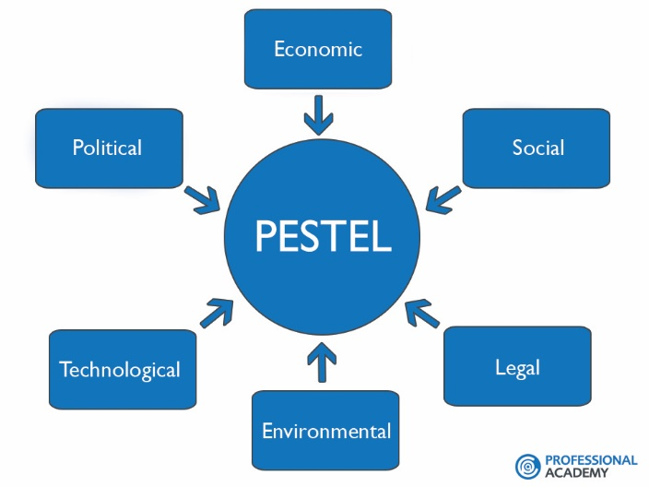
The pestel analysis, according to (Bruin, n.d.), is a marketing model that is used to analyze a business framework, and it helps a firm to know the macro-environmental factors that can affect the organization in its performance aspect? Furthermore, this marketing model is reliable and efficient when entering a foreign market. The pestel analysis factors consist of political, economic, social, technological, environmental.
- The political factors. This factor explains how the government intervene the market and economy. Basically, It consist of the contribution and influence that the government possess on the business. For example, political stability and instability, corruption, tax policy, trade restrictions, etc. nevertheless, the government does not only possess a negative impact but could also possess a positive impact in a business entering a foreign market such as health regulations, decreasing tax revenue for foreign business.

- Economic factors: this determines how an economy performs in every aspect; an example of such factors include, exchange rates, disposable income, interest rates, and determination of unemployment. These factors, however, in different ways, affect the purchasing power of a customer. Furthermore, these factors might direct and indirect functions in the company and how the company set prices for their commodity in a foreign market.

- Social factors. These entail the culture and demographics of the people within the organization. It, however, determines the population size, the age group, income distribution, behaviour, and lifestyle of the people. These factors are necessary for the foreign market to choose the target market and specific customers; this is an essential factor for kereksuk strategy to move into a foreign market.

- Technological factors: this consists of the different kinds of innovations that can affect the business in a favourably or unfavourably manner. It consists of innovation concepts, technological incentives, automation research, and development. However, these technological factors sometimes influence marketing decisions to enter a new foreign market or not. Alternatively, to launch a new product or not, also it influences the decisions to outsource a kind of production into a foreign market or not. Furthermore, due to the help of technology, it is helpful for the organization not to spend a lot of money buying or investing in a technology that would be outdated in the nearest future.

- Environmental factors: it is now becoming a trend because people are beginning to pay attention to the environment and, most importantly, pollution and scarcity of raw materials. Other factors include the carbon footprint that is set by the government, which includes environmental offsets and climate change, which is likely to affect the hospitality and tourism sectors in the nearest future. However, due to the global trend, industries are beginning to pay attention to these factors. A company that can operate sustainably has a chance of having more customers than others. Kereksuk, for example, that is expanding its business in a foreign market, should be aware of operating in a sustainable way, which is a plus for the organization.

- Legal factors. This determines unique kinds of laws, although these kinds of factors may have some similarities with the political factors. Nevertheless, examples of these hereditary factors include safety laws, discrimination laws, customer protection rights, patent laws, etc. these factors should be put into considerations when establishing a firm. It helps in knowing what is right and what is wrong, what is legal and what is not legal. These help in successful and ethical trading. An organization trades globally should be aware of the legislation and rules and regulations because the different country has its own rules and regulations.

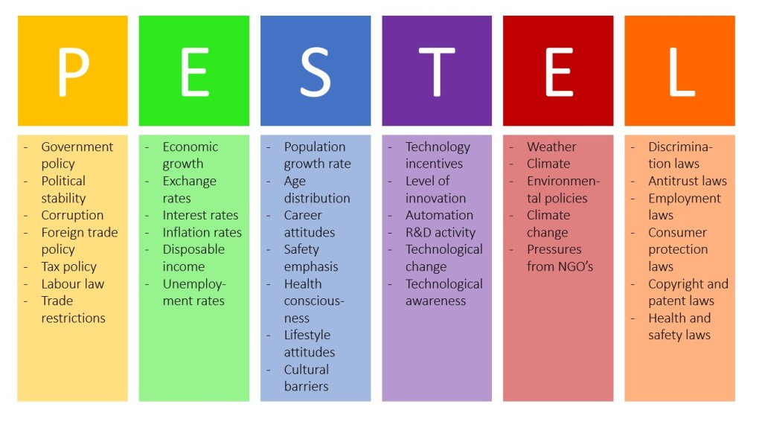
This image from (Bruin, n.d.). summarizes the pestel analysis and also covers some of the general external factors that companies might want to put into consideration.

Reference
- Bhat, A., n.d. WHAT IS STRATEGIC ANALYSIS?. [Blog] Questionpro, Available at: <https://www.questionpro.com/blog/strategic-analysis/> [Accessed 7 April 2020].

- Bruin, L., n.d. PESTEL Analysis (PEST Analysis) EXPLAINED With EXAMPLES | B2U. [online] B2U - Business-to-you.com. Available at: <https://www.business-to-you.com/scanning-the-environment-pestel-analysis/> [Accessed 11 April 2020].

- Christ, S., 2017. Ice Cream Marketing Strategy. [online] Bizfluent. Available at: <https://bizfluent.com/info-7774221-ice-cream-marketing-strategy.html> [Accessed 14 April 2020].
- Newman, C., 2018. What is a Value Proposition? (Plus 3 Great Examples and 3 Common Mistakes). [Blog] Kuno creative, Available at: <https://www.kunocreative.com/blog/good-value-proposition-examples> [Accessed 11 April 2020].

- Riley, J., 2020. Porter's Model Of Generic Strategies For Competitive Advantage | Business | Tutor2u. [online] tutor2u. Available at: <https://www.tutor2u.net/business/reference/porters-generic-strategies-for-competitive-advantage> [Accessed 7 April 2020].

- White, C., n.d. What's A Competitive Analysis & How Do You Conduct One?. [online] Blog.hubspot.com. Available at: <https://blog.hubspot.com/marketing/competitive-analysis-kit> [Accessed 8 April 2020].

