NAME: ADEBOYE GRACIOUS ADEOLA
MATRIC NO: 18/LAW01/007
LEVEL: 200
COLLEGE: LAW
COURSE CODE: AFE 202

A FEASIBILITY REPORT / BUSINESS PLAN FOR THE DEVELOPMENT OF A 700 HECTERS DIARY FARM AND ESTABLISHMENT OF 33,900 GALLONS PER LACTATING CYCLE CAPACITY DIARY PROCESSING PLANT IN SANGO OTA, OGUN STATE, NIGERIA. BY GRACIOUS AGRO BUSINESS VENTURES AND CONSULTANCY CONFIDENTIALITY AGREEMENT.

The undersigned reader acknowledges that the information provided in this business plan is a confidential intellectual property; therefore the reader agrees not to disclose it to a third party without the express written permission of the promoters of the proposed business.
It is acknowledged by the reader that information furnished in this business plan is in all respect confidential in nature, other than information which is in the public domain through other means and that any disclosure or use of same by the reader, may cause serious harm or damage to the promoters of the proposed business.
Upon request, this document is to be immediately returned to the promoters of the proposed business
Signature:
Name: ADEBOYE GRACIOUS ADEOLA
Date: 28th of April, 2020

TABLE OF CONTENT
Executive summary/ brief description of the project………..pg. 4
Sponsorship, management and technical assistance……….. Pg.4-6
Market and sales……………………………………………. Pg. 6
Competition analysis…………………………………………..pg. 7
Tariff and import analysis……………………………………..pg. 7
Market potential………………………………………………pg. 8
Profitability…………………………………………………pg. 8
Technical feasibility, resources and environment………….pg. 9
Government support and regulation………………………pg. 10
Timelines of project……………………………………………. Pg. 10
Estimated project cost and revenue……………………….pg. 11-12
Funding Mechanism………………………………………….pg. 13
Conclusion……………………………………………………pg. 13

Executive Summary/ Project Description
This report provides an analysis and evaluation of the current and prospective profitability, liquidity and financial stability of establishing a Dairy Farm.
The farm will occupy 700 hectares of land and produce about 34,000 gallons of milk per lactating cycle. The dairy processing plant would process raw milk gotten from the farm into cheese, butter and milk all suitable for human consumption and further application in food and beverage industry.
There is an ever increasing demand for these products domestically and industrially in Nigeria, food and beverage companies want to reduce the cost of production of commodities by supporting homed based dairy farms instead of continued importation of dairy products or raw materials. Also the domestic demand for these products is on the rise, households are turning to healthier lifestyles therefore looking to purchase natural milk from farms and store outlets due to its higher nutritional value compared to the packaged widely available milk variants.
The proposed project will lead to immense economic growth, create multiple job opportunities and reduce reliance on foreign or imported goods or raw materials.
Sponsorship
This project is sponsored by Aliko Dangote, CEO and chairperson of Dangote group. Dangote group is looking to make strides into the Nigerian dairy market and this one of the many steps to guarantee a solid footing and forward movement. Dangote group already employs a large number of food scientists, technologists and experts with vast knowledge on the proposed enterprise. SENCE AGRIC will be responsible for the management consultancy of the project,

Management
At the helm of all things concerning the farm would be a farm manager or general manager with proven proficiency in human and livestock management. Operational managers or head of departments would be installed to ensure independence of operations.
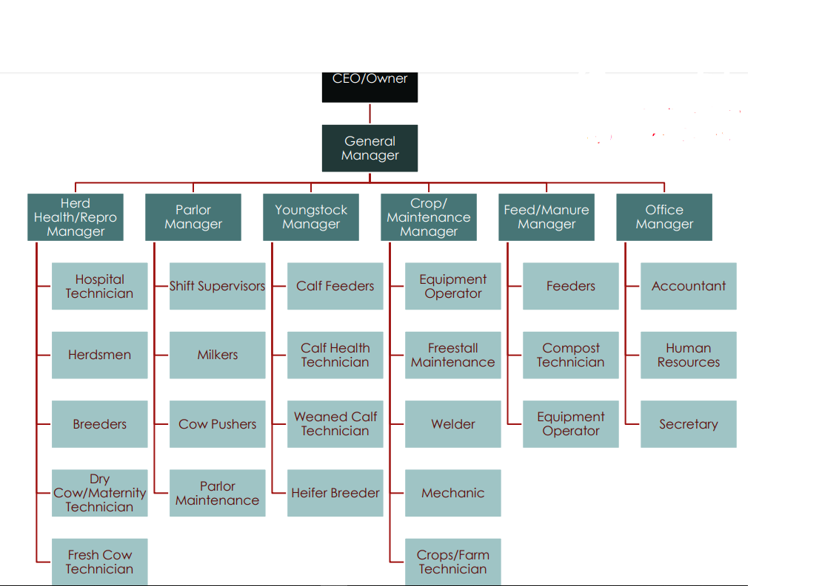
A vertical system of information transfer would be implemented whereby information flows from down up, from the staff to department head to farm manager who then informs the owner of the activities and progress of the farm.
Technical Assistance
Affiliations will be setup with numerous academic and professional institutions alongside government bodies to assist in the implementation and execution of the proposed plan.
Working on precendent, an MOU will be signed with the Federal government through the Federal Ministry of Agriculture and Rural Development for a public private partnership on dairy value chain development.
A partnership has been established with the Federal University of Agriculture, Abeokuta (FUNAAB). His partnership would allow intellectuals and highly trained professionals with a wide array of knowledge to be consulted on matters concerning the farm, increase agricultural education in state and offer avenue for their students to explore firsthand the operations of a dairy farm.
Animal care services konsult limited would also bring technical inputs on animal health and safety: from vaccinations, to breeding, to living conditions, nutrition and other requirements.
Distribution of farm produce would be contracted to
Market Sales
Market orientation: domestic; South West, Nigeria
Market share: there is a possibility of controlling a major part of the market if the plan is executed efficiently.
Uses of products: edible milk for human consumption, cheese and butter for human consumption. Milk, cheese and butter for food and beverage companies in Nigeria.
Consumers: local market, homes, supermarket, hotels, companies and restaurants.
Competition Analysis
The average amount of milk produced daily in dairy farms in the country is at 7000litres while the average amount being processed daily by food and beverage companies daily is 500 million litres. The 7000 litres from local or home based daily production makes up for just 1% of the demand. This statistic shows that there is a great gap to be filled in the dairy produce market in Nigeria.
90% of the dairy farms in the country are located in the northern part of the country. The south west is currently open for the taking and the weather conditions of Ogun state is suitable for operating and running a dairy farm.
In 2011, Freshland Campina WAMCO Nigeria began putting measures in place to setup a dairy farm in Oyo state. Currently they have signed MOU’s with the state government and other professional bodies in achieving this goal. This seems to be the only competing establishment in the south west part of Nigeria. By forming affiliations with local cooperatives, professional bodies, food store chains and other related bodies and with the current standing of other elements and divisions of the Dangote group, there would be no gap too large for us to cover.

Tariff and Import Restriction
There have been recent forex restrictions placed on the importation of milk and increased government support for intending and promising dairy farmers. The zero duty on imported agricultural equipment will also benefit the execution of this project under consideration.

Market Potential
There is a great and increasing demand for milk and other dairy products or derivatives in Nigeria. Currently, Nigeria spends 1.2-1.5 billion on milk and dairy importation, the Central Bank of Nigeria are in search of processes and measures that would internalize that money. The establishment of the proposed dairy farm should help secure a major portion of the funs being spent on milk importation.
Profitability
The dairy farm is a business with many fronts and avenues for profit generation. The unused hectares of land would be used to generate livestock feed to subsidize the cost of livestock feeding. Raw milk gotten from the cows can be distributed and marketed to food store chains and outlets, processed milk would be sold to interested companies and stores, cheese and butter gotten from the processing of raw milk provides another avenue for profit generation, and cows or livestock that are no longer able to serve the primary purpose of the farm would be sold as beef and hides. Cow excreta and waste would also serve as a source for manure and biogas production.

Technical Feasibility
The projects (cattle rearing, milk extraction and processing) are technically feasible. There exists a plethora of suitable, implementable and cost effective methods and measures to be semployed in the execution of the proposed business plan.
In terms of technology, which involves milk processing and milking, there are available and cost effective industrial processes that can be employed. There is also an abundance of knowledgeable professional and specialist to oversee operations.
On cattle rearing and herding, there is no shortage of specialist and manpower in animal husbandry, vetinary medicine, animal nutrition, animal behavior and other concerned aspects of the livestock affairs. We also have specialist in food science to ensure the products from the farm are of premium quality and causing no adverse effect to human health. The proximity of the farm to the Federal University of Agriculture, Abeokuta (FUNAAB) is adequate for smooth and fluid communications between professionals and the farm.
Dangote Dairy farms would employ globally approved methods and practices in the rearing and breeding of livestock, and in the extraction and processing of dairy products. The farm would be run in a manner whereby there would be no waste generated on the farm leading to a zero net effect on the eco system. All products generated on the farm would be recycled and applied to beneficial aspects. The bio waste of livestock would be used as source for manure and biogas production, this avenue would reduce reliance of the dairy farm on alternate sources of electricity and manure.

Government Support and Regulation
This project is in accordance with the Federal government’s action to diversify the agricultural activities of the country, localize milk production, increase food security and reduce reliance on imports. It provides economic opportunities and avenues and contributes towards the country’s quest for food security.
The government loans and grants dedicated to promoting the establishment of dairy farms in Nigeria would also be beneficial. Zero tax duties on agricultural equipment and supplies would help mitigate cost of execution. Forex restriction on milk importation will widen market opportunity.
Project Timeline
The project will be completed within 9 months. Preferably between June to December. Studies show that milk production in cow’s peak in December (known for its cooler temperatures). Also the demand for milk spikes during festive periods and this would be a good period to open the establishment and introduce ourselves to the market.
Estimated Project Costs and Revenue
- Cost
ITEM | DESCRIPTION | PRICE €
Stock | 265 lactating cows at 1300  70 helfers at 1200 | 389,286  84,000
Reseeding farm | Fertilizer, one pass till, sow, roll, grass seed | 48,589
Fencing | 20,000 m at 0.9/m | 17,617
Infrastructure | Standoff pad, earthen bank tank, roadways, site work, gate, tank fencing, bark mulch, head feed, calf shed, gates, yarding | 326,738
Milking palour | 30 unit herring bone shed, dairy and collecting yard | 228,709
Silage | Silage slab | 16,300
Labour | Labour from start to December | 3,500
Planning | Site assessment, mapping, planning application | 24,800
Office | Computers, farm package, connectivity ( phone and internet) | 25,688
Contingency | 10% allowance incase of unexpected cost | 8,689
VACCINATION | At 2000 per animal | 530,000
TOTAL |  | 1703916

Machinery
Description | Price ₦
Maize cutter | 450,000
Milking machine (milking parlor) | 3,800000
Milk cooling unit | 1,400000
Generator 25kva | 500,000
Submersible pump | 350,000
Tractor | 600,000
Heavy duty ventilation fans | 300,000
Trolley | 150,000
Total cost | 7,550,000

- Revenue (1 lactating cycle)
Item | Description | Price ₦
Milk export | Expected milk production volume: 333,900 gallons at 3000 per gallon | 1,001,700,000
TOTAL |  | 1,001,700,000

Funding mechanism
Dangote group would provide capital for the establishment of the proposed venture.
Gracious agro business venture would provide the land for the proposed project.
Conclusion
The proposed project is one with the ability for both long term and short term value creation. The project is technically feasible and commercially viable. It is therefore recommend for funding

