ADEKANYE, ITUNU OLUWADARA
17/MHS01/017
GROSS ANATOMY OF HEAD AND NECK
300L
ASSIGNMENT TITLE: NOSE AND ORAL CAVITY
QUESTIONS:
- Discuss the anatomy of the tongue and comment on its applied anatomy
- Write an essay on the air sinuses

GROSS ANATOMY OF THE TONGUE WITH APPLIED ANATOMY
The tongue is a mobile muscular organ that can assume a variety of shapes and positions. The tongue is partly in the oral cavity and partly in the pharynx. At rest it occupies essentially all the oral cavity proper. The tongue is involved with mastication, taste, deglutition, articulation and oral cleansing. Its main functions are:
- Forming words during speaking
- Squeezing food into the pharynx when swallowing.
Parts and surfaces of the Tongue
The tongue has three parts and two surfaces. The parts includes:
- A root: this is the posterior (postsulcal) third of the tongue.
- A body: this is the remaining part of the tongue; it is the anterior (presulcal) two-thirds of the tongue.
- An apex: is usually the pointed anterior part of the body.
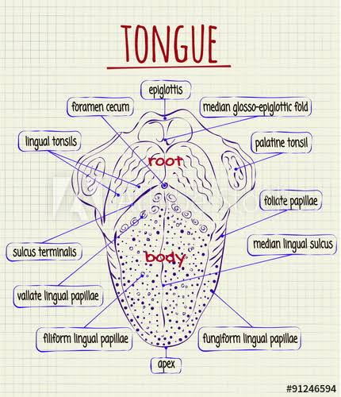
While the surfaces are:
- A curved dorsal surface or dorsum: is the posterosuperior surface of the tongue, which includes a V-shaped groove – the terminal sulcus. The terminal sulcus divides the dorsum of the tongue into:
- Anterior Part: lies in the oral cavity proper. Contains small lingual papillae:
-vallate papillae: are large and flat-topped
-foliate papillae: papillae are small lateral folds of the lingual mucosa; they are poorly developed in humans
-Filiform papillae: Scaly and threadlike papillae and pinkish-grey are long and numerous and contain afferent nerve endings that are sensitive to touch
-Fungiform papillae: are mushroom-shaped and appear as pink or red spots; they are scattered among the filiform papillae but are most numerous at the apex and sides of the tongue.
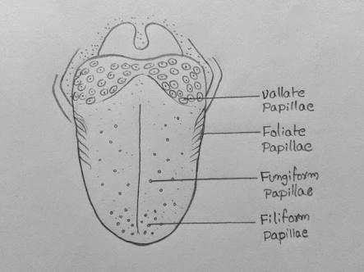
The vallate, foliate, and most of the fungiform papillae contain taste buds.
- Posterior part: which lies in the oropharynx. It is that part located posterior to the terminal sulcus and the palatoglosseal arches (structures that demarcate the posterior boundary of the oral cavity). . It has no lingual papillae but he underlying nodules of lingual lymphatic follicles give this part of the tongue its irregular, cobblestone appearance. The nodular masses of lingual follicles are collectively known as the lingual tonsil.
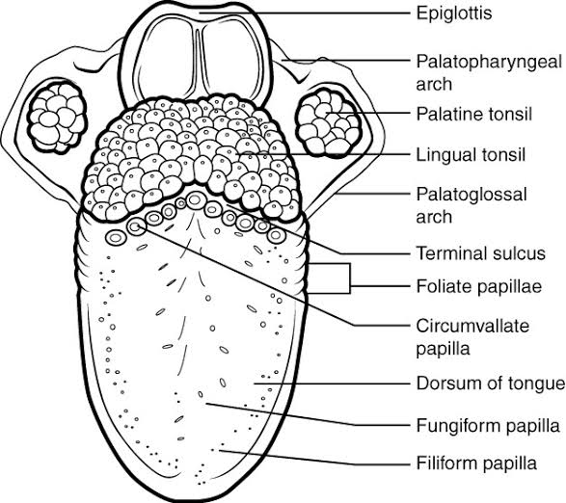
- An inferior surface: is covered with a thin, transparent mucous membrane through which one can see underlying veins. With the tongue raised, the lingual frenulum, a large midline fold of mucosa that passes from the gingiva covering the lingual aspect of the anterior alveolar ridge to the posteroinferior surface of the tongue. The frenulum connects the tongue on the floor to the mouth while allowing the anterior part of the tongue to move freely.
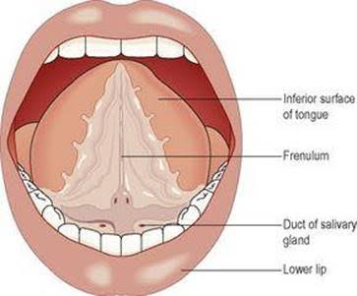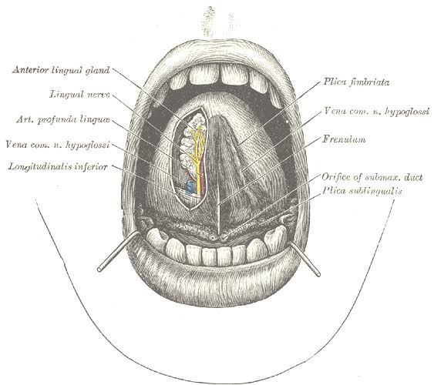
Relations:
Anterior and lateral – teeth
Superior – hard and soft palate
Inferior – mucosa of the floor of the oral cavity, sublingual salivary glands, posterior wall of oropharynx
Posterior – epiglottis, pharyngeal inlet
Lateral – palatoglosseal and palatopharyngeal arches

Muscles of the tongue
Extrinsic muscles
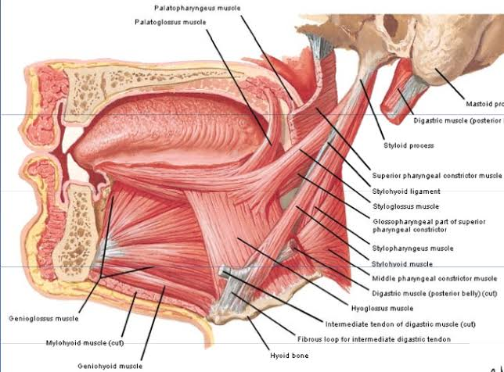
Muscle | Origin | Insertion | Innervation | Main Action
Genioglossus | Superior part of mental spine of mandible. | Dorsum of tongue and body of hyoid bone | Hypoglossal nerve (CN XII) | Depresses tongue; its posterior part pulls tongue anteriorly for protrusion
Hyoglossus | Body and greater horn of hyoid bone | Side and inferior aspect of tongue | Hypoglossal nerve (CN XII) | Depresses and retracts tongue
Styloglossus | Styloid process and stylohyoid ligament. | Side and inferior aspect of tongue | Hypoglossal nerve (CN XII) | Retracts tongue and draws it up to create a trough for swallowing
Palatoglossus | Palatine aponeurosis of soft palate | Side of tongue | Cranial root of CN XI via pharyngeal branch of CN X and pharyngeal plexus | Elevates posterior part of tongue

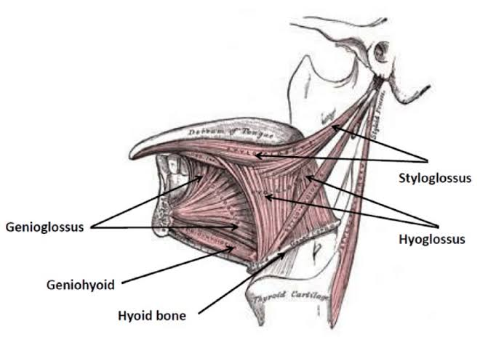
Intrinsic muscles
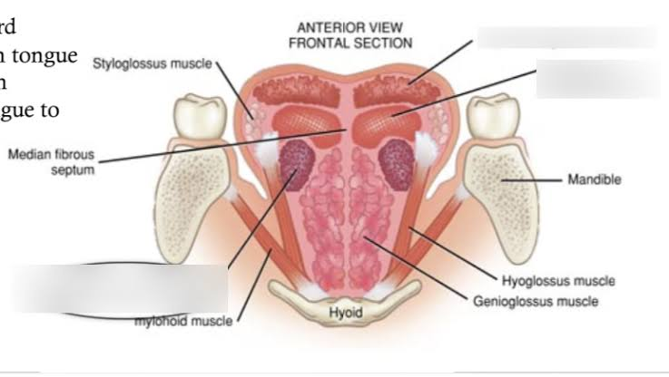
Muscle | Origin | Insertion | Innervation | Main Action
Superior longitudinal | Submucous fibrous layer and median fibrous | Margins of tongue and mucous membrane | Hypoglossal nerve (CN XII) | Curls tip and sides of tongue superiorly
Inferior longitudinal | Root of tongue and body of hyoid bone | Apex of tongue | Hypoglossal nerve (CN XII) | Curls tip of tongue inferiorly and shortens tongue
Transverse | Median fibrous septum | Fibrous tissue at margins of tongue | Hypoglossal nerve (CN XII) | Narrows and elongates the tongue
vertical | Superior surface of borders of tongue | Inferior surface of borders of the tongue | Hypoglossal nerve (CN XII) | Flattens and broadens the tongue

Lymphatics:
The lymph from the tongue drains into four different lymph nodes:
- The root of the tongue drains into the superior deep cervical nodes
- The medial part of the body of the tongue drains into the inferior deep cervical nodes
- The lateral parts of the body drain into the submandibular lymph nodes
- The frenulum and the apex of the tongue drain into the submental lymph nodes
Each group of the listed nodes eventually drains into the deep cervical nodes, which then drain into venous systemic circulation

Innervation:
- All the muscles are innervated by the hypoglossal nerve (CN XII) except for the palatoglossus muscle
- The palatoglossus muscle is innervated by the vagus nerve (CN X)
- The posterior one-third of the tongue is innervated by the glossopharyngeal nerve (CN IX) which carries both general sensory information from mucosa and special sensory information from the vallate papillae.
- The anterior two-thirds of the tongue have double sensory innervation. The lingual nerve, a branch of the mandibular nerve (CN V3) carries general sensory information (temperature and touch) from this surface. Special sensory taste information is carried by the fibers of the facial nerve (CN VII) which leave the tongue as a part of the lingual nerve, but at the infratemporal fossa they join the chorda tympani (a branch of the facial nerve).
Vasculature:
The arteries of the tongue derive from the lingual artery, which arises from the external carotid artery. On entering the tongue, the lingual artery passes deep to the hyoglossus muscle. The main branches of the lingual artery are the:
-Dorsal lingual arteries, which supply the posterior part and send a tonsillar branch to the palatine tonsil
-Deep lingual artery, which supplies the anterior part
-sublingual artery, which supplies the sublingual gland and the floor of the mouth
The dorsal lingual arteries communicate with each other near the apex of the tongue. The other branches of the lingual artery are prevented from communicating by the fibrous lingual septum, which separates the tongue into right and left halves. The veins of the tongue are the:
-Dorsal lingual veins, which accompany the lingual artery
- Deep lingual veins, which begin at the apex of the tongue and run posteriorly beside the lingual frenulum to join the sublingual vein.

APPLIED ANATOMY
- GAG REFLEX: one may touch the anterior part of the tongue without feeling discomfort; however, when the posterior part is touched, one gags. CN IX and CN X are responsible for the muscular contraction of each side of the pharynx. Glossopharyngeal branches provide the afferent limb of the gag reflex.
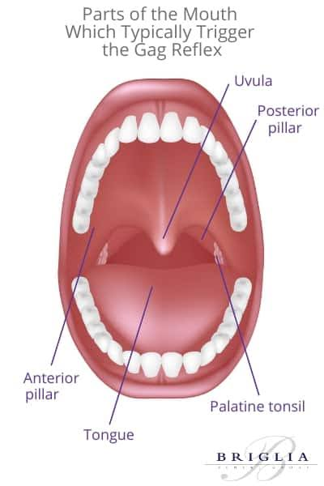
- Paralysis of the Genioglossus: when the genioglossus muscle is paralyzed, the tongue has a tendency to fall posteriorly, obstructing the airway and presenting the risk of suffocation. Total relaxation of the genioglossus muscles occurs during general anaesthesia; the tongue of an anesthetized patient must be prevented from relapsing by inserting an airway.
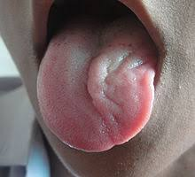
- Injury to the Hypoglossal nerve: Trauma, such as a fractured mandible, may injure the hypoglossal nerve, resulting in paralysis and eventual atrophy of one side of the tongue. The tongue deviates to the paralyzed side during protrusion because of the action of the unaffected genioglossus muscle on the other side.
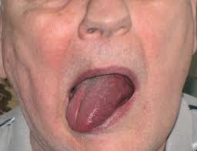
- Sublingual absorption of drugs: for quick absorption of a drug—for instance, when nitro-glycerine is used as a vasodilator in angina pectoris (chest pain)—the pill or spray is put under the tongue where it dissolves and enters the deep lingual veins in less than a minute. The sublingual veins in older people are often varicose, but they do not bleed and have no clinical significance.
- Lingual carcinoma: lymphatic drainage of the tongue is of particular importance because of the common occurrence of lingual carcinoma. Malignant tumours in the posterior part of the tongue metastasize to the superior deep cervical lymph nodes on both sides, whereas tumours in the anterior part usually do not metastasize to the inferior deep cervical lymph nodes until late in the disease.
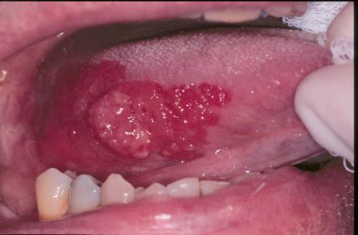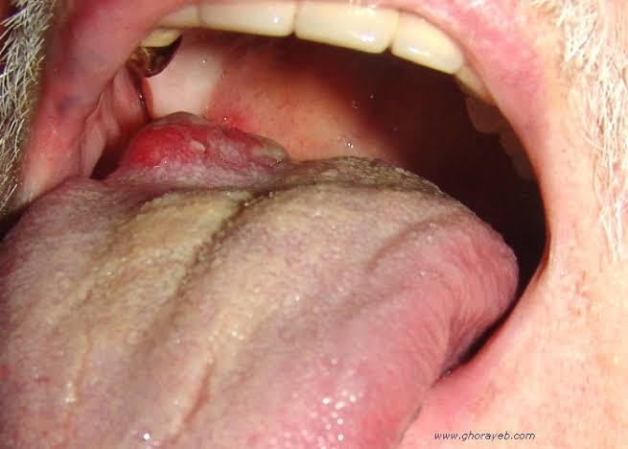
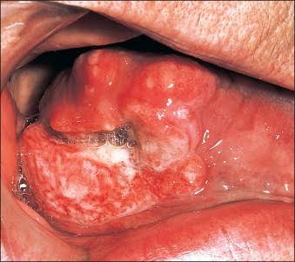
- Frenectomy: an overly large lingual frenulum may interfere with tongue movements and affect speech. A short lingual frenulum (tongue-tie) rarely interferes with eating or speech. In unusual cases, a frenectomy (cutting of the frenulum) may be necessary in infants to free the tongue for normal speech.
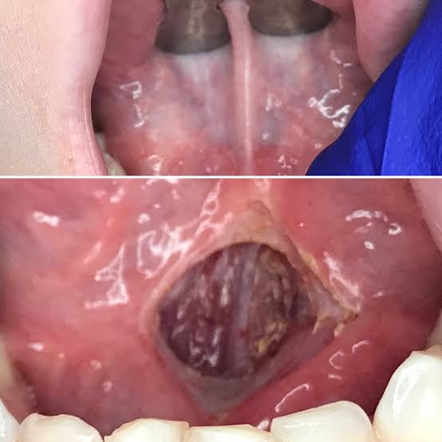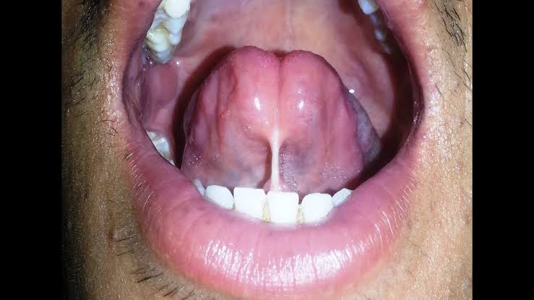

AIR SINUSES/PARANASAL SINUSES
The paranasal sinuses are air filled extensions of the respiratory part of the nasal cavity into the following cranial bones: frontal, ethmoid, sphenoid, and maxilla. They are named according to the bones in which they are located.
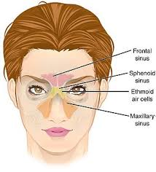
FRONTAL SINUSES
The frontal sinuses are between the outer and inner tables of the frontal bone, posterior to the superciliary arches and the root of the nose. Frontal sinuses are usually detectable in children by 7 years of age. Each sinus drains through the frontonasal duct into the infundibulum, which opens into the semilunar hiatus of the middle meatus. The frontal sinuses are innervated by branches of the supraorbital nerves (CN V₁).
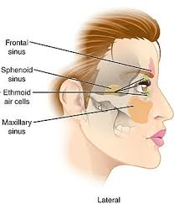
MEDICAL APPLICATION:
Sinusitis: because the paranasal sinuses are continuous with the nasal cavities through apertures that open into them, infection may spread from the nasal cavities, producing inflammation and swelling of the mucosa of the sinuses (sinusitis) and local pain. Sometimes several sinuses are inflamed (pansinusitis), and the swelling of the mucosa may block one or more openings of the sinuses into the nasal cavities.
ETHMOIDAL SINUSES
The ethmoidal sinuses comprise several cavities -- ethmoidal cells–that are located in the several mass of the ethmoid bone between the nasal cavity and orbit. The ethmoidal sinuses usually are not visible in plain radiographs before 2 years of age but are recognizable I computerized tomography (CT) scans. The anterior ethmoidal cells drain directly or indirectly into the middle meatus through the infundibulum. The middle ethmoidal cells open directly into the middle meatus and are sometimes called ‘‘bullar cells’’ because they form the ethmoidal bulla, a swelling on the superior border of the semilunar hiatus. The posterior ethmoidal cells open directly into the superior meatus. The ethmoidal sinuses are supplied by the anterior and posterior ethmoidal branches of the nasociliary nerves (CN V₁)
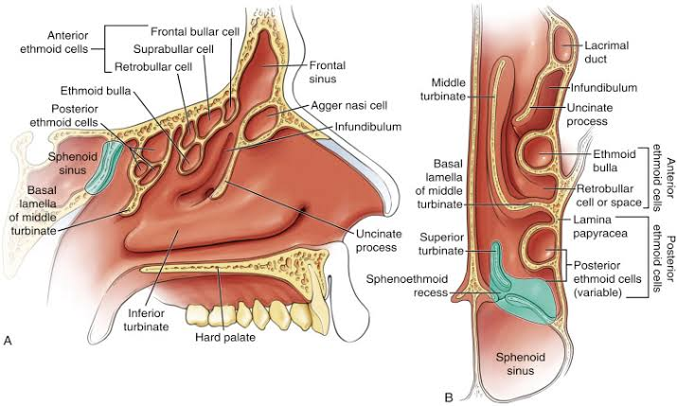
MEDICAL APPLICATION:
Infection of the Ethmoidal cells: If nasal drainage is blocked, infections of the ethmoidal cells may break through the fragile medial wall of the orbit. Severe infections from this source may cause blindness because some posterior ethmoidal cells lie close to the optic canal, which gives passage to the optic nerve and ophthalmic artery. Spread of infection from these cells could also affect the dural nerve sheath of the optic nerve, causing optic neuritis.
SPHENOIDAL SINUSES
The sphenoidal sinuses, unevenly divided and separated by a bony septum, are in the body of the sphenoid; they may extend into the wings of this bone. Because of these sinuses, the body of the sphenoid is fragile. Only thin plates of bone separate the sinuses from very important structures: the optic nerves and optic chiasm, the pituitary gland, the internal carotid arteries, and the cavernous sinuses. The sphenoidal sinuses derive from a posterior ethmoidal cell that begins to invade the sphenoid bone at approximately 2 years of age. In some people, several posterior ethmoidal cells invade the sphenoid bone, giving rise to multiple sphenoidal sinuses that open separately into the sphenoethmoidal recess. The posterior ethmoidal arteries and posterior ethmoidal nerve supply the sphenoidal sinuses.
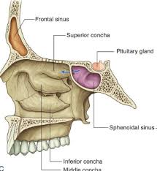
MAXILARY SINUSES
The maxillary sinuses are the largest of the paranasal sinuses. These large pyramidal cavities occupy the bodies of the maxillae.
- The apex of the maxillary sinus extends toward and often into the zygomatic bone.
- The base of the maxillary sinus forms the inferior part of the lateral wall of the nasal cavity.
- The roof of the maxillary sinus is formed by the floor of the orbit.
- The floor of the maxillary sinus is formed by the alveolar part of the maxilla. The roots of the maxillary teeth, particularly the first two molars, often produce conical elevations in the floor of the sinus.
Each maxillary sinus drains by an opening–the maxillary ostium—into the middle meatus of the nasal cavity by way of the semilunar hiatus.
The arterial supply of the maxillary sinus is mainly from superior alveolar branches of the maxillary artery; however, branches of the greater palatine artery supply the floor of the sinus. Innervation of the maxillary sinus is from the anterior, middle and posterior superior alveolar nerves—branches of the maxillary nerve.
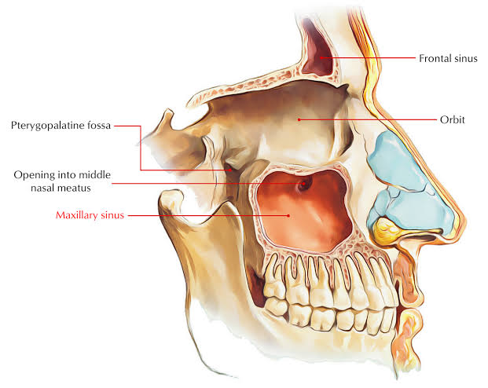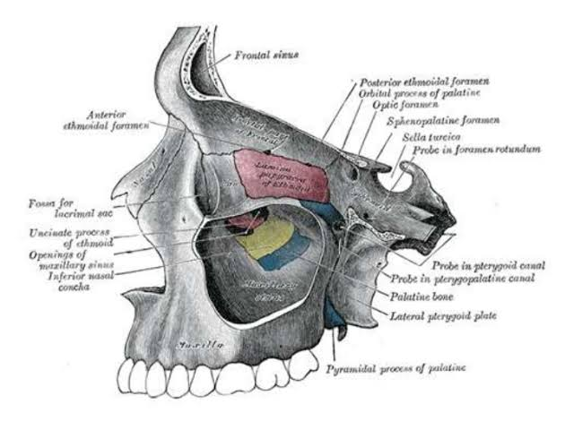
MEDICAL APPLICATION
Infection of the maxillary sinuses: The maxillary sinuses are the most commonly infected, probably because their ostia are located on their superiomedial walls, a poor location for natural drainage of the sinus. When the mucous membrane of the sinus is congested, the maxillary ostia are often obstructed. Because of the high location of the ostia, when the head is erect it is impossible for the sinuses to drain until they are full. Because the ostia of the right and left sinuses lie on the medial sides, only the upper ostium drains while lying on one’s side. A cold or allergy involving both sinuses can result in nights of rolling from side-to-side in an attempt to keep the sinuses drained. The maxillary sinuses can be cannulated and drained by passing a cannula from the nostril through the maxillary ostium into the sinus.

