GROSS ANATOMY OF HEAD AND NECK
NOSE AND ORAL CAVITY ASSIGNMENT

18/MHS01/379
AMOO OLUWANIFEMI MICHAEL
MEDICINE AND SURGERY

- Discuss the anatomy of the tongue and comment on its applied anatomy
The tongue is the muscular organ found in the vertebrate mouth. It is attached via muscles to the hyoid bone, mandible, styloid process, palate, and pharynx and divided into two parts by the V-shaped sulcus terminalis. At the tip of this sulcus is the foramen cecum, a remnant of the proximal thyroglossal duct. The base of tongue contains the lingual tonsils, the inferior most portion of Waldeyer’s ring. It is known for its role in taste, but it also assists with mastication (chewing), deglutition (swallowing), articulation (speech), and oral cleansing.
The embryologic origins of the tongue first appear at 4 weeks' gestation. The body of the tongue forms from derivatives of the first branchial arch. This gives rise to 2 lateral lingual swellings and 1 median swelling (known as the tuberculum impar). The lateral lingual swellings slowly grow over the tuberculum impar and merge, forming the anterior two thirds of the tongue. Parts of the second, third, and fourth branchial arches give rise to the base of the tongue. Occipital somites give rise to myoblasts, which form the intrinsic tongue musculature.
From anterior to posterior, the tongue has 3 surfaces: tip, body, and base. The tip is the highly mobile, pointed anterior portion of the tongue. Posterior to the tip lies the body of the tongue, which has dorsal (superior) and ventral (inferior) surfaces. Injury to the hypoglossal nerve (cranial nerve XII) results in deviation of the tongue toward the paralyzed side during protrusion. The tongue also atrophies over time on the paralyzed side.
The following papillae cover the tongue and are used for taste perception:
- Vallate papillae are arranged in a V-shape anterior to the sulcus terminalis and studded with numerous taste buds. The vallate papillae are flat, prominent papillae that are surrounded by troughs. In humans, there are 8-12 vallate papillae, located directly anterior to the terminal sulcus. The ducts of the lingual glands of Von Ebner secrete lingual lipase into the surrounding troughs to begin the process of lipolysis. Innervation is by the glossopharyngeal nerve (CN IX).
- Fungiform papillae are mushroom-shaped papillae with erythematous domes, located on the lateral aspects and at the apex of the tongue. Humans have approximately 200-300 fungiform papillae.
- Filiform papillae are slim, cone-shaped projections organized in rows parallel to the sulcus terminalis; they are the most numerous papillae and are located along the entire dorsum of the tongue, but they are not involved in taste sensation.
- Foliate papillae are small folds of mucosa located along the lateral surface of the tongue. They are rarely found in humans (vestigial).

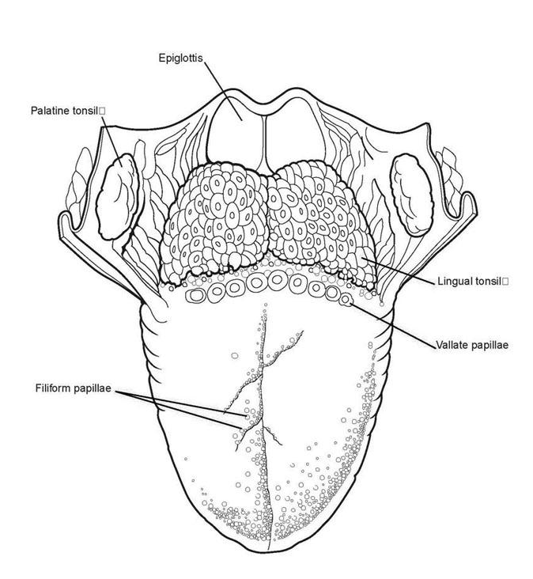
fungiform papillae

On the undersurface of the tongue is a fold of mucous membrane called the frenulum that tethers the tongue at the midline to the floor of the mouth. On either side of the frenulum are small prominences called sublingual caruncles that the major salivary submandibular glands drain into.
Musculature
The tongue has 4 intrinsic and 4 extrinsic muscles (see Table 1 and the image below). [4] The muscles on each side of the tongue are separated by a fibrous lingual septum. Extrinsic muscles are so named because they originate outside the tongue and insert within it; intrinsic muscles are within the substance of the organ and do not insert on bone. Although the muscles do not act in isolation, intrinsic muscles generally alter the shape of the tongue, whereas extrinsic muscles alter its position.
Muscle | Type | Origin | Insertion | Action
Superior longitudinal | Intrinsic | Lingual septum and sub mucous fibrous layer | Margins of tongue | Elevates tip and sides of tongue; shortens tongue
Inferior longitudinal | Intrinsic | Body of hyoid and base of tongue | Apex of tongue | Curls tip inferiorly; shortens tongue
Transverse | Intrinsic | Lingual septum | Sub mucous fibrous layer | Narrows and lengthens tongue
Vertical | Intrinsic | Superior surface of tongue | Inferior surface of tongue | Flattens and broadens tongue
Genioglossus | Extrinsic | Mental spine of mandible | Lateral and inferior tongue | Depresses and protrudes tongue
Hyoglossus | Extrinsic | Body and greater horn of hyoid | Lateral and inferior tongue | Depresses and retracts tongue
Styloglossus | Extrinsic | Styloid and stylohyoid ligament | Lateral and inferior tongue | Retracts tongue
Palatoglossus | Extrinsic | Palatine aponeurosis | Lateral tongue | Elevates posterior tongue

Vasculature
Similar to most of the head and neck region, the tongue derives its arterial blood supply from the external carotid artery. The lingual artery branches off the external carotid artery deep to the stylohyoid muscle. At first, it travels superomedially; after a short distance, it changes direction and moves anteroinferiorly. The hypoglossal nerve (cranial nerve XII) crosses over it laterally before it enters the tongue deep in the hyoglossus muscle.
Within the tongue, the lingual artery gives rise to its 3 main branches: the dorsal lingual, deep lingual, and sublingual arteries. The dorsal lingual artery supplies the base of the tongue. The deep lingual artery travels on the lower surface of the tongue to the tip. A branch to the sublingual gland and the floor of the mouth is known as the sublingual artery.
The veins of the tongue parallel the lingual artery branches. The deep lingual vein begins at the tip of the tongue and travels posteriorly to join the sublingual vein. This drains into the dorsal lingual vein, which accompanies the lingual artery. Directly or indirectly, this vein empties into the internal jugular vein.
Nerve supply
Motor innervation for all of the muscles of the tongue comes from the hypoglossal nerve--with the exception of the palatoglossus, which is supplied by the pharyngeal plexus (fibers from the cranial root of the spinal accessory nerve carried by the vagus nerve).
General sensation of the anterior two thirds of the tongue is supplied by the lingual nerve, a terminal branch of the third division of the trigeminal nerve (V3). Taste sensation for this portion of the tongue is carried by the chorda tympani branch of the facial nerve. The posterior third of the tongue relays general and sensation via the lingual-tonsillar branch of the glossopharyngeal nerve. Some general and taste sensation from the base of tongue anterior to the epiglottis is carried by the internal laryngeal branch of the superior laryngeal nerve (CN X).
Lymphatic drainage
The lymphatic drainage of the tongue is complex. Lymphatics from the tip of the tongue travel to the submental lymph nodes. This can be ipsilateral or bilateral depending on the site of the lesion. Lymph from the medial anterior two thirds of the tongue travels to the deep cervical lymph nodes, and lymph from the lateral anterior tongue goes to the submandibular nodes. The tongue-base lymphatics drain bilaterally into the deep cervical lymph nodes.
Clinical/Applied Anatomy
- Aglossia is a congenital defect resulting in a partial development or complete absence of a tongue. Aglossiais commonly associated with craniofacial and limb defects (Adactylia syndrome) and is thought to belong to a family of oromandibular limb hypogenesis syndrome or OLHS. It is believed to be caused by heat-induced vascular disruption near the fourth week of embryonic development.
- Hypoglossia is a short, incompletely developed tongue. It can occur either as an isolated malformation or in association with other deformities, particularly limb defects in a syndrome known as oromandibular limb hypogenesis syndrome.
- Microglossia abnormal smallness of the tongue.
- Ankyloglossia is also known as tongue-tie, is a congenital oral anomaly that may decrease the mobility of the tongue tip and is caused by an unusually short, thick lingual frenulum, a membrane connecting the underside of the tongue to the floor of the mouth

- Write an Essay on the air Sinuses
The air sinuses are air cavities that help circulate the air that is breathed in and out of the respiratory system. They are situated around the nasal cavity and they are all paired and sometimes symmetrical, while always being bilateral. There are four different pairs of sinuses and they are called the: maxillary sinuses, frontal sinuses, sphenoidal sinuses, ethmoidal sinuses. At birth only the maxillary sinus and the ethmoid sinus are developed but not yet pneumatized; only by the age of seven they are fully aerated. The sphenoid sinus appears at the age of three, and the frontal sinuses first appear at the age of six, and fully develop during adulthood.
The maxillary sinuses are the largest of the all the paranasal sinuses. They have thin walls which are often penetrated by the long roots of the posterior maxillary teeth. The superior border of this sinus is the bony orbit, the inferior is the maxillary alveolar bone and corresponding tooth roots, the medial border is made up of the nasal cavity and the lateral and anterior border are limited by the cheekbones. Posteriorly, two anatomical spaces known as the pterygopalatine fossa and the infratemporal fossa exist. The submandibular lymph nodes are the main destination during lymphatic drainage. The blood supply includes a contribution from the: anterior superior alveolar artery, middle superior artery, posterior superior alveolar artery Innervation occurs through nerves of the same names as the arteries.
The frontal sinuses, anteriorly, the frontal sinuses are contained by the forehead and the superciliary arches, superiorly and posteriorly by the anterior cranial fossa and inferiorly by the bony orbit, the anterior ethmoidal sinuses and the nasal cavity. Medially the sinuses face one another, separated by the midline. This pair of sinuses are irregular in shape when compared to one another and is underdeveloped at birth. They reach their full size and shape around seven to eight years of age. They drain primarily into the ethmoidal infundibulum and the corresponding lymph drainage occurs via the submandibular lymph nodes. It is innervated by the ophthalmic nerve, including the supraorbital and supratrochlear branches. The frontal sinuses are supplied by the: anterior ethmoidal artery, supraorbital artery, supratrochlear artery.
The sphenoidal sinuses. The most posterior of all the sinuses in the head, the sphenoidal sinuses are large and irregular, just like their septum, which is made by the sphenoid bone. Laterally, a cavernous sinus exists which is part of the middle cranial fossa and also the carotid artery and cranial nerves III, IV, V/I, V/II and VI can be found. The anterior wall separates this pair of sinuses from the nasal cavity, as does the hypophyseal fossa, the pituitary gland and the optic chiasm superiorly and the nasopharynx and pterygoid canal inferiorly. The lymphatic drainage occurs in the same way as the posterior ethmoid sinus. The posterior ethmoidal artery and the posterior lateral nasal branches supply the sphenoidal sinuses. The posterior ethmoidal nerve and the orbital branch of the pterygopalatine ganglion innervate them.
The ethmoidal sinuses. Superior to the ethmoidal sinus is the anterior cranial fossa and the frontal bone, laterally the orbit can be found, while the nasal cavity is situated medially. The ethmoid sinuses are unique because they are the only paranasal sinuses that are more complex than just a single cavity. On each side of the midline, anywhere from three to eighteen ethmoidal air cells may be grouped together. These air cells are smaller individual sinuses grouped together to form one large one which encompass the anterior, middle and posterior nasal meatuses. The anterior and middle ethmoid sinuses send their lymphatic drainage to the submandibular lymph nodes while the posterior ethmoid sinus sends its own to the retropharyngeal lymph nodes. The anterior and posterior ethmoidal arteries, as well as the posterior lateral nasal branches provide an ample blood supply to this region. Meanwhile the anterior and posterior ethmoidal nerves and the posterior lateral superior and inferior nasal nerves help innervate it.
A clinical condition within the air sinuses is a condition called, Sinusitis. Sinusitis is an extremely common outpatient case which presents as an inflammation of the epithelia of the sinuses. The causes can be either a viral or bacterial infection, or an allergic reaction. The inflammation can be acute or chronic and the maxillary sinuses are the most frequently affected. Antivirals, antibiotics and antihistamines are prescribed in persistent cases.

