NAME: OGUNNIKE IYANUOLUWA.O
MATRIC NO: 18/MHS05/011
COURSE: ANA 204
DEPARTMENT: PHYSIOLOGY
COLLEGE: MHS

QUESTION
Describe the microanatomy of small and large intestine.
Note: You are expected to state the functions, segment, layers, general features and epithelium of each part of the small and large intestine.
MICROANATOMY OF THE SMALL INTESTINE
The small intestine is a primary digestive organ in the body. This is where chime released from the stomach comes into. It is the longest section of the digestive tube and it consists of three segments;
- The duodenum: it is the shortest region (25.4cm, 10inches), which begins at the pyloric sphincter. The hepatopancreatic ampulla which marks the transition from the anterior portion of the alimentary canal to the mid-region is located in the duodenal wall, and this is where the bile duct joins the main pancreatic duct.
- The jejunum: is about 0.9m long and runs from the duodenum to the ileum.
- The ileum: the longest part of the small intestine, about 1.8m in length. It is thicker, more vascular and has more developed mucosal folds than the jejunum.
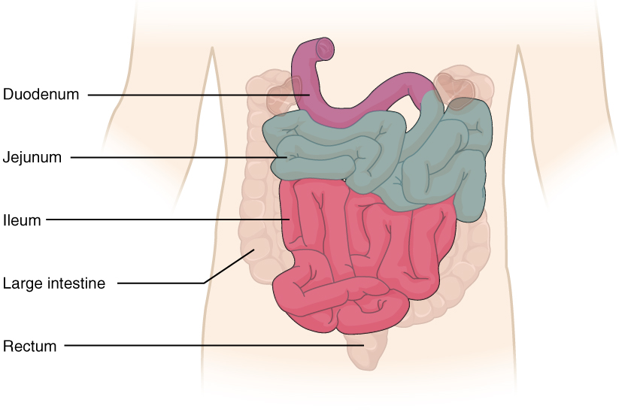

Functions
- Lined with villi and microvilli to increase surface area for absorption of nutrients from food.
- Completes digestion of food.
- Receives secretions from from the pancreas and the liver to aid digestion.
Layers
The small intestine has four layers:
- The outermost serosa: it surrounds the intestine. A smooth membrane consisting of a thin layer of cells that secrete serous fluid which lubricates and reduces friction between the muscles.
- Muscularis layer: contracts and moves the small intestine. It is responsible for gut movement or peristalsis. It has two layers of smooth muscles; circular and longitudinal.
- Submucosa: layer of dense, irregular connective tissue or loose connective tissue which provides blood vessels, lymphatic vessels and nerves to support mucosa on the surface.
- Innermost mucosa: it is a mucous membrane that secretes hormones. It also absorbs nutrients from chyme. The villi are part of the mucosa.

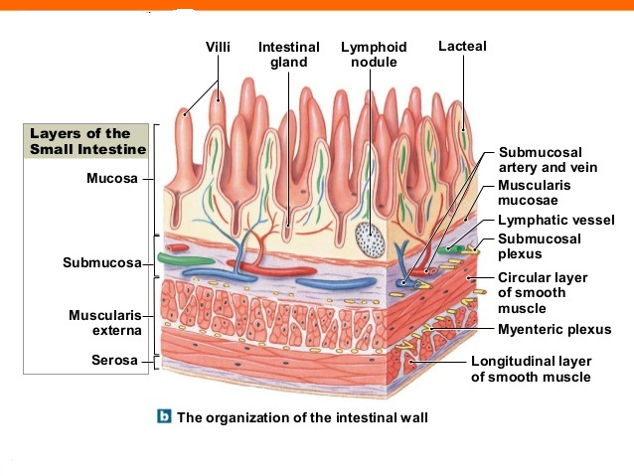
Features
- A long, narrow, folded or coiled tube extending from the stomach to the large intestine.
- It is highly convoluted and contained in the central and lower abdominal cavity.
- It is about 6.7 to 7.6m long.
Epithelial lining of each parts
The mucosa is lined by a simple columnar epithelium.
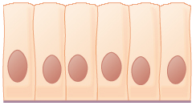

MICROANATOMY OF THE LARGE INTESTINE
The large intestine is a large bowel and the last part of the digestive system in vertebrate animals. It consists of the rectum, cecum, colon and anal canal. It starts in the right iliac region of the pelvis and join the bottom end of the small intestine. Its wall is lined the Simple columnar epithelium. It has invaginations called the intestinal glands. The large intestine also has the appendix which is attached to the inferior surface of the cecum. A schematic of the large intestine, with the colon marked as follows: cecum;
- Ascending colon.
- Transverse colon.
- Descending colon
- Sigmoid colon, rectum and anus.

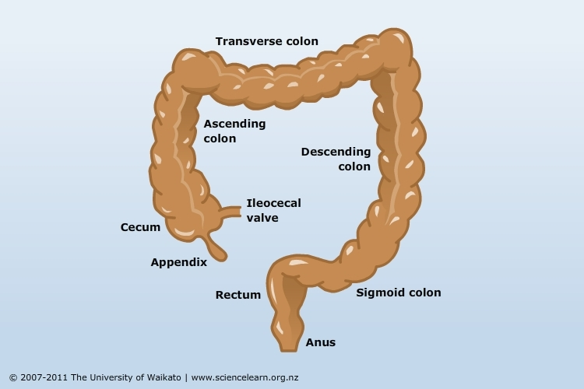
Functions
- It absorbs water from the ingestible remnants.
- Compacts feces prior to defecation.
- The ileocaecal valve controls entry of material from the ileum.
- Fermentation of some indigestible food matter by bacteria.

Layers
- The mucosa: made up of simple columnar epithelial tissue. Many mucous glands secrete mucus into the lumen to lubricate its surface and protect it from rough food particles.
- The submucosa: a layer of blood vessels, nerves and connective tissues.
- The muscularis layer: made up of two layers of smooth muscles; the inner circular layer and the outer longitudinal layer. Continuous contraction of smooth muscle bands in the muscularis produces pouch-like structures called Haustra.
- The serosa: a thin layer of simple squamous epithelial tissue that secretes serous fluid.
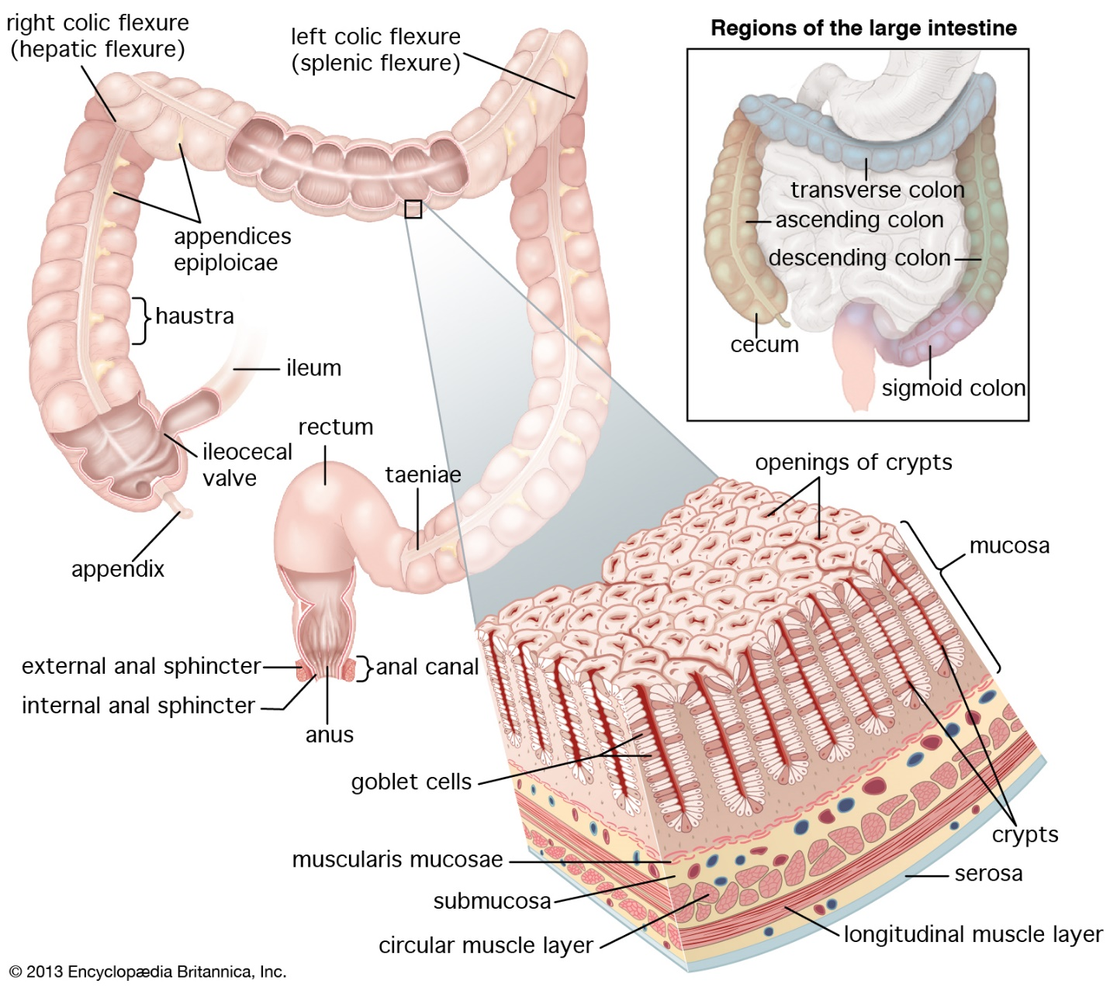
Features
- It is about 1.5m long and 5cm wide.
- It consists of the rectum, caecum, appendix and colon.

Epithelial lining
The wall is lined with simple columnar epithelium.

