NAME: NWAOKEZI DESIRE OGOCHUKWU
MATRIC No.: 17/MHS01/206
DEPARTMENT: MEDICINE AND SURGERY
COURSE: GROSS ANATOMY OF THE HEAD AND NECK (ANA301)
DATE: 23RD APRIL, 2020.

ASSIGNMENT
- Discuss the anatomy of the tongue and comment on its applied anatomy.
- Write an essay on air sinuses.
ANSWERS
- ANATOMY OF THE TONGUE.
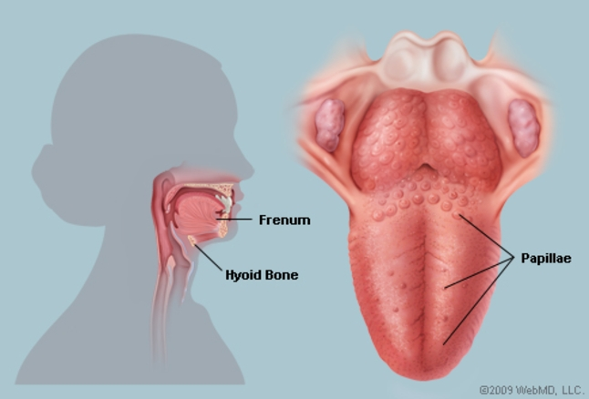
The tongue is a muscular organ in the mouth of most vertebrates. It is attached via muscles to the hyoid bone, mandible, styloid process, palate and pharynx. The tongue’s upper surface is covered by Taste Buds housed in numerous Lingual Papillae (which gives the tongue its rough texture). It is sensitive and kept moist by saliva and is richly supplied with nerves and blood vessels.
Functions of the tongue
- Functions as a digestive organ by facilitating the movement of food during mastication and assisting swallowing.
- The tongue helps in speech (phonetics) and taste (salty, sour, sour and bitter tastes).
- The tongue is also a natural way of cleansing the teeth.
- The tongue plays an important role in intimacy.
The human tongue is divided into 2 parts by the V-shaped Sulcus Terminalis.
- Oral Part; at the front. It is the anterior two third of the tongue.
- Pharyngeal Part; at the back. It is the structural one third.
The following papillae cover the tongue and are used for taste perception;
- Vallate Papillae; are arranged in a V-shaped anterior to the sulcus terminalis and studded with numerous taste buds. Innervation is by the Glossopharyngeal Nerve (CNIX).
- Fungiform Papillae; are mushroom shaped papillae with erythematous domes, located on the lateral aspects and at the apex of the tongue.
- Filiform Papillae; are slim, cone-shaped projections organized in rows parallel to the sulcus terminalis.
- Foliate Papillae; are rarely found in humans (vestigial).
Another important part of the tongue is the LINGUAL TONSIL, a collection of nodular lymphatic tissue towards the posterior one third of the dorsum.
Muscles of the Tongue
The intrinsic muscles of the tongue include; 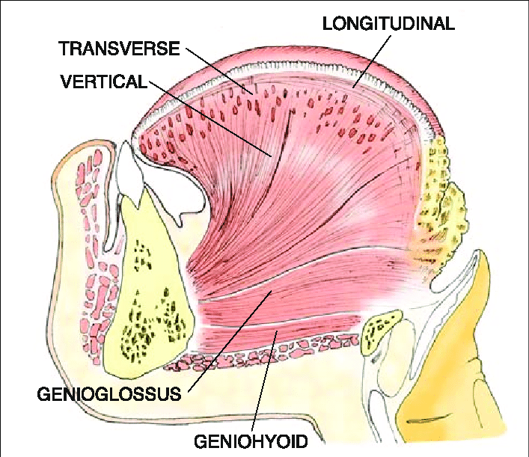
- Superior Longitudinal Lingual Muscle; shortens the tongue and curls it upward.
- Inferior Longitudinal Lingual Muscle; shortens the tongue and curls it downward.
- Transverse Lingual Muscle; elongates and narrows the tongue.
- Vertical Lingual Muscle; flattens the tongue.
The extrinsic muscles of the tongue include;
- Genioglossus Muscle; protrudes the tongue and it is innervated by Hypoglossal Nerve
- Styloglossus Muscle; draws up the sides of the tongue to create a trough for swallowing following adequate mastication. The pair of Styloglossus muscles works together on each side to retract the tongue. It is also innervated by the Hypoglossal Nerve.
- Hyoglossus Muscle; depresses and retracts the tongue and is innervated by the Hypoglossal Nerve.
- Palatoglossus Muscle; elevates the posterior tongue, closes the oropharyngeal isthmus, aids in the initiation of swallowing and prevents the spill of saliva from the vestibule into the oropharynx by maintaining the palatoglossal arch. It is innervated by the Vagus Nerve.
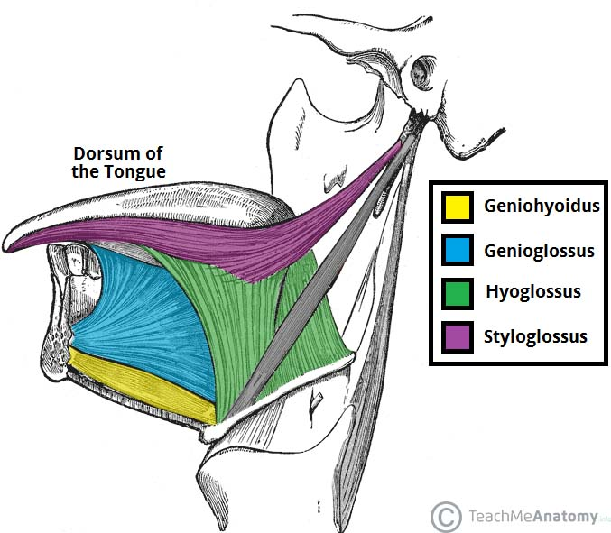

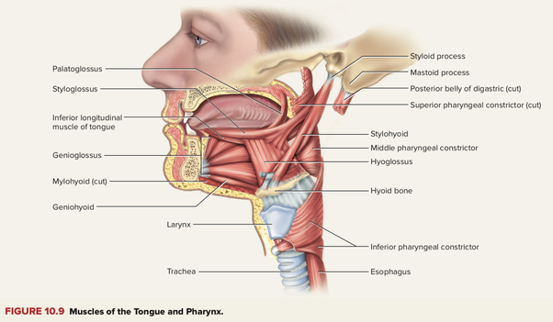
Blood Supply and Lymphatics
Arterial Supply; this is predominantly from the Lingual Artery, a branch of the External Carotid Artery;
- Suprahyoid Artery; supplies the omohyoid, sternothyroid and thyrohyoid muscles.
- Dorsal Lingual Arteries; supplies the mucous membrane of the posterior part of the dorsum of the tongue, as well as the glossopalatine arch, lingual tonsils, soft palate and epiglottis.
- Sublingual Artery; supplies the sublingual gland
- Deep Lingual Artery; supplies the genioglossus muscle and inferior longitudinal muscle.
Innervations;
- Taste to the oral part of the tongue is achieved through innervations from the Chorda Tympani Nerve (facial nerve).
- General sensation to the oral part of the tongue is by innervations from the Lingual Nerve (mandibular branch of trigeminal nerve).
- Taste to the posterior one third of the tongue is by innervation from the Glossopharyngeal Nerve which also provides general sensation to the posterior one third of the tongue.
Physiological Variants
- Ankyloglossia (tongue-tie); occurs as a result of an abnormal length of the frenulum linguae which causes limited manipulation of the tongue during speech and result in speech impediment.
. 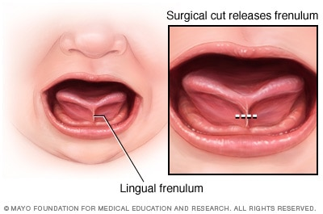
- Fissured Tongue (scrotal tongue, plicated tongue); occurs when several small furrows present on the dorsal surface of the tongue. It is an oral manifestation of psoriasis. It is generally painless and benign and is often associated with other syndromes.
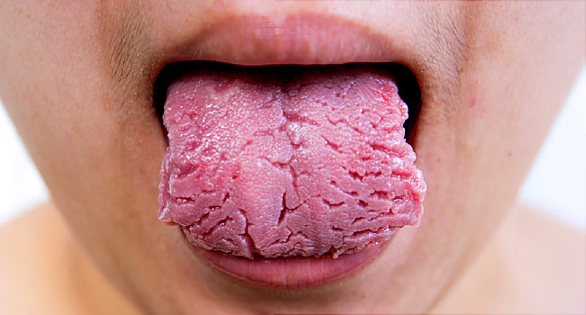
- Geographic Tongue (migratory glossitis); it is a benign, asymptomatic condition characterized by presence of red patches with a grayish-white border covering the dorsum. It is caused by inflammation of the mucous membrane of the tongue which results in loss of lingual papillae. 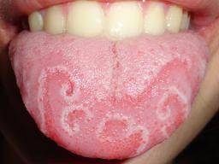

2. PARANASAL AIR SINUSES
These are a group of 4 paired air-spaces that surround the nasal cavity. These sinuses are;
- Maxillary Sinus: located under the eyes.
- Frontal Sinus: located above the eyes.
- Ethmoidal Sinus: located between the eyes.
- Sphenoidal Sinus: located behind the eyes.
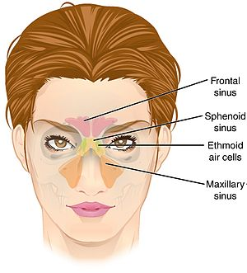
Note; the sinuses are named after the facial bones in which they are located.
Functions of air sinuses
- They contribute to the humidifying of inspired air.
- They lighten the weight of the head.
- They also increase the resonance of speech.
- Sinuses serve as crumple zone to protect vital structures in the event of facial trauma.
- They also have immunological defense.
- they insulate sensitive structures from rapid temperature fluctuations in the nose.

- Maxillary Sinus
This is the largest paranasal sinus which is approximately 15mL and it is located laterally and slightly inferior to the nasal cavities. It lies inferior to the eyes in the maxillary bone. Adjacent structures include the lateral nasal wall, orbital floor and posterior maxillary wall which contains the pterygopalatine fossa.
It is the first sinus to develop and it is filled with fluid at birth. It grows according to a biphasic pattern, in which the first phase occurs during the years 0-3 and the second during years 6-12. The earliest stage of pneumatization (development of air-filled cavities in a bone) is directed horizontally and posteriorly, whereas the later phase proceeds inferiorly towards the maxillary teeth.
Arterial Supply
It is supplied by;
- Internal Maxillary Artery; infraorbital, alveolar, greater palatine, and sphenopalatine arteries.
- Facial Arteries.
Venous Drainage
- Maxillary Vein.
Innervations
- Infraorbital Nerve of the 2nd division of the trigeminal nerve (maxillary division)
- Greater Palatine Nerve.
The maxillary sinus drains into the Ethmoid Infundibulum (hiatus semilunaris), underneath the frontal sinus opening. This is a potential pathway for the spread of infection - fluid draining from the frontal sinus can enter the maxillary sinus.
- FRONTAL SINUS
The frontal sinus is located superior to the orbit and within the frontal bone. The typical volume at the adult stage is 4 to 7mL. It is formed by the upward movement of anterior ethmoid cells after the age of 2. Developmentally, this is the last sinus to pneumatize. Growth increases at age 6 and continues until late teenage years. It varies in size but it’s always triangular-shaped.
Arterial Supply
- Supraorbital Artery
- Supratrochlear Artery.
They are both branches of the Ophthalmic Artery.
Venous Drainage
- Ophthalmic Vein
- Supraorbital Vein.
Innervations
- Supraorbital Nerve
- Supratrochlear Nerve
They are both branches of the ophthalmic division of the Trigeminal Nerve (CNV₁).
The frontal sinus drains into the frontal recess via the middle meatus.
- Sphenoid Sinus.
This is located centrally and posteriorly within the sphenoid bone. It lies relatively superiorly at the level of the sphenoethmoidial recess. Typical adult size is 0.5 to 8mL. There are several important structures with close anatomical relationship with the sinus; the carotid artery is located adjacent to the lateral wall of the sinus, the optic nerve is also located adjacent to the lateral wall of the sinus. The pituitary gland can also be surgically accessed via passing through the nasal roof into the sphenoid sinus and through the sphenoid bone.
It arises from the nasal embryonic lining and not from the outpouching of the nasal cavity. The sinus reaches its full size by the late teenage years. The sinus is variably pneumatized and may extend as far as the foramen magnum in some people.
Arterial Supply
- Sphenopalatine Artery
Venous Drainage
- Maxillary Vein.
Innervations
- Sphenopalatine Nerve which is composed of parasympathetic fibers and CNV₂.
NOTE;
- The sinus drains into the sphenoethmoidial recess located within the superior meatus.
- There are several important structures with close anatomical relationship with the sinus; the carotid artery is located adjacent to the lateral wall of the sinus.
- The pituitary gland can be surgically accessed via passing through the nasal roof into the sphenoid sinus and through the sphenoid bone.

- ETHMOID SINUS.
This arises in the Ethmoid bone, forming several distinct air cells between the eyes. There are 3 to 4cells at birth and develop into 10 to 15 by adulthood for a total of 2 to 3mL.
There are a collection of fluid-filled cells at birth that grow and pneumatize until the age of 12. The Ethmoid cells are shaped like pyramids and are divided by septa.
There are 3 Ethmoid sinuses and they empty into the nasal cavity at different places, they are;
- Anterior Ethmoid Sinus; empties into the Hiatus Semilunaris
- Middle Ethmoid Sinus; empties into the Ethmoid Bulla
- Posterior Ethmoid Sinus; empties into the Sphenoethmoidial Recess located in the Superior Meatus.
Arterial Supply
- Anterior and Posterior Ethmoidal Arteries from the Ophthalmic Artery (internal carotid system).
Venous Drainage
- Maxillary Vein
- Ethmoid Vein
Clinical Importance
- As the paranasal sinuses are continuous with the nasal cavity, an upper respiratory tract infection can spread to the sinuses. Infection of the sinuses causes inflammation (particularly pain and swelling) of the mucosa and is known as SINUSITIS. If more than one sinus is infected, it is called PANSINUSITIS.
- The maxillary nerve supplies both the maxillary sinus and maxillary teeth and so inflammation of that sinus can present with toothache.

