PEPPLE IBIM
16/ENG06/088
MECHANICAL ENGINEERING
MEE 586
28TH APRIL, 2020
ASSIGNMENT
- What is an integrated CAD/CAM?
An integrated CAD/CAM is a system that provides one model supporting both design and manufacturing functions rather than having various file formats, numerous data translations/conversions, and different CAD and CAM models. CAD/CAM stands for computer-aided design & computer-aided manufacturing. CAD/CAM software is used to design and manufacture prototypes, finished products and production runs. CAD/CAM applications are used to design a product and program manufacturing processes (CNC machining). CAM software uses the models and assemblies created in CAD software to generate toolpaths that drive machine tools to turn designs into physical parts.
An advantage of CAD/CAM is rapid prototyping; Rapid prototyping allows designers to construct physical prototypes during the design process. These physical prototypes can be used to test various aspects of the design.
- Draw a product cycle to describe the scope of CAD/CAM in the operation of manufacturing firm?
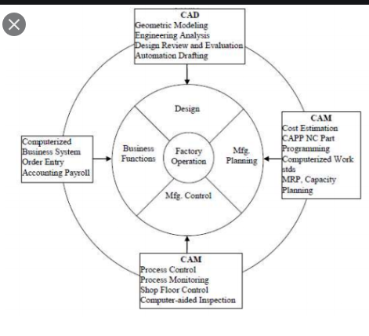
Figure 1: Product Cycle of CAD/CAM Scope

- Explain 7 characteristics of a good CAD software?
- Efficiency: An Efficient software is that which can use less resources (CPU) in terms of time and usage to give a better output.
- Simplicity: A software must be simple to use and easy to understand and must be user friendly, i.e. the ability for a new user to navigate the CAD software
- Flexibility: The software must be able to incorporate the design modification without too much complication.
- Readability: This provides the capability within the software to help the user as and when required.
- Portability: The software must have the capacity to get transferred from one system to other.
- Recover ability: - A Good software must be able to give warnings before getting crashed and must be able to recover.
- Reliability: - To avoid causality the software must be able to avoid unwanted operation, like virus and so on.
- Explain 3 divisions of software components?
Computer software are divided into three basic categories; System software or operating system, application software and programming languages.
- System Software: System software or operating system is the software used by the computer to translate inputs from various sources into a language which a machine can understand. Basically, the OS coordinates the different hardware components of a computer. There are many OS in the market. The most popular Os are from the stable of Microsoft which uses windows operating system. Another operating system can be found in our phones; the most commonly used are; android and iOS.
- Application software: application software is used to interact with a computer. Popular examples of application software are the Microsoft office suite which includes Word, Excel and PowerPoint. Internet explorer, Mozilla Firefox is two applications used to access the internet. E-mail software like Outlook express is used to manage Emails. All user interfaces are an application. The anti-virus is an application and so is the Media player.
- Programming languages: this is a kind of software is samiliar to programmers. C++, Java and Simlab are some popular programming languages. Generally, Java is used for internet applications. C++ is a language of professional developers and used extensively in developing operating systems. PHP is another language used for internet applications. There is a new class of languages which are being utilized for the mobiles. These are light weight, modular languages which are used to design mobile applications.

