Name: Gadzama Esther Stephen

College: Social And Management Sciences

Matriculation number: 18/SMS03/013

Department: Business Administration

Assignment Title: Food Production And Health Awareness

Course Code: AFE202

Question
Prepare a business plan on a chosen agricultural enterprises following the guidelines in the notes. Spiral bind and submit upon resumption. Minimum of five pages, times new Roman size 12 with double spacing. Send a soft copy to me to view.

Esther Poultry bounty

Esther Poultry bounty an existing farm dedicated or focused on caring for chickens and other poultry animals to supply food production to companies. It is formed on a L.L.C - limited liability outside lagos Ibadan express way, Esther poultry bounty is working on being the market leader in the poultry business by organizing and hiring a well skilled management team.

Key to success
Esther has identified that to be successful in this market she has to implement a philosophy of a 100% customer satisfaction, through this Esther poultry bounty would be getting an increase in the market share favoring her business. Secondly by having a proper quality control measure, that is making sure production is efficient.

Products
Chicken egg
Meat
Turkey
Pigeon
Duck
Goose

Market
Esther poultry Bounty has decided to do a market research on the total market and having gotten the statistics and analysis, she has decided to do market segmentation strategy and has a target population of roughly 20,000 individuals
This research involves
Employing individuals to move round the local market to find out what local retailers don’t like about the products being delivered to them, in other words a survey of the market was made. This survey would help Esther poultry bounty in a long run to gain a larger market share.

Management team
This business would be headed by Esther Okolocha as the Chairwoman of the company, also a team of 20-40 employees to cover all activities that would be done, Esther has knowledge in agriculture science as she studies it both in BCH and masters, also working in some top firm to help her gain experience and more knowledge.

Finance
To help the growth of Esther poultry bounty, equipment would need to be purchased, equipment worth of #60,000-#90,000 these would be long term assets, also seeking financial loan of #500,000 naira.

Objective in Nigeria
1. to achieve the sales growth targets by the end of six months and by end of year one
2. Aggressive gain in market share and average monthly revenue in two
3. To increase the number of institutions and cooperate bodies who book our products
4. To achieve net profit in one year
5. To achieve quality sales service and products

Goal for the poultry business plan
1. to be the leading poultry meat and egg producer in Nigeria

Vision for the poultry business in Nigeria
1. to provide a one stop location for accessing excellent and high quality poultry meat and egg products

Mission for the poultry business in Nigeria
1. to exceed the customer expectations by providing high quality service products and exceptional customer care service in a loving and caring way.

Company Summary
Esther poultry bounty is a newly started up business grows a variety of poultry products.

Company History
Esther poultry bounty has been in operation for a year. Initially it was started as a family business where Esther was learning from her father who was just a local farmer in his village. After Esther years of studying agriculture year, she decided that although she had the money to live on for many years, it would be irresponsible to needlessly spend it so she got serious about the business and made a concerted effort to become profitable.
Esther poultry bounty has chosen Lagos as a good place to rear her poultry products. 10 acres of land which they use for production was acquired.

Company Ownership- Esther poultry bounty is privatized owed business headed by Esther Okolocha as the Chairwoman of the company
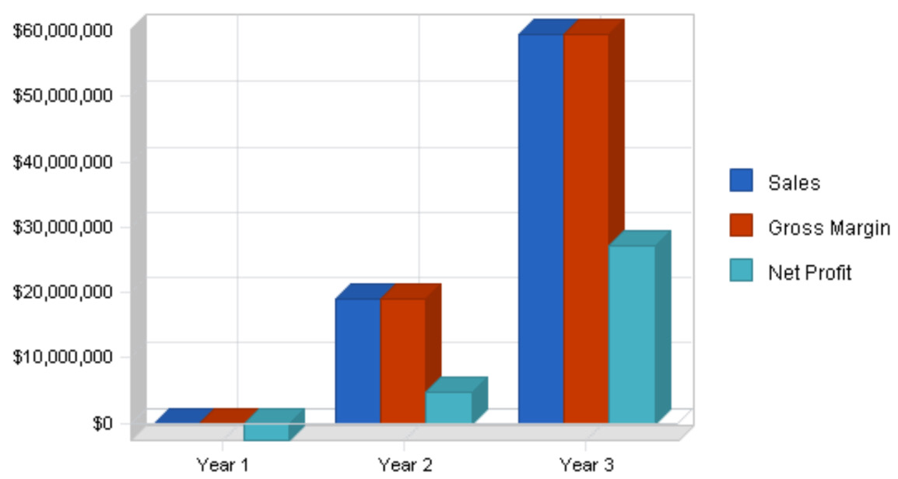

The above graph shows how Esther has forecasted her sales, gross profit and also her net profit
($) = #

Market Analysis Summary
Esther poultry Bounty has decided to do a market research on the total market and having gotten the statistics and analysis, she has decided to do market segmentation strategy and has a niche population of roughly 20,000 individuals
This research involves employing individuals to move round the local market to find out what local retailers don’t like about the products being delivered to them, in other words a survey of the market was made. This survey would help Esther poultry bounty in a long run to gain a larger market share.

Market Segmentation
Esther poultry Bounty has identified different target market segments which they will sell to:
Supplement Companies
In other words, these are retail local shops that would purchase products of Esther poultry and sell it in bulk to the local markets around.
Also selling her product to some larger organizations that could later use their own brand to market the product.
The five main channels of distribution are: consumer-direct (includes direct mail/catalog, direct from sales representatives, multi-level marketing, Internet & infomercial/direct from television); food, drug, mass-market stores, health and natural food stores, and practitioners, others.

Channels of Distribution | % of # Sales
Consumer-direct | 42%
Food, drug, mass-market stores | 30%
Health & natural food stores | 20%
Other | 4%

Competition and Buying Patterns
As mentioned previously, competition takes two forms, farms similar in size and production capacity to Esther poultry Bounty and megafarms. The similarly sized farms range in size from 5-30 acres. The number of different herbs grown varies from a handful to upwards of 50. The choice of poultry products products is based on owner preference as well as location and the ability of the local growing conditions to support the different plants.
On the other end of spectrum is the megafarm. These farms have a similar range of species cultivated, however they differ greatly in production capacity. These farms are huge, typically not less than 100 acres, peaking at 300 acres. These growers however are few number.
The buying patterns of the different customers are typically based on these variables:
* Price
* Availability
* Ability to deliver consistently on long-term contracts
* Significant % of active ingredients
* Consistency.

Financial plan
The following sections will outline important financial information.
Note all the figures are based on financial assumptions
GENERAL ASSUMPTIONS | Y/R 1 | Y/R 2 | Y/R 3
Plan month | 1 | 2 | 3
Current interest rate | 15.040% | 15.040% | 15.040%
Long term interest rate | 10% | 10% | 10%
Tax rate | 24% | 24% | 24%
Other | 0 | 0 | 0
 | --------- | ---------- | ---------

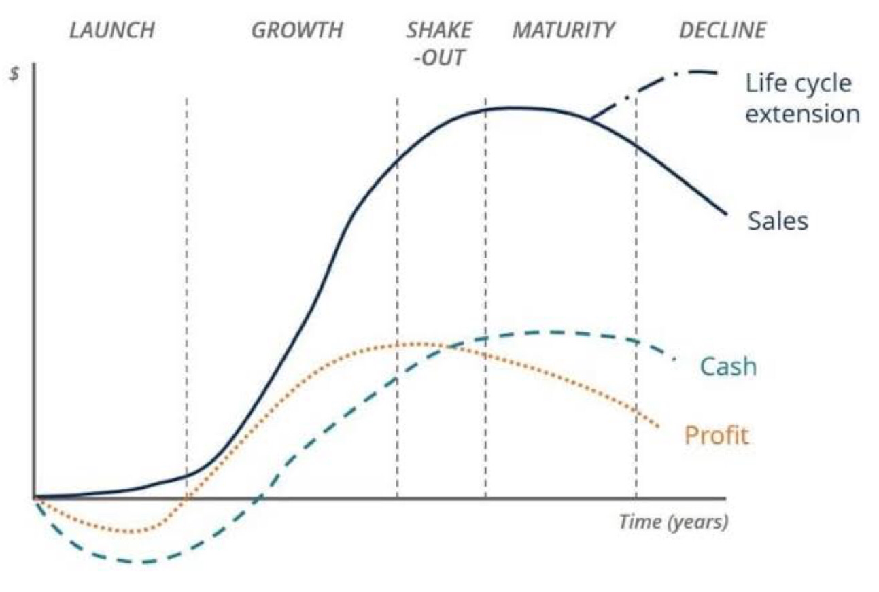
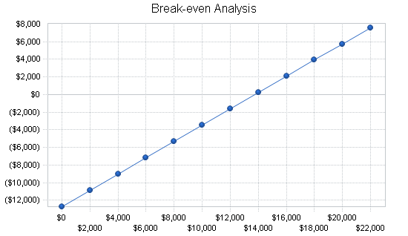
Break even analysis

THE PRODUCT LIFE CYCLE DIAGRAM
this diagram explain how Esther has forecasted her sales, profit, and cash price, and have concluded that the business will hit growth during its 3 year.
In conclusion
Financing Esther poultry bounty will tend to improve the quality poultry products that are sold in Nigeria, this is because in 2-4 years this business would be the #1 business in Nigeria that every other poultry looks up to because of the quality product that would be sold.

