- Discuss the Anatomy of the tongue and comment on its applied anatomy.
Under normal circumstances, the tongue is a pink, muscular organ located within the oral cavity proper. It is kept moist by the products of the major and minor salivary glands, which aids the organ as it facilitates deglutition, speech, and gustatory perception. While there is significant variability in the length of the tongue among individuals, on average, the organ is roughly 10 cm long. It has three main parts:
- The tip or apex of the tongue is the most anterior and most mobile aspect of the organ.
- The tip is followed by the body of the tongue. It has a rough dorsal (superior) surface that abuts the palate and is populated with taste buds and lingual papillae, and a smooth ventral (inferior) surface that is attached to the floor of the oral cavity by the lingual frenulum.
- The base/root of the tongue is the most posterior part of the organ. It is populated by numerous lymphoid aggregates known as the lingual tonsils along with foliate papillae along the posterolateral surface.
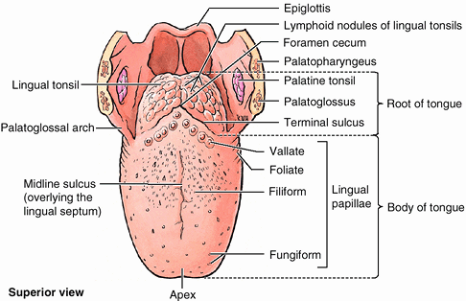
There are numerous important structures surrounding the tongue. It is limited anteriorly and laterally by the maxillary and mandibular rows of teeth. Superiorly, it is bordered by the hard (anterior part) and soft (posterior part) palates. Inferiorly, the root of the tongue is continuous with the mucosa of the floor of the oral cavity; with the sublingual salivary glands and vascular bundles being located below the mucosa of the floor of the oral cavity.
The palatoglossal and palatopharyngeal arches (along with the palatine tonsils) have lateral relations to the posterior third of the tongue. Posterior to the base of the tongue is the dorsal surface of the epiglottis and laryngeal inlet, and the posterior wall of the oropharynx. The presulcal and postsulcal parts of the tongue differ not only by anatomical location, but also based on embryological origin, innervation, and the type of mucosa found on its surface.

ANTERIOR TWO THIRDS
The presulcal tongue includes the apex and body of the organ. It terminates at the sulcus terminalis; which can be seen extending laterally in an oblique direction from the foramen cecum towards the palatoglossal arch. The mucosa of the dorsal surface of the oral tongue is made up of circumvallate, filiform, and fungiform papillae. There is also a longitudinal midline groove running in an anteroposterior direction from the tip of the tongue to the foramen cecum. This marks the embryological point of fusion of the lateral lingual swellings that formed the oral tongue. It also represents the location of the median lingual (fibrous) septum of the tongue that inserts in the body of the hyoid bone.

Terminal sulcus of tongue (Sulcus terminalis linguae)
On the lateral surface of the oral tongue are foliate papillae arranged as a series of vertical folds. The ventral mucosa of the oral tongue is comparatively unremarkable. It is smooth and continuous with the mucosa of the floor of the mouth and the inferior gingiva. The lingual veins are relatively superficial and can be appreciated on either side of the lingual frenulum. Lateral to the lingual veins are pleated folds of mucosa known as the plica fimbriata. They are angled anteromedially toward the apex of the tongue.

Posterior third
The remainder of the tongue that lies posterior to the sulcus terminalis is made up by the base of the organ. It lies behind the palatoglossal folds and functions as the anterior wall of the oropharynx. Unlike the oral tongue, the pharyngeal tongue does not have any lingual papillae. Instead, its mucosa is populated by aggregates of lymphatic tissue known as the lingual tonsils. The mucosa is also continuous with the mucosa of the laterally located palatine tonsils, the lateral oropharyngeal walls, and the posterior epiglottis and glossoepiglottic folds.
Muscles
The tongue is chiefly a muscular organ with some amount of fatty and fibrous tissue distributed throughout its substance. All the muscles of the tongue are paired structures, with each copy being found on either side of the median fibrous septum. There are muscles that extend outside of the organ to anchor it to surrounding bony structures, known as extrinsic muscles. The other set of muscles are confined to each half of the organ and contribute to altering the shape of the organ; these are the intrinsic muscles.

Intrinsic tongue muscles
The intrinsic tongue muscles are responsible for adjusting the shape and orientation of the organ. It is made up of four paired muscles which can operate independently, or in combination with each other to give rise to numerous shapes. This is an important feature of the tongue as it facilitates molding of the food particles into a bolus in preparation for deglutition and speech.
Superior longitudinal | Origin - submucosa of posterior tongue, lingual septum  Insertion - apex/anterolateral margins of tongue  Innervation - hypoglossal nerve (CN XII)  Blood supply - lingual branch of external carotid artery  Action - retracts and broadens tongue, elevates apex of tongue
Inferior longitudinal | Origin - root of tongue, body of hyoid bone  Insertion - apex of tongue  Innervation - hypoglossal nerve (CN XII)  Blood supply - lingual branch of external carotid artery  Action - retracts and broadens tongue, lowers apex of tongue
Transverse muscle | Origin - lingual septum  Insertion - lateral margin of tongue  Innervation - hypoglossal nerve (CN XII)  Blood supply - lingual branch of external carotid artery  Action - narrows and elongates tongue
Vertical muscle | Origin - root of tongue, genioglossus muscle  Insertion-lingual aponeurosis  Innervation - hypoglossal nerve (CN XII)  Blood supply - lingual branch of external carotid artery  Action - broadens and elongates tongue

Extrinsic tongue muscles
While the shape of the tongue is determined by the intrinsic muscles of the tongue, movement of the organ within (and out of) the oral cavity is dependent on the extrinsic tongue muscles. There are four pairs of extrinsic muscles, which can be viewed as those arising from above the tongue, and those that originate from below the tongue.
ORIGINATING FROM BELOW THE TONGUE
Genioglossus | Origin - Superior mental spine of mandible  Insertion - entire length of dorsum of tongue, lingual aponeurosis, body of hyoid bone  Innervation - hypoglossal nerve (CN XII)  Blood supply - sublingual branch of lingual artery, submental branch of facial artery  Action - depresses and protrudes tongue (bilateral contraction); deviates tongue contralaterally (unilateral contraction)
Hyoglossus | Origin - body and greater horn of hyoid bone  Insertion - inferior/ventral parts of lateral tongue  Innervation - hypoglossal nerve (CN XII)  Blood supply - sublingual branch of lingual artery, submental branch of facial artery  Action - depresses and retracts tongue
ORIGINATING FROM ABOVE THE TONGUE
Styloglossus | Origin - anterolateral aspect of styloid process (of temporal bone), stylomandibular ligament  Insertion - blends with inferior longitudinal muscle (longitudinal part); blends with hyoglossus muscle (oblique part)  Innervation - hypoglossal nerve (CN XII)  Blood supply - sublingual branch of lingual artery  Action - retracts and elevates lateral aspects of tongue
Palatoglossus | Origin - palatine aponeurosis of soft palate  Insertion - lateral margins of tongue, blends with intrinsic muscles of tongue  Innervation - vagus nerve (CN X) (via branches of pharyngeal plexus)  Blood supply - ascending palatine branch of facial artery, ascending pharyngeal artery  Action - elevates root of tongue, constricts isthmus of fauces

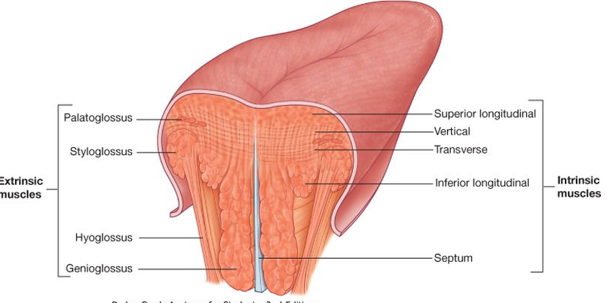

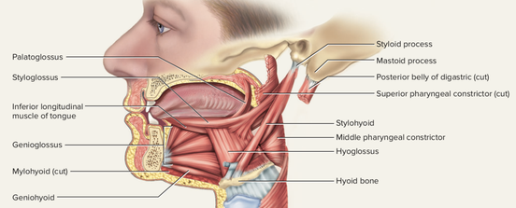

Histology
The lingual mucosa is covered by stratified squamous epithelium with varying degrees of keratinization. Since the dorsal surface of the oral tongue is more at risk for desiccation and abrasions from contact with food boluses of varying temperatures and textures, it is covered by epithelium that is keratinized. However, the ventral surface of the tongue as well as the pharyngeal part, are relatively well protected from the harsh environment. Therefore, the epithelia in these areas are non-keratinized. The epithelium is adherent to the underlying striated muscle fibers of the tongue. There is a fibrous raphe in the midline of the tongue that marks the point of fusion of the embryonic lateral lingual swellings. Posteriorly, there is a variable amount of adipose tissue within the pharyngeal tongue.
The dorsal mucosa of the oral tongue is characterized by numerous raised structures known as lingual papillae. They give the characteristic rough appearance of the dorsal surface that is not appreciated on the ventral surface of the tongue. The pharyngeal tongue also has raised dome-like structures throughout the mucosa. However, these are lymphatic aggregates (i.e. lingual tonsils) and should not be confused with papillae.

The lingual papillae
There are four types of lingual papillae found on the surface of the human tongue. These include:
- Filiform papillae are the most abundant of the four types of papillae. They are stretched, conical, grey-white papillae that are covered in a heavy coat of keratinized squamous epithelium. By making the dorsal surface of the tongue rough, these papillae provide friction to allow movement of the food bolus during chewing. It should be noted that these papillae do not possess taste buds.
- Fungiform papillae are weakly keratinized and less abundant than the filiform papillae. However, they are scattered across the entire dorsal surface of the tongue. These highly vascular, mushroom-shaped papillae contain a few taste buds on the apical aspect.
- Foliate papillae appear as bilaterally paired, parallel, longitudinal slits on the posterolateral margin of the tongue, near the sulcus terminalis. The mucosa is non-keratinized and the papillae are populated with numerous taste buds.
- Circumvallate (Vallate) papillae are organized linearly, as a set of four to six large papillae anterior to each limb of the sulcus terminalis (i.e. eight to twelve papillae in total). In longitudinal section, the characteristic furrow found within the papillae can be appreciated. These moats facilitate the drainage of serous salivary von Ebner glands that empty into the structure. The persistent lubrication creates a favorable environment for gustatory particles to dissolve so that they can be detected by the taste buds.

The Taste Buds
While taste buds are distributed throughout the entire oral cavity, they are at higher concentrations on the tongue. Each taste bud is clear, oval and covered by stratified squamous epithelium. A combination of elongated taste (gustatory), supportive, and basal stem cells can be found within each taste bud. The gustatory cells have an apical taste pore surrounded by numerous microvilli that binds dissolved molecules and brings them closer to the receptors responsible for taste. However, these cells have a relatively high turnover rate, as their shelf life is roughly seven to ten days.
Taste buds (Caliculi gustatorii): There are five gustatory sensations that are perceived by individuals. These are sweet, salty, sour, bitter, and umami. The microvilli found on the apical surface of the taste cells are equipped with various receptors that bind to varying molecules. The reaction generated from this compound-receptor interaction gives rise to varying action potentials that are subsequently perceived as taste. Saltiness is often associated with the cationic component of a compound (i.e. sodium ions), while sourness is related to the acidity (concentration of hydrogen ions) in the compound. Organic compounds such as carbohydrates or amino acids give rise to sweet taste, while bitterness is associated with long-chain organic compounds. The final taste - umami - also known as savory, is related to compounds with the left-handed chiral isomer of glutamic acid.
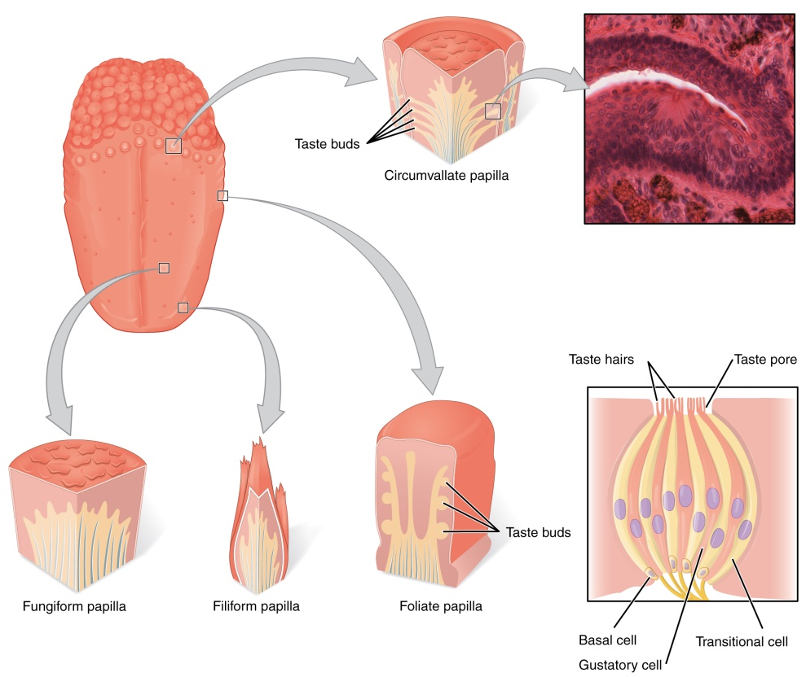

Blood Supply And Lymphatic Drainage

Arteries
The vascular supply to the tongue muscles is provided by derivatives of the lingual artery. This is a branch of the external carotid artery that traverses the region between the middle pharyngeal constrictor and hyoglossus in order to access the floor of the mouth. It takes a sharp superior turn at the anterior border of hyoglossus as it travels alongside CN IX. Of note, the tongue has good collateral supply as the lingual artery also anastomosis with the contralateral vessel. The named branches of the lingual artery are as follows:
- The dorsal lingual arteries are relatively small derivatives of the lingual artery that arise medial to hyoglossus. In addition to supplying the dorsal mucosa of the tongue, it also gives branches to the palatoglossus, soft palate, palatine tonsils, and epiglottis.
- Emerging at the anterior limit of the hyoglossus, the sublingual arteries course between the mylohyoid and genioglossus as it travels towards the sublingual glands in the floor of the oral cavity. As it arborizes, one of its branches anastomoses with the submental branches of the facial artery, while another traverses the gingiva of the mandible to anastomose with the analogous contralateral vessel.
- As the lingual artery terminates near the lingual frenulum on the ventral surface of the tongue, it is referred to as the deep lingual artery.
The lingual artery is supported by other branches of the external carotid artery. The facial artery gives off the ascending palatine and tonsillar arteries that also supply the tongue. The ascending pharyngeal branch of the external carotid artery also supplies the organ.
Veins
The veins of the tongue are named similarly to the arteries that they accompany. They are formed from numerous venous tributaries that eventually coalesce. As the deep lingual vein forms adjacent to the apex of the tongue, it courses along the ventral surface of the tongue (deep to the mucosa). As the deep lingual vein anastomosis with the sublingual vein, they become the vena comitans of CN XII. This venous network eventually drains to the lingual vein that later join the facial or the anterior division of the retromandibular veins. Here, they form the common facial vein, which is a tributary to the internal jugular vein. Alternatively, the venae comitantes may drain directly to the internal jugular vein.
The dorsal lingual veins are responsible for draining the lateral margins and dorsal surface of the tongue. They travel alongside the similarly named artery as they drain into the internal jugular vein.

Lymphatic drainage
When discussing the lymphatic drainage of the tongue, it helps to group them according to the region of the tongue that they drain. The marginal and central groups drain the anterior parts of the tongue, while the dorsal group drains lymph from the posterior third of the organ. It is not uncommon to see the central area of the tongue draining to both marginal and dorsal groups of lymph vessels.
The marginal lymph vessels will carry lymph to the submandibular nodes or to the jugulo-omohyoid nodes. It is not uncommon to see lymph vessels decussating to drain to contralateral lymph nodes. The vessels from the central region may go to the deep cervical nodes, with a particular preference for the jugulo-omohyoid or jugulodigastric nodes. The dorsal group of vessels also pass laterally on either side to eventually join the marginal vessels in their course to the jugulo-omohyoid and jugulodigastric vessels.

Innervation
The tongue has multiple sources of innervation based on its embryological origins. The nerve supply to the tongue can be grouped based as efferent fibers that carry motor impulses, general sensory that conveys touch and proprioception, and special afferent that conveys gustatory impulses.

Motor innervation
The muscles of the tongue arise from occipital myotomes that migrated to the floor of the pharyngeal apparatus during development. These primitive myocytes took the fibers of CN XII along with them during their journey. As a result, CN XII provides motor innervation to all the muscles of the tongue, except palatoglossus. As CN XII pierces the ventrolateral part of the pharyngeal tongue, it gives a branch to the geniohyoid muscle. Subsequently, it bifurcates into medial and lateral branches. The medial branch innervates the posterior part of the transverse and vertical muscles, as well as the medial part of the inferior longitudinal muscle, and the entire genioglossus. The lateral branch of CN XII innervates the lateral part of the inferior longitudinal, superior longitudinal, hyoglossus and styloglossus muscles. Palatoglossus (actually a palatine muscle) is supplied by the vagus nerve(X) of the pharyngeal plexus.

Tactile sensory innervation
The lingual nerve is a branch of maxillary branch of the trigeminal nerve, CN V₃. It is responsible for conveying general somatic afferent impulses from the anterior two-thirds of the tongue. Additionally, it also carries sensory information from the oral mucosa beneath the ventral surface of the tongue as well as the gingival mucosa of the lingual side of the mandible. General afferent impulses from the circumvallate papillae, along with the posterior third of the tongue are carried by fibers of CN IX.

Taste innervation
There are three cranial nerves responsible for conveying taste sensation from the tongue to the brain. These are CN VII, CN IX, and (to a lesser extent) CN X. The region of the tongue covered by each nerve is dependent on the proximity of the developing taste bud (and lingual papilla) to the free nerve ending. CN VII mitigates special sensory signals from the anterior two-thirds of the tongue, as well as from the inferior part of the soft palate.
Fibers of the chorda tympani travel by means of the lingual nerve to detect impulses from the sulcal tongue. The postsulcal tongue, circumvallate papillae, palatoglossal arches, and oropharynx are governed by CN IX. CN X only provides supply to taste buds in the extreme areas of the pharyngeal tongue. These impulses are conveyed by the internal laryngeal branch of the vagus nerve.
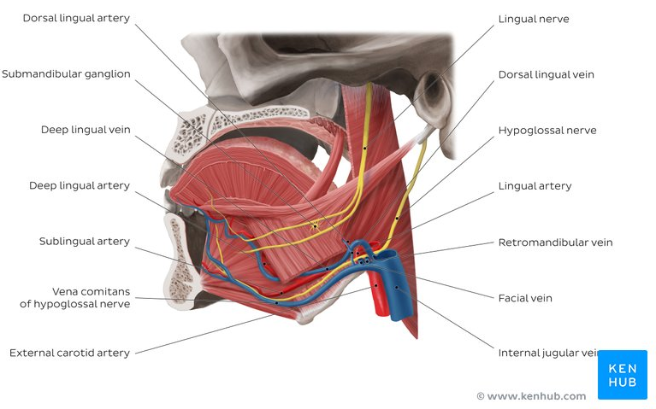
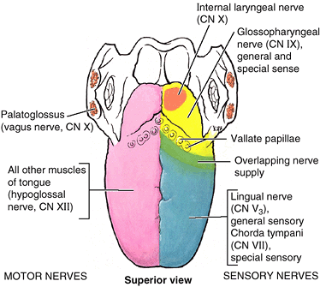
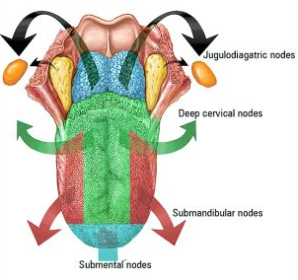

Clinical aspects
- Pierre Robin Syndrome, causes glossoptosis among other symptoms. An infant has a smaller than normal lower jaw, a tongue that falls back in the throat, and difficulty breathing. It is present at birth.
- Ankyloglossia, also known as tongue-tie, is a congenital oral anomaly that may decrease mobility of the tongue tip and is caused by an unusually short, thick lingual frenulum. Ankyloglossia can also prevent the tongue from contacting the anterior palate. This can then promote an infantile swallow and hamper the progression to an adult-like swallow which can result in an open bite deformity. It can also result in mandibular prognathism; this happens when the tongue contacts the anterior portion of the mandible with exaggerated anterior thrusts. The treatment is to surgically relieve the connection between the frenum and the floor of the mouth.
- Frenuloplasty: surgical alteration of a frenulum when its presence restricts range of motion between interconnected tissues.
- Frenectomy: removal of the frenulum.
- Macroglossia is the medical term for an unusually large tongue. It may be caused by a wide variety of congenital and acquired conditions. The most common causes of tongue enlargement are vascular malformations and muscular hypertrophy. Severe enlargement of the tongue can cause cosmetic and functional difficulties in speaking, eating, swallowing and sleeping. Treatment involves correction of autodontic abnormalities that might have been caused by the enlarged tongue.
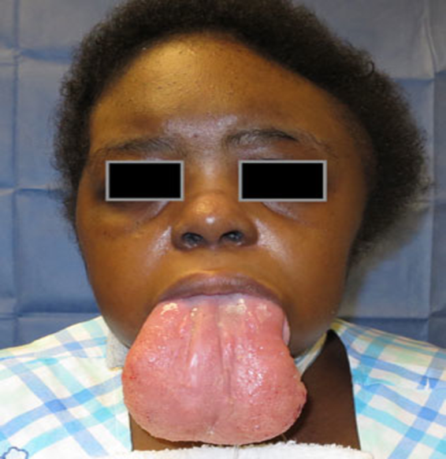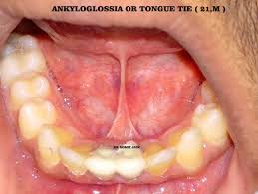

- Write an essay on the air sinuses.
The paranasal sinuses are air cavities that help circulate the air that is breathed in and out of the respiratory system. They are situated around the nasal cavity and they are all paired and sometimes symmetrical, while always being bilateral. There are four different pairs of sinuses and they are called the:
- maxillary sinuses
- frontal sinuses
- sphenoidal sinuses
- ethmoidal sinuses
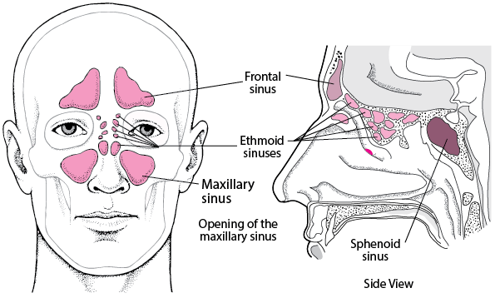

The Maxillary Sinuses
The maxillary sinuses are the largest of the all the paranasal sinuses, the size of the maxillary sinus at adult stage is approximately 15 mL. They have thin walls which are often penetrated by the long roots of the posterior maxillary teeth. The superior border of this sinus is the bony orbit, the inferior is the maxillary alveolar bone and corresponding tooth roots, the medial border is made up of the nasal cavity and the lateral and anterior border are limited by the cheekbones. Posteriorly, two anatomical spaces known as the pterygopalatine fossa and the infratemporal fossa exist. The maxillary sinus drains into the ethmoid infundibulum.
The submandibular lymph nodes are the main destination during lymphatic drainage. The blood supply includes a contribution from the:
- anterior superior alveolar artery
- middle superior artery
- posterior superior alveolar artery
The maxillary vein supplies venous drainage. Innervation occurs through nerves of the same names as the arteries.

The Frontal Sinuses
Anteriorly, the frontal sinuses are contained by the forehead and the superciliary arches, superiorly and posteriorly by the anterior cranial fossa and inferiorly by the bony orbit, the anterior ethmoidal sinuses and the nasal cavity. Medially the sinuses face one another, separated by the midline.This pair of sinuses is irregular in shape when compared to one another and is underdeveloped at birth. They reach their full size and shape around seven to eight years of age.
The typical volume at the adult stage is 4 to 7 mL. The frontal sinus drains into the frontal recess via the middle meatus. This drainage can be variable, either medial or lateral to the uncinate, depending on its attachment.They drain primarily into the ethmoidal infundibulum and the corresponding lymph drainage occurs via the submandibular lymph nodes.
The frontal sinuses are supplied by the: anterior ethmoidal artery, supraorbital artery and supratrochlear artery. Ophthalmic and supraorbital veins supply venous drainage. It is innervated by the ophthalmic nerve, including the supraorbital and supratrochlear branches.
Several anatomical spaces/structures are important to frontal sinus anatomy:
- Frontal recess: Drainage space between the frontal sinus and semilunar hiatus that is bounded by the posterior wall of the agger nasi cell, lamina papyracea, and the middle turbinate.
- Frontal sinus infundibulum: Space that drains into the frontal recess that is located superior to the agger nasi cells
- Frontal cells: anterior ethmoid cells that pneumatize the frontal recess. These cells may cause obstruction or persistent sinus disease. They are located posterior and superior to the agger nasi cell, and there are 4 types as classified by Bent and Kuhn:
- Type I: Single cell above the agger nasi cell but below the floor of the frontal sinus
- Type II: Multiple cells above the agger nasi, may extend into the frontal sinus
- Type III: Single large cell that extends supraorbitally through the floor of the frontal sinus, attaches to the anterior table
- Type IV: Single isolated cell that is contained within the frontal sinus

The Sphenoidal Sinuses
The most posterior of all the sinuses in the head, the sphenoidal sinuses are large and irregular, just like their septum, which is made by the sphenoid bone. Laterally, a cavernous sinus exists which is part of the middle cranial fossa and also the carotid artery and cranial nerves III, IV, V/I, V/II and VI can be found.
The anterior wall separates this pair of sinuses from the nasal cavity, as does the hypophyseal fossa, the pituitary gland and the optic chiasm superiorly and the nasopharynx and pterygoid canal inferiorly. They drain into the sphenoethmoidal recess located within the superior meatus. The typical adult size is 0.5 to 8 mL.

Vascularization, innervation and lymphatics
The lymphatic drainage occurs in the same way as the posterior ethmoid sinus, to the retropharyngeal lymph nodes.. The posterior ethmoidal artery, the sphenopalatine artery and the posterior lateral nasal branches supply the sphenoidal sinuses. Venous drainage is via the maxillary vein.
The posterior ethmoidal nerve, the sphenopalatine nerve and the orbital branch of the pterygopalatine ganglion innervate them.

The Ethmoidal Sinuses
Superior to the ethmoidal sinus is the anterior cranial fossa and the frontal bone, laterally the orbit can be found, while the nasal cavity is situated medially. The ethmoid sinuses are unique because they are the only paranasal sinuses that are more complex than just a single cavity.
On each side of the midline, anywhere from three to eighteen ethmoidal air cells may be grouped together. These air cells are smaller individual sinuses grouped together to form one large one which encompass the anterior, middle and posterior nasal meatuses. There are 3 to 4 cells at birth and develop into 10 to 15 by adulthood for a total volume of 2 to 3 mL. The anterior ethmoids drain into the ethmoid infundibulum, in the middle meatus. The posterior ethmoid sinuses drain into the sphenoethmoidal recess located in the superior meatus.

Vascularization, innervation and lymphatics
The anterior and middle ethmoid sinuses send their lymphatic drainage to the submandibular lymph nodes while the posterior ethmoid sinus sends its own to the retropharyngeal lymph nodes.
The anterior and posterior ethmoidal arteries, as well as the posterior lateral nasal branches provide an ample blood supply to this region. Ethmoid sinus venous drainage is by the maxillary and ethmoid veins. Meanwhile the anterior and posterior ethmoidal nerves and the posterior lateral superior and inferior nasal nerves help innervate it.
The function of the paranasal sinuses is debated. However, they are implicated in several roles:
- Decreasing the relative weight of the skull
- Increasing the resonance of the voice
- Providing a buffer against facial trauma
- Insulating sensitive structures from rapid temperature fluctuations in the nose
- Humidifying and heating inspired air
- Immunological defence

Clinical Significance

Sinusitis: Paranasal sinuses are prone to inflammation and infection. Sinusitis is an extremely common outpatient case which presents as an inflammation of the epithelia of the sinuses. The causes can be either a viral or bacterial infection, or an allergic reaction. If the paranasal sinuses become blocked from secretions or a mass, the drainage of mucus is interrupted, and sinusitis can result. The maxillary sinus may be involved from any process in the teeth or the gums. The frontal and maxillary sinuses may be involved in allergies. The inflammation can be acute or chronic. Depending on the cause, sinusitis is treated with corticosteroids, decongestant, nasal irrigation, and hydration. Antivirals, antibiotics and antihistamines are prescribed in persistent cases. Rarely surgical intervention may be required to enhance drainage.
- Cancer:Malignancies of the paranasal sinuses are rare. The majority of cancers occur in the maxillary sinus and are more common in men than women. Maxillary sinus malignancies occur between ages 45 to 70, and the most frequent is a sarcoma. Even though metastases are rare, these malignancies are locally invasive and destructive. Diagnosis in most cases is delayed, and the prognosis is poor.

