NAME: HARRISON-OKWAGBE OGHENERUME IRENE
DEPARTMENT: NURSING
MATRIC NUMBER: 18/MHS02/085
COURSE CODE: PHS 212
ASSIGNMENT:
Write short note on spermatogenesis and semen
- SPERMATOGENESIS

Spermatogenesis, the origin and development of the sperm cells within the male reproductive organs, the testes. The testes are composed of numerous thin, tightly coiled tubules known as the seminiferous tubules; the sperm cells are produced within the walls of the tubules. Within the walls of the tubules, also, are many randomly scattered cells, called Sertoli cells, that function to support and nourish the immature sperm cells by giving them nutrients and blood products. As the young germ cells grow, the Sertoli cells help to transport them from the outer surface of the seminiferous tubule to the central channel of the tubule.
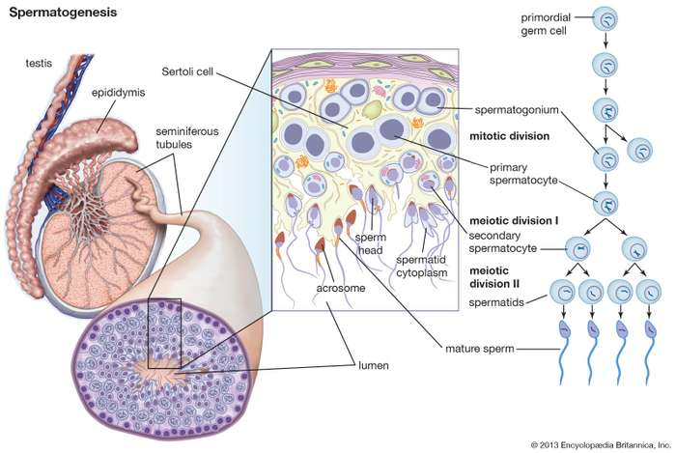

Sperm cells are continually being produced by the testes, but not all areas of the seminiferous tubules produce sperm cells at the same time. One immature germ cell takes as long as 74 days to reach final maturation, and during this growth process there are intermittent resting phases.
The immature cells (called spermatogonia) are all derived from cells called stem cells in the outer wall of the seminiferous tubules. The stem cells are composed almost entirely of nuclear material. (The nucleus of the cell is the portion containing the chromosomes.) The stem cells begin their process by multiplying in the process of cell duplication known as mitosis. Half of the new cells from this initial crop go on to become the future sperm cells, and the other half remain as stem cells so that there is a constant source of additional germ cells. Spermatogonia destined to develop into mature sperm cells are known as primary sperm cells. These move from the outer portion of the seminiferous tubule to a more central location and attach themselves around the Sertoli cells. The primary sperm cells then develop somewhat by increasing the amount of cytoplasm (substances outside of the nucleus) and structures called organelles within the cytoplasm. After a resting phase the primary cells divide into a form called a secondary sperm cell. During this cell division there is a splitting of the nuclear material. In the nucleus of the primary sperm cells there are 46 chromosomes; in each of the secondary sperm cells there are only 23 chromosomes, as there are in the egg. When the egg and sperm combine and their chromosomes unite, the characteristics of both individuals blend and the new organism starts to grow.
The secondary sperm cell still must mature before it can fertilize an egg; maturation entails certain changes in the shape and form of the sperm cell. The nuclear material becomes more condensed and oval in shape; this area develops as the head of the sperm. The head is covered partially by a cap, called the acrosome, which is important in helping the sperm to gain entry into the egg. Attached to the opposite end of the head is the tailpiece. The tail is derived from the secondary sperm cell’s cytoplasm. In the mature sperm, it consists of a long, slender bundle of filaments that propel the sperm by their undulating movement. Once the sperm has matured, it is transported through the long seminiferous tubules and stored in the epidymis of the testes until it is ready to leave the male body.

- SEMEN
The sperm in human beings is a highly specialised structure. Also called male gamete, several thousand of them are produced and contained in a fluid called semen before it is transfered to the female for the process of fertilization. A mature sperm (also called spermatozoa) consists of the following four parts –
I. Head:
The head is almost concial in shape and is formed of acrosome and nucleus.
Acrosome:
This is found at the anterior tip of the sperm (Gr.akron = extremity; soma = body). The acrosome forms a cap like structure called the head cap. This occupies the space between anterior half of the nucleus and the plasma membrane of the sperm tip. In its origin (during spermatogenesis), the acrosome is formed from the golig complex.
The acrosome itself is bounded by a unit membrane. It consists of a number of hydrolytic enzymes such as acid phosphatase, hyaluronidase and others. These enzymes help in tissue lysis (dissolving) and this facilitates the penetration of the sperm into the egg membrane. The enzymes are protolytic and help in dissolving the egg membrane.
Sperm nucleus:
The nucleus occupies most of the available space of the sperm head. It is the shape of the nucleus that ultimately decides the shape of the sperm head. Structurally it is enveloped by a nuclear membrane. Sometimes however the posterior part of nuclear membrane (towards the body of the sperm) is somewhat depressed to accommodate the proximal centriole. The nucleus consists of DNA as well as basic proteins. There is no nucleolus or any fluid contents.
2. Neck:
The head is followed by a short neck to separate the middle piece of the sperm. The neck consists of just two granules (centrioles). These granules are called the proximal centriole and the distal centriole. Both these granules are situated very close and lie in the posterior depression of the sperm neck. The two centrioles enter the egg at the time of fertilization along with the nucleus. These two centrioles are necessary to initiate division in the zygote.
It is known that the centrioles help the zygotic division by forming the first mitotic spindle. The posterior or the distal centriole is responsible for the formation of the microtubules of the sperm tail.
3. Middle piece:
The middle piece of the sperm consists of the upper portion of the axial filament and in its structure it has the same organisation as the axial filament of any flagellum. It has a pair of longitudinal fibres called beta fibres surrounded by a ring of nine pairs of longitudinal fibres called alpha fibres. In human sperms, the alpha fibres of axial filament are accompanied on the outside by 9, much thicker fibres called gamma fibres or coarse fibres. The alpha, beta and gamma fibres are the sites of various enzymes.
For instance alpha fibres have ATPase enzyme, while beta fibres have acetylchosuccinic dehydrogenese. These fibres are anchored to the distal centrioles. The fibres are surrounded by the mitochondria. Very often the mitochondria are fused together and form a spiral sheet that surrounds the axonemal fibres. Around the periphery of mid piece of the sperm is found a thin sheet of cytoplasm mainly composed of microtubules. This layer is called manchettee.
4. Tail:
The tail usually is the longest part in the sperm. In human beings it is about 55JJ. long. It consists of two main parts – the principal piece and the end piece. The principal piece which constitutes most of the length of tail consists of the central core made up of axial filaments with a 9+2 arrangement (2 central, 9 peripheral).
Surrounding this core is a fibrous tail sheath which often appears as semicircular ribs oriented at right angles to the long axis of the filament. Sometimes they appear as helical coils. In human beings two of the gamma fibres are fused with the surrounding ribs to form anterior and posterior columns extending throughout the length of the principle piece.
This arrangement divides the principal piece into two functional compartments – one having three gamma fibres and the other containing four. This symmetry is thought to help in a more powerful stroke of the tail in one direction. This is called the power stroke. The end piece is a small tapering portion of the tail containing only the axial filament covered with cytoplasm and plasma membrane. There is not stored food in the sperm. It also does not have cytoplasmic organelles such as ribosome’s and endoplasmic reticulum.

