COURSE: MCB 308
LECTURER: DR. CHINWE C. ISITUA

COMPONENTS OF AERIAL ENVIRONMENT

FUMUDOH SAMUEL
18/SCI17/006
APRIL 22, 2020

Abstract

We discuss the various components of atmosphere.

Table of contents

Page
- 4………………….…………………… Introduction
- 5………………….……. Fungal hyphal fragments
- 6……………………….…………… Fungal spores
- 7…….……………….…………… Bacterial spores
- 8…………...………..…… Spores of pteridophytes
- 9…………………........……………… Pollen grains
- 10…………………….…......….……. Dust particles
- 11………………….……………...... Actinomycetes
- 12………………..………………….... Water vapour
- 13………………………………...…. Water droplets
- 14……………….……………... Atmospheric gases
- 15……………….………………………. Conclusion
- 16……………….…………………….... References

Introduction

The atmosphere is comprised of several particles, microscopic, liquid, solid & gaseous, which have different effects on the biotic & abiotic environment.

Fungal hyphal fragments

Hyphal fragments or mycelia are components of fungal growth (similar to the roots and branches of a tree); it is common to find small hyphal fragments in outdoor air and possibly in indoor dust.
Hyphal fragments might be just one or two little bits or a rats nest of growing mycelia.
Hyphal fragments or hyphae may be colored (brown) or colorless as in our photograph below (mycologists report colorless spores or hyphae as hyaline)
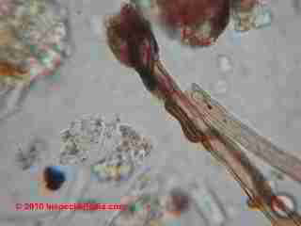 .Hyphal fragments

Mycelia: a mass of hyphae; the thallus of a fungus, this is the vegetative body portion of the organism, akin to the "root" structure of a plant, used to absorb nutrients.
Mycelia would not easily be visually identifiable as belonging to a specific species unless other components of the fungus are present. Particles of this material are probably allergenic.
Mycelial cord, a discrete filamentous aggregation of hyphae which, in contrast to a rhizomorph, has no apical meristem.
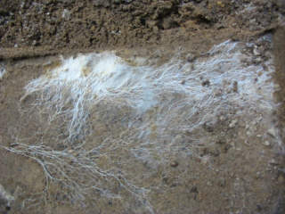 .Fungal mycelium

Some fungi hyphal fragments may be allergenic or may even contain mycotoxins (fungal material may be harmless-cosmetic, allergenic, toxic, or pathogenic, depending on the genera/species and on its growth conditions).
The hyphal fragments or pieces found in air or dust samples are usually quite large and not likely to be inhaled deeply into the lungs. So mold hyphal fragments are less of an airborne risk to building occupants than say a high level of airborne toxic or allergenic mold spores such as Aspergillus sp.

Fungal spores

Fungal spores are microscopic biological particles that allow fungi to be reproduced, serving a similar purpose to that of seeds in the plant world.

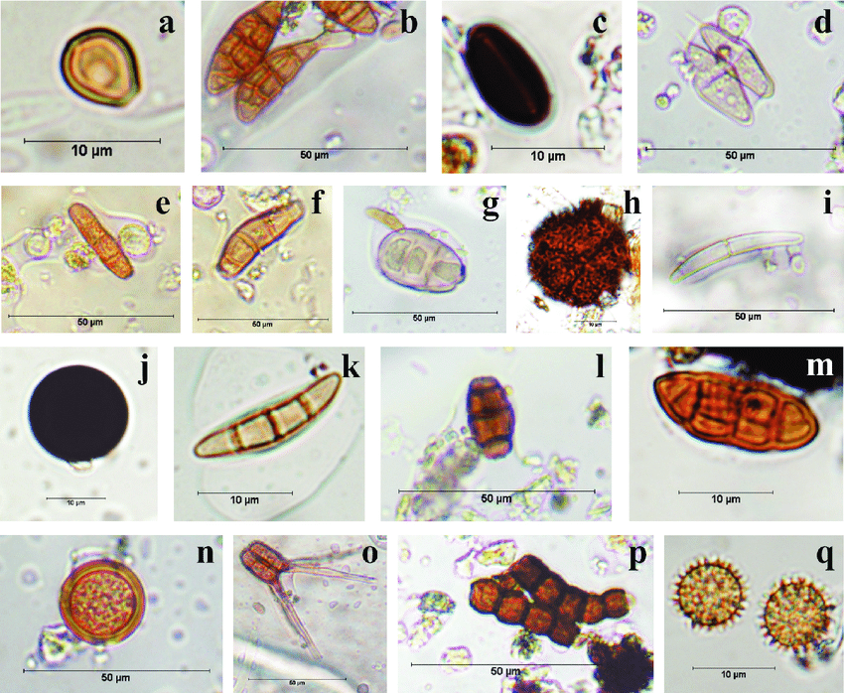 Types of fungal spores

Fungi reproduce by spores, which are produced by either sexual or asexual methods, and the majority of fungal spores are adapted for airborne dispersal. Spores may originate from fungal saprobes, pathogens, or symbionts. Fungi growing on living plants and on plant debris in the soil are important contributors to the air spora. Spore levels can be especially high during harvesting, under certain meteorological conditions, as well as in contaminated indoor environments.
Fungal spores can impact human health as triggers of allergic reactions or as the cause of infectious disease. Although many fungal spores are allergenic, only a limited number of species are considered human pathogens.

Bacterial spores

Bacterial spores are highly resistant, dormant structures (i.e. no metabolic activity) formed in response to adverse environmental conditions. They help in the survival of the organisms during adverse environmental conditions; they do not have a role in reproduction.
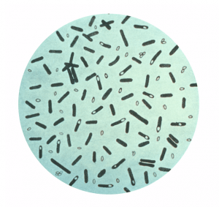Spore of clostridium

Spores of Pteridophytes

Pteridophytic spores, similarly to pollen grains and fungal spores, are components of biological aerosol (aeroplankton) contained in the air
Pteridophyta (pteridophytes) a division of the plant kingdom, comprising the vascular cryptogams. They are flowerless plants exhibiting an alternation of 2 distinct and dissimilar generations. The first is a non-sexual, spore-bearing, sporophyte generation. It usually appears as a relatively large plant, with stems containing vascular tissue that conducts water and dissolved solutes through the plant, and usually bears the leaves and roots. Spores are produced in sporangia that are either attached to the leaves (as in ferns) or are on specialized scales grouped into cones (as in horsetails and club-mosses), or in the axils of leaves on unspecialized stems (as in Psilotaceae and some clubmosses). The second is a sexual, gametophyte generation, in which the plants generally are relatively small, and without differentiation of stem, leaves, or roots. These plants bear male (antheridia) and female (archegonia) sex organs, together or on separate plants. When the eggs in the archegonia are fertilized by sperms from the antheridia, an embryo results: this can grow into a new sporophyte generation. The cells of the sexual, gametophyte generation each contain a single chromosome set in their nuclei (the haploid condition). Those of the sporophyte generation each contain a double chromosome set (the diploid condition), reduced to a single set in the spores. The Pteridophyta, in the wide sense as it is usually understood, includes the classes Lycopsida (families Lycopodiaceae, Selaginellaceae, and Isoetaceae), Sphenopsida (or Arthropsida; family Equisetaceae), Psilopsida (family Psilotaceae), and Filicopsida (the various families of ferns). They first enter the fossil record in the Silurian.
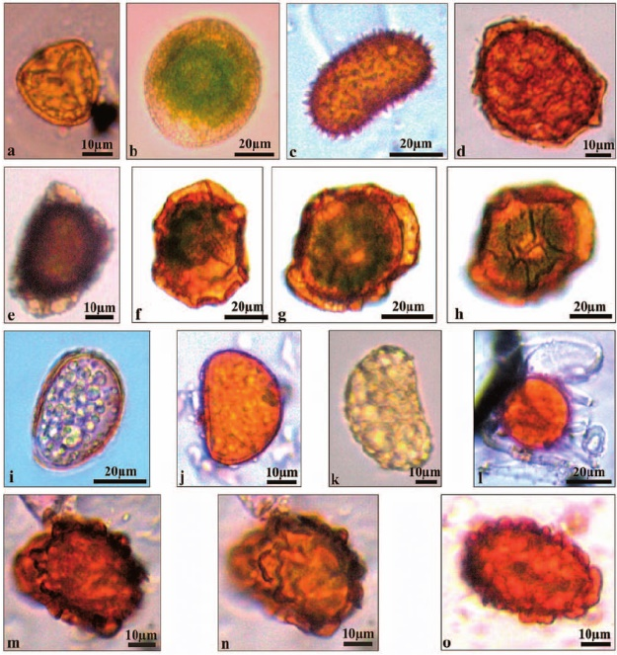 .Spores of Pteridophtyes
Pollen grains

Pollination sends millions of tiny pollen grains through the air, many of which end up in our nose. Pollen grains represent the male portion of the reproductive process in plants and trees. These tiny bodies are swirling in the air and on the legs of insects so that they can join the female part of the plant to create a new seed. This important process is known as fertilization. As we will discover, pollen plays a crucial role in the plant world.
Pollen grains are microscopic structures that vary in size and shape. Some are tiny orbs, while others are egg-shaped. Although too small to see individually, they can be seen by the naked eye in large quantities.
Viewed through a microscope, a pollen grain hardly looks real. An extremely durable body, it has a tough outer coating. This hardy coat offers great protection from the harsh outdoor environment. This is important because inside this tough shell lie two cells: the tube cell, which will eventually become the pollen tube, and a generative cell, which contains the male sperm nuclei needed for fertilization. There are three main components of a pollen grain. The inside of the grain is made up of cytoplasm. This fluid medium houses the aforementioned living cells, keeping them moist and alive. The outer shell is made up of two layers. The inside layer is aptly named the intine (think interior). It is composed partly of cellulose, a common component in the cell walls of plant cells. The tough-as-nails outer layer is known as the exine (exterior). This highly sophisticated and complex outer layer is rich in a compound known as sporopollenin. Waterproof, resistant to deterioration and very stiff, this shell is basically one of nature's most advanced polymers. It ensures that the tender cells inside have a strong chance of survival.

In addition, often times the exine has folds, creases and spikes rising from its surface. Like extra armor, these features add to the protective nature of this layer. They also play an important role in the mobility of the grains, making it more likely that they will stick to the legs of insects as well as catch the wind.
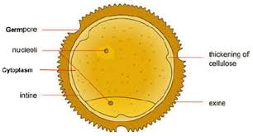 .Pollen grain

Dust particles

Dust is made of fine particles of solid matter. On Earth, it generally consists of particles in the atmosphere that come from various sources such as soil, dust lifted by wind, volcanic eruptions, and pollution. Dust in homes, offices, and other human environments contains small amounts of plant pollen, human and animal hairs, textile fibers, paper fibers, minerals from outdoor soil, human skin cells, burnt meteorite particles, and many other materials which may be found in the local environment.
House dust mites are present indoors wherever humans live. Positive tests for dust mite allergies are extremely common among people with asthma. Dust mites are microscopic arachnids whose primary food is dead human skin cells, but they do not live on living people. They and their feces and other allergens which they produce are major constituents of house dust, but because they are so heavy they are not suspended for long in the air. They are generally found on the floor and other surfaces until disturbed (by walking, for example). It could take somewhere between twenty minutes and two hours for dust mites to settle back down out of the air.
Dust mites are a nesting species that prefers a dark, warm, and humid climate. They flourish in mattresses, bedding, upholstered furniture, and carpets. Their feces include enzymes that are released upon contact with a moist surface, which can happen when a person inhales, and these enzymes can kill cells within the human body. House dust mites did not become a problem until humans began to use textiles, such as western style blankets and clothing.
Atmospheric or wind-borne fugitive dust, also known as aeolian dust, comes from arid and dry regions where high velocity winds are able to remove mostly silt-sized material, deflating susceptible surfaces. This includes areas where grazing, ploughing, vehicle use, and other human activities have further destabilized the land, though not all source areas have been largely affected by anthropogenic impacts. One-third of the global land area is covered by dust-producing surfaces, made up of hyper-arid regions like the Sahara which covers 0.9 billion hectares, and drylands which occupy 5.2 billion hectares.
Dust in the atmosphere is produced by saltation and sandblasting of sand-sized grains, and it is transported through the troposphere. This airborne dust is considered an aerosol and once in the atmosphere, it can produce strong local radiative forcing.

Actinomycete spore

Actinomycetes are a diverse group of gram-positive bacteria. They resemble fungi because they are adapted to life on solid surfaces and they can produce mycelium and dry spores like most fungi. Actinomycete spores are known to be important air contaminants in occupational environments, such as agriculture and waste composting facilities, and have recently gained special attention as indicators of mold problems in buildings. They do not belong to the normal microbial flora in indoor air but have been found in buildings suffering from moisture and mold problems. In addition, airborne spores of several actinomycete species (e.g., Saccharopolyspora rectivirgula, Micropolyspora faeni, Thermoactinomyces vulgaris, and Streptomyces albus) have been related to the incidence of allergic alveolitis and other severe health effects.
Actinomycete spores are formed either by subdivision of existing hyphae by fragmentation or swelling or by endogenous spore formation. The hyphae that subdivide into spores can be sheathless or have a sheath, which partly remains in the spores after fragmentation. This leads to three main spore types: arthrospores (subdivision of sheathed hypha), aleuriospores (subdivision of sheathless hypha), and endospores. In nature, actinomycete spores can become airborne by mechanical disturbance of the substance they are growing on.
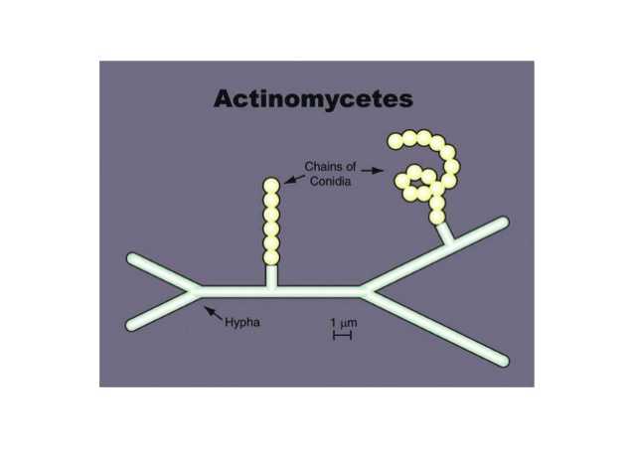 .Actinomycetes spore
Water vapour

Water vapor is one of the most important atmospheric trace gases. It plays a central role in defining the unique chemical, dynamical, and radiative properties of the Earth's atmosphere. It is also a critical component of Earth's climate system. Water vapor absorbs throughout the infrared (IR) region of the electromagnetic spectrum and as a result is the dominant greenhouse gas. Furthermore, because it can condense into both liquid and solid phases, it is the critical element for aerosol and cloud formation, even at stratospheric altitudes.
Water evaporates from the Earth's surface and rises on warm updrafts into the atmosphere. It condenses into clouds, is blown by the wind, and then falls back to the Earth as rain or snow. This cycle is one important way that heat and energy are transferred from the surface of the Earth to the atmosphere, and transported from one place to another on our planet. Heat radiated from Earth's surface is absorbed by water vapor molecules in the lower atmosphere. The water vapor molecules, in turn, radiate heat in all directions. Some of the heat returns to the Earth's surface. Thus, water vapor is a second source of warmth (in addition to sunlight) at the Earth's surface.

Droplets

These are aerosols which can be generated from living (respiratory fluid) or non-living (drilling of rocks).
Droplets can remain airborne depending on their sizes, large droplets like respiratory fluids (10¹-10²µm) are easily pulled to the ground by gravity unlike the aerosolized droplets (<10µm) which can travel over long distances.

Atmospheric gases

There are a number of atmospheric gases which make up air. The main gases are nitrogen and oxygen, which make up 78% and 21% of the volume of air respectively. Oxygen is utilised primarily by animals, including humans, but also to a small degree by plants, in the process of respiration (the metabolism of food products to generate energy).
The remaining 1% of the atmospheric gases is made up of trace gases. These include the noble gases, very inert or unreactive gases, of which the most abundant is argon. Other noble gases include neon, helium, krypton and xenon. Hydrogen is also present in trace quantities in the atmosphere, but because it is so light, over time much of it has escaped Earth's gravitational pull to space.
The remaining trace gases include the greenhouse gases, carbon dioxide, methane, nitrous oxide, water vapour and ozone, so-called because they are involved in the Earth natural greenhouse effect which keeps the planet warmer than it would be without an atmosphere.

Conclusion

Some of these aerial components also play an important role in climate conditions through the effects of greenhouse gases.

References

http://www.enviropedia.org.uk/Atmosphere/Atmospheric_Gases.php
https://www.nature.com/articles/s41598-019-38825-y
https://www.sciencedirect.com/topics/earth-and-planetary-sciences/water-vapor
https://earthobservatory.nasa.gov/global-maps/MYDAL2_M_SKY_WV
https://www.ncbi.nlm.nih.gov/pmc/articles/PMC106555/
https://en.wikipedia.org/wiki/Dust
https://study.com/academy/lesson/pollen-grain-definition-structure-function.html
https://www.encyclopedia.com/plants-and-animals/botany/botany-general/pteridophyta
https://inspectapedia.com/mold/Mold_Hyphal_Fragments.php
https://www.sciencedirect.com/topics/agricultural-and-biological-sciences/fungal-spores
https://microbeonline.com/bacterial-spores-structure-importance-and-examples-of-spore-forming-bacteria/

