- Discuss the Anatomy of the tongue and comment on its applied anatomy
ANSWER
OVERVIEW
The tongue is a pink, muscular organ located within the oral cavity proper. It is kept moist by the products of the major and minor salivary glands, which aids the organ as it facilitates deglutition, speech, and gustatory perception. While there is significant variability in the length of the tongue among individuals, on average, the organ is approximately 10 cm long. The tongue possesses three main parts:
- The Tip: The tip or apex of the tongue is the most anterior and most mobile aspect of the organ.
- The Body: The tip is followed by the body of the tongue. It has a rough superior (dorsal) surface that abuts the palate and is populated with taste buds and lingual papillae, and a smooth inferior (ventral) surface that is attached to the floor of the oral cavity by the lingual frenulum.
- The Base: The base of the tongue is the most posterior part of the organ. It is populated by numerous lymphoid aggregates known as the lingual tonsils along with foliate papillae along the posterolateral surface.

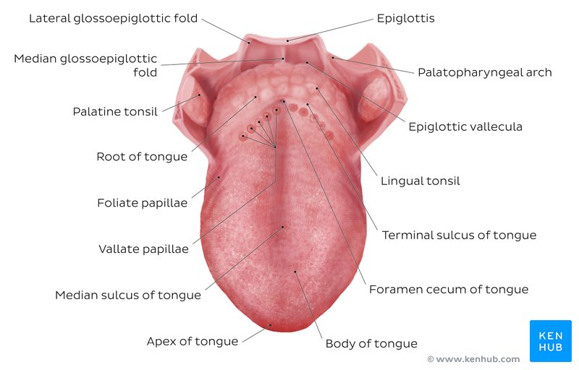

There are numerous important structures surrounding the tongue. It is limited anteriorly and laterally by the upper and lower rows of teeth. Superiorly, it is bordered by the hard (anterior part) and soft (posterior part) palates. Inferiorly, the root of the tongue is continuous with the mucosa of the floor of the oral cavity; with the sublingual salivary glands and vascular bundles being located below the mucosa of the floor of the oral cavity.

STRUCTURE
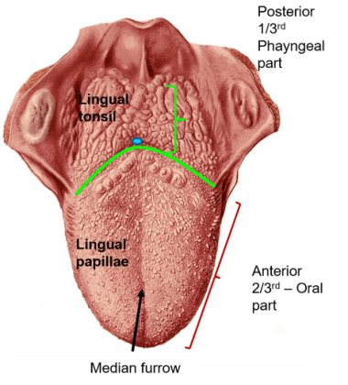
The human tongue is divided into anterior and posterior parts by the terminal sulcus which is a V-shaped groove.

Anterior two-thirds: The presulcal tongue includes the apex and body of the organ. It terminates at the sulcus terminalis; which can be seen extending laterally in an oblique direction from the foramen cecum towards the palatoglossal arch. The mucosa of the dorsal surface of the oral tongue is made up of circumvallate, filiform, and fungiform papillae. There is also a longitudinal midline groove running in an anteroposterior direction from the tip of the tongue to the foramen cecum. This marks the embryological point of fusion of the lateral lingual swellings that formed the oral tongue. It also represents the location of the median lingual (fibrous) septum of the tongue that inserts in the body of the hyoid bone.

On the lateral surface of the oral tongue are foliate papillae arranged as a series of vertical folds. The ventral mucosa of the oral tongue is comparatively unremarkable. It is smooth and continuous with the mucosa of the floor of the mouth and the inferior gingiva. The lingual veins are relatively superficial and can be appreciated on either side of the lingual frenulum. Lateral to the lingual veins are pleated folds of mucosa known as the plica fimbriata. They are angled anteromedially toward the apex of the tongue.

Posterior third: The remainder of the tongue that lies posterior to the sulcus terminalis is made up by the base of the organ. It lies behind the palatoglossal folds and functions as the anterior wall of the oropharynx. Unlike the oral tongue, the pharyngeal tongue does not have any lingual papillae. Instead, its mucosa is populated by aggregates of lymphatic tissue known as the lingual tonsils. The mucosa is also continuous with the mucosa of the laterally located palatine tonsils, the lateral oropharyngeal walls, and the posterior epiglottis and glossoepiglottic folds.
MUSCLES
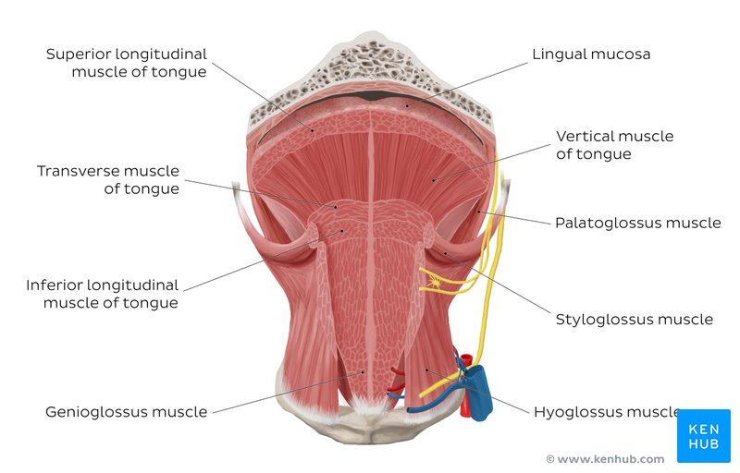
The tongue is chiefly a muscular organ with some amount of fatty and fibrous tissue distributed throughout its substance. All the muscles of the tongue are paired structures, with each copy being found on either side of the median fibrous septum. There are muscles that extend outside of the organ to anchor it to surrounding bony structures, known as extrinsic muscles. The other set of muscles are confined to each half of the organ and contribute to altering the shape of the organ; these are the intrinsic muscles.
Intrinsic Muscles
The intrinsic muscles are as follows:
- Superior longitudinal muscle
- Origin - submucosa of posterior tongue, lingual septum
- Insertion - apex/anterolateral margins of tongue
- Innervation - hypoglossal nerve (CN XII)
- Blood supply - lingual branch of external carotid artery
- Action - retracts and broadens tongue, elevates apex of tongue

- Inferior longitudinal muscle
- Origin – root of tongue, body of hyoid bone.
- Insertion – apex of tongue
- Innervation - hypoglossal nerve (CN XII)
- Blood supply - lingual branch of external carotid artery
- Action- retracts and broadens the tongue, lowers the apex of the tongue

- Transverse muscle
- Origin- lingual septum
- Insertion - lateral margin of the tongue
- Innervation - hypoglossal nerve (CN XII)
- Blood supply - lingual branch of external carotid artery
- Action – narrows and elongates the tongue

- Vertical muscle
- Origin - root of the tongue, genioglossus muscle
- Insertion - lingual aponeurosis
- Innervation - hypoglossal nerve (CN XII)
- Blood supply - lingual branch of external carotid artery
- Action - lengthens and broadens the tongue

Extrinsic Muscles
The extrinsic muscles are as follows:
- Genioglossus
- Origin - Arises from the mandibular symphsis.
- Insertion - body of the hyoid bone and the entire length of the tongue.
- Action - Inferior fibres protrude the tongue, middle fibres depress the tongue, and superior fibres draw the tip back and down
- Innervation - Motor innervation via the hypoglossal nerve (CNXII).

- Hyoglossus
- Origin - Arises from the hyoid bone
- Insertion - inserts into the side of the tongue
- Action - Depresses and retracts the tongue
- Innervation - Motor innervation via the hypoglossal nerve (CNXII).

- Styloglossus
- Origin - Originates at the styloid process of the temporal bone
- Insertion - inserts into the side of the tongue
- Action - Retracts and elevates the tongue
- Innervation - Motor innervation via the hypoglossal nerve (CNXII).
- Palatoglossus
- Origin - Arises from the palatine aponeurosis
- Insertion - inserts broadly across the tongue
- Action - Elevates the posterior aspect of the tongue
- Innervation - Motor innervation via the vagus nerve (CNX).

BLOOD SUPPLY AND INNERVATION

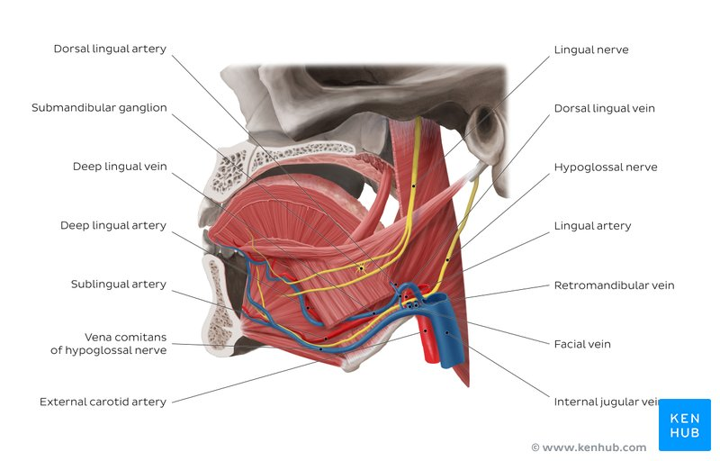

ARTERIAL SUPPLY
The vascular supply to the tongue muscles is provided by derivatives of the lingual artery. This is a branch of the external carotid artery that traverses the region between the middle pharyngeal constrictor and hyoglossus in order to access the floor of the mouth.The named branches of the lingual artery are as follows:
- The dorsal lingual arteries are relatively small derivatives of the lingual artery that arise medial to hyoglossus. In addition to supplying the dorsal mucosa of the tongue, it also gives branches to the palatoglossus, soft palate, palatine tonsils, and epiglottis.
- Emerging at the anterior limit of the hyoglossus, the sublingual arteries course between the mylohyoid and genioglossus as it travels towards the sublingual glands in the floor of the oral cavity. As it arborizes, one of its branches anastomoses with the submental branches of the facial artery, while another traverses the gingiva of the mandible to anastomose with the analogous contralateral vessel.
- As the lingual artery terminates near the lingual frenulum on the ventral surface of the tongue, it is referred to as the deep lingual artery.
The lingual artery is supported by other branches of the external carotid artery. The facial artery gives off the ascending palatine and tonsillar arteries that also supply the tongue. The ascending pharyngeal branch of the external carotid artery also supplies the organ.

VENOUS DRAINAGE

The veins of the tongue are named similarly to the arteries that they accompany. They are formed from numerous venous tributaries that eventually coalesce. As the deep lingual vein forms adjacent to the apex of the tongue, it courses along the ventral surface of the tongue (deep to the mucosa). As the deep lingual vein anastomosis with the sublingual vein, they become the vena comitans of CN XII. This venous network eventually drains to the lingual vein that later join the facial or the anterior division of the retromandibular veins. Here, they form the common facial vein, which is a tributary to the internal jugular vein. Alternatively, the venae comitantes may drain directly to the internal jugular vein.
The dorsal lingual veins are responsible for draining the lateral margins and dorsal surface of the tongue. They travel alongside the similarly named artery as they drain into the internal jugular vein.
INNERVATION
The nerve supply to the tongue can be grouped based as efferent fibers that carry motor impulses, general sensory that conveys touch and proprioception, and special afferent that conveys gustatory impulses.
In the anterior 2/3, general sensation is supplied by the trigeminal nerve (CNV). Specifically the lingual nerve, a branch of the mandibular nerve (CN V3).
On the other hand, taste in the anterior 2/3 is supplied from the facial nerve (CNVII). In the petrous part of the temporal bone, the facial nerve gives off three branches, one of which is chorda tympani. This travels through the middle ear, and continues on to the tongue.
The posterior 1/3 of the tongue is slightly easier. Both touch and taste are supplied by the glossopharyngeal nerve (CNIX).
LYMPHATIC DRAINAGE
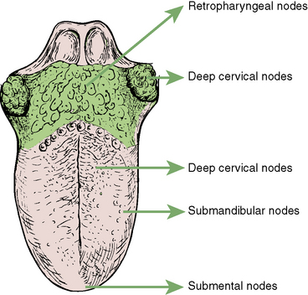
The marginal and central groups drain the anterior parts of the tongue, while the dorsal group drains lymph from the posterior third of the organ.
The marginal lymph vessels will carry lymph to the submandibular nodes or to the jugulo-omohyoid nodes. The vessels from the central region may go to the deep cervical nodes, with a particular preference for the jugulo-omohyoid or jugulodigastric nodes. The dorsal group of vessels also pass laterally on either side to eventually join the marginal vessels in their course to the jugulo-omohyoid and jugulodigastric vessels.
CLINICAL ANATOMY
- Ankyloglossia (Tongue-tie)
Ankyloglossia, also known as tongue-tie, is a congenital oral anomaly that may decrease the mobility of the tongue tip and is caused by an unusually short, thick lingual frenulum, a membrane connecting the underside of the tongue to the floor of the mouth.
- Glossitis
Glossitis refers to inflammation of the tongue. The condition causes the tongue to swell in size, change in color, and develop a different appearance on the surface. Glossitis may cause the small bumps on the surface of the tongue (papillae) to disappear. Severe tongue inflammation that results in swelling and redness can cause pain and may change the way you eat or speak.
- Glossoptosis
Glossoptosis is a medical condition and abnormality which involves the downward displacement or retraction of the tongue. It may cause non-fusion of the hard palate, causing cleft palate. It is one of the features of Pierre Robin sequence and Down syndrome.

- Write an essay on the air sinuses
ANSWER
The paranasal sinuses are air-filled extensions of the respiratory part of the nasal cavity. The paranasal sinuses are air cavities that help circulate the air that is breathed in and out of the respiratory system. They may contribute to the humidifying of inspired air. They also reduce the weight of the skull. Sinuses are formed in childhood by the nasal cavity eroding into surrounding bone. As they are outgrowths of the nasal cavity, they all drain back into it – openings to the paranasal sinuses are found on the roof and lateral walls of the nasal cavity. The inner surface is lined by a respiratory mucosa. They are situated around the nasal cavity and they are all paired and sometimes symmetrical, while always being bilateral. There are four paired sinuses, named according to the bone in which they are located.

They are as follows;
- maxillary sinuses
- frontal sinuses
- sphenoidal sinuses
- ethmoidal sinuses
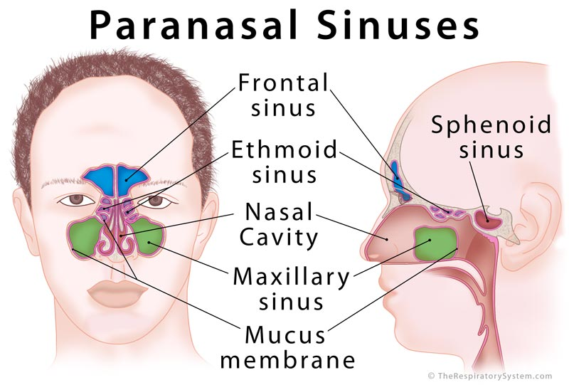
ANATOMY OF THE AIR SINUSES
- MAXILLARY SINUSES
The maxillary sinuses are the largest of the all the paranasal sinuses. They have thin walls which are often penetrated by the long roots of the posterior maxillary teeth. The superior border of this sinus is the bony orbit, the inferior is the maxillary alveolar bone and corresponding tooth roots, the medial border is made up of the nasal cavity and the lateral and anterior border are limited by the cheekbones. Posteriorly, two anatomical spaces known as the pterygopalatine fossa and the infratemporal fossa exist.
It drains into the nasal cavity at the hiatus semilunaris, underneath the frontal sinus opening. This is a potential pathway for spread of infection – fluid draining from the frontal sinus can enter the maxillary sinus.

Vascularization, innervation and lymphatic drainage
The submandibular lymph nodes are the main destination during lymphatic drainage. The blood supply includes a contribution from the:
- anterior superior alveolar artery
- middle superior artery
- posterior superior alveolar artery
Innervation occurs through nerves of the same names as the arteries. However, these nerves are branches of the maxillary nerve.
- FRONTAL SINUSES
Anteriorly, the frontal sinuses are contained by the forehead and the superciliary arches, superiorly and posteriorly by the anterior cranial fossa and inferiorly by the bony orbit, the anterior ethmoidal sinuses and the nasal cavity. Medially the sinuses face one another, separated by the midline. This pair of sinuses are irregular in shape when compared to one another and is underdeveloped at birth. They reach their full size and shape around seven to eight years of age.
They drain into the nasal cavity via the frontonasal duct, which opens out at the hiatus semilunaris on the lateral wall.

Vascularization, innervation and lymphatic drainage

They drain primarily into the ethmoidal infundibulum and the corresponding lymph drainage occurs via the submandibular lymph nodes. It is innervated by the ophthalmic nerve, including the supraorbital and supratrochlear branches.
The frontal sinuses are supplied by the:
- anterior ethmoidal artery
- supraorbital artery
- supratrochlear artery
- SPHENOIDAL SINUSES
The most posterior of all the sinuses in the head, the sphenoidal sinuses are large and irregular, just like their septum, which is made by the sphenoid bone. Laterally, a cavernous sinus exists which is part of the middle cranial fossa and also the carotid artery and cranial nerves III (Oculomotor nerve), IV (Trochlear nerve), V/I (Ophthalmic nerve), V/II (Maxillary nerve) and VI (Abducens nerve) can be found.
The anterior wall separates this pair of sinuses from the nasal cavity, as does the hypophyseal fossa, the pituitary gland and the optic chiasm superiorly and the nasopharynx and pterygoid canal inferiorly.
The relationships of this sinus are of clinical importance because the pituitary gland can be surgically accessed via passing through the nasal roof, into the sphenoid sinus and through the sphenoid bone.

Vascularization, innervation and lymphatics
The lymphatic drainage occurs in the same way as the posterior ethmoid sinus. The posterior ethmoidal artery and the posterior lateral nasal branches supply the sphenoidal sinuses.
The posterior ethmoidal nerve and the orbital branch of the pterygopalatine ganglion innervate them.
- ETHMOIDAL SINUSES
Superior to the ethmoidal sinus is the anterior cranial fossa and the frontal bone, laterally the orbit can be found, while the nasal cavity is situated medially. The ethmoid sinuses are unique because they are the only paranasal sinuses that are more complex than just a single cavity.
On each side of the midline, anywhere from three to eighteen ethmoidal air cells may be grouped together. These air cells are smaller individual sinuses grouped together to form one large one which encompass the anterior, middle and posterior nasal meatuses.

Vascularization, innervation and lymphatics
The anterior and middle ethmoid sinuses send their lymphatic drainage to the submandibular lymph nodes while the posterior ethmoid sinus sends its own to the retropharyngeal lymph nodes.
The anterior and posterior ethmoidal arteries, as well as the posterior lateral nasal branches provide an ample blood supply to this region. Meanwhile the anterior and posterior ethmoidal nerves and the posterior lateral superior and inferior nasal nerves help innervate it.
CLINICAL ANATOMY
- Sinusitis
Sinusitis is an inflammation or swelling of the tissue lining the sinuses. Healthy sinuses are filled with air. But when they become blocked and filled with fluid, germs can grow and cause an infection. Conditions that can cause sinus blockage include: The common cold.

