NAME: Bob-Manuel, Jaeingor Mia
MATRIC NO: 18/LAW01/058
COURSE CODE: AFE 202
DATE: 27/04/2020

Business Plan for the production and supply of bananas at Ota Farm, Ogun State, Nigeria.
OTANAS (Ota Bananas)

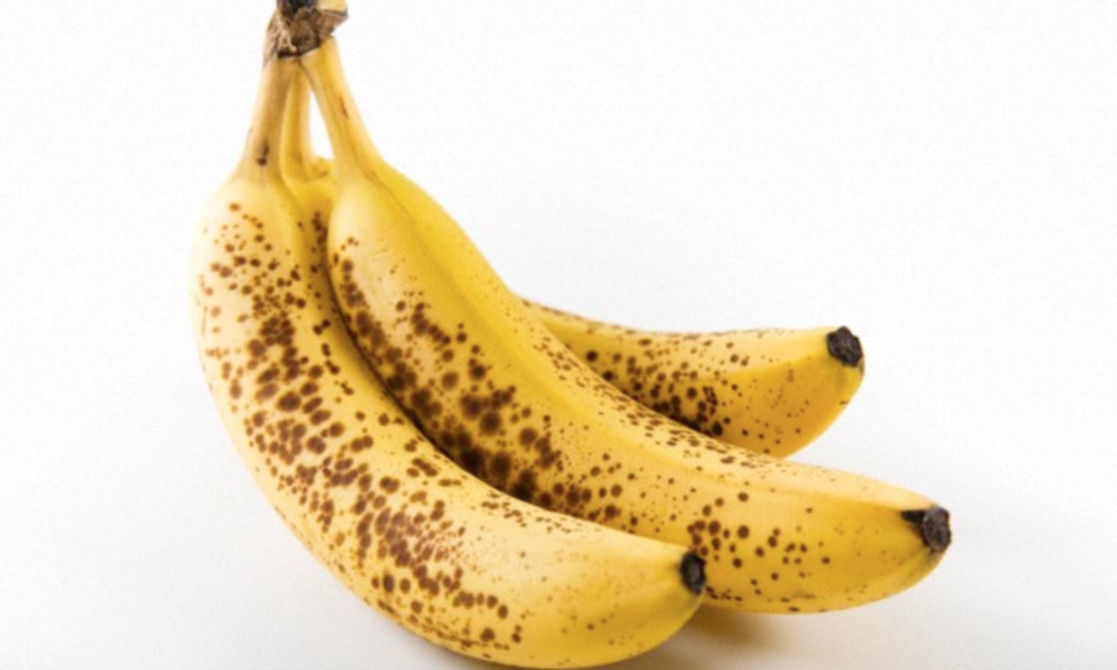

Table of Contents
- Business Description
- Introduction of bananas (benefits, producers, statistics)
- Marketing strategy
- Competition
- Operating procedures

About the business
The Ota farm owned by the former president Olusegun Obasanjo is one of the largest farms in Nigeria boasting of a variety of poultry, livestock and food products. The farm provides employment for thousands of indigenes of Ogun State. School students are also able to embark on excursions to the farm. Tax paid by the farm to the government also makes up over 20% of revenue generated by the state’s government. The main aim of this organization is to provide food and maximize profit.
The farm is said to generate a sum of N34,000,000 every day. However, that amount can be increased simply by introducing new produce to the mix. The farm is known for its largescale production of a variety of poultry, eggs, livestock and food produce such as cocoa etc.

According to Wikipedia, a banana is an elongated, edible fruit – botanically a berry – produced by several kinds of large herbaceous flowering plants in the genus Musa. In some countries, bananas used for cooking may be called "plantains", distinguishing them from dessert bananas.
Banana is the fruit cultivated around the world, the fruit famous and used widely as part of the food. Banana is healthy and tasty, hundreds of types of Bananas found with different taste, size and colours. Usually, Bananas cultivated and sold locally as it no longer stays fresh. The total world production of banana is over 145 million tonnes as per statistics 2013.
India is the largest producer of Bananas with around 30 million tonnes of production annually, most bananas cultivated in south Indian states and exports to other states of the country. China, the Philippines and Ecuador are the next largest Bananas producers. The production of banana increasing every year since its demand growing, many countries importing quality banana. Banana is the largest cultivated fruits and fourth-largest cultivated food after Rice, Wheat and Maize. Ecuador, Costa Rica and Colombia are the largest exporters of bananas, it exports around 17 million tonnes of banana annually.

Rank | Country | Production (in Tonnes) | Production Value
1 | India | 29,666,973 | $8,355,139,000
2 | Uganda | 12,000,000 | $3,107,962,000
3 | China, mainland | 10,400,000 | $2,928,962,000
4 | Philippines | 9,165,043 | $2,323,044,000
5 | Ecuador | 7,427,776 | $2,091,891,000
6 | Brazil | 7,329,471 | $2,064,206,000
7 | Indonesia | 6,132,695 | $1,727,157,000
8 | United Republic of Tanzania | 3,143,835 | $885,401,000
9 | Angola | 2,646,073 | $745,216,000
10 | Guatemala | 2,679,934 | $726,589,000
11 | Mexico | 2,138,687 | $602,320,000
12 | Costa Rica | 1,937,122 | $531,472,000
13 | Burundi | 1,848,727 | $520,658,000
14 | Colombia | 2,042,925 | $517,685,000
15 | Thailand | 1,600,000 | $450,609,000
16 | Viet Nam | 1,523,428 | $429,044,000
17 | Cameroon | 1,394,675 | $392,783,000
18 | Kenya | 1,197,988 | $337,390,000
19 | Egypt | 1,054,243 | $296,907,000
20 | Papua New Guinea | 1,000,000 | $253,467,000
21 | Dominican Republic | 829,827 | $233,705,000

Bananas are produced mainly in temperate regions and Nigeria is perhaps one of the most temperate regions in the world as the country is very tropical in nature. It is the most largely consumed fruit in the world and so, it is always in demand.
Since we intend to be the top producers of the fruit, we must produce the best kind which is the yellow and spotted species. The fruit is in demand because of its taste as well as its health benefits which include:
Health benefits of bananas
​​1. ​Bananas are one of the best fruit sources of vitamin B6​
Vitamin B6 from bananas is easily absorbed by your body and a medium-sized banana can provide about a quarter of your daily vitamin B6 needs.

Vitamin B6 helps your body:

produce red blood cells,
metabolise carbohydrates and fats, turning them into energy,
metabolise amino acids,
remove unwanted chemicals from your liver and kidneys, and
maintain a healthy nervous system.
Vitamin B6 is also good for pregnant women as it helps meet their baby’s development needs.

2. Bananas are respectable sources of vitamin C
You may not associate bananas with vitamin C but a medium-sized banana will provide about 10% of your daily vitamin C needs.

Vitamin C helps:

protect your body against cell and tissue damage,
your body absorb iron better,
your body produce collagen - the protein which holds your skin, bones and body together, and
support brain health by producing serotonin, a hormone that affects our sleep cycle, moods, and experiences of stress a​nd pain.
3. Manganese in bananas is good for your skin
One medium-sized banana provides approximately 13% of your daily manganese needs. Manganese helps your body make collagen and protects your skin and other cells against free radical damage.

4. Potassium in bananas is good for your heart health and blood pressure
A medium-sized banana will provide around 320-400 mg of potassium, which meets about 10% of your daily potassium needs.

Potassium helps your body maintain a healthy heart and blood pressure. In addition, bananas are low in sodium. The low sodium and high potassium combination helps to control high blood pressure.

5. Bananas can aid digestion and help beat gastrointestinal issues
A medium banana will provide about 10-12% of your daily fiber needs. Singapore’s Health Promotion Board recommends a daily dietary fiber intake of 20g for women and 26g for men.

Soluble and insoluble fibers play an important role in your health. Soluble fiber helps your body control your blood sugar level and get rid of fatty substances such as cholesterol. Insoluble fiber adds weight and softness to stools, making it easier for you to have regular bowel movements. This helps to keep your gut healthy and safe from harmful bacteria.

Bananas, especially newly-ripened ones, contain starch that does not digest (resistant starch) in your small intestine and is able to pass into the large intestine. Such bananas help you manage your weight better as you stay full for longer.

That said, bananas can help you beat gastrointestinal issues such as:

constipation,
stomach ulcers, and
heartburn
6. Bananas give you energy – minus the fats and cholesterol​
Bananas contain three natural sugars – sucrose, fructose and glucose – giving you a fat and cholesterol-free source of energy. As such, bananas are ideal, especially for children and athletes, for breakfast, as a midday snack or before and after sports.

The first step in marketing would be to come up with a catchy name. Thus, “OTANAS” and also making use of eco-friendly packaging since the world is going green. Catchy commercials showing the benefits of otanas over regular bananas and its affordability.

COMPETITION
- Artificially ripened bananas: these bananas are sprayed with chemicals and are forced to ripen. The chemicals have proven to be cancerous in nature however, these bananas are in high supply and are accessible to most Nigerians as store bought bananas are more expensive and smaller in quantity.
- Imported bananas: these are often from countries such as Cameroon and Uganda. They are yellow throughout and are often found in supermarkets and are very expensive. They also contain preservatives so they can last for the duration of the journey to Nigeria.
- Farms already producing bananas on largescale in Nigeria.
OPERATING PROCEDURES
To create the best method of growing bananas, we must first outline and understand what bananas need to grow.
Banana plants like:

- Rich, dark, fertile soils.
- Lots of mulch and organic matter.
- Lot of nitrogen and potassium. (Chicken manure)
- Steady warmth, not too hot and not too cold. (Bananas are sensitive when it comes to temperatures...)
- Steady moisture, in the ground and in the air.
- The shelter of other bananas. That's the most overlooked aspect by home growers...

Ota farm (Ogun State) was basically built to encourage the growth and production of bananas. They require NPK fertilizer and pesticides only as they grow on their own. Thus, unskilled labor may be used.
Banana plants dislike:
- Strong winds.
- Extreme heat or cold.
- Being hungry or thirsty.
- Being alone and exposed.

