GROSS ANATOMY OF THE TONGUE
The tongue is a mass of muscle that is almost completely covered by a mucous membrane. It occupies most of the oral cavity and the oropharynx. It is known for its role in taste, but it also assists with mastication, deglutition, articulation and oral cleansing. Five cranial nerves contribute to the complex innervations of the multifunctional organ.
ANATOMY
Under normal circumstances, the tongue is a pink, muscular organ located within the oral cavity proper. It is kept moist by the products of the major and minor salivary glands that aid the organ as it facilitates deglutition and speech. While there is significant variability in the length of the tongue among individuals, the average length of the tongue is roughly 10cm long. The tongue is composed of three parts:
- The tip/apex of the tongue is the most anterior and most mobile part of the tongue.
- The body of the tongue, which follows directly after the tip, has a rough dorsal (superior) surface that lies adjacent to the palate and is populated with taste buds and lingual papillae, and a smooth ventral (inferior) surface that is attached to the floor of the oral cavity by the lingual frenulum.
- The base of the tongue is the most posterior part of the organ. It is populated by numerous lymphoid aggregates known as the lingual tonsils along with foliate papillae along the poster lateral surface.
ANTERIOR TWO THIRDS
Te presulcal tongue includes the apex and the body of the organ. It terminates at the sulcus terminalis, a V-shaped grove. The mucosa of the dorsal surface of the oral tongue is made up of circumvallate, filiform, and fungiform papillae. There is also a longitudinal midline groove running in an anteroposterior direction from the tip of the tongue to the foramen cecum(a region posterior to the sulcus terminalis).It represents the location of the median lingual septum of the tongue that inserts in the body of the hyoid bone. On the lateral side of the oral tongue are foate papillae arranged as a series of vertical folds. The lingual veins are relatively superficial and can be appreciated on either side of the lingual frenulum.
POSTERIOR THIRD
The remainder of the tongue that lies posterior to the sulcus terminalis is made up by the base of the organ. It lies behind the palatoglossal folds and functions as the anterior wall of the oropharynx. Unlike the oral tongue, the pharyngeal tongue does not have any lingual papillae. Instead, its mucosa is populated by aggregates of lymphatic tissue known as the lingual tonsil. The mucosa is also continuous with the mucosa of the laterally placed palatine tonsils, the lateral oropharyngeal walls, and the posterior epiglottis and glossoepiglottic folds.
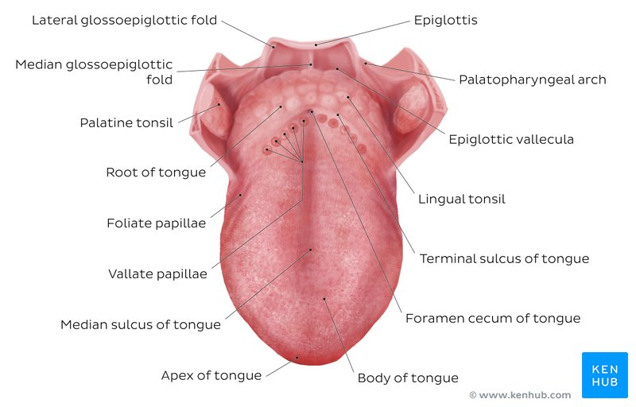
MUSCLES OF THE TONGUE
The tongue is chiefly a muscular organ with some amount of fatty or fibrous tissue distributed throughout its substance. All the muscles of the tongue are paired structures, with each copy found on either side of the median fibrous septum. There are a few muscles that extend outside of the organ to anchor it to bony structures, known as extrinsic muscles. The other set of muscles which are known as the intrinsic muscles are confined to each half of the organ and contribute to altering the shape of the organ.
INTRINSIC TONGUE MUSCLES
The intrinsic tongue muscles are responsible for adjusting the shape and orientation of the organ. It is made up of four paired muscles, namely:
- Superior longitudinal:
Origin- submucosa of posterior tongue, lingual septum
Insertion- apex/anterolateral margins of tongue
Action-retracts and broadens tongue, elevates apex of tongue
- Inferior longitudinal:
Origin- root of tongue, body of hyoid bone
Insertion- apex of tongue
Action- retracts and broadens tongue, lowers apex of tongue
- Transverse muscle:
Origin- lingual septum
Insertion- Lateral margin of tongue
Action-narrows and elongates tongue
- Vertical muscle:
Origin- root of tongue, genioglossus muscle
Insertion- lingual aponeurosis
Action- Broadens and elongates tongue
EXTRINSIC TONGUE MUSCLES
The extrinsic muscles play an important role in pressing and molding food bolus in preparation for the initial phase of swallowing. There are also four pairs of extrinsic tongue muscles, namely:
- Genioglossus:
Origin- Superior mental spine of the mandible
Insertion- the entire length of dorsum of the tongue, lingual aponeurosis, and body of hyoid bone.
Action- depresses and protrudes tongue (bilateral contraction); deviates tongue contralaterally
- Hypoglossus:
Origin- body and greater horn of hyoid bone
Insertion- inferior/ventral parts of lateral tongue
Action- depresses and retracts tongue
- Styloglossus:
Origin- anterolateral aspect of styloid process, stylomandibular ligament
Insertion- blends with inferior longitudinal muscle (longitudinal part); blends with hypoglossus muscle (oblique part)
Action- retracts and elevates lateral aspects of tongue
- Palatoglossus:
Origin- palatine aponeurosis of soft palate
Insertion- lateral margins of tongue, blends with intrinsic muscles of tongue
Action- elevates root of tongue, constricts isthmus of fauces
LINGUAL PAPILLAE
The mucous membrane on the anterior part of the tongue is rough because of the presence of small lingual papillae (small nipple like processes). There are four types namely:
- Vallate papaillae:
Large and flat topped, they lie directly anterior to the termina sulcus arranged in a V shape row.
- Foliate papillae:
Small lateral folds of the lingual mucosa that are poorly developed in humans.
- Filiform papillae:
Long and numerous, they contain afferent nerve endings that are sensitive to touch.
- Fungiform papaillae:
Mushroom shaped pink or red spots, they are scattered among the filiform papillae but are most numerous at the apex and margins of the tongue.
The vallate, foliate and most of the fungiform papillae contain taste receptors in the taste buds. There are four basic taste sensations: sweet, sour, salty, bitter.
- SWEETNESS is detected at the apex
- SALTINESS at the anterolateral margins
- SOURNESS at the osterolateral margins
- BITTERNESS at the posterior part of the tongue.
VASCULATURE OF THE TONGUE
ARTERIAL SUPPLY
The lingual artery (branch of the external carotid artery) does most of the supply, but there is a branch from the facial artery, called the tonsilar artery which can provide some collateral circulation. On entering the tongue, the lingual artery passes deep to the hyoglossus muscle and give rise to the:
- The dorsal lingual arteries which supply the posterior part (root);
- The deep lingual arteries supply the anterior part.
VENOUS DRAINAGE
The veins of the tongue are the dorsal lingual veins, which accompany the lingual artery; the deep lingual veins, which begin at the apex of the tongue, run posterior beside the lingual frenulum to join the sublingual vein. The sublingual veins in elderly people are often varicose (enlarged and tortuous) All these lingual veins terminate, directly or indirectly, in the internal jugular vein.
LYMPHATIC DRAINAGE
Lymph from the tongue takes four routes:
- Lymph from the posterior third drains into the superior deep cervical lymph nodes
- Lymph from the medial part of the anterior two thirds drains directly to the inferior deep cervical lymph nodes
- Lymph from the lateral parts of the anterior two thirds drains to the submandibular lymph nodes
- The apex and frenulum drain to the submental lymph nodes
- The posterior third and the medial part of the anterior two thirds drain bilaterally
INNERVATION
Motor innervation
- All muscles of the tongue, except the palatoglossus (actually a palatine muscle supplied by the vagus nerve(X) of the pharyngeal plexus), receive motor innervation from the hypoglossal nerve (CN XII)

Sensory innervation
The anterior two thirds of the tongue are supplied by:
- the lingual nerve (CN V₃) for general sensation
- the chorda tympani, a branch of the facial nerve (CN VII) transferring nerve fibers to the lingual nerve, for taste
The posterior third of the tongue and the vallate papillae are supplied by:
- the lingual branch of the glossopharyngeal nerve (CN IX) for both general sensation and taste
- Another contribution is made by the internal laryngeal branch of the vagus (CN X) for general sensation and taste
- Hence CN VII, CN IX, and CN X provide nerve fibers for taste; those from CN VII are ultimately conveyed by CN V₃
CLINICAL ANATOMY
Lingual Carcinoma
- A lingual carcinoma in the posterior part of the tongue metastasizes to the superior deep cervical lymph nodes on both sides, whereas a tumor in the anterior part usually does not metastasize to the inferior deep cervical lymph nodes until late in the disease.
- Because these nodes are closely related to the IJV, metastases from the tongue may be widely distributed through the submental and submandibular regions and along the IJVs in the neck.
Frenectomy
- An overly large lingual frenulum (tongue-tie/ ankyloglossa) interferes with tongue movements and may affect speech
- In unusual cases, a frenectomy (cutting the frenulum) in infants may be necessary to free the tongue for normal movement and speech
Thyroglossal Duct Cyst
- A cystic remnant of the thyroglossal duct, associated with development of the thyroid gland, may be found in the root of the tongue and be connected to a sinus that opens at the foramen cecum
- Surgical excision of the cyst may be necessary
- Most thyroglossal duct cysts are in the neck, close or just inferior to the body of the hyoid bone

AIR SINUSES
The paranasal sinuses are air-filled spaces located within the bones of the skull and facial bones. They are centered on the nasal cavity and have various functions, including lightening the weight of the head, humidifying and heating inhaled air, increasing the resonance of speech and serving as a crumple zone to prevent vital structures in the event of facial trauma. Four sets of paired sinuses are recognized: maxillary, frontal, sphenoid, and ethmoid
MAXILLARY SINUS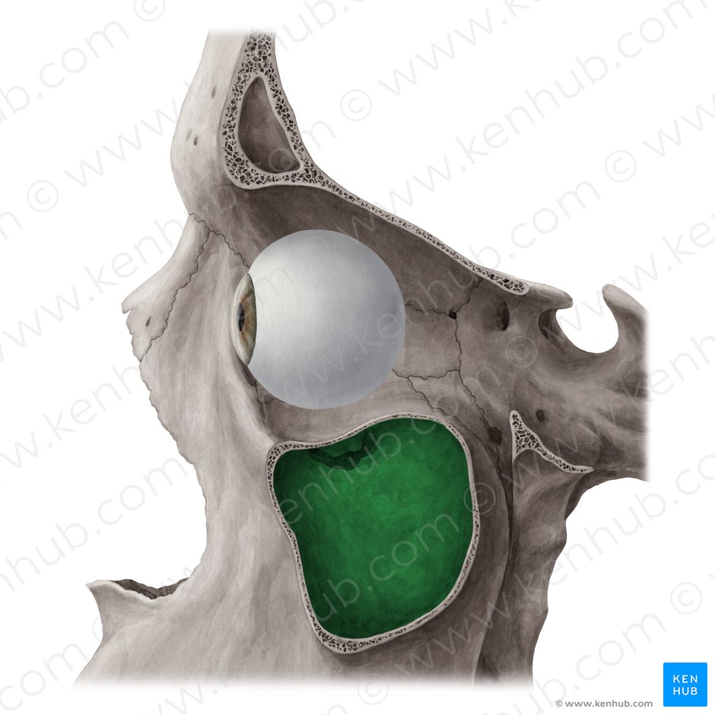
The maxillary sinuses are the largest of the all the paranasal sinuses. They have thin walls which are often penetrated by the long roots of the posterior maxillary teeth. The superior border of this sinus is the bony orbit, the inferior is the maxillary alveolar bone and corresponding tooth roots, the medial border is made up of the nasal cavity and the lateral and anterior border are limited by the cheekbones.Posteriorly, two anatomical spaces known as the pterygopalatine fossa and the infratemporal fossa exist.
VASCULARIZATION, INNERVATION AND LYMHPATICS
The submandibular lymph nodes are the main destination during lymphatic drainage. The blood supply includes a contribution from the:
- anterior superior alveolar artery
- middle superior artery
- posterior superior alveolar artery
Innervation occurs through nerves of the same names as the arteries.

FRONTAL SINUS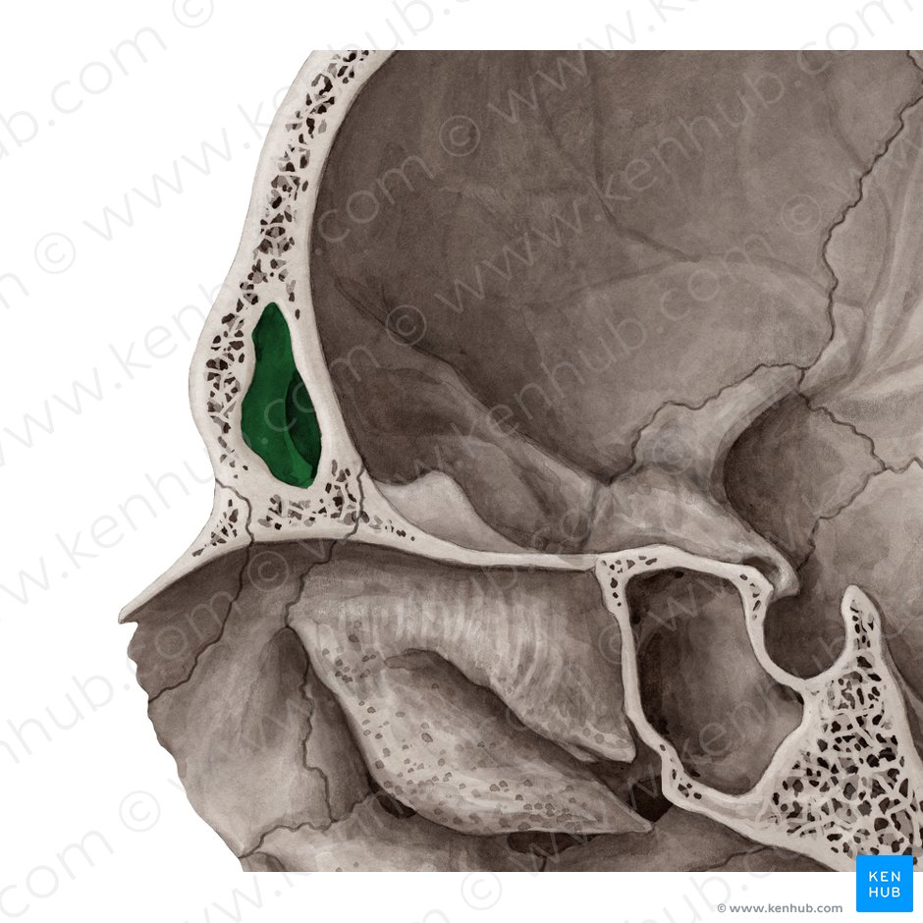

Anteriorly, the frontal sinuses are contained by the forehead and the superciliary arches, superiorly and posteriorly by the anterior cranial fossa and inferiorly by the bony orbit, the anterior ethmoidal sinuses and the nasal cavity. Medially the sinuses face one another, separated by the midline.
This pair of sinuses is irregular in shape when compared to one another and is underdeveloped at birth. They reach their full size and shape around seven to eight years of age
VASCULARISATION, INNERVATION AND LYMPHATICS
They drain primarily into the ethmoidal infundibulum and the corresponding lymph drainage occurs via the submandibular lymph nodes. It is innervated by the ophthalmic nerve, including the supraorbital and supratrochlear branches.
The frontal sinuses are supplied by the:
- anterior ethmoidal artery
- supraorbital artery
- supratrochlear artery

SPHENOIDAL SINUS
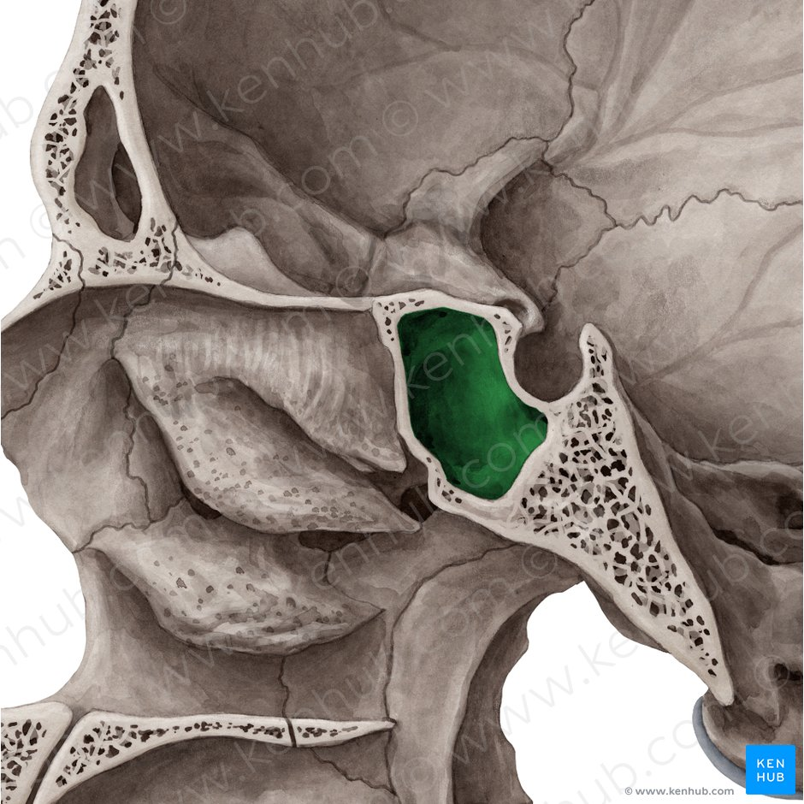
The most posterior of all the sinuses in the head, the sphenoidal sinuses are large and irregular, just like their septum, which is made by the sphenoid bone. Laterally, a cavernous sinus exists which is part of the middle cranial fossa and also the carotid artery and cranial nerves III, IV, V/I, V/II and VI can be found.
The anterior wall separates this pair of sinuses from the nasal cavity, as does the hypophyseal fossa, the pituitary gland and the optic chiasm superiorly and the nasopharynx and pterygoid canal inferiorly.
VASCULARIZATION, INNERVATION AND LYMHPATICS
The lymphatic drainage occurs in the same way as the posterior ethmoid sinus. The posterior ethmoidal artery and the posterior lateral nasal branches supply the sphenoidal sinuses.
The posterior ethmoidal nerve and the orbital branch of the pterygopalatine ganglion innervate them.

ETHMOIDAL SINUS
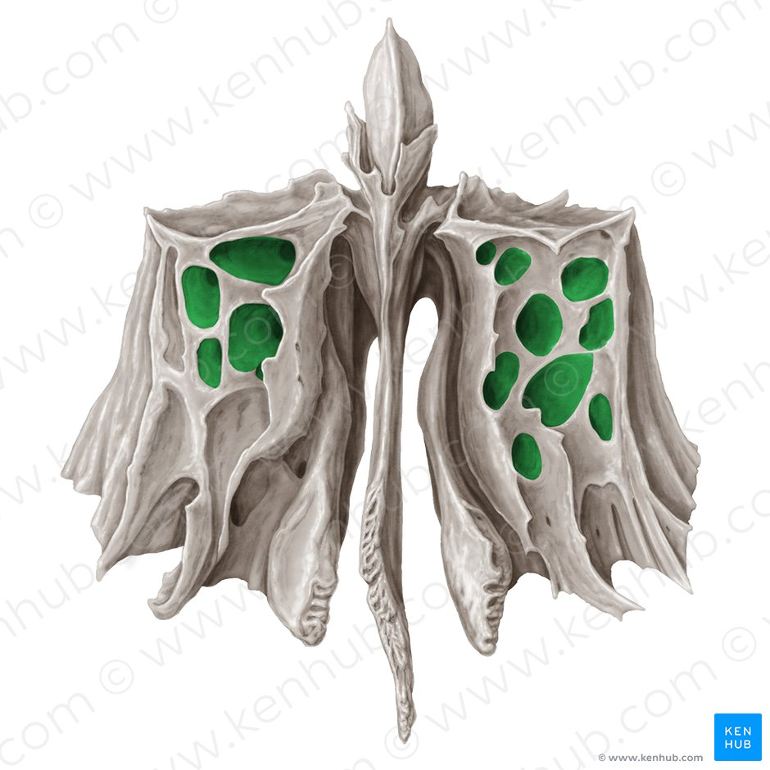
Superior to the ethmoidal sinus is the anterior cranial fossa and the frontal bone, laterally the orbit can be found, while the nasal cavity is situated medially. The ethmoid sinuses are unique because they are the only paranasal sinuses that are more complex than just a single cavity.
On each side of the midline, anywhere from three to eighteen ethmoidal air cells may be grouped together. These air cells are smaller individual sinuses grouped together to form one large one which encompass the anterior, middle and posterior nasal meatuses.
VASCULATURE, INNERVATION AND LYMPHATICS
The anterior and middle ethmoid sinuses send their lymphatic drainage to the submandibular lymph nodes while the posterior ethmoid sinus sends its own to the retropharyngeal lymph nodes.
The anterior and posterior ethmoidal arteries, as well as the posterior lateral nasal branches provide an ample blood supply to this region. Meanwhile the anterior and posterior ethmoidal nerves and the posterior lateral superior and inferior nasal nerves help innervate it.
CLINICAL CORRELATE
SINUSITIS
Sinusitis is an extremely common outpatient case which presents as an inflammation of the epithelia of the sinuses. The causes can be either a viral or bacterial infection, or an allergic reaction. The inflammation can be acute or chronic and the maxillary sinuses are the most frequently affected. Antivirals, antibiotics and antihistamines are prescribed in persistent cases
REFRENCES
- kenhub.com
- medscape.com

.

