TOPIC: MICROSCOPY
MATRIC NUMBER:16/MHS03/033
NAME: ZUBAIRU KAMARU MAHMUD
DEPARTMENT: HUMAN ANATOMY
COURSE CODE: ANA 402
COURSE NAME: ELECTRON MICROSCOPIC TECHNIQUE & ULTRASTRUCTURE
LECTURER: DR OGEDENGBE O.
HISTORY OF MICROSCOPY
Microscopy is the technical field of using microscopes to view objects and areas of objects that cannot be seen with the naked eye (objects that are not within the resolution range of the normal eye). There are three well-known branches of microscopy: optical, electron, and scanning probe microscopy, along with the emerging field of X-ray microscopy. Optical microscopy and electron microscopy involve the diffraction, reflection, or refraction of electromagnetic radiation/electron beams interacting with the specimen, and the collection of the scattered radiation or another signal in order to create an image. This process may be carried out by wide-field irradiation of the sample (for example standard light microscopy and transmission electron microscopy) or by scanning a fine beam over the sample (for example confocal laser scanning microscopy and scanning electron microscopy). Scanning probe microscopy involves the interaction of a scanning probe with the surface of the object of interest. The development of microscopy revolutionized biology, gave rise to the field of histology and so remains an essential technique in the life and physical sciences. X-ray microscopy is three-dimensional and non-destructive, allowing for repeated imaging of the same sample for in situ or 4D studies, and providing the ability to "see inside" the sample being studied before sacrificing it to higher resolution techniques. A 3D X-ray microscope uses the technique of computed tomography (micro CT), rotating the sample 360 degrees and reconstructing the images. CT is typically carried out with a flat panel display. A 3D X-ray microscope employs a range of objectives, e.g., from 4X to 40X, and can also include a flat panel.
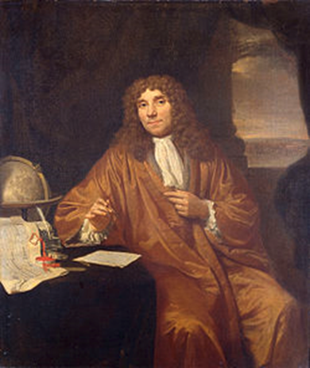
Often considered to be the first acknowledged microscopist and microbiologist, Antonie van Leeuwenhoek is best known for his pioneering work in the field of microscopy and for his contributions toward the establishment of microbiology as a scientific discipline.
The field of microscopy (optical microscopy) dates back to at least the 17th-century. Earlier microscopes, single lens magnifying glasses with limited magnification, date at least as far back as the wide spread use of lenses in eyeglasses in the 13th century but more advanced compound microscopes first appeared in Europe around 1620.The earliest practitioners of microscopy include Galileo Galilei, who found in 1610 that he could close focus his telescope to view small objects close up and Cornelis Drebbel, who may have invented the compound microscope around 1620 Antonie van Leeuwenhoek developed a very high magnification simple microscope in the 1670s and is often considered to be the first acknowledged microscopist and microbiologist.

Perspective
Throughout history, the purpose of the optical or light microscope has not always been for research and the production of beautiful, accurate images. For many centuries, the construction of microscopes and the underpinning optical systems was entirely an issue of exterior cosmetic craftsmanship, with the design of optical components lagging seriously behind advances in the fabrication of microscope bodies and frames. Greater trouble and effort was invested in the outer appearance of these early instruments, while their performance depended on the experience of the lens grinders, and the (good or bad) results obtained were often sheer coincidence. In many cases, microscopes were simply toys or show pieces intended to increase the prestige of their owners. The dichotomy between appearance and quality of the images such instruments provided was, by today's standards, striking (see Figure 1). Nevertheless, microscopy became a beloved pastime of the wealthy in the 18th century and many nights were spent observing local specimens, an affair that often involved entire families. For example, Elizabeth Charlotte of the Palatinate, who became famous as the sister-in-law of Louis XIV, owned a valuable microscope and used it regularly. She correctly predicted that this instrument would be of inestimable value for medical applications in the future. Her foresight was almost visionary at that time.
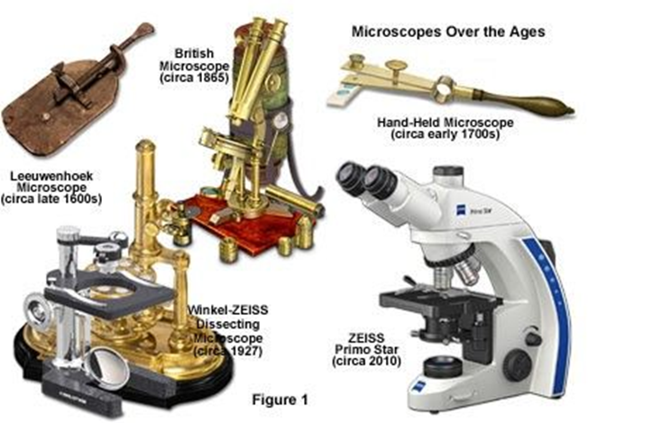

While working in a store where magnifying glasses were used to count the number of threads in cloth, Anton van Leeuwenhoek of Holland, who is often referred to as the father of microscopy, taught himself new methods for grinding and polishing small, curved lenses that magnified up to 270 diameters. He went on to build microscopes that gave way to several noted biological discoveries. Leeuwenhoek was the first to observe and describe bacteria (after viewing the very little living animalcules in the mouth of an old man who had never cleaned his teeth), the circulation of blood corpuscles in capillaries, and living sperm cells, among a host of other unique (at the time) specimens. In England, Robert Hooke re-confirmed Leeuwenhoek's discoveries of tiny living organisms in a drop of water. He replicated Leeuwenhoek's light microscope and proceeded to improve upon its design.
Hooke was also an avid student of fossils and geology. As the first person to examine fossils with a microscope, he observed close similarities between the structures of fossil shells and petrified wood, as well as living wood and living mollusk shells. His examinations proved that dead wood could be turned to stone by the action of water that is rich in dissolved minerals. As the water seeped into the wood, the saturated solution would slowly deposit minerals throughout the wood. In his book Micrographia, published in 1665, Hooke concluded that the shell-like fossils he studied actually represented organisms that no longer existed on Earth. Two and a half centuries before Darwin, Hooke realized that the fossil record proves there is transformation among the life forms on the planet, and that species have both materialized and disappeared throughout the history of life on earth. His revelations would continue to challenge the field of natural science.
Another breakthrough, in the 18th Century, was the invention of the Achromat lens system by Chester Moor Hall. Around the year 1733, he managed to build the first achromatic objective, consisting of a combination of a convex Crown glass and a concave Flint glass. Hall tried to keep this a secret by having one type of glass manufactured by one company and the other by another company. Unbeknownst to him, both companies used the same lens shop which realized, of course, that the final customer was one and the same person. It took another 25 years until John Dollond picked up on the idea and got a patent for "a new method of making the object glasses of refracting telescopes by compounding mediums of different refractive qualities".
During the 19th Century, the exacting natural sciences experienced an enormous upswing in activity. In the 1820s and 1830s, the science of light and the theory of optical imaging were placed on a sound foundation. One of the most successful researchers in this field was Joseph von Fraunhofer (1787-1826). Astronomy was the main field of Fraunhofer's activities, and his most noted achievement is the first description of the dark lines of the solar spectrum as reference points for the measurement of refraction indexes. But most important to the history of microscopy, Fraunhofer also refined the achromat by using scientific and precise manufacturing methods, creating what is now known as the achromat system, the most commonly deployed optical lens system with chromatic aberration correction, and for basic advancement of knowledge on the diffraction of light. Early microscopists were hampered by optical aberration, blurred images, and poor lens design, which hampered high-resolution observations until late in the 1800s. Aberrations were partially corrected by the mid-19th Century with the introduction of Lister and Amici achromatic objectives that reduced chromatic aberration and raised numerical apertures to around 0.65 for dry objectives and up to 1.25 for homogeneous immersion objectives. It would take a master craftsman to improve lens design further.
Within this period (the 1800s) of innumerable technical advances, a mechanic named Carl Zeiss (Figure 2) began his own business in the German university town of Jena, Thuringia, with the goal of providing researchers with high-quality instruments. Between 1846 and 1866, microscopes of uniformly high quality were built in Zeiss' workshop in accordance with very strict rules of craftsmanship. In the beginning, these were very simple instruments that were used as dissection microscopes, but in 1857 the Zeiss workshop produced the first genuine compound microscope (equipped with an eyepiece and an objective). The new instrument was called the Stativ 1, which combined practical functionality with the skilled optical refinement provided by a craftsman.
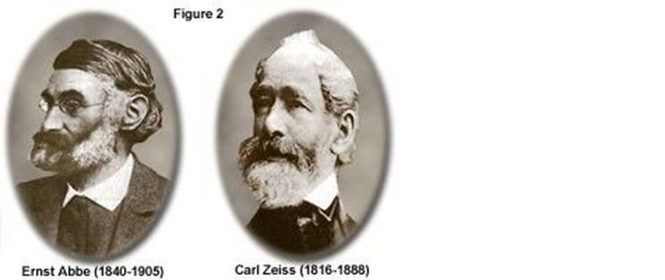
After almost 20 years, Zeiss was employing about 20 qualified staff members and took great pride in what had become a prosperous business. He knew that his instruments were good, but he refused to accept the trial and error method used at the time for the production of optics. Zeiss also was aware that competition from other microscope manufacturers would eventually bypass his accomplishments if he failed to continue to produce innovations. With the ultimate goal of creating reproducible products, Zeiss acknowledged that his manufacturing procedure had to be based on precise rules and strict guidelines, or as he once said:
"The working hand should have no other function than to precisely implement the shapes and dimensions of all the design components determined beforehand by computation."
For assistance in this endeavor, Zeiss formed a partnership with Dr. Ernst Abbe (Figure 2), a brilliant physicist and mathematician. Abbe was appointed as the research director of Zeiss Optical Works in late 1866. For the next six years, the team worked intensively to lay the scientific foundations for the design and fabrication of advanced optical systems. In 1869, they introduced a new illumination apparatus that was designed to improve the performance of microscope illumination. Three years later, in 1872, Abbe formulated his wave theory of microscopic imaging and defined what would become known as the Abbe Sine Condition. Several years later, Zeiss was producing a line of 17 different objectives, including three immersion systems, all featuring a level of image quality unknown until then. The construction of microscopes on a sound theoretical basis was possible at last, and still is today. The original formula for the calculation of the possible resolution of the microscope:
Resolution_{x,y} = λ / 2[η • sin(α)] (1)
is still utilized more than a century later. The Zeiss enterprise continued to push onward in the late 1800s. Abbe became an equal partner, and forward-thinking intelligence became the inherent capital of the young company. In his later years, Abbe became equally famous as a social reformist. Several problems still remained for Zeiss Optical Works however, since the quality of optical glass produced during the period was not sufficient to provide the theoretical resolution that was dictated by Abbe's sine condition. The glass used in the construction of microscope lenses was not homogeneous and it tended to undergo a phase separation during cooling, which led to a varying refractive index throughout the glass, and therefore, light waves passing through these lenses were refracted unpredictably. In short, first-rate resolution was unattainable with the poor quality glass.
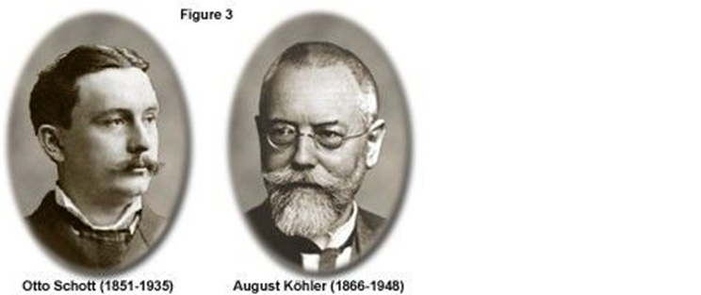

Abbe first met Otto Schott, a glass chemist, in 1881. Over the next several years, Abbe and Schott (Figure 3) developed several new glass formulas and made adjustments to the mixing and annealing process to eliminate internal defects and produce optical-grade glass with a uniform refractive index. In 1884, Schott, Abbe, and Zeiss formed a new company known as "Jenaer Glaswerk Schott und Genossen". Continued experimentation with glass recipes and preparation techniques yielded highly successful results, and in 1886, they introduced a new type of objective, the apochromat. By this time, an incredible 44 different types of optical glass were being produced. The creation of the apochromat objectives (with and without immersion media) eliminated color aberrations, which greatly assists bacteriologists in identifying infectious bacteria, and brought the resolving power of the microscope to the limit we know today. The progress made in the development of objectives led to fields of view larger than anything ever achieved before. In the course of time, it also became evident that more attention would have to be paid to illumination.
Professor August Köhler (1866-1948; Figure 3) became an early member of staff at Carl Zeiss in Jena, and in 1893 he published guidelines for an innovative scheme to illuminate microscope specimens. Köhler cleverly devised a microscope illumination system that made it possible to use the entire resolving power of Abbe's objectives. The Köhler illumination system provides homogeneously illuminated images. By incorporating a field iris diaphragm into the microscope illumination beam path, stray light was minimized and a simple procedure ensured proper positioning of the condenser for highest resolution and desired contrast (it is particularly beneficial that the aperture diaphragm in the condenser allows the image contrast and the resolving power to be balanced against each other without any loss in the consistency of the image brightness). Köhler's innovation was important in microphotography at the time of its development, and has since become a highly significant method for virtually all forms of optical microscopy. Knowledge and observance of Köhler's rules and the associated settings of the microscope (whether automatically via personal computer and motorized functions or manually) are still essential today.
Early in the twentieth century, microscope manufacturers began parfocalizing objectives, allowing the image to remain in focus when the microscopist exchanged objectives on the rotating nosepiece. In 1924, Zeiss introduced a LeChatelier-style metallograph with infinity-corrected optics, but this method of correction would not see widespread application for another 60 years. Shortly before World War II, Zeiss created several prototype phase contrast microscopes based on optical principles advanced by Frits Zernike. Several years later the same microscopes were modified to produce the first time-lapse cinematography of cell division photographed with phase contrast optics. This contrast-enhancing technique did not become universally recognized until the 1950s and is still one of the methods of choice for many cell biologists today.
Physicist Georges Nomarski introduced improvements in Wollaston prism design for another powerful contrast-generating microscopy theory in 1955. This technique is commonly referred to as Nomarski interference or differential interference contrast (DIC) microscopy and, along with phase contrast, has allowed scientists to explore many new arenas in biology using living cells or unstained tissues. Robert Hoffman introduced another method of increasing contrast in living material by taking advantage of phase gradients near cell membranes. This technique is now termed Hoffman Modulation Contrast, and is available as optional equipment on most modern microscopes.
Stereo microscope
Optical or light microscopy involves passing visible light transmitted through or reflected from the sample through a single lens or multiple lenses to allow a magnified view of the sample. The resulting image can be detected directly by the eye, imaged on a photographic plate, or captured digitally. The single lens with its attachments, or the system of lenses and imaging equipment, along with the appropriate lighting equipment, sample stage, and support, makes up the basic light microscope. The most recent development is the digital microscope, which uses a CCD camera to focus on the exhibit of interest. The image is shown on a computer screen, so eye-pieces are unnecessary.
Limitations of standard optical microscopy (bright field microscopy) lie in three areas;
- This technique can only image dark or strongly refracting objects effectively.
- Diffraction limits resolution to approximately 0.2 micrometres (see: microscope). This limits the practical magnification limit to ~1500x.
- Out-of-focus light from points outside the focal plane reduces image clarity.
Live cells in particular generally lack sufficient contrast to be studied successfully, since the internal structures of the cell are colorless and transparent. The most common way to increase contrast is to stain the different structures with selective dyes, but this often involves killing and fixing the sample. Staining may also introduce artifacts, which are apparent structural details that are caused by the processing of the specimen and are thus not legitimate features of the specimen. In general, these techniques make use of differences in the refractive index of cell structures. Bright field microscopy is comparable to looking through a glass window: one sees not the glass but merely the dirt on the glass. There is a difference, as glass is a denser material, and this creates a difference in phase of the light passing through. The human eye is not sensitive to this difference in phase, but clever optical solutions have been devised to change this difference in phase into a difference in amplitude (light intensity).
Techniques
In order to improve specimen contrast or highlight certain structures in a sample, special techniques must be used. A huge selection of microscopy techniques are available to increase contrast or label a sample.
- Four examples of transillumination techniques used to generate contrast in a sample of tissue paper. 1.559 μm/pixel.
- 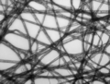
Bright field illumination, sample contrast comes from absorbance of light in the sample.
- 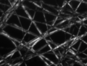
Cross-polarized light illumination, sample contrast comes from rotation of polarized light through the sample.
- 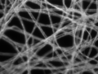
Dark field illumination, sample contrast comes from light scattered by the sample.
- 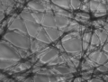
Phase contrast illumination, sample contrast comes from interference of different path lengths of light through the sample.
Bright field
Bright field microscopy is the simplest of all the light microscopy techniques. Sample illumination is via transmitted white light, i.e. illuminated from below and observed from above. Limitations include low contrast of most biological samples and low apparent resolution due to the blur of out-of-focus material. The simplicity of the technique and the minimal sample preparation required are significant advantages.
Oblique illumination
The use of oblique (from the side) illumination gives the image a three-dimensional (3D) appearance and can highlight otherwise invisible features. A more recent technique based on this method is Hoffmann's modulation contrast, a system found on inverted microscopes for use in cell culture. Oblique illumination suffers from the same limitations as bright field microscopy (low contrast of many biological samples; low apparent resolution due to out of focus objects).
Dark field
Dark field microscopy is a technique for improving the contrast of unstained, transparent specimens. Dark field illumination uses a carefully aligned light source to minimize the quantity of directly transmitted (unscattered) light entering the image plane, collecting only the light scattered by the sample. Dark field can dramatically improve image contrast – especially of transparent objects – while requiring little equipment setup or sample preparation. However, the technique suffers from low light intensity in final image of many biological samples and continues to be affected by low apparent resolution.
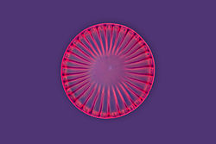
A diatom under Rheinberg illumination
Rheinberg illumination is a special variant of dark field illumination in which transparent, colored filters are inserted just before the condenser so that light rays at high aperture are differently colored than those at low aperture (i.e., the background to the specimen may be blue while the object appears self-luminous red). Other color combinations are possible, but their effectiveness is quite variable.

Phase contrast
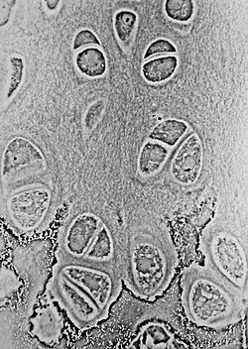
Phase-contrast light micrograph of undecalcified hyaline cartilage showing chondrocytes and organelles, lacunae and extracellular matrix.
More sophisticated techniques will show proportional differences in optical density. Phase contrast is a widely used technique that shows differences in refractive index as difference in contrast. It was developed by the Dutch physicist Frits Zernike in the 1930s (for which he was awarded the Nobel Prize in 1953). The nucleus in a cell for example will show up darkly against the surrounding cytoplasm. Contrast is excellent; however, it is not for use with thick objects. Frequently, a halo is formed even around small objects, which obscures detail. The system consists of a circular annulus in the condenser, which produces a cone of light. This cone is superimposed on a similar sized ring within the phase-objective. Every objective has a different size ring, so for every objective another condenser setting has to be chosen. The ring in the objective has special optical properties: it, first of all, reduces the direct light in intensity, but more importantly, it creates an artificial phase difference of about a quarter wavelength. As the physical properties of this direct light have changed, interference with the diffracted light occurs, resulting in the phase contrast image. One disadvantage of phase-contrast microscopy is halo formation (halo-light ring).
Differential interference contrast
Superior and much more expensive is the use of interference contrast. Differences in optical density will show up as differences in relief. A nucleus within a cell will actually show up as a globule in the most often used differential interference contrast system according to Georges Nomarski. However, it has to be kept in mind that this is an optical effect, and the relief does not necessarily resemble the true shape. Contrast is very good and the condenser aperture can be used fully open, thereby reducing the depth of field and maximizing resolution.
The system consists of a special prism (Nomarski prism, Wollaston prism) in the condenser that splits light in an ordinary and an extraordinary beam. The spatial difference between the two beams is minimal (less than the maximum resolution of the objective). After passage through the specimen, the beams are reunited by a similar prism in the objective.
In a homogeneous specimen, there is no difference between the two beams, and no contrast is being generated. However, near a refractive boundary (say a nucleus within the cytoplasm), the difference between the ordinary and the extraordinary beam will generate a relief in the image. Differential interference contrast requires a polarized light source to function; two polarizing filters have to be fitted in the light path, one below the condenser (the polarizer), and the other above the objective (the analyzer).
Note: In cases where the optical design of a microscope produces an appreciable lateral separation of the two beams we have the case of classical interference microscopy, which does not result in relief images, but can nevertheless be used for the quantitative determination of mass-thicknesses of microscopic objects.
Interference reflection
An additional technique using interference is interference reflection microscopy (also known as reflected interference contrast, or RIC). It relies on cell adhesion to the slide to produce an interference signal. If there is no cell attached to the glass, there will be no interference.
Interference reflection microscopy can be obtained by using the same elements used by DIC, but without the prisms. Also, the light that is being detected is reflected and not transmitted as it is when DIC is employed.
Fluorescence
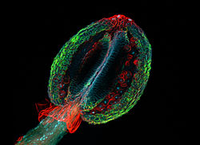
Images may also contain artifacts. This is a confocal laser scanning fluorescence micrograph of thale cress anther (part of stamen). The picture shows among other things a nice red flowing collar-like structure just below the anther. However, an intact thale cress stamen does not have such collar, this is a fixation artifact: the stamen has been cut below the picture frame, and epidermis (upper layer of cells) of stamen stalk has peeled off, forming a non-characteristic structure. Photo: Heiti Paves from Tallinn University of Technology.
When certain compounds are illuminated with high energy light, they emit light of a lower frequency. This effect is known as fluorescence. Often specimens show their characteristic autofluorescence image, based on their chemical makeup.
This method is of critical importance in the modern life sciences, as it can be extremely sensitive, allowing the detection of single molecules. Many different fluorescent dyes can be used to stain different structures or chemical compounds. One particularly powerful method is the combination of antibodies coupled to a fluorophore as in immunostaining. Examples of commonly used fluorophores are fluorescein or rhodamine.
The antibodies can be tailor-made for a chemical compound. For example, one strategy often in use is the artificial production of proteins, based on the genetic code (DNA). These proteins can then be used to immunize rabbits, forming antibodies which bind to the protein. The antibodies are then coupled chemically to a fluorophore and used to trace the proteins in the cells under study.
Highly efficient fluorescent proteins such as the green fluorescent protein (GFP) have been developed using the molecular biology technique of gene fusion, a process that links the expression of the fluorescent compound to that of the target protein. This combined fluorescent protein is, in general, non-toxic to the organism and rarely interferes with the function of the protein under study. Genetically modified cells or organisms directly express the fluorescently tagged proteins, which enables the study of the function of the original protein in vivo.
Growth of protein crystals results in both protein and salt crystals. Both are colorless and microscopic. Recovery of the protein crystals requires imaging which can be done by the intrinsic fluorescence of the protein or by using transmission microscopy. Both methods require an ultraviolet microscope as protein absorbs light at 280 nm. Protein will also fluorescence at approximately 353 nm when excited with 280 nm light.
Since fluorescence emission differs in wavelength (color) from the excitation light, an ideal fluorescent image shows only the structure of interest that was labeled with the fluorescent dye. This high specificity led to the widespread use of fluorescence light microscopy in biomedical research. Different fluorescent dyes can be used to stain different biological structures, which can then be detected simultaneously, while still being specific due to the individual color of the dye.
To block the excitation light from reaching the observer or the detector, filter sets of high quality are needed. These typically consist of an excitation filter selecting the range of excitation wavelengths, a dichroic mirror, and an emission filter blocking the excitation light. Most fluorescence microscopes are operated in the Epi-illumination mode (illumination and detection from one side of the sample) to further decrease the amount of excitation light entering the detector.
An example of fluorescence microscopy today is two-photon or multi-photon imaging. Two photon imaging allows imaging of living tissues up to a very high depth by enabling greater excitation light penetration and reduced background emission signal.
Confocal
Confocal microscopy uses a scanning point of light and a pinhole to prevent out of focus light from reaching the detector. Compared to full sample illumination, confocal microscopy gives slightly higher resolution, and significantly improves optical sectioning. Confocal microscopy is, therefore, commonly used where 3D structure is important.
Electron microscopy
Until the invention of sub-diffraction microscopy, the wavelength of the light limited the resolution of traditional microscopy to around 0.2 micrometers. In order to gain higher resolution, the use of an electron beam with a far smaller wavelength is used in electron microscopes.
- Transmission electron microscopy (TEM) is quite similar to the compound light microscope, by sending an electron beam through a very thin slice of the specimen. The resolution limit in 2005 was around 0.05 nanometer and has not increased appreciably since that time.
- Scanning electron microscopy (SEM) visualizes details on the surfaces of specimens and gives a very nice 3D view. It gives results much like those of the stereo light microscope. The best resolution for SEM in 2011 was 0.4 nanometer.
Electron microscopes equipped for X-ray spectroscopy can provide qualitative and quantitative elemental analysis. This type of electron microscope, also known as analytical electron microscope, can be a very powerful characterization tool for investigation of nanomaterials.
Scanning probe microscopy
This is a sub-diffraction technique. Examples of scanning probe microscopes are the atomic force microscope (AFM), the Scanning tunneling microscope, the photonic force microscope and the recurrence tracking microscope. All such methods use the physical contact of a solid probe tip to scan the surface of an object, which is supposed to be almost flat.
Application in forensic science
Microscopy has many applications in the forensic sciences; it provides precision, quality, accuracy, and reproducibility of results. These applications are almost limitless. This is due to the ability of microscope to detect, resolve and image the smallest items of evidence, often without any alteration or destruction. The microscope is used to identify and compare fibers, hairs, soils, and dust...etc.
The aim of any microscope is to magnify images or photos of a small object and to see fine details. In forensic; the type of specimen, the information one wishes to obtain from it and the type of microscope chosen for the task will determine if the sample preparation is required. For example, ink lines, blood stains or bullets, no treatment is required and the evidence shows directly from appropriate microscope without any form of sample preparation, but for traces of particular matter, the sample preparation must be done before microscopical examination occurs.
A variety of microscopes are used in forensic science laboratory. The light microscopes are the most use in forensic and these microscopes use photons to form images⁴, these microscopes which are most applicable for examining forensic specimens as mentioned before are as follows:
1. The compound microscope
2. The comparison microscope
3. The stereoscopic microscope
4. The polarizing microscope
5. The micro spectrophotometer
This diversity of the types of microscopes in forensic applications comes mainly from their magnification ranges, which are (1- 1200X), (50 -30,000X) and (500- 250,000X) for the optical microscopy, SEM and TEM respectively.

Light microscope vs Electron microscope

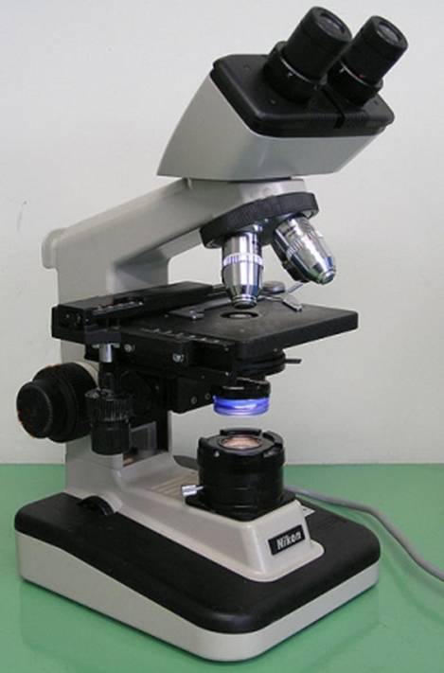
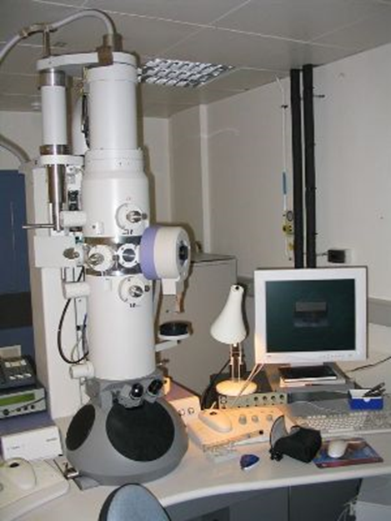
Light microscope Electron microscope
What is the difference between a light microscope and an electron microscope? A number of differences such as the source of light they use, their magnification level, cost, resolving power, among other factors sets these two types of microscopes apart from each other.
- An electron microscope is very expensive to buy and requires special environments. This makes it expensive to maintain. In addition, it requires high technical skills to use and is therefore limited to specialized use such as research. A light microscope, on the other hand, is cheap to buy and maintain. It requires no special skills to use. As a result, it is suitable for most basic functions, and is very common in schools and other learning institutions.
- While a light microscope uses light to illuminate specimens and glass lenses to magnify images, an electron microscope uses a beam of electrons to illuminate specimens and magnetic lenses to magnify images.
- The resolution (the level of image detailing) is the main difference between these two microscopes. A light microscope has a resolution of up to 0.3µm, i.e. 3 micrometers. This limits it as two close objects cannot be seen as separate. In an electron microscope, the resolution is about 0.0001µm, i.e. 0.01 nanometers. This resolution can be used in situations that require greater details, such as studying cell nuclei.
- A light microscope can be used to view both dead and live specimens. This makes it important in studying live ones. By contrast, an electron microscope cannot be used to view living specimens as it uses electrons that are destructive to life.
- Comparison Chart
Light microscope | Electron microscope
Simple to use | Users require technical skills
Can view both live and dead specimens | Views only dead specimens
Poor surface view | Good surface view and internal details
Uses light rays to illuminate specimens | Uses a beam of electrons to view specimens
Lenses are made of glass | Lenses are made of electromagnets
Low resolving power, usually below 0.30µm. | High resolving power of up to 0.0001µm.
Low magnification of up to 1,500x | High magnification of up to 1,000,000x
Images are viewed by the eyes through the eyepiece | Images are viewed on a photographic plate or zinc sulphate fluorescent screen
Not used under a vacuum | Operates under a high vacuum
Cheap to buy and has low maintenance costs | Very expensive to buy and maintain

SEM VS TEM
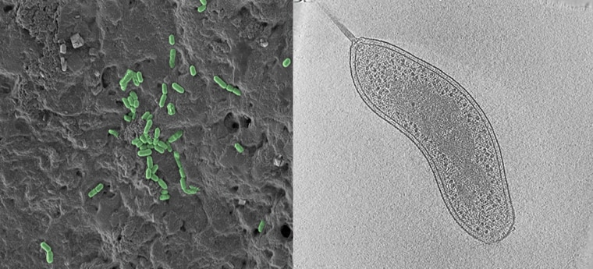
SEM (left) and TEM (right) images of bacteria. Whereas SEM shows numerous bacteria on a surface (green), the TEM image shows the interior structure of a single bacterium.
Scanning Electron Microscope (SEM)
Imagine you are in a dark room with a weak flashlight. To explore your surroundings, you might sweep the light across the room, much like someone reading a book: left to right and top to bottom. SEM functions similarly, sweeping the electron beam across the sample and recording the electrons that bounce back. This technique allows you to see the surface of just about any sample, from industrial metals to geological samples to biological specimens like spores, insects, and cells. While SEM cannot see features to the level of detail as a TEM can it is much faster, less restrictive, and can sometimes be performed with limited or no sample preparation.

Transmission Electron Microscope (TEM)
When a movie plays in the theater, light is transmitted through an image on a film. As the beam of light passes through, it is modified by the image and the contents of the film are then displayed. TEM works in the same way but with electrons, passing through, or transmitting, an ultrathin sample to a detector below. TEM allows you to observe details as small as individual atoms, giving unprecedented levels or structural information at the highest possible resolution. As it goes through objects it can also give you information about internal structures, which SEM cannot provide. TEM is, however, limited to samples that can be thin enough to let electrons pass through them. This thinning process is technically challenging and requires additional tools to perform.

However, an SEM and TEM also share some differences. The method used in SEM is based on scattered electrons while TEM is based on transmitted electrons. The scattered electrons in SEM are classified as backscattered or secondary electrons. However, there is no other classification of electrons in TEM.
The scattered electrons in SEM produced the image of the sample after the microscope collects and counts the scattered electrons. In TEM, electrons are directly pointed toward the sample. The electrons that pass through the sample are the parts that are illuminated in the image.
The focus of analysis is also different. SEM focuses on the sample’s surface and its composition. On the other hand, TEM seeks to see what is inside or beyond the surface. SEM also shows the sample bit by bit while TEM shows the sample as a whole. SEM also provides a three-dimensional image while TEM delivers a two-dimensional picture.
References
- The University of Edinburgh (2018). "What is Microscopy?". The University of Edinburgh.
- Ford, Brian J. (1992). "From Dilettante to Diligent Experimenter: a Reappraisal of Leeuwenhoek as microscopist and investigator". Biology History. 5 (3).
- Albert Van Helden; Sven Dupré; Rob van Gent (2010). The Origins of the Telescope. Amsterdam University Press. p. 24. ISBN 978-90-6984-615-6.
- William Rosenthal, Spectacles and Other Vision Aids: A History and Guide to Collecting, Norman Publishing, 1996, page 391 - 392
- Robert D. Huerta, Giants of Delft: Johannes Vermeer and the Natural Philosophers: the Parallel Search for Knowledge During the Age of Discovery, Bucknell University Press - 2003, page 126
- Mark Smith, From Sight to Light: The Passage from Ancient to Modern Optics, University of Chicago Press - 2014, page 387
- Raymond J. Seeger, Men of Physics: Galileo Galilei, His Life and His Works, Elsevier - 2016, page 24
- J. William Rosenthal, Spectacles and Other Vision Aids: A History and Guide to Collecting, Norman Publishing, 1996, page 391
- Lane, Nick (6 March 2015). "The Unseen World: Reflections on Leeuwenhoek (1677) 'Concerning Little Animal'." Philos Trans R Soc Lond B Biol Sci. 2015 Apr; 370 (1666): 20140344. [doi:10.1098/rstb.2014.0344]
- Abramowitz M, Davidson MW (2007). "Introduction to Microscopy". Molecular Expressions. Retrieved 2007-08-22.
- Abramowitz M, Davidson MW (2003). "Darkfield Illumination". Retrieved 2008-10-21.
- Abramowitz M, Davidson MW (2003). "Rheinberg Illumination".
- Gill, Harindarpal (January 2010). "Evaluating the efficacy of tryptophan fluorescence and absorbance as a selection tool for identifying protein crystals". Acta Crystallographica. F66 (Pt 3): 364–372. doi:10.1107/S1744309110002022. PMC 2833058. PMID 20208182.
- Voie, A.H. (1993). "Imaging the intact guinea pig tympanic bulla by orthogonal-plane fluorescence optical sectioning microscopy". Hearing Research. 71 (1–2): 119–128. doi:10.1016/S0378-5955(02)00493-8. ISSN 0378-5955. PMID 12204356.
- Greger, K.; J. Swoger; E. H. K. Stelzer (2007). "Basic building units and properties of a fluorescence single plane illumination microscope". Review of Scientific Instruments. 78 (2): 023705–023705–7. Bibcode:2007RScI...78b3705G. doi:10.1063/1.2428277. ISSN 0034-6748. PMID 17578115. Archived from the original on 2012-07-12. Retrieved 2011-10-16.
- Buytaert, J.A.N.; E. Descamps; D. Adriaens; J.J.J. Dirckx (2012). "The OPFOS Microscopy Family: High-Resolution Optical Sectioning of Biomedical Specimens". Anatomy Research International. 2012: 206238. arXiv:1106.3162. doi:10.1155/2012/206238. ISSN 2090-2743. PMC 3335623. PMID 22567307.
- F. J. Duarte, in High Power Dye Lasers (Springer-Verlag, Berlin,1991) Chapter 2.
- Duarte FJ (1993), Electro-optical interferometric microdensitometer system, US Patent 5255069 Archived 2017-10-13 at the Wayback Machine.
- Peterson, Mark D.; Hayes, Patrick L.; Martinez, Imee Su; Cass, Laura C.; Achtyl, Jennifer L.; Weiss, Emily A.; Geiger, Franz M. (2011-05-01). "Second harmonic generation imaging with a kHz amplifier [Invited]". Optical Materials Express. 1 (1): 57. Bibcode:2011OMExp...1...57P. doi:10.1364/ome.1.000057.
- Macias-Romero, Carlos; Didier, Marie E. P.; Jourdain, Pascal; Marquet, Pierre; Magistretti, Pierre; Tarun, Orly B.; Zubkovs, Vitalijs; Radenovic, Aleksandra; Roke, Sylvie (2014-12-15). "High throughput second harmonic imaging for label-free biological applications". Optics Express. 22 (25): 31102–12. Bibcode:2014OExpr..2231102M. doi:10.1364/oe.22.031102. PMID 25607059.
- Cheng, Li-Chung; Chang, Chia-Yuan; Lin, Chun-Yu; Cho, Keng-Chi; Yen, Wei-Chung; Chang, Nan-Shan; Xu, Chris; Dong, Chen Yuan; Chen, Shean-Jen (2012-04-09). "Spatiotemporal focusing-based widefield multiphoton microscopy for fast optical sectioning". Optics Express. 20 (8): 8939–48. Bibcode:2012OExpr..20.8939C. doi:10.1364/oe.20.008939. PMID 22513605.
- Oron, Dan; Tal, Eran; Silberberg, Yaron (2005-03-07). "Scanningless depth-resolved microscopy". Optics Express. 13 (5): 1468–76. Bibcode:2005OExpr..13.1468O. doi:10.1364/opex.13.001468. PMID 19495022.
- Ahi, Kiarash; Anwar, Mehdi (2016-05-26). "Modeling of terahertz images based on x-ray images: a novel approach for verification of terahertz images and identification of objects with fine details beyond terahertz resolution". Terahertz Physics, Devices, and Systems X: Advanced Applications in Industry. Terahertz Physics, Devices, and Systems X: Advanced Applications in Industry and Defense. 9856: 985610. doi:10.1117/12.2228685.
- Solomon, Chris (2010). Fundamentals of Digital Image Processing. John Wiley & Sons, Ltd. ISBN 978-0-470-84473-1.
- Nasse M. J.; Woehl J. C. (2010). "Realistic modeling of the illumination point spread function in confocal scanning optical microscopy". J. Opt. Soc. Am. A. 27 (2): 295–302. Bibcode:2010JOSAA..27..295N. doi:10.1364/JOSAA.27.000295. PMID 20126241.
- Wallace W, Schaefer LH, Swedlow JR (2001). "A workingperson's guide to deconvolution in light microscopy". BioTechniques. 31 (5): 1076–8, 1080, 1082 passim. doi:10.2144/01315bi01. PMID 11730015.
- Kaufmann Rainer; Müller Patrick; Hildenbrand Georg; Hausmann Michael; Cremer Christoph (2010). "Analysis of Her2/neu membrane protein clusters in different types of breast cancer cells using localization microscopy". Journal of Microscopy. 242 (1): 46–54. CiteSeerX 10.1.1.665.3604. doi:10.1111/j.1365-2818.2010.03436.x. PMID 21118230.
- van de Linde S.; Wolter S.; Sauer S. (2011). "Single-molecule Photoswitching and Localization". Aust. J. Chem. 64 (5): 503–511. doi:10.1071/CH10284.
- K. Goda; K. K. Tsia; B. Jalali (2009). "Serial time-encoded amplified imaging for real-time observation of fast dynamic phenomena". Nature. 458 (7242): 1145–9. Bibcode:2009Natur.458.1145G. doi:10.1038/nature07980. PMID 19407796.
- Jalali, Bahram; Capewell, Dale; Goda, Keisuke; Tsia, Kevin K. (2010-05-10). "Performance of serial time-encoded amplified microscope". Optics Express. 18 (10): 10016–10028. doi:10.1364/OE.18.010016. hdl:10722/91333. ISSN 1094-4087.
- Kosasih, Felix Utama; Ducati, Caterina (2018). "Characterising degradation of perovskite solar cells through in-situ and operando electron microscopy". Nano Energy. 47: 243–256. doi:10.1016/j.nanoen.2018.02.055.
- H M Pollock and S G Kazarian, Microspectroscopy in the Mid-Infrared, in Encyclopedia of Analytical Chemistry (Robert A. Meyers, Ed, 1-26 (2014), John Wiley & Sons Ltd,
- Pollock Hubert M (2014). Microspectroscopy in the Mid-Infrared. Encyclopedia of Analytical Chemistry. pp. 1–26. doi:10.1002/9780470027318.a5609.pub2. ISBN 9780470027318.
- H M Pollock and D A Smith, The use of near-field probes for vibrational spectroscopy and photothermal imaging, in Handbook of vibrational spectroscopy, J.M. Chalmers and P.R. Griffiths (eds), John Wiley & Sons Ltd, Vol. 2, pp. 1472 - 1492 (2002)
- Duarte FJ (2016). "Tunable laser microscopy". In Duarte FJ (ed.). Tunable Laser Applications (3rd ed.). Boca Raton: CRC Press. pp. 315–328. ISBN 9781482261066.
- Thomas JL, Rudolph W (2008). "Biological Microscopy with Ultrashort Laser Pulses". In Duarte FJ (ed.). Tunable Laser Applications (2nd ed.). Boca Raton: CRC Press. pp. 245–80. ISBN 978-1-4200-6009-6.
- Solem, J. C. (1983). "X-ray imaging on biological specimens". Proceedings of International Conference on Lasers '83: 635–640. OSTI 5998195.
- Solem, J. C. (1982). "High-intensity x-ray holography: An approach to high-resolution snapshot imaging of biological specimens". Los Alamos National Laboratory Technical Report LA-9508-MS. doi:10.2172/7056325. OSTI 7056325.
- Solem, J. C.; Baldwin, G. C. (1982). "Microholography of living organisms". Science. 218 (4569): 229–235. Bibcode:1982Sci...218..229S. doi:10.1126/science.218.4569.229. PMID 17838608.
- Solem, J. C.; Chapline, G. F. (1984). "X-ray biomicroholography". Optical Engineering. 23 (2): 193. Bibcode:1984OptEn..23..193S. doi:10.1117/12.7973410.
- Solem, J. C. (1985). "Microholography". McGraw-Hill Encyclopedia of Science and Technology.
- Solem, J. C. (1984). "X-ray holography of biological specimens". Proceedings of Ninth International Congress on Photobiology, Philadelphia, PA, USA, 3 July 1984 (LA-UR-84-3340, CONF-840783-3): 19. OSTI 6314558.
- Solem, J. C. (1986). "Imaging biological specimens with high-intensity soft X-rays". Journal of the Optical Society of America B. 3 (11): 1551–1565. Bibcode:1986JOSAB...3.1551S. doi:10.1364/josab.3.001551.
- Haddad, W. S.; Solem, J. C.; Cullen, D.; Boyer, K.; Rhodes, C. K. (1987). "A description of the theory and apparatus for digital reconstruction of Fourier transform holograms", Proceedings of Electronics Imaging '87, Nov. 2-5, 1987, Boston; Journal of Electronic Imaging, (Institute for Graphic Communication, Inc., Boston), p. 693.
- Haddad, W. S.; Cullen, D.; Boyer, K.; Rhodes, C. K.; Solem, J. C.; Weinstein, R. S. (1988). Design for a Fourier-transform holographic microscope. Proceedings of International Symposium on X-Ray Microscopy II, Springer Series in Optical Sciences. Springer Series in Optical Sciences. 56. pp. 284–287. doi:10.1007/978-3-540-39246-0_49. ISBN 978-3-662-14490-9.
- Haddad, W. S.; Solem, J. C.; Cullen, D.; Boyer, K.; Rhodes, C. K. (1988). "Design for a Fourier-transform holographic microscope incorporating digital image reconstruction". Proceedings of CLEO '88 Conference on Lasers and Electro-Optics, Anaheim, CA, April, 1988; Optical Society of America, OSA Technical Digest. 7: WS4.
- Haddad, W. S.; Cullen, D.; Solem, J. C.; Boyer, K.; Rhodes, C. K. (1988). "X-ray Fourier-transform holographic microscope". Proceedings of the OSA Topical Meeting on Short Wavelength Coherent Radiation: Generation and Applications, September 26–29, 1988, Cape Cod, MA., Falcone, R.; Kirz, J.; Eds. (Optical Society of America, Washington, DC): 284–289.
- Solem, J. C.; Boyer, K.; Haddad, W. S.; Rhodes, C. K. (1990). Prosnitz, D.; ed. SPIE. "Prospects for X-ray holography with free-electron lasers". Free Electron Lasers and Applications. Free-Electron Lasers and Applications. 1227: 105–116. doi:10.1117/12.18609.
- Haddad, W. S.; Cullen, D.; Solem, J. C.; Longworth, J. W.; McPherson, L. A.; Boyer, K.; Rhodes, C. K. (1991). "Fourier-transform holographic microscope". Proceedings of SPIE Electronic Imaging '91, San Jose, CA; International Society for Optics and Photonics. Camera and Input Scanner Systems. 1448: 81–88. doi:10.1117/12.45347.
- Haddad, W. S.; Cullen, D.; Solem, J. C.; Longworth, J.; McPherson, A.; Boyer, K.; Rhodes, C. K. (1992). "Fourier-transform holographic microscope". Applied Optics. 31 (24): 4973–4978. Bibcode:1992ApOpt..31.4973H. doi:10.1364/ao.31.004973. PMID 20733659.
- Boyer, K.; Solem, J. C.; Longworth, J.; Borisov, A.; Rhodes, C. K. (1996). "Biomedical three-dimensional holographic microimaging at visible, ultraviolet and X-ray wavelengths". Nature Medicine. 2 (8): 939–941. doi:10.1038/nm0896-939.
- Bell, A. G. (1880). "On the production and reproduction of sound by light". American Journal of Science. s3-20 (118): 305–324. doi:10.2475/ajs.s3-20.118.305.
- Yao, J.; Wang, L. V. (2013). "Photoacoustic Microscopy". Laser Photon Rev. 7 (5): 1–36. Bibcode:2013LPRv....7..758Y. doi:10.1002/lpor.201200060. PMC 3887369. PMID 24416085.
- Langer, G.; Buchegger, B.; Jacak, J.; Klar, T. A.; Berer, T. (2016). "Frequency domain photoacoustic and fluorescence microscopy". Biomedical Optics Express. 7 (7): 2692–702. doi:10.1364/BOE.7.002692. PMC 4948622. PMID 27446698.
- Kotrly M (2015). "New Possibilities of Using Micrscopic Techniques in Forensic Field". Proceedings of Microscopy & Microanallysis. 21 (S3): 1365–1366. Bibcode:2015MiMic..21S1365K. doi:10.1017/S1431927615007618.
- Basu S, Millette JR (1986). Electron Microscopy in Forensic Occupational and Environmental Health Sciences. New York: Plenum Press.

