NAME: LAWAL AMINAT TEMITOPE
MATRIC NO.: 17/MHS01/177
DEPARTMENT: MEDICINE AND SURGERY
LEVEL: 300
ASSIGNMENT: NOSE AND ORAL CAVITY
COURSE CODE: ANA 301
QUESTION 1:
ANATOMY OF THE TONGUE
The tongue is a mobile muscular organ covered with mucous membrane. It is located partly in the oral cavity and partly in the oropharynx. Its main functions are articulation and squeezing food into the oropharynx as part of deglutition. The tongue is also involved in mastication, taste and oral cleansing.
The tongue has a root, body and an apex. The root of the tongue is the attached posterior portion, extending between the mandible, hyoid and the nearly vertical posterior surface of the tongue. The body is the anterior, approximately two-thirds of the tongue between the root and the apex. The apex or tip of the tongue is the anterior end of the body which rests against the incisor teeth. The body and the apex of the tongue are extremely mobile.
The tongue has two surfaces. The more extensive, superior and posterior surface is the dorsum of the tongue. The inferior surface of the tongue (underside) usually rests against the floor of the mouth. The margin of the tongue separating the two surfaces is related on each side to the lingual gingivae and lateral teeth. The dorsum of the tongue is characterized by a V-shaped groove, the terminal sulcus of the tongue, the angle of which points posteriorly to the foramen cecum. The terminal sulcus divides the dorsum of the tongue transversely into a presulcal anterior part in the oral cavity and a post-sulcal posterior part in the oropharynx.
A midline groove divides the anterior part of the tongue into right and left parts. The mucosa of the anterior part of the tongue is relatively thin and has a rough texture because of numerous small lingual papillae.
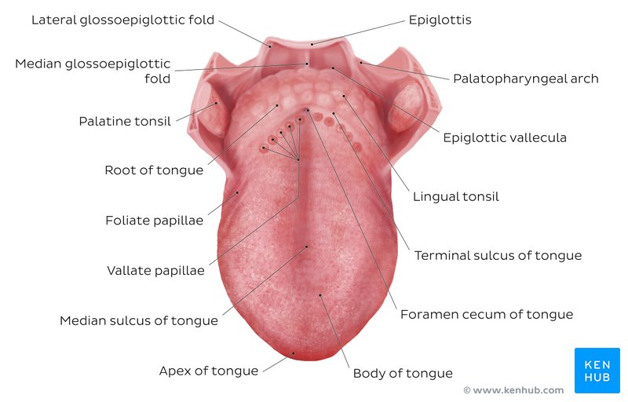

LINGUAL PAPILLAE OF THE TONGUE
- VALLATE PAPILLAE: They are large and flat-topped. They lie directly anterior to the terminal sulcus and are arranged in a V-shaped row. They are surrounded by deep circular trenches, the walls of which are studded with taste buds. The ducts of the serous glands of the tongue open into the trenches.
- FOLIATE PAPILLAE: They are small lateral folds of the lingual mucosa. They are poorly developed in humans.
- FILIFORM PAPILLAE: They are long and numerous, contain afferent nerve endings that are sensitive to touch. These scaly, conical projections are pinkish gray and are arranged in V-shaped rows that are parallel to the terminal sulcus, except at the apex, where they tend to be arranged transversely.
- FUNGIFORM PAPILLAE: They are mushroom-shaped pink or red spots scattered among the filiform papillae but are most numerous at the apex and margins of the tongue.
The vallate, foliate and most of the fungiform papillae contain taste receptors in the taste buds. The mucosa of the posterior part of the tongue has no lingual papillae but the underlying lymphoid nodules give this part of the tongue an irregular, cobblestone appearance. The lymphoid nodules are known collectively as the lingual tonsil.
The inferior surface of the tongue is connected to the floor of the mouth by a midline fold called the frenulum of the tongue. The frenulum allows the anterior part of the tongue to move freely.
MUSCLES OF THE TONGUE
Extrinsic muscles alter the position of the tongue while intrinsic muscles alter its shape. The four intrinsic muscles and the four extrinsic muscles in each half of the tongue are separated by the lingual septum.
The extrinsic muscles of the tongue include genioglossus, hyoglossus, styloglossus and palatoglossus. They originate outside the tongue and attach to it. They mainly move the tongue but they can alter its shape as well. Genioglossus helps to depress tongue and pulls tongue anteriorly for protrusion. Hyoglossus depresses tongue ans also helps to retrude the tongue. Styloglossus retrudes tongue and works with genioglossus to form a central trough during swallowing. Palatoglossus elevates posterior tongue and depresses soft palate.
The intrinsic muscles of the tongue include the superior and inferior longitudinal, transverse and vertical muscles. They have their attachments entirely within the tongue and are not attached to bone. The superior and inferior longitudinal muscles act together to make the tongue short and thick to retract the protruded tongue. The transverse and vertical muscles act together to make the tongue long and narrow.
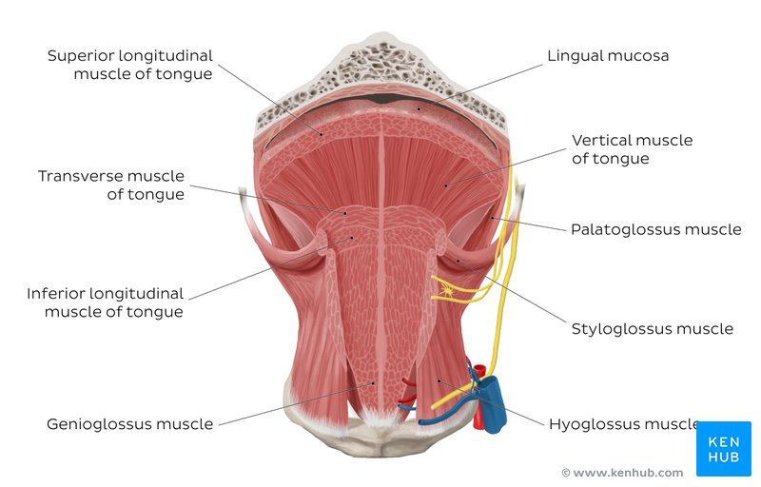
INNERVATION OF THE TONGUE
All muscles of the tongue, except the palatoglossus, receive motor innervations from the hypoglossal nerve (CN XII). Palatoglossus is supplied by the pharyngeal plexus.
For general sensation (touch and temperature), the mucosa of the anterior two-thirds of the tongue is supplied by the lingual nerve (branch of ophthalmic division of trigeminal nerve). For special sensation (taste), the mucosa of the anterior two-thirds of the tongue, except the vallate papillae, is supplied by the chorda tympani branch of facial nerve. The mucosa of the posterior third of the tongue and the vallate papillae are supplied by the lingual branch of the glossopharyngeal nerve. The internal laryngeal nerve supplies a small area of the tongue just anterior to the tongue.
VASCULATURE OF THE TONGUE
The arteries of the tongue arise from the lingual artery which arises from the external carotid artery. The dorsal lingual artery supplies to the root of the tongue while the deep lingual arteries supply the body of the tongue.
The veins of the tongue are the dorsal lingual veins which accompany the lingual artery. The deep lingual veins run posteriorly to join the sublingual vein. Some or all of the veins may drain into the internal jugular vein or they can join to form a lingual vein.
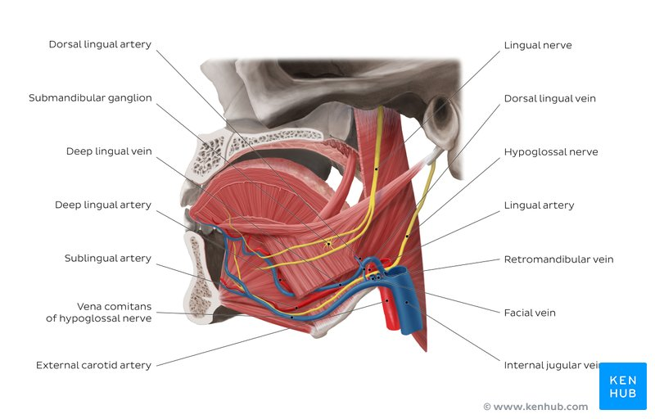
LYMPHATIC DRAINAGE
Lymph from the root of the tongue drains bilaterally into the superior deep cervical lymph nodes. Lymph from the medial part of the body drains bilaterally and directly to the inferior deep cervical lymph nodes. Lymph from the right and left lateral parts of body drains to the submandibular lymph nodes on the ipsilateral side. The apex and frenulum drain to the submental lymph nodes.
All lymph from the tongue ultimately drain to the deep cervical nodes.
CLINICAL ANATOMY
- INJURY TO HYPOGLOSSAL NERVE: Trauma, such as a fractured mandible, may injure the hypoglossal nerve, resulting in paralysis and eventual atrophy of one side of the tongue. The tongue deviates to the paralyzed side during protrusion because of the action of the unaffected genioglossus muscle on the other side.
- LINGUAL CARCINOMA: A lingual carcinoma in the posterior part of the tongue metastasizes to the superior deep cervical lymph nodes on both sides. However, a tumor in the anterior part usually does not metastasize to the inferior deep cervical nodes until late into the disease.
- LINGUAL FRENECTOMY: A frenulum of the tongue extending farther anteriorly towards the apex (tongue-tie) interferes with the movements of the tongue and may affect speech. In unusual cases, a frenectomy in infants may be necessary to free the tongue for normal movements and speech.
QUESTION 2:
AIR SINUSES
Air sinuses or paranasal sinuses are air-filled extensions of the respiratory part of the nasal cavity into the frontal, ethmoid, maxilla and sphenoid bones. They are named according to the bones in which they are located.
- MAXILLARY SINUSES: They are the largest of the sinuses. They are located in the maxillae and communicate with the middle nasal meatus. The apex of the maxillary sinus extends toward and often into the zygomatic bone. The base forms the inferior part of the lateral wall of the nasal cavity. The roof is formed by the floor of the orbit. The floor is formed by the alveolar part of the maxilla. Each maxillary sinus drains by one or more openings, the maxillary ostium, into the middle nasal meatus of the nasal cavity by way of the semilunar hiatus. Arterial supply is mainly from superior alveolar branches of the maxillary artery. Innervation is from the anterior, middle and posterior superior alveolar nerves which are branches of the maxillary nerve.
- FRONTAL SINUSES: They are located in the frontal bone, posterior to the superciliary arches and root of the nose. The right and left sinuses each drain through a frontonasal duct into the ethmoidal infundibulum which opens into the semilunar hiatus of the middle nasal meatus. They are innervated by branches of the supraorbital nerves. The frontal sinus has two parts; a vertical part in the squamous part of the frontal bone and a horizontal part in the orbital part of the frontal bone.
- ETHMOIDAL SINUSES: They are small invaginations of the mucous membrane of the middle and superior nasal meatus into the ethmoid bone. The anterior ethmoidal cells drain directly or indirectly into the middle nasal meatus through the ethmoidal infundibulum. The middle ethmoidal cells open directly into the middle meatus and are sometimes called the “bullar cells.” The posterior ethmoidal cells open directly into the superior nasal meatus. The ethmoidal cells are supplied by the anterior and posterior branches of the nasociliary nerves.
- SPHENOIDAL SINUSES: They are located in the body of the sphenoid but may extend into the wings. They are unevenly divided and separated by a bony septum. Because of this extensive pneumatization, the body of the sphenoid is fragile. The posterior ethmoidal arteries and the posterior ethmoidal nerves that accompany the arteries supply the sphenoidal sinuses.
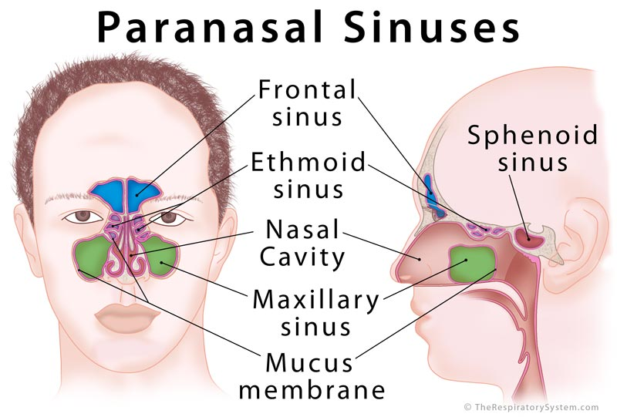
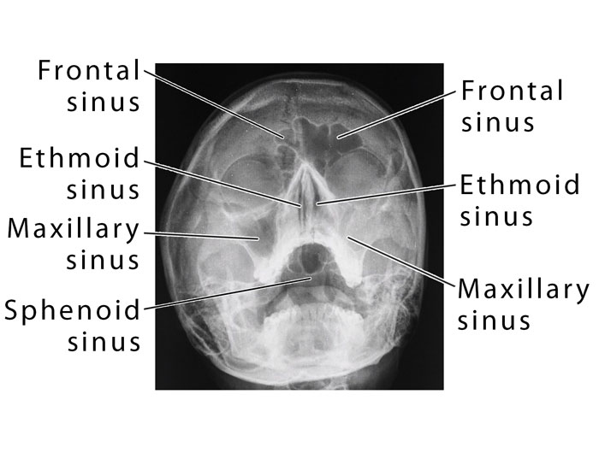
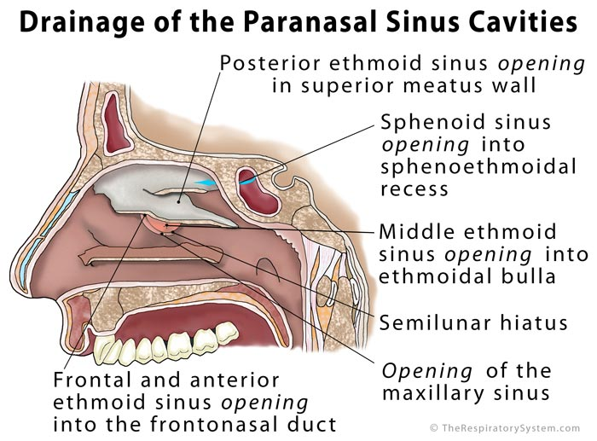
CLINICAL ANATOMY
- SINUSITIS: Because the paranasal sinuses are continuous with the nasal cavities through apertures that open into them, infection may spread from the nasal cavities, producing inflammation and swelling of the mucosa of the sinuses and local pain.
- INFECTION OF ETHMOIDAL CELLS: If nasal drainage is blocked, infections of the ethmoidal cells may break through the fragile medial wall of the orbit. Severe infections from this source can cause blindness because some posterior ethmoidal cells lie close to the optic canal which gives passage to the optic nerve and ophthalmic artery.
- INFECTION OF MAXILLARY SINUSES: The maxillary sinuses are the most commonly infected, probably because their openings are commonly small and are located high on their superomedial walls. When the mucous membrane of the sinus is congested, the maxillary ostia are often obstructed. A maxillary sinus can be cannulated and drained by passing a cannula from the naris through the maxillary ostium into the sinus.

