NNAMOCHA UCHE CHRIS
15/ENG04/036
3G ARCHITECTURE and working principles
- 3G makes use of WCDMA, a technology that shares much with CDMA networks used throughout the world, though it is not compatible with them.
- Base level 3G networks are generally capable of downlink speeds as 384 kbps.
- The 3G architecture takes advantage of the existing GSM and GPRS networks which serve as a core network in 3G infrastructure.
The UMTS is made up of 3 main components: a) User Equipment:
It is assigned to a single user and contains all the functions needed to access UMTS services. It contains: – Mobile Equipment (ME) : It is a radio terminal which is used to connect the UMTS subscriber with the fixed part of UMTS system via the radio interface Uu.
– UMTS Subscriber Identity Module (USIM): A smartcard which contains the subscriber identity, authentication algorithms, encryption keys etc.
b) UMTS Terrestrial Radio Access Network (UTRAN):
It handles cell-level mobility. It is a system of base station and controller handling function related to mobility. It contains:
1. Nodes B (Base Stations):
• It converts the data between Uu radio interface and the Iub interface connecting a Node B with the RNC. • It performs physical level processing such as channel coding, data interleaving, rate matching, modulation etc.
2. Radio Network Controllers (RNC):
• RNC’s controls and manages radio resources to Node B. • RNC performs the data-link layer processing and participates in handover operations. • RNC is considered a single access point of UTRAN for the core network. • It’s connected to a single MSC/VLR to route circuit-switched traffic and to a single SGSN to route packet switched traffic.
c) Core Network (CN):
The core network is shared with GSM and GPRS. The CN contains functions for intersystem handover, gateways to other networks and performs location management. It contains:
- Home Location Register (HLR)
- Mobile Station Controller / Visitor Location Register (MSC/VLR).
- Gateway MSC: Connect UMTS to external circuit switch n/w (e.g PSTN)
- Serving GPRS Support Node (SGSN): It serves the Packet-switched traffic.
- Gateway GPRS Support Node (GGSN): Connects UMTS to external packet switched. (e.g. Internet)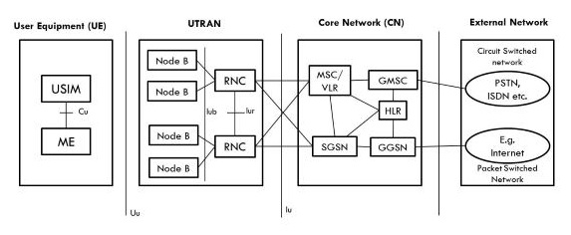

4G ARCHITECTURE and working Principles
- 4G stands for fourth generation cellular system.
- 4G is evaluation of 3G to meet the forecasted rising demand.
- It is an integration of various technologies including GSM,CDMA,GPRS,IMT-2000 ,Wireless LAN.
- Data rate in 4G system will range from 20 to 100 Mbps.
Features:
- Fully IP based Mobile System.
- It supports interactive multimedia, voice, streaming video, internet and other broadband service.
- It has better spectrum efficiency.
- It supports Ad-hoc and multi hop network.
4G Architecture
- Figure shows Generic Mobile Communication architecture.
- 4 G network is an integration of all heterogeneous wireless access networks such as Ad-hoc, cellular, hotspot and satellite radio component.
- Technologies used in 4 G are smart antennas for multiple input and multiple output (MIMO), IPv6, VoIP, OFDM and Software defined radio (SDR) System.
Smart Antennas:
- Smart Antennas are Transmitting and receiving antennas.
- It does not require increase power and additional frequency.
IPV6 Technology:
- 4G uses IPV6 Technology in order to support a large number of wireless enable devices.
- It enables a number of application with better multicast, security and route optimization capabilities.
VoIP:
- It stands for Voice over IP.
- It allows only packet to be transferred eliminating complexity of 2 protocols over the same circuit.
OFDM:
- OFDM stands for Orthogonal Frequency Division Multiplexing.
- It is currently used as WiMax and WiFi.
SDR:
- SDR stands for Software Defined Radio.
- It is the form of open wireless architecture.

Advantages:
- It provides better spectral efficiency.
- It has high speed, high capacity and low cost per bit.
Disadvantage:
- Battery usage is more.
- Hard to implement.
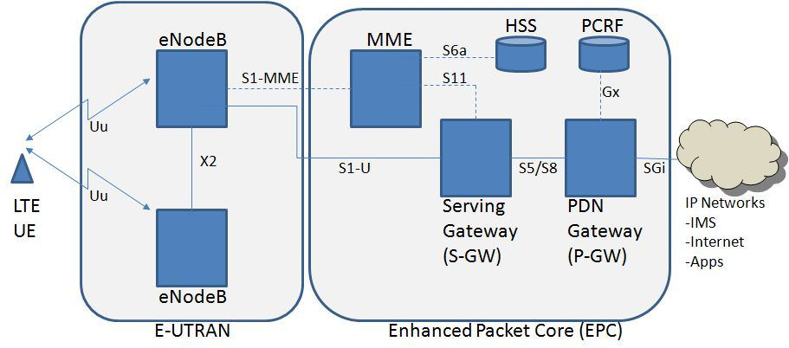
MME- Mobility Management Entity
It is used for Paging ,Authentication, Handover and Selection of Serving Gateway
SGW- Serving gateway
It is used to Routing and Forwarding user data packet.
PDN-GW Packet Data Network Gateway
It is used for user equipment (UE) IP allocation
HSS -Home Subscriber Server
It is a user Database used for service subscriber, user identification and addressing
PCRF -Policy and Charging Rule Function
It provide quality of service and charging
eNode B-evolved Node B
It is used as radio resources management and radio bearer control

WORKING PRINCIPLE OF 5G
This is the 5th generation of mobile wireless systems. It integrates perfectly with the internet of things. Like other cellular networks, 5G uses a system of cell sites that divides their territory into sectors and send encoded data through radio waves. Each cell site must be connected to a network backbone, whether it is wired or wireless connection. It uses a type of encoding called OFDM, which is similar to the 4G LTE uses. The air interface is designed so it has much lower latency and greater flexibility than LTE.

ADVANTAGE OF 3G
- Faster data rates.
- Increased capacity
- High speed mobile internet access.
- Support multimedia applications such as video
- Value added services like mobile television, GPS, video call and video conference.

DISADVANTAGE OF 3G
- Power consumption is high
- Requires 3G compatible handsets
- 3G requires closer base stations which is expensive.

ADVANTAGES OF 4G
- Seamless network of multiple protocol and air interfaces.
- Higher bandwidith.
- 4G is faster than 3G.
- Quickly download files over a wireless network.
- Support for interactive multimedia, voice, internet and other broadband service.
- Extremely high voice quality.

DISADVANTAGES OF 4G
- Need complex hardware.
- New ferquencies means new componets in cell towers.
- It is impossible to make your current equipment compatible with the 4G network.
- Higher data prices for consumers.

ADVANTAGES OF 5G
- More effective and efficient.
- High resolution and bi-directional large bandwidth shaping.
- Technology to facilitate subscriber supervision tools for the quick action.
- New frequency means new components in cell towers.

DISADVANTAGE OF 5G
- 5G network technology will take more time for security and privacy issues.
- 5G is more costly compared to other Mobile network technology because many technical/ official engineers are required to install and maintain it.
- Coverage indoor distance up to 2 meters and 300 meters outdoors can be achieved due to greater losses at higher frequencies as 5Gmm wave influences fron such losses.

DIFFERENCE BETWEEN 2G,3G,4G AND 5G
Technology | 2G | 3G | 4G | 5G
FREQUENCY | 850-1900MHZ | 1.6-2.5GHZ | 2-8GHZ
STANDARD | GSM,GPRS,EDGE ETC. | WCDMA,CDMA  2000 | All access convergence including:OFMDA, MC-CDMA Network-LMPS | CDMA & BDMA
SWITCHING | CIRCUIT PACKET | CIRCUIT PACKET | PACKET | ALL PACKET
DATA BANDWIDTH | 14.4 kbps to 384 kbps | 2 Mbps | 2Mbps to 1 Gbps | 1Gbps & Higher (as demand)
SERVICE | Digital voice higher capacity, packetized data | Integrated high quality audio, video and data | Dynamic information access, wear-able devices, HD streaming global roaming | Dynamic information access, wear-able devices,HD streaming any demand of users; upcoming all technologies; global roaming smoothly.
CORE NETWORK | PSTN Packet Network | Packet network | All IP Network | Flatter IP Network and 5G Network Interfacing (5H-NI)
MULTIPLE ACCESS | TDMA CDMA | CDMA | CDMA | CDMA And BDMA
REQUIREMENTS | No official requirements Digital Technology | ITU’s IMT-2000 required 144kbps mobile, 384 kbps indoors | ITU’s IMT Advanced requirements include ability to operate in up to 40 MHz radio channels and with very high spectral efficiency. | At least 1 GB/s or more data rates to support ultra-high definition video and virtual reality, application, 10 GB/s data rates to support mobile cloud service
STARTS FROM | 1990 | 2001 | 2010 | 2015

THE CORRELATION BETWEEN 5G AND COVID 19.
There is no correlation between 5G and COVID-19. There is no scientific evidence that any electromagnetic wave can give rise to a virus let alone spread it. Since the beginning of the year there have been ongoing conversations about the COVID-19 virus for obvious reasons [countries are on lockdown and people are dying]. Somehow, in the middle of all this, conversations about 5G technology being the cause of the virus began to be popular.
5G is the fifth generation of wireless network technology. The 5g is at the end of the day just electromagnetic waves.
How harmful electromagnetic waves are depends on the frequency of the wave. The lower the frequency, the less harmful it is and vice versa. 5G is more powerful than 4G, meaning the frequency of 5G is higher so in theory it is more dangerous.
COVID-19 is however a virus. Viruses are extremely tiny and they do not just infect humans, they can infect basically any living organism
In conclusion, 5G and COVID-19 are two entirely different things. One is a contagious virus that is in no shape or form related to electromagnetic waves and the other is a wireless technology. Another fact to support my claim that there is no correlation what so ever is that the COVID-19 virus has hit nations like Chad, Niger, Mali where 5G isn’t even in use yet.

