HAASTRUP OLUWADOYINSOLA MERCY
15/ENG06/032
MECHANICAL ENGINEERING
MEE 586
ASSIGNMENT
- An integrated CAD/CAM is an application that provides one model supporting both design and manufacturing functions instead of having various file formats, numerous data translations/conversions, and different CAD and CAM models.
Advantages of integrated CAD/CAM
The advantages of integrated CAD/CAM can be discussed under the following; Time, Cost and Quality.
TIME
- Improved quality – Working with a single model and data format having with no need to import, translate, or convert data which eliminates chances for error, maintains high levels of accuracy, and minimizes delays related to design errors.
- Elimination of wasted effort – Accessing design data in a single data format is simple and straightforward, eliminating file conversions/translations and the need to update drawings and associated tool paths when changes are made.
COST
- Faster design through manufacturing cycles – Accelerating design through manufacturing cycles saves time and money.
- Early identification of cost-effective production techniques – Evaluating cost-effective production techniques and materials early in the process can result in significant cost savings.
QUALITY
- Improved accuracy – Operating on a single, common model and data format eliminates the potential for manual errors that can negatively affect quality.
- Fewer machining issues – Iterating on manufacturability up front as part of product development minimizes the likelihood for machining issues once production starts.

- Scope of CAD/CAM
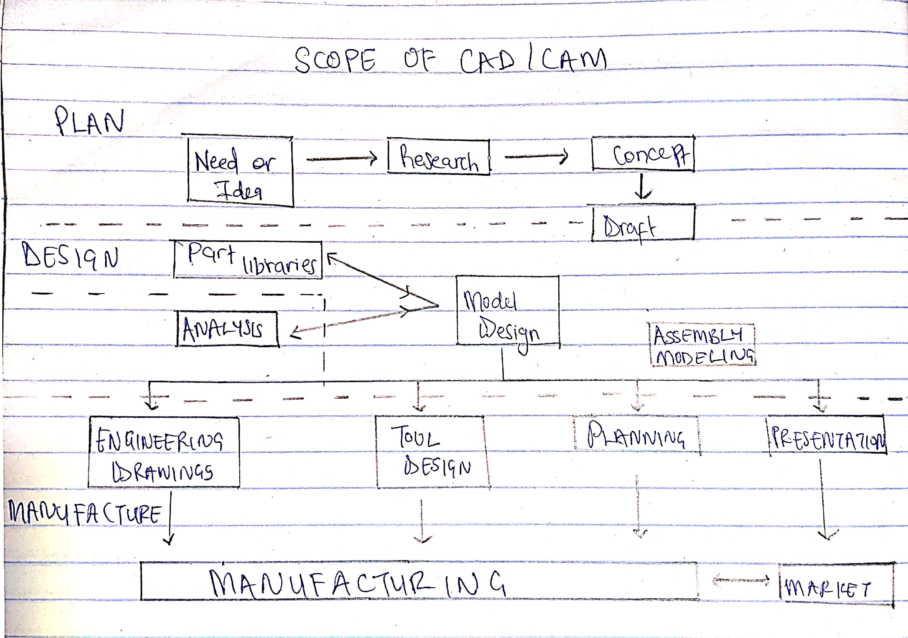

Characteristics of good CAD software
- Efficiency: An efficient software is that which can use fewer resources such as CPU in terms of time and usage to give a better output.
- Simplicity: A software must be simple to use and easy to understand and must be user friendly.
- Flexibility: The software must be able to incorporate the design modification with out much of difficulty.
- Readability: This provides the capability within the software to help the user as and when required.
- Portability: The software must have the capacity to get transferred from one system to other.
- Reliability: To avoid causality the software must be able to avoid unwanted operation.
- Recover ability: A good software must be able to give warnings before getting crashed and must be able to recover.

