FOLASHADE JEGEDE
300 LEVEL
17/MHS01/168

MEDICINE AND SURGERY

GROSS ANATOMY OF HEAD AND NECK

Assignment
1) Discuss the Anatomy of the tongue and comment on its applied anatomy.
2) Write an essay on the air sinuses.

Answers
1) Anatomy of the Tongue
Introduction: The tongue is a mobile muscular organ in the mouth covered with mucous membrane which is a moist, pink tissue. It can assume a variety of shapes and positions. It is partly in the oral cavity and party in the oropharynx. The tongue functions in mastication, taste and oral cleansing but its main functions are forming words during speech (articulation) and transporting food down the oropharynx as part of deglutition (swallowing). There are tiny bumps on the tongue called papillae which give it its rough texture. The papillae are covered by thousands of taste buds. Taste buds are collections of nerve-like cells that connect to nerves running into the brain.
Parts and Surfaces of Tongue
The tongue has a root, body and apex. The root of the tongue is attached to the posterior portion of the mouth, extending between the mandible, hyoid and nearly vertical posterior surface of the tongue. The body of the tongue is the anterior, approximately two-thirds of the tongue between the root and apex. The apex of the tongue is the anterior end of the body, which rests against the incisor teeth. The body and apex of the tongue are extremely mobile.
The tongue has two surfaces. The more extensive, superior and posterior surface is the dorsum of the tongue. The inferior surface of the tongue, also known as its underside usually rests against the floor of the mouth. The margin of the tongue separating the two surfaces is related on each side to the lingual gingivae and lateral teeth. The dorsum of the tongue features a V-shapes groove, which is the terminal sulcus of the tongue and points posteriorly to the foramen cecum. It does not have any function and is absent in some individuals.
The terminal sulcus divides the dorsum of the tongue transversely into a presulcal anterior part in the oral cavity proper and a postsulcal posterior part in the oropharynx. A midline groove divides the anterior part of the tongue into right and left parts. The mucosa of the anterior part of the tongue is relatively thin and closely attached to the underlying muscle. The papillae found on it are:
i) Vallate papillae: They are large and flat topped, lies directly anterior to the terminal sulcus and are arranged in a V-shaped row. They are surrounded by deep circular trenches, whose walls are studded with taste buds.
ii) Foliate papillae: They are small lateral folds of the lingual mucosa. They are poorly developed in humans.
iii) Filiform papillae: They are long, numerous and contain afferent nerve endings that are sensitive to touch. These scaly, conical projections are pinkish grey and are arranged in V-shaped rows that are parallel to the terminal sulcus, except at the apex, where they tend to be arranged transversely.
iv) Fungiform papillae: They are mushroom-shaped pink or red spots scattered among the filiform papillae, but most numerous at the apex and the margins of the tongue.
The vallate, foliate and most of the fungiform papillae contain taste receptors in the taste buds. The mucosa of the posterior part of the tongue is thick and freely movable. It has no lingual papillae. The underlying lymphoid nodules collectively known as lingual tonsil give this part of the tongue an irregular cobblestone appearance.
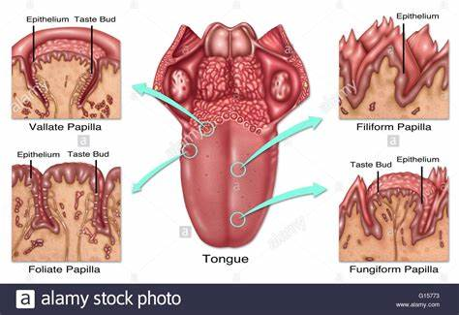
The inferior surface of the tongue is covered with a thin, transparent mucous membrane. This surface is connected to the floor of the mouth by a midline fold called the frenulum of the tongue. The frenulum allows the anterior part of the tongue to move freely.
Muscles of the Tongue
The tongue is essentially a mass of muscles that is mostly covered by mucosa. The muscles of the tongue do not act in isolation, and some muscles perform multiple actions. In general, extrinsic muscles alter the position of the tongue, and intrinsic muscles alter its shape. The four intrinsic and four extrinsic muscles in each half of the tongue are separated by a median fibrous lingual septum, which merges posteriorly with the lingual aponeurosis.
The extrinsic muscles of the tongue are genioglossus, hyoglossus, styloglossus and palatoglossus originate outside the tongue and attach to it. They mainly move the tongue but they can alter its shape as well.

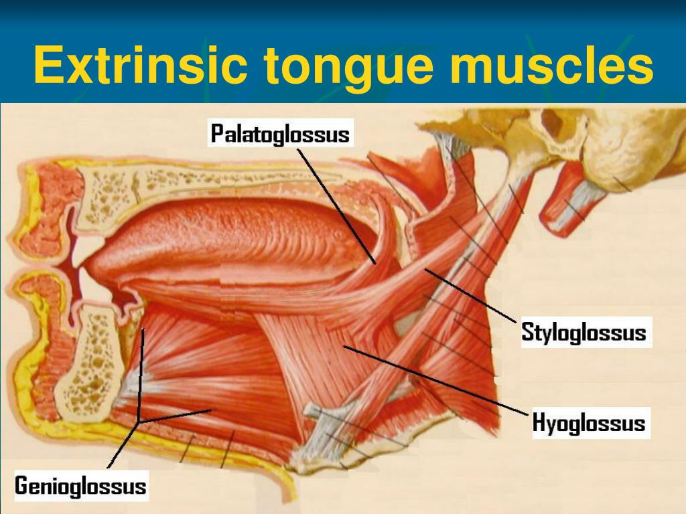
The intrinsic muscles of the tongue are the superior and inferor longitudinal, transverse and vertical muscles. They have their attachments entirely within the tongue and are not attached to the bone. The superior and inferior longitudinal muscles act together to make the tongue short and thick and to retract the protruded tongue. The transverse and vertical muscles act simultaneously to make the tongue long, narrow, which may push the tongue against the incisor teeth or protrude the tongue from the open mouth, especially when acting with the posterior inferior part of the genioglossus.

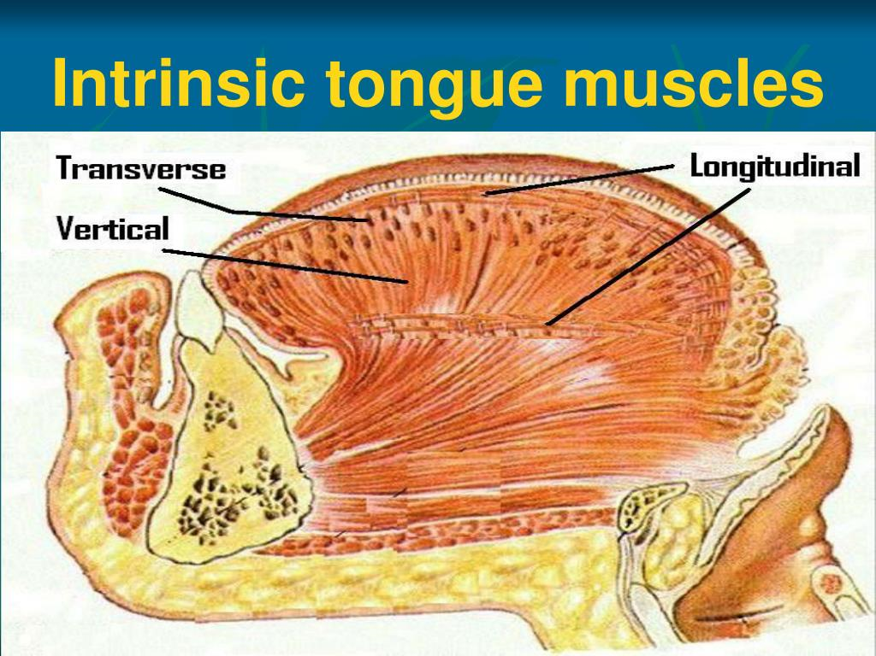
Innervation of the Tongue
All muscles of the tongue, except the palatoglossus, receive motor innervation from hypoglossal nerve (CN XII). Palatoglossus is supplied by the pharyngeal plexus. For general sensation, the mucosa of the anterior two-thirds of the tongue is supplies by the lingual nerve, a branch of mandibular nerve (CN V₃). For special sensation (taste), this part of the tongue except for vallate papillae is supplied by the chorda tympani nerve, a branch of facial nerve (CN VII). The mucosa of the posterior third of the tongue and the vallate papillae are supplied by the lingual branch of the glossopharyngeal nerve (CN IX) for both general ans special sensation. A small area of the tongue, just anterior to the epiglottis is supplied by a part of internal laryngeal nerve, a branch of vagus nerve (CN X) for mostly general sensation and some special sensation.
There are four basic taste sensations, which are: sweet, salty, sour and bitter. A fifth basic taste (umami-stimulated by monosodium glutamate) has more recently been identified. Certain areas of the tongue have been described as being most sensitive to different tastes, but evidence indicates all areas are capable of detecting different tastes. Other tastes expressed by gourmets are influenced by olfactory sensation. (smell and aroma).
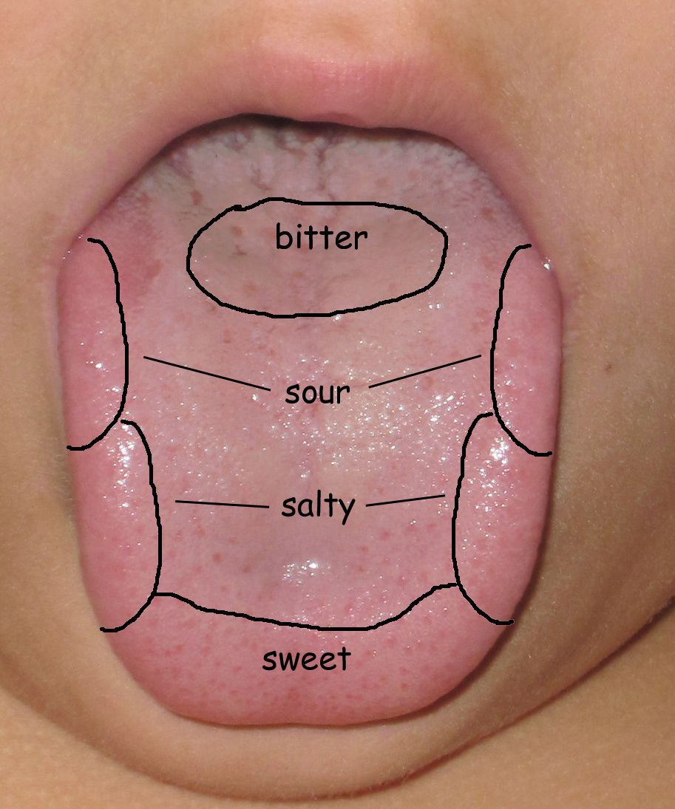
Vasculature of the Tongue
The arteries of the tongue are derived from the lingual artery, which arises from the external carotid artery. The dorsal lingual arteries supply the root of the tongue, the deep lingual arteries supply the body of the tongue.
The veins of the tongue are dorsal lingual veins, which accompany the lingual artery. The deep lingual veins which begin at the apex of the tongue, run posteriorly to join the sublingual vein which often varicose in elderly people. Some or all the veins may drain into the internal jugular vein, or they may do so indirectly, joining first to form a lingual vein that accompanies the initial part of the lingual artery.
The lymphatic drainage of the tongue is exceptional. Most of he lymphatic drainage converges toward and follows the venous drainage; however, lymph from the tip of the tongue, frenulum, and central lower lip runs an independent course. Lymph from root of the tongue drains bilaterally into the superior deep cervical lymph nodes. Lymph from the medial part of the body drains bilaterally and directly to the inferior deep cervical lymph nodes. Lymph from the right and left lateral parts of the body drains into the submandibular lymph nodes on the ipsilateral side. The apex and frenulum drain into the submental lymph nodes, the medial portion draining bilaterally.
All lymph nodes of the tongue ultimately drain to the deep cervical nodes and passes via the jugular venous trunks into the venous system at the right and left venous angles.
Tongue Pathological Conditions
1) Thrush (candidiasis): A yeast (candida albicans) grows over the surface of the tongue and mouth.
2) Hairy Tongue: Papillae can over grow on the surface of the tongue, giving it a white or black appearance. Scraping of the papillae corrects this harmless condition.
Applied Anatomy
1) Injury to the hypoglossal nerve produces paralysis of the muscles of the tongue.
2) Glossitis: It is usually a part of generalized ulceration. In certain anemias tongue becomes bald due to atrophy of filiform papillae.
3) Due to the presence of rich network of lymphatics and of loose areolar tissue in the substance of the tongue, it is responsible for enormous swelling of the tongue in acute glossitis.
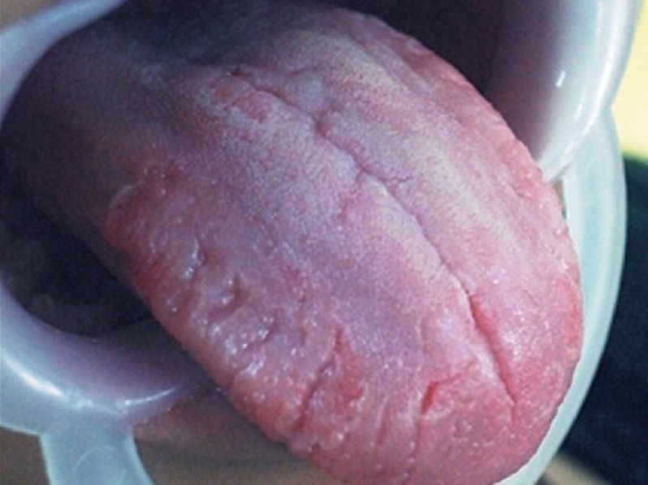
4) Undersurface of the tongue is a good site for observation of jaundice.

2) AIR SINUSES
The air sinuses also known as paranasal sinuses are air-filled extensions of the respiratory part of the nasal cavity into the following cranial bones: frontal, ethmoid, sphenoid and maxilla. They are named according to the bones in which they are located. The sinuses continue to invade the surrounding bone, and marked extensions are common in crania of older people.
Frontal Sinuses: The right and left frontal sinuses are between the outer and inner tables of the frontal bone, posterior to the superciliary arches and the root of the nose. Frontal sinuses are usually detectable in children by 7 years of age. The right and left sinuses each drain through a frontonasal duct into the ethmoidal infundibulum, which opens into the semilunar hiatus of the middle nasal meatus. The frontal sinuses are innervated by branches of supraorbital nerves (CN V₁).
The right and left frontal sinuses are rarely of equal size, and the septum between them is not usually situated entirely in the median plane. The frontal sinuses vary in size from approximately 5mm to large spaces extending laterally into the greater wings of the sphenoid. Often, a frontal sinus has two part: a vertical part in the squamous part of the frontal bone, and a horizontal part in the orbital part of the frontal bone. One or both parts may be large or small. When the supra-orbital part is large, its roof forms the floor of the anterior cranial fossa and its floor forms the roof of the orbit.
Ethmoid Sinuses: The ethmoidal sinuses are small invaginations of the mucous membrane of the middle and superior nasal meatus into the ethmoid bone between the nasal cavity and the orbit. The ethmoidal sinuses usually are not visible in plain radiographs before 2 years of age; however, they are recognizable in CT scans. The anterior ethmoidal sinuses drain directly or indirectly into the middle nasal meatus through the ethmoidal infundibulum. The middle ethmoidal sinuses open directly into the middle meatus and are sometimes called bullar cells because they form the ethmoidal bulla. The posterior ethmoidal sinuses open directly into the superior meatus. The ethmoidal cells are supplied by the anterior and posterior ethmoidal branches of the nasociliary nerves (CN V₁).
Sphenoidal Sinuses: The sphenoidal sinuses are located in the body of the sphenoid, but they may extend into the wings of this bone. They are unevenly divided and separated by a bony septum. Because of this extensive formation of air cells (pneumatization), the body of sphenoid is fragile. Only thin plates of bone separate the sinuses from several important structures: the optic nerves and optic chiasm, the pituitary gland, the internal carotid arteries, and the cavernous sinuses. The sphenoidal sinuses are derived from a posterior ethmoidal several posterior ethmoidal cells invade the sphenoid, giving rise to multiple sphenoidal sinuses that open separately into the sphenoethmoidal recess. The posterior ethmoidal arteries and the posterior ethmoidal nerves that accompany the arteries supply the sphenoidal sinuses.
Maxillary Sinuses: The maxillary sinuses are the largest of the air sinuses. They occupy the bodies of the maxillae and communicate with the middle nasal meatus. The apex of the maxillary sinus extends toward and often into the zygomatic bone. The base of the maxillary sinus forms the inferior part of the lateral wall of the nasal cavity. Its roof is formed by the floor of the orbit and its the floor is formed by the alveolar part of the maxilla. The roots of maxillary teeth, particularly the first two molars, often produce conical elevations in the floor of the sinus.
Each maxillary sinus drains by one or more openings, the maxillary ostium, into the middle nasal meatus of the nasal cavity by way of the semilunar hiatus. The arterial supply of the maxillary sinus is mainly from superior alveolar branches of the maxillary artery. Innervation of the maxillary sinus is from the anterior, middle and posterior superior alveolar nerves, which are branches of the maxillary nerve.
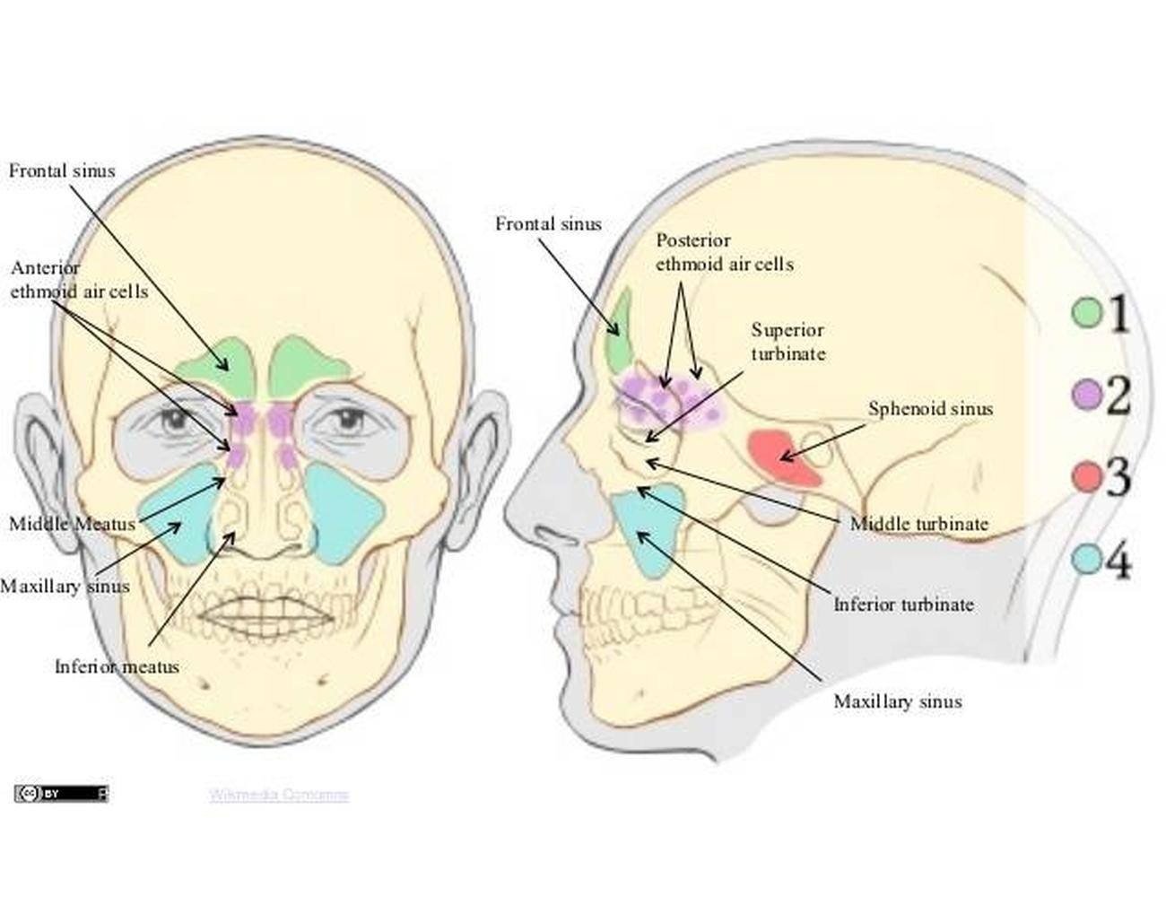 Clinical Significance
i) Dental infection: It is infection from the maxillary premolar and molars can easily communicate and infect the maxillary antrum.
ii) Maxillary sinusitis: Because of the thickened and inflammed sinus lining compresses the nerve supply of the maxillary posterior teeth causing tenderness of the maxillary teeth.
iii) The infraorbital and superior alveolar vessels are frequently ruptured in maxillary fracture causing the hematoma formation in the antrum.
iv) Root pieces: Root pieces of maxillary teeth may sometimes be accidentally forced into the maxillary antrum.
v) Oroantral Communication: Traumatic extraction of maxillary teeth can cause oroantral communication.
