- Write an essay on the cavernous sinus
ANSWER
The human brain is a highly vascular organ responsible for coordinating a myriad of processes throughout the body. Therefore, it is important that a pathway exists to return blood that enters the cranium to systemic circulation. The cavernous sinuses are one of several drainage pathways for the brain. In addition to receiving venous drainage from the brain, it also receives tributaries from parts of the face.
The cavernous sinuses are 1 cm wide cavities that extend a distance of 2 cm from the most posterior aspect of the orbit to the petrous part of the temporal bone. They are bilaterally paired collections of venous plexuses. They are located within the middle cranial fossa, on either side of the sella turcica of the sphenoid bone. They are enclosed by the endosteal and meningeal layers of the dura mater.
The cavernous sinus is roofed by an inner layer of dura mater that continues with the diaphragma sellae that covers the superior part of the pituitary gland. The roof of the sinus also has several other attachments. Anteriorly, it attaches to the anterior and middle clinoid processes, posteriorly it attaches to the tentorium (at its attachment to the posterior clinoid process). Part of the periosteum of the greater wing of the sphenoid bone forms the floor of the sinus. The body of the sphenoid acts as the medial wall of the sinus while the lateral wall is formed from the visceral part of the dura mater. Anteriorly, the sinus is bordered by the superior orbital fissure.
Several important structures pass through the cavernous sinus to enter the orbit. They can be sub-classified by whether they travel through the sinus itself, or through its lateral wall:
Travel through the sinus themselves: | Travel through the lateral wall of the sinus:
Internal carotid artery | Oculomotor nerve (CNIII)
Abducens nerve (CNVI) | Trochlear nerve (CNIV)
 | The Ophthalamic(CNV₁) and maxillary(CNV₂) divisions of the trigeminal nerve (CNV).
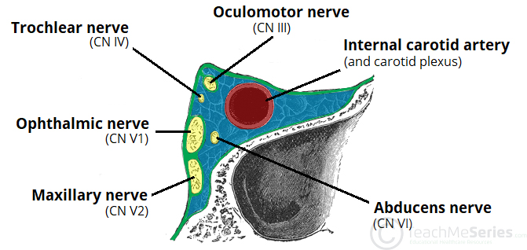
The cavernous sinus is the only site in the body where an artery (internal carotid) passes completely through a venous structure. This is thought to allow for heat exchange between the warm arterial blood and cooler venous circulation.
The cavernous sinuses also receive blood from the superior and inferior ophthalmic veins, cerebral veins and the emissery veins from the pterygoid plexus of veins in the infratemporal fossa.
There are however several relations to the cavernous sinus. Medially, the sinus is adjacent to the lateral walls of the pituitary fossa with the pituitary gland, the sphenoid bone and its air sinus. The cerebral part of the internal carotid artery courses superiorly. Laterally, the medial aspect of the temporal lobe of each hemisphere lies adjacent to the sinus. And posteriosuperiorly, the uncus of the temporal lobe has a relation to the sinus.
Clinical Anatomy: An infection can spread to the cavernous sinus, which can result in a cavernous sinus thrombosis.

- Discuss the walls of the nose.
ANSWER
The nose is the most prominent part of the human face. It has internal and external parts. It is a pyramidal structure, with its root located superiorly and apex sitting inferiorly. The root is continuous with the anterior surface of the head and the part between the root and the apex is called the dorsum of the nose. Inferior to the apex are the two nostrils, which are the openings to the nasal cavity. The nostrils are separated by the nasal septum and are laterally bounded by the ala nasi (wings of the nostrils) which are the lateral processes of the septum.
The external nose is comprised of both bony and cartilaginous components. The bony part shapes the nose root, formed by the nasal, maxillae and frontal bones. The cartilaginous part is located inferiorly and is comprised of several alar, two lateral, and one septal cartilage: alar cartilages, lateral processes of the alar cartilage and the septal cartilage.
The internal part of the nose is the nasal cavity. The two nasal cavities sit within the external nose and the adjacent skull. The cavities open anteriorly to the face through the two nares. Posteriorly the cavities communicate with the nasopharynx by two apertures called choanae.
Besides the anterior and posterior apertures, each nasal cavity has a roof, floor, and lateral and medial walls. The nasal cavity is bordered by the following structures:
- Roof: Formed by the nasal, frontal, sphenoid, and ethmoid bones (cribriform foramina, which transmits CN I for smell).
- Floor: Formed by the maxilla and the palatine bones. The incisive foramen transmits branches of the sphenopalatine artery and the nasopalatine nerve for general sensation from the nasal cavity and palate.
- Medial wall (nasal septum): Formed by the perpendicular plate of the ethmoid bone, the vomer bone, and the septal cartilage.
- Lateral wall: Formed by the superior, middle and inferior nasal conchae. In addition, the maxillary, sphenoid, and palatine bones contribute to the lateral wall. The lateral wall contains the following openings:
  - Sphenoethmoidal recess: The space between the superior nasal concha and the sphenoid bone, with openings from the sphenoid sinus.
  - Superior meatus: The space inferior to the superior nasal concha, with openings from the posterior ethmoidal air cells.
  - Middle meatus: The space inferior to the middle nasal concha, with openings for the frontal sinus via the nasofrontal duct, the middle ethmoidal air cells on the ethmoidal bulla, and the anterior ethmoidal air cells and maxillary sinus in the hiatus semilunaris.
  - Inferior meatus: The space inferior to the inferior nasal concha, with an opening for the nasolacrimal duct, which drains tears from the eye into the nasal cavity.
  - Sphenopalatine foramen: An opening posterior to the middle nasal concha receives the nasopalatine nerve and the sphenopalatine artery from the pterygopalatine fossa into the nasal cavity.

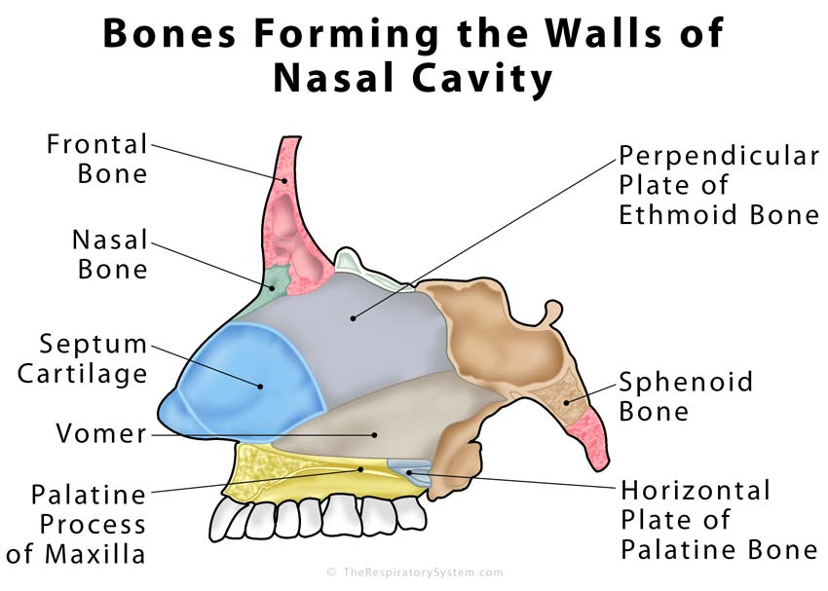
The nasal cavities and septum are lined with a mucous membrane and are richly vascularized by branches of the maxillary, facial, and ophthalmic arteries. The nasal cavity receives innervation via branches of the olfactory(CNI), ophthalmic (CNV₁), and maxillary nerves (CNV₂).
Clinical Anatomy: Epistaxis is defined as acute hemorrhage from the nostril, nasal cavity, or nasopharynx.

