NAME: ALAO BOLAJI WILLIAMS

MATRIC NO: 17/MHS01/049

CLASS: 300 LEVEL

COURSE: GROSS ANATOMY

ASSIGNMENT: 1) Discuss the Anatomy of the tongue and comment on its applied anatomy. 2) write an essay on the air sinuses

1) Discuss the Anatomy of the tongue and comment on its applied anatomy
TONGUE
The world is riddled with numerous stimuli that living organisms interact with every day. Each individual is able to perceive, process, and integrate these stimuli with the aid of general and specialized sensory receptors throughout the body. The tongue is a mass of muscle that is almost completely covered by a mucous membrane. It occupies most of the oral cavity and oropharynx. It is known for its role in taste, but it also assists with mastication (chewing), deglutition (swallowing), articulation (speech), and oral cleansing the embryologic origins of the tongue first appear at 4 weeks' gestation. The body of the tongue forms from derivatives of the first branchial arch. This gives rise to 2 lateral lingual swellings and 1 median swelling (known as the tuberculum impar). The lateral lingual swellings slowly grow over the tuberculum impar and merge, forming the anterior two thirds of the tongue. Parts of the second, third, and fourth branchial arches give rise to the base of the tongue. Occipital somites give rise to myoblasts, which form the intrinsic tongue musculature.
Parts and surfaces of tongue
Under normal circumstances, the tongue is a pink, muscular organ located within the oral cavity proper. It is kept moist by the products of the major and minor salivary glands, which aids the organ as it facilitates deglutition, speech, and gustatory perception. While there is significant variability in the length of the tongue among individuals, on average, the organ is roughly 10 cm long. It has three main parts:
- The Apex: the tip or apex of the tongue is the most anterior, and most mobile aspect of the organ.
- The Body: the body of the tongue. It has a rough dorsal (superior) surface that abuts the palate and is populated with taste buds and lingual papillae, and a smooth ventral (inferior) surface that is attached to the floor of the oral cavity by the lingual frenulum.
- The Root or Base: the base of the tongue is the most posterior part of the organ. It is populated by numerous lymphoid aggregates known as the lingual tonsils along with foliate papillae along the posterolateral surface.
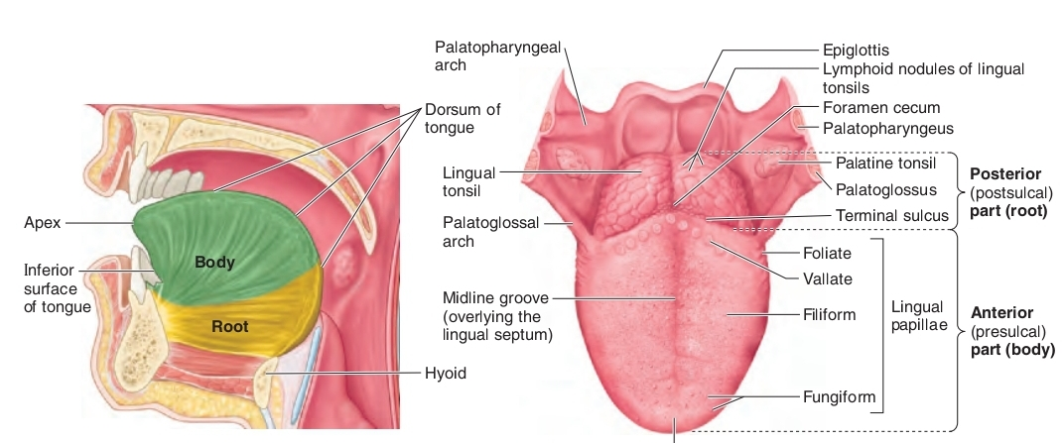
The median sulcus of the tongue separates the body into left and right halves. The terminal sulcus, or groove, is a v-shaped furrow that separates the body from the base of the tongue. At the tip of this sulcus is the foramen cecum, a remnant of the proximal thyroglossal duct. The base of tongue contains the lingual tonsils, the inferiormost portion of waldeyers ring. There are numerous important structures surrounding the tongue. It is limited anteriorly and laterally by the upper and lower rows of teeth. Superiorly, it is bordered by the hard (anterior part) and soft (posterior part) palates. Inferiorly, the root of the tongue is continuous with the mucosa of the floor of the oral cavity; with the sublingual salivary glands and vascular bundles being located below the mucosa of the floor of the oral cavity.
The tongue features two surfaces. The more extensive, superior and posterior surface is the dorsum of the tongue (commonly referred to as the top of the tongue). The inferior surface of the tongue (commonly referred to as its underside) usually rests against the floor of the mouth. The margin of the tongue separating the two surfaces is related on each side to the lingual gingivae and lateral teeth. The dorsum of the tongue is characterized by a v-shaped groove, the terminal sulcus of the tongue, and the angle of which points posteriorly to the foramen cecum. This small pit, frequently absent, is the non-functional remnant of the proximal part of the embryonic thyroglossal duct from which the thyroid gland developed. The terminal sulcus divides the dorsum of the tongue transversely into a presulcal anterior part in the oral cavity proper and a postsulcal posterior part in the oropharynx. A midline groove divides the anterior part of the tongue into right and left parts. The dorsal mucosa of the oral tongue is characterized by numerous raised structures known as lingual papillae. They give the characteristic rough appearance of the dorsal surface that is not appreciated on the ventral surface of the tongue. The pharyngeal tongue also has raised dome-like structures throughout the mucosa. However, these are lymphatic aggregates (i.e. lingual tonsils) and should not be confused with papillae.
The Lingual Papillae
There are four types of lingual papillae found on the surface of the human tongue.
- Filiform papillae are the most abundant of the four types of papillae. They are stretched, conical, grey-white papillae that are covered in a heavy coat of keratinized squamous epithelium. By making the dorsal surface of the tongue rough, these papillae provide friction to allow movement of the food bolus during chewing. It should be noted that these papillae do not possess taste buds.
- Fungiform papillae are weakly keratinized and less abundant than the filiform papillae. However, they are scattered across the entire dorsal surface of the tongue. These highly vascular, mushroom-shaped papillae contain a few taste buds on the apical aspect.
- Foliate papillae appear as bilaterally paired, parallel, longitudinal slits on the posterolateral margin of the tongue, near the sulcus terminalis. The mucosa is non-keratinized and the papillae are populated with numerous taste buds.
- Circumvallate (vallate) papillae are organized linearly, as a set of four to six large papillae anterior to each limb of the sulcus terminalis (i.e. eight to twelve papillae in total). In longitudinal section, the characteristic furrow found within the papillae can be appreciated. These moats facilitate the drainage of serous salivary von ebner glands that empty into the structure. The persistent lubrication creates a favorable environment for gustatory particles to dissolve so that they can be detected by the taste buds.
The inferior surface of the tongue is covered with a thin, transparent mucous membrane. This surface is connected to the floor of the mouth by a midline fold called the frenulum of the tongue. The frenulum allows the anterior part of the tongue to move freely. On each side of the frenulum, a deep lingual vein is visible through the thin mucous membrane. A sublingual caruncle (papilla) is present on each side of the base of the lingual frenulum that includes the opening of the submandibular duct from the sub mandibular salivary gland.
The Taste Buds
While taste buds are distributed throughout the entire oral cavity, they are at higher concentrations on the tongue. Each taste bud is clear, oval and covered by stratified squamous epithelium. A combination of elongated taste (gustatory), supportive, and basal stem cells can be found within each taste bud. The gustatory cells have an apical taste pore surrounded by numerous microvilli that binds dissolved molecules and brings them closer to the receptors responsible for taste. However, these cells have a relatively high turnover rate, as their shelf life is roughly seven to ten days.
There are five gustatory sensations that are perceived by individuals. These are sweet, salty, sour, bitter, and umami. The microvilli found on the apical surface of the taste cells are equipped with various receptors that bind to varying molecules. The reaction generated from this compound-receptor interaction gives rise to varying action potentials that are subsequently perceived as taste. Saltiness is often associated with the cationic component of a compound (i.e. sodium ions), while sourness is related to the acidity (concentration of hydrogen ions) in the compound. Organic compounds such as carbohydrates or amino acids give rise to sweet taste, while bitterness is associated with long-chain organic compounds. The final taste - umami - also known as savory, is related to compounds with the left-handed chiral isomer of glutamic acid.
Musculature
The tongue has 4 intrinsic (superior and inferior longitudinal, transverse, and vertical muscles) and 4 extrinsic muscles (genioglossus, hyoglossus, styloglossus, and palatoglossus).the muscles on each side of the tongue are separated by a fibrous lingual septum. 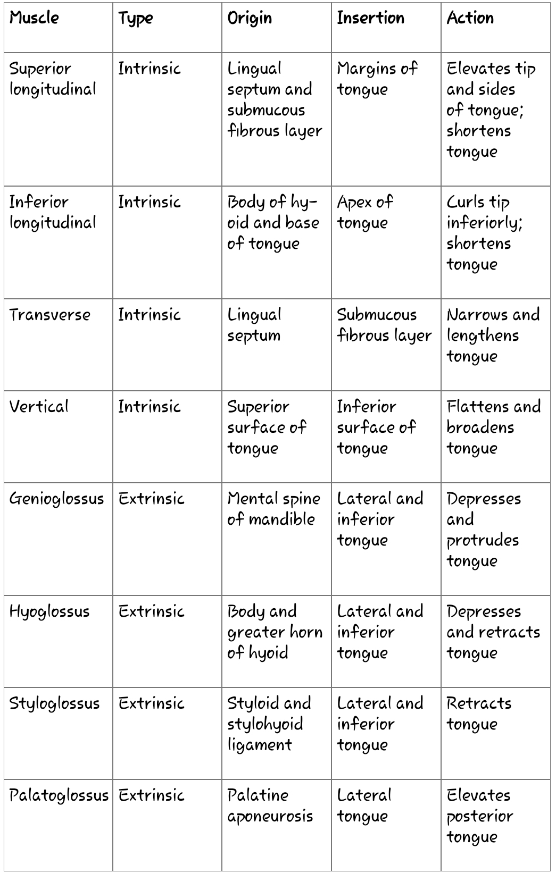

Extrinsic muscles are so named because they originate outside the tongue and insert within it; intrinsic muscles are within the substance of the organ and do not insert on bone. Although the muscles do not act in isolation, intrinsic muscles generally alter the shape of the tongue, whereas extrinsic muscles alter its position.
Vasculature
Similar to most of the head and neck region, the tongue derives its arterial blood supply from the external carotid artery. The lingual artery branches off the external carotid artery deep to the stylohyoid muscle. At first, it travels superomedially; after a short distance, it changes direction and moves anteroinferiorly. The hypoglossal nerve (cranial nerve xii) crosses over it laterally before it enters the tongue deep in the hyoglossus muscle. Within the tongue, the lingual artery gives rise to its 3 main branches: the dorsal lingual, deep lingual, and sublingual arteries. The dorsal lingual artery supplies the base of the tongue. The deep lingual artery travels on the lower surface of the tongue to the tip. A branch to the sublingual gland and the floor of the mouth is known as the sublingual artery. The veins of the tongue parallel the lingual artery branches. The deep lingual vein begins at the tip of the tongue and travels posteriorly to join the sublingual vein. This drains into the dorsal lingual vein, which accompanies the lingual artery. Directly or indirectly, this vein empties into the internal jugular vein.
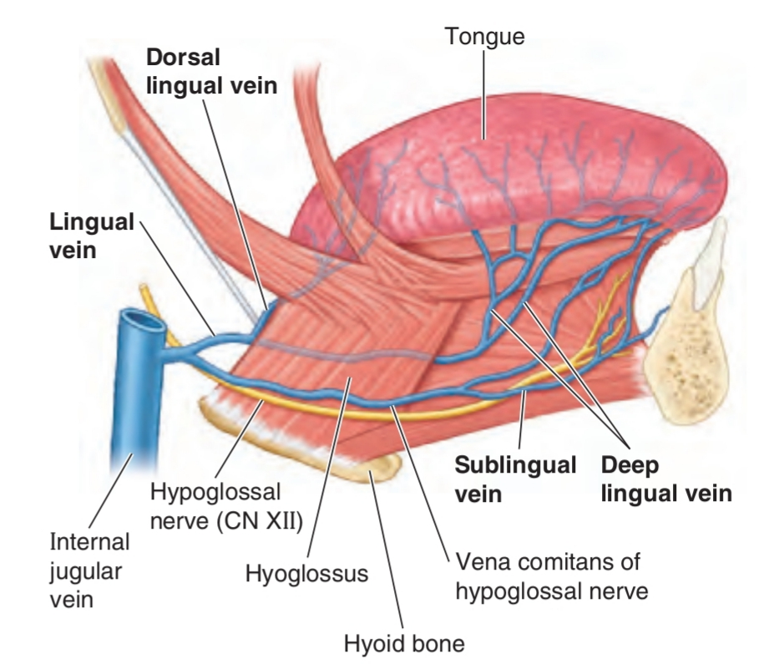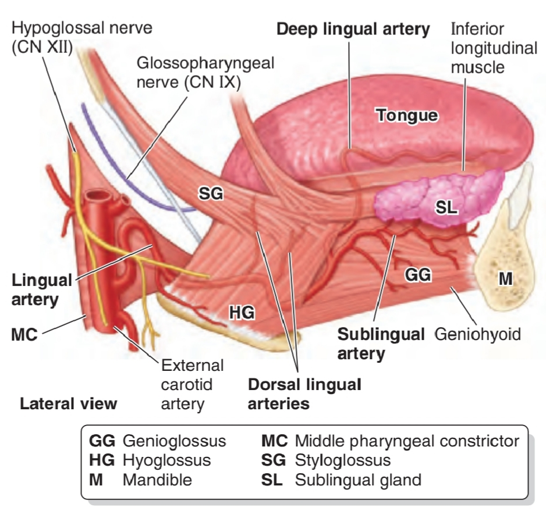
Nerve supply
Motor innervation for all of the muscles of the tongue comes from the hypoglossal nerve--with the exception of the palatoglossus, which is supplied by the pharyngeal plexus (fibers from the cranial root of the spinal accessory nerve carried by the vagus nerve).
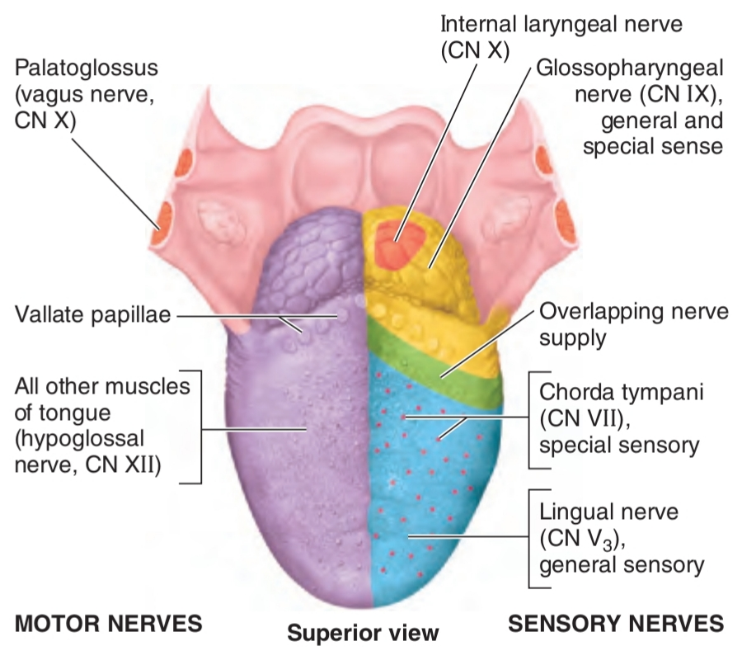
General sensation of the anterior two thirds of the tongue is supplied by the lingual nerve, a terminal branch of the third division of the trigeminal nerve (v3). Taste sensation for this portion of the tongue is carried by the chorda tympani branch of the facial nerve. The posterior third of the tongue relays general and sensation via the lingual-tonsillar branch of the glossopharyngeal nerve. Some general and taste sensation from the base of tongue anterior to the epiglottis is carried by the internal laryngeal branch of the superior laryngeal nerve (CN x).
Lymphatic drainage
The lymphatic drainage of the tongue is complex. Lymphatics from the tip of the tongue travel to the submental lymph nodes. This can be ipsilateral or bilateral depending on the site of the lesion. Lymph from the medial anterior two thirds of the tongue travels to the deep cervical lymph nodes, and lymph from the lateral anterior tongue goes to the submandibular nodes. The tongue-base lymphatics drain bilaterally into the deep cervical lymph nodes.
Clinical significance/pathophysiologic variants
- Ankyloglossia (tongue-tie) is caused by an abnormally short lingual frenulum, which can inhibit tongue movement.
- Macroglossia is a congenital enlargement of the tongue.
- Thrush (candidiasis): candida albicans (a yeast) grows over the surface of the mouth and tongue. Thrush can occur in almost anyone, but it occurs more often in people taking steroids or with suppressed immune systems, the very young, and the elderly.
- Oral cancer: a growth or ulcer appears on the tongue and grows steadily. Oral cancer is more common in people who smoke and/or drink alcohol heavily.
- Macroglossia (big tongue): this can be broken down into various categories based on the cause. These include congenital, inflammatory, traumatic, cancerous, and metabolic causes. Thyroid disease, lymphangiomas, and congenital abnormalities are among some of the causes of an enlarged tongue.
- Geographic tongue: ridges and colored spots migrate over the surface of the tongue, periodically changing its appearance. Geographic tongue is a harmless condition.
- Oral leukoplakia: white patches appear on the tongue that cant be scraped off. Leukoplakia may be benign, or it can progress to oral cancer.
- Hairy tongue: papillae can overgrow the surface of the tongue, giving it a white or black appearance. Scraping off the papillae corrects this harmless condition.

2) write an essay on the air sinuses
PARANASAL SINUSES
The paranasal sinuses are air-filled spaces located within the bones of the skull and facial bones. They are centered on the nasal cavity and have various functions, including lightening the weight of the head, humidifying and heating inhaled air, increasing the resonance of speech, and serving as a crumple zone to protect vital structures in the event of facial trauma.There are four sets of paired sinuses are recognized: maxillary, frontal, sphenoid, and ethmoid.
Maxillary sinuses
The maxillary sinuses are the largest of the paranasal sinuses. They occupy the bodies of the maxillae and communicate with the middle nasal meatus.
- The apex of the maxillary sinus extends toward and often into the zygomatic bone.
- The base of the maxillary sinus forms the inferior part of the lateral wall of the nasal cavity.
- The roof of the maxillary sinus is formed by the floor of the orbit.
- The floor the maxillary sinus is formed by the alveolar part of the maxilla. The roots of the maxillary teeth, particularly the first two molars, often produce conical elevations in the floor of the sinus. Each maxillary sinus drains by one or more openings, the maxillary ostium (ostia), into the middle nasal meatus of the nasal cavity by way of the semilunar hiatus.
The arterial supply of the maxillary sinus is mainly from superior alveolar branches of the maxillary artery however, branches of the descending and greater palatine arteries supply the floor of the sinus. Innervation of the maxillary sinus is from the anterior, middle, and posterior superior alveolar nerves, which are branches of the maxillary nerve
Frontal sinuses
The right and left frontal sinuses are between the outer and inner tables of the frontal bone, posterior to the superciliary arches and the root of the nose. Frontal sinuses are usually detectable in children by 7 years of age. The right and left sinuses each drain through a frontonasal duct into the ethmoidal infundibulum, which opens into the semilunar hiatus of the middle nasal meatus. The frontal sinuses are innervated by branches of the supra-orbital nerves (CN v1).the right and left frontal sinuses are rarely of equal size, and the septum between them is not usually situated entirely in the median plane. The frontal sinuses vary in size from approximately 5 mm to large spaces extending laterally into the greater wings of the sphenoid. Often a frontal sinus has two parts: a vertical part in the squamous part of the frontal bone, and a horizontal part in the orbital part of the frontal bone. One or both parts may be large or small. When the supra-orbital part is large, its roof forms the floor of the anterior cranial fossa and its floor forms the roof of the orbit.
Sphenoidal sinuses
The sphenoidal sinuses are located in the body of the sphenoid, but they may extend into the wings of this bone. They are unevenly divided and separated by a bony septum. Because of this extensive pneumatization (formation of air cells), the body of the sphenoid is fragile. Only thin plates of bone separate the sinuses from several important structures: the optic nerves and optic chiasm, the pituitary gland, the internal carotid arteries, and the cavernous sinuses. The sphenoidal sinuses are derived from a posterior ethmoidal cell that begins to invade the sphenoid at approximately 2 years of age. In some people, several posterior ethmoidal cells invade the sphenoid, giving rise to multiple sphenoidal sinuses that open separately into the sphenoethmoidal recess. The posterior ethmoidal arteries and the posterior ethmoidal nerves that accompany the arteries supply the sphenoidal sinuses.
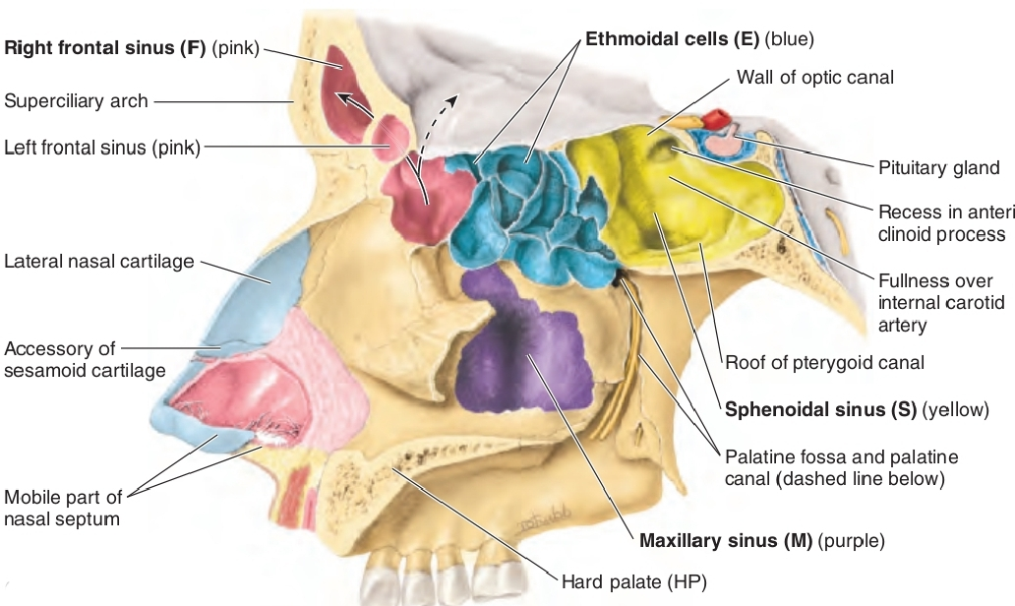
Ethmoidal cells sinuses
The ethmoidal cells (sinuses) are small invaginations of the mucous membrane of the middle and superior nasal meatus into the ethmoid bone between the nasal cavity and the orbit. The ethmoidal cells usually are not visible in plain radiographs before 2 years of age but are recognizable in CT scans. The anterior ethmoidal cells drain directly or indirectly into the middle nasal meatus through the ethmoidal infundibulum. The middle ethmoidal cells open directly into the middle meatus and are sometimes called bullar cells because they form the ethmoidal bulla, a swelling on the superior border of the semilunar hiatus. The posterior ethmoidal cells open directly into the superior meatus. The ethmoidal cells are supplied by the anterior and posterior ethmoidal branches of the nasociliary nerves (CN v1).
Microscopic anatomy
The nasal and paranasal sinuses are lined with respiratory mucosa composed of pseudostratified ciliated columnar epithelium. The underlying lamina propria contains a rich capillary network and is firmly adherent to the periosteum or perichondrium of adjacent bone or cartilage. Four types of cells are found in the sinonasal mucosa: ciliated columnar epithelial cells, nonciliated columnar cells, goblet cells, and basal cells. The ciliated columnar epithelial cells make up 20-50% of the epithelium and have 50-200 cilia per cell, beating at 700-800 times per minute. These cilia move the 10-15 micron thick mucous blanket at an approximate rate of 9 mm/min. Nonciliated cells comprise about 70% of the epithelium and have microvilli on the apical surfaces that enhance humidification and warming of air before it enters the lower airway. The goblet cells secrete glycoproteins, which influence the character of the mucus. The parasympathetic input to these glands produces thicker mucus, whereas the sympathetic innervation produces thinner, watery mucus. The function of the basal cells is unknown.
Clinical significance
Inflammation: The paranasal sinuses are joined to the nasal cavity via small orifices called ostia. These become blocked easily by allergic inflammation, or by swelling in the nasal lining that occurs with a cold. If this happens, normal drainage of mucus within the sinuses is disrupted, and sinusitis may occur.
Cancer: Malignancies of the paranasal sinuses comprise approximately 0.2% of all malignancies. About 80% of these malignancies arise in the maxillary sinus. Men are much more often affected than women. They most often occur in the age group between 40 and 70 years. Carcinomas are more frequent than sarcomas. Metastases are rare. Tumours of the sphenoid and frontal sinuses are extremely rare.

