NAME: AKINGBOLA OLUWAFIKAYOMI
MATRIC NO: 18/MHS01/054
COLLEGE: MEDICINE AND HEALTH SCIENCES
DEPARTMENT: MBBS

EMBROYOLOGY ASSIGNMENT
- Discuss ovulation
Ovulation is the release of a mature secondary oocyte from the ovarian follicle. A few days before ovulation, under the influence of follicle stimulating hormone and luteinizing hormone the secondary follicle grows to a diameter of about 25mm to become mature vesicular/ mature secondary/Graafian follicle. Coincident with the final development of vesicular follicle, there is an abrupt increase in luteinizing hormone that causes;
- The primary oocyte to complete meiosis 1
- The follicle them enters preovulatory mature vesicular stage.
Meiosis II IS also initiated, but the secondary oocyte is arrested in metaphase by cytostatic factor for approximately 3 hours before ovulation. In the meantime, the surface of the surface of the ovary begins to bulge locally, and at the apex, an avascular spot, the stigma, appears.

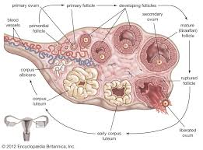

For the oocyte to be released, 2 events occur which are caused by LH surge:
- It increases collagenase activity, resulting in digestion of collagen fibers (connective tissue) surrounding the follicle
- Prostaglandin levels also increase in response to the LH surge and cause local muscular contractions in the ovarian wall
- Those contractions extrude the oocyte, which together with its surrounding follicular (granulosa) cells from the region of the cumulus oophorus,
- this causes ovulation in which oocyte floats out of the ovary
- Some of the cumulus oophorus cells then rearrange themselves around the zona pellucida to form the corona radiata
- Note:
- Ovulation is triggered by a surge of LH production
- Ovulation usually follows the LH peak by 12 to 24 hours
- The LH surge, elicited by the high estrogen level in the blood, appears to cause the stigma to balloon out, forming a vesicle

Clinical correlates
During ovulation some women feel a variable amount of abdominal pain called mittelschmerz also known as middle pain because it normally occurs near the middle of the menstrual cycle. In these cases, ovulation results in slight bleeding into the peritoneal cavity, which results in sudden constant pain in lower abdomen. Mittelschmerz may be used as a symptom of ovulation. Other signs include;
- Increased libido/ increase urge for sex
- Tenderness of breast
- Swollen vagina or vulva
- Changes in cervical mucus: when you are not ovulating, cervical mucus may appear creamy and may be entirely absent. As ovulation occurs, cervical mucus becomes abundant and take on a watery to raw egg white consistency.
- During ovulation, there is a decrease in basal body temperature. After ovulation there is an abrupt increase which is a sign of ovulation.
Some women fail to ovulate, this is called Anovulation. This is because of low concentration of gonadotropin. In these cases, administration of an agent to stimulate gonadotropin to make ovulation occur. But this often leads to multiple pregnancies.
- Differentiate Meiosis 1 and meiosis 2

MEIOSIS 1 | MEIOSIS 2
It is heterotypic or reduction division | It is homotypic or equatorial division
In prophase 1, synapsis occurs, crossing over occurs and chiasma is formed | In prophase 2, synapsis does not occur, crossing over does not occur and also there is no chiasma formation.
Metaphase 1, alignment of the 46 homologous duplicated chromosomes at the equator | Metaphase 2, alignment of the 23 duplicated chromosomes occurs at the equator
Anaphase 1, separation of the 46 homologous duplicated chromosomes but the centromere does not split | Anaphase 2, separation of the 23 homologous duplicated chromosomes and the centromere splits
Telophase 1, two daughter cells are formed having duplicated haploid number | Telophase 2, four daughter cells ae formed having single haploid number
It is a complicated and long duration division | It is a simple and short duration division
Preceded by interphase | No interphase takes place
The number of chromosomes is reduced to half i.e. from diploid to haploid (46 duplicated – 23 duplicated) | The number of chromosomes remain the same but it is single stranded chromosomes  (23 duplicated – 23 single stranded chromosomes)

- Discuss the stages involved in fertilization.
Fertilization takes place during the first week of human development. Fertilization is the union of the sperm and oocyte. The usual site of fertilization is the ampulla of the uterine tube. This process takes place approximately 24 hours. It is a sequence of coordinated events which include the following stages;
- Passage of the sperm through the corona radiata: the sperm to pass through the corona radiata of the oocyte capacitation must occur first. Capacitation is the removal of glycoprotein coat and seminal plasma proteins from the plasma membrane that overlies the acrosome of the sperm.
- Penetration of the zona pellucida: the sperm cell precedes to the region of the zona pellucida. On the surface of the zona pellucida there are binding sites. On these binding sites the there are some receptors. The sperm binds with a zona glycoprotein (ZP3) on the zona pellucida. The release of acrosomal enzymes (acrosin) allows the sperm to penetrate the zona pellucida, thereby coming in contact with the plasma membrane of the oocyte. As soon as the head of the sperm comes in contact with the oocyte the permeability of the zona pellucida changes. Once the head of the sperm comes in contact with the oocyte, lysosomal enzymes are released from cortical granules lining the plasma membrane of the oocyte. This will inactivate all binding sites on the zona pellucida and prevent polyspermy.
- Fusion of the plasma membrane of sperm and oocyte: during fusion, the head and tail of the sperm enters the cytoplasm of the oocyte, leaving behind the plasma membrane of the head and the tail.
- Completion of second meiotic division and formation of female pronucleus: once the sperm penetrates the oocyte second meiotic division is complete forming mature oocyte and second polar body. The nucleus of the mature oocyte is now called female pronucleus.
- Formation of male pronucleus: within the cytoplasm of the oocyte, the nucleus of sperm enlarges to form the male pronucleus and the tail of the sperm degenerates. All energy comes from maternal side because it still has its mitochondria, the sperm loses its mitochondria. The oocyte now contains 2 pronuclei, having haploid number of chromosomes and it is called an ootid.
- Formation of the zygote: the 2 pronuclei fuse into a single diploid aggregation of chromosomes, the ootid becomes a zygote. The chromosomes in the zygote become arranged on a cleavage spindle in preparation for cleavage of the zygote.

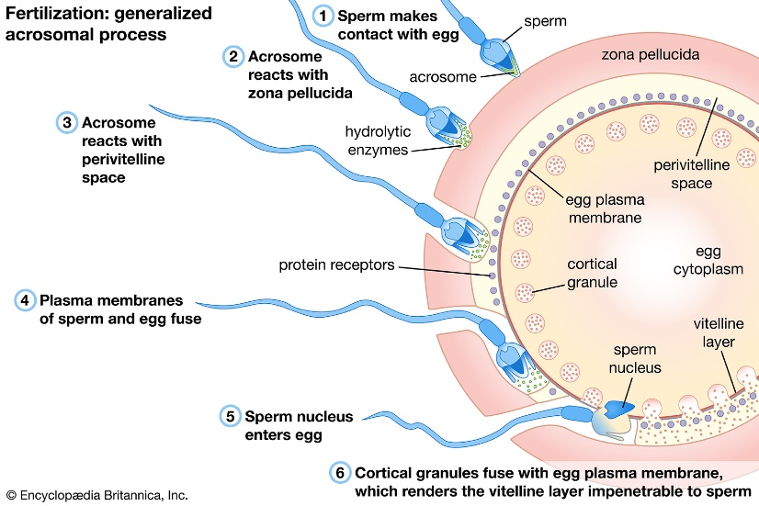
- Differentiate between monozygotic twins and dizygotic twins.
MONOZYGOTIC TWINS | DIZYGOTIC TWINS
Form single zygote | Form 2 zygotes
Incidence is more common | Incidence is less common
They are of the same sex | Same sex or different sex
Genetically identical | They are genetically identical
Arise from one sperm and one oocyte | Arise from two different secondary oocytes and two different sperms
Share placenta, chorionic sac and amniotic sac | They do not share placenta, chorionic sac and amniotic sac

