Oyekanmi Gideon Ademola
15/ENG04/051
EEE 512: DIGITAL COMMUNICATION
ELECT/ELECT

QUESTION 1
3G ARCHITECTURE

UMTS (Universal Mobile Telecommunications System)
UMTS, short for Universal Mobile Telecommunications System, is a 3G networking standard used throughout much of the world as an upgrade to the existing GSM module.
- UMTS makes use of WCDMA, a technology that shares much with CDMA networks used throughout the world, though it is not compatible with them.
- Base level UMTS networks are generally capable of downlink speeds as 384 kbps.
- The UMTS architecture takes advantage of the existing GSM and GPRS networks which serve as a core network in UMTS infrastructure.
The UMTS is made up of 3 main components: a) User Equipment:
It is assigned to a single user and contains all the functions needed to access UMTS services. It contains – Mobile Equipment (ME): It is a radio terminal that is used to connect the UMTS subscriber with the fixed part of the UMTS system via the radio interface Uu.
– UMTS Subscriber Identity Module (USIM): A smartcard that contains the subscriber identity, authentication algorithms, encryption keys, etc.
b) UMTS Terrestrial Radio Access Network (UTRAN):
It handles cell-level mobility. It is a system of base station and controller handling function related to mobility. It contains:
1. Nodes B (Base Stations):
• It converts the data between the Uu radio interface and the Iub interface connecting a Node B with the RNC. • It performs physical level processing such as channel coding, data interleaving, rate matching, modulation, etc.
2. Radio Network Controllers (RNC):
• RNC’s controls and manages radio resources to Node B. • RNC performs the data-link layer processing and participates in handover operations. • RNC is considered a single access point of UTRAN for the core network. • It’s connected to a single MSC/VLR to route circuit-switched traffic and to a single SGSN to route packet-switched traffic.

c) Core Network (CN):
The core network is shared with GSM and GPRS. The CN contains functions for intersystem handover, gateways to other networks, and performs location management. It contains:
- Home Location Register (HLR)
- Mobile Station Controller / Visitor Location Register (MSC/VLR).
- Gateway MSC: Connect UMTS to external circuit switch n/w (e.g PSTN)
- Serving GPRS Support Node (SGSN): It serves the Packet-switched traffic.
- Gateway GPRS Support Node (GGSN): Connects UMTS to external packet-switched. (e.g. Internet)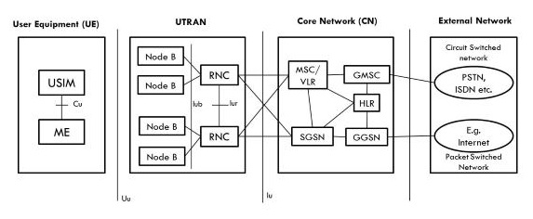

4G ARCHITECTURE
- 4G stands for the fourth-generation cellular system.
- 4G is the evolution of 3G to meet the forecasted rising demand.
- It is an integration of various technologies including GSM,CDMA,GPRS,IMT-2000 ,Wireless LAN.
- The data rate in the 4G system will range from 20 to 100 Mbps.
Features:
- Fully IP based Mobile System.
- It supports interactive multimedia, voice, streaming video, internet, and other broadband services.
- It has a better spectrum efficiency.
- It supports Ad-hoc and multi-hop networks.
4 G Architecture
- The figure shows Generic Mobile Communication architecture.
- 4 G network is an integration of all heterogeneous wireless access networks such as Ad-hoc, cellular, hotspot, and satellite radio component.
- Technologies used in 4G are smart antennas for multiple inputs and multiple-output (MIMO), IPv6, VoIP, OFDM, and Software-defined radio (SDR) systems.
Smart Antennas:
- Smart Antennas are Transmitting and receiving antennas.
- It does not require increased power and additional frequency.
IPV6 Technology:
- 4G uses IPV6 Technology to support a large number of wireless-enabled devices.
- It enables several applications with better multicast, security, and route optimization capabilities.
VoIP:
- It stands for Voice over IP.
- It allows the only packet to be transferred eliminating the complexity of 2 protocols over the same circuit.

OFDM:
- OFDM stands for Orthogonal Frequency Division Multiplexing.
- It is currently used as WiMax and WiFi.
SDR:
- SDR stands for Software Defined Radio.
- It is the form of open wireless architecture.
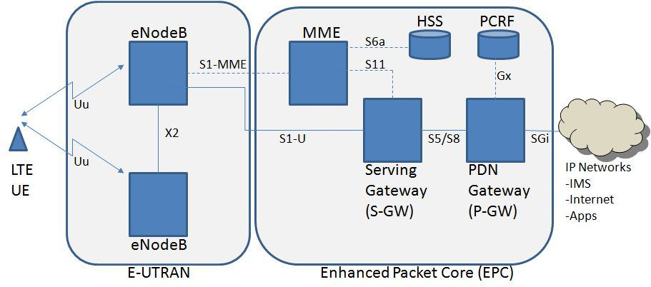
MME- Mobility Management Entity
It is used for Paging, Authentication, Handover, and Selection of Serving Gateway
SGW- Serving gateway
It is used to Routing and Forwarding the user data packet.
PDN-GW Packet Data Network Gateway
It is used for user equipment (UE) IP allocation
HSS -Home Subscriber Server
It is a user Database used for service subscriber, user identification and addressing
PCRF -Policy and Charging Rule Function
It provides quality of service and charging
eNode B-evolved Node B
It is used as radio resources management and radio bearer control

5G ARCHITECTURE
The architecture of 5G is highly advanced, its network elements and various terminals are characteristically upgraded to afford a new situation. Likewise, service providers can implement advanced technology to adopt value-added services easily.
However, upgradeability is based upon cognitive radio technology that includes various significant features such as the ability of devices to identify their geographical location as well as weather, temperature, etc. Cognitive radio technology acts as a transceiver (beam) that perceptively can catch and respond to radio signals in its operating environment. Further, it promptly distinguishes the changes in its environment and hence responds accordingly to provide uninterrupted quality service.
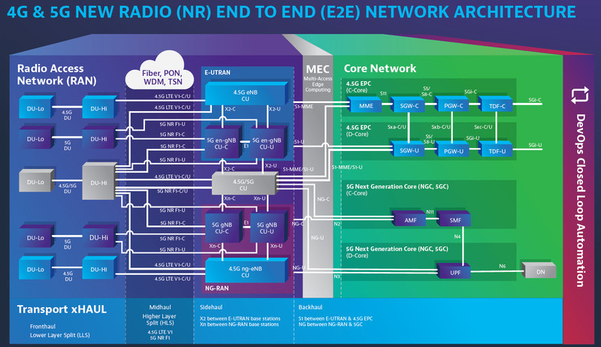

Still, in its early days, the 5G network could be well explained with 4G technology as it is currently in conjugation with it. The current network of 5G consists of two main components:
- Radio Access Network
- Core Network

To use a 4G network, a frequency of 2-6 GHz is needed, but that’s only good for the traditional set of technologies. With the world adopting much better technologies, like 5G, the same frequency won’t do any good. So, to counter this issue, the usage of millimetre waves is brought into action. Millimetre waves have a better frequency spectrum of 30-300 GHz, with the transmission through millimetre waves being fast. But the drawback of these waves is that they aren’t able to penetrate through trees, buildings, and mountains. Thus, smaller cells are introduced. Instead of opting for one powerful antenna, these smaller cells are brought in to work together to counter the attenuation issues.
In the radio access network, apart from millimetre waves and small cells, 5G closely depends on MIMO antennas as well. Earlier in 4G networks, there was the usage of approximately dozens of such antennas, but considering the concept of a faster network i.e. 5G, such antennas are increased multiple times. Thereby, allowing the faster transmissions to happen. MIMO antennas while making the faster transmission a reality, do encounter a glitch which is interference. Transference of many signals from the same stations leads to interference issues that are easily encountered by beamforming. Beamforming allows the transmission of higher beam signals through a single port, first in a particular direction thus reducing the issue of interference.
The core network, on the other hand, manages the data as well as the internet connection. As of now, the core network is being redesigned to work better with other platforms like a cloud. The Core network also provides the facility of functions like network slicing and distributed servers that are responsible for better response.

COMPONENTS OF 5G ARCHITECTURE

Spectrum-5GNR
Three sets of use cases were suggested for the implications of the 5G network after considering more than 70 cases. It consists of three sets
- EMBB (Enhanced Mobile Broadband)
- URLLC (Ultra-Reliable Low Latency Communication)
- MMTC (Massive Machine Type Communications)
The main concept behind these use cases was to categorize the usage patterns and features that the 5G network will need to deliver.

Multiple hop network and device to device communication

Often it happens that signal strength is weak in certain areas. To bridge the gap cellular repeaters are used. 5G allows the concept of multiple hop networks and devices to device communication which improves the signal strength and connectivity. Multiple hop networks work on the concept of relaying data to other nodes to deliver quality service. Whereas device to device communication works on the concept of allowing two users to communicate without any dependency on base stations.
- Cloud-Radio Network Access
Future technologies like 5G are more inclined towards this process wherein processing of information is done remotely. A radio access network provides a connecting link between base stations and end-users. Whereas in the CRAN, signals get processed remotely and the base unit is connected with efficient fiber-optic connection, thus maintaining the efficient services. All of this is supported by the concept of cloud computing and is built on interface cards which are efficient in handling interconnections within the stations.

Carrier Aggregation
Carrier aggregation can simply be explained as the medium of carrying data. In carrier aggregation, more than two data carriers are combined in a single channel for optimizing data capacity. Mainly three techniques are used in it:
- intra-band contiguous
- intra-band non-contiguous
- Inter-band

- 3G ARCHITECTURE
Advantages
- Faster data rates.
- Support multimedia applications such as video and photography.
- Value-added services like mobile television, GPS, video call, and video conference.
- High-speed mobile internet access.
- Increased capacity.

Disadvantages
- Requires 3G compatible handsets.
- The cost of upgrading to a 3G device is expensive.
- Power consumption is high.
- 3G requires closer base stations which is expensive.

4G ARCHITECTURE
Advantages
- Quickly download files over a wireless network
- Extremely high voice quality
- Easily access the Internet, IM, social networks, streaming media, video calling
- Higher bandwidth
- 4G is 10 times faster than 3G

Disadvantages
- New frequencies mean new components in cell towers.
- Higher data prices for consumers
- The consumer is forced to buy a new device to support the 4G
- It is impossible to make your current equipment compatible with the 4G network
5G ARCHITECTURE
Advantages
- High resolution and bi-directional large bandwidth shaping.
- Technology to gather all networks on one platform.
- More effective and efficient.
- Technology to facilitate subscriber supervision tools for quick action.

Disadvantages
- 5G is more costly compared to other Mobile Network Technology because many technical/ official engineers are required to install and maintain it.
- The risk of overcrowding the frequency range of the 5G wireless spectrum is greater as more devices are connected to one channel.
- 5G Network Technology will take more time for security and privacy issues.
- Coverage indoor distance up to 2 meters and 300 meters outdoors can be achieved due to greater losses at higher frequencies as 5Gmm wave influences from such losses (rain losses, attenuation due to rain, etc.).

QUESTION 2

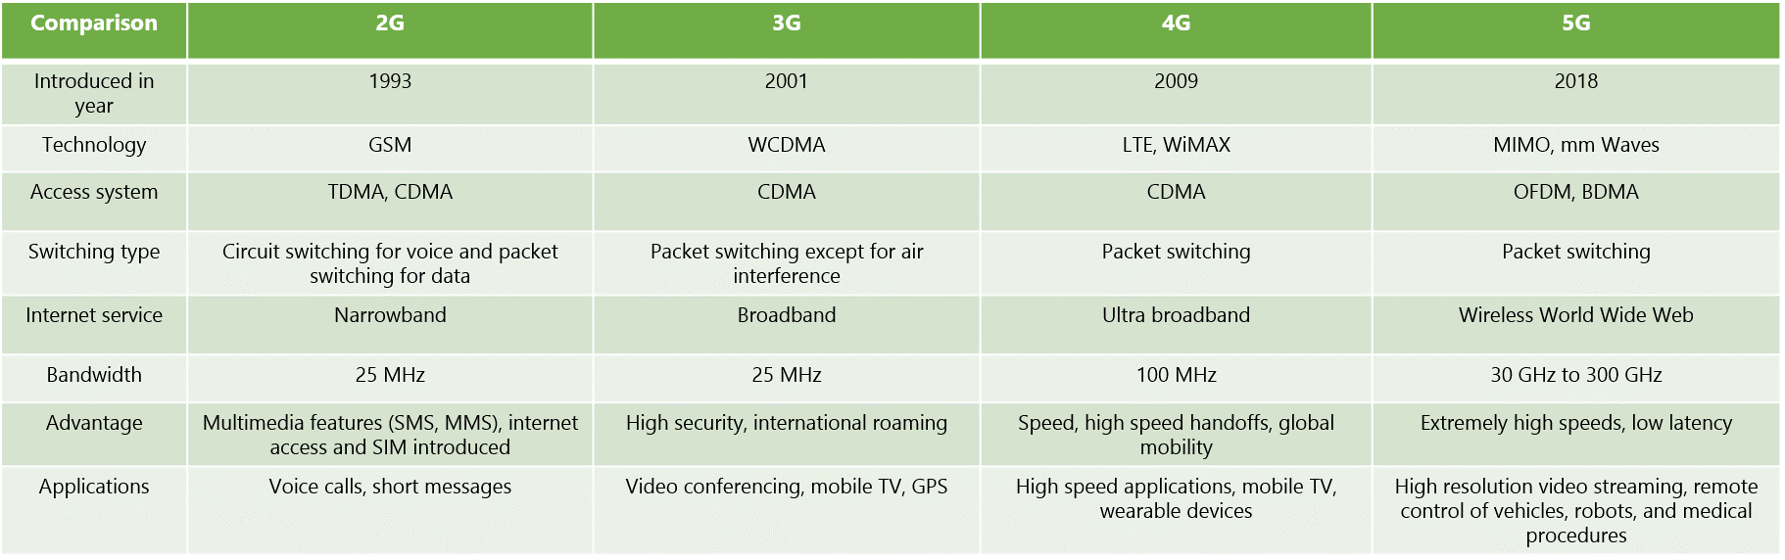

QUESTION 3
- No, I don’t think there is a correlation between 5G and the coronavirus

II None of the conspiracy theories that try to link 5G and the coronavirus even make sense. The virus is spreading in countries without access to 5G, the frequencies from 5G can’t harm your body, and COVID-19 is caused by a contagious virus that is in no way related to electromagnetic waves. Even the general correlation between 5G and COVID-19 doesn’t stand up to scrutiny: they’re both global phenomena happening at roughly the same time, but as soon as you look at specific countries, the correlation falls apart.
Some of these theories suggest that the novel coronavirus can be transmitted through 5G or that 5G suppresses the immune system. Both are untrue. To understand why 5G and the virus aren’t linked, you have to understand why 5G radio waves aren’t powerful enough to damage the cells in your body alone or transmit a virus. Much like 4G or 3G before it, the radio waves used in 5G are low frequency and non-ionizing radiation. These are on the opposite end of the electromagnetic spectrum to ionizing radiation sources like X-rays, gamma rays, and ultraviolet rays. These 5G radio waves simply aren’t strong enough to heat your body and weaken your immune system.
Likewise, radio waves and viruses aren’t transmitted in the same way. The novel coronavirus spreads from one person to another, typically through tiny droplets of saliva produced when a sick person coughs, sneezes, or breathes. The only types of viruses you can transmit via radio waves are ones that affect computers, not humans.

