Oghene-Karo Ifoto
17/mhs01/149
Medicine and surgery

Gross anatomy of the head and neck

QUESTION 1 - anatomy of the tongue and it’s applied anatomy
INTRODUCTION
The tongue is a muscular organ in the human mouth that manipulates food for mastication and is used in the act of swallowing.
Under normal circumstances, the tongue is a pink, muscular organ located within the oral cavity proper. It is kept moist by the products of the major and minor salivary glands, which aids the organ as it facilitates deglutition, speech, and gustatory perception. While there is significant variability in the length of the tongue among individuals, on average, the organ is roughly 10 cm long.
Functions of the tongue
Deglutition
Taste sensation
Speech production
Breast feeding
Self cleansing system
Mastication

PARTS AND SURFACES OF THE TONGUE
It has three main parts:
- The tip or apex of the tongue is the most anterior, and most mobile aspect of the organ.
- The tip is followed by the body of the tongue. It has a rough dorsal (superior) surface that abuts the palate and is populated with taste buds and lingual papillae( the superior surface has an oral part, pharyngeal part and a posterior part), and a smooth ventral (inferior) surface that is attached to the floor of the oral cavity by the lingual frenulum.
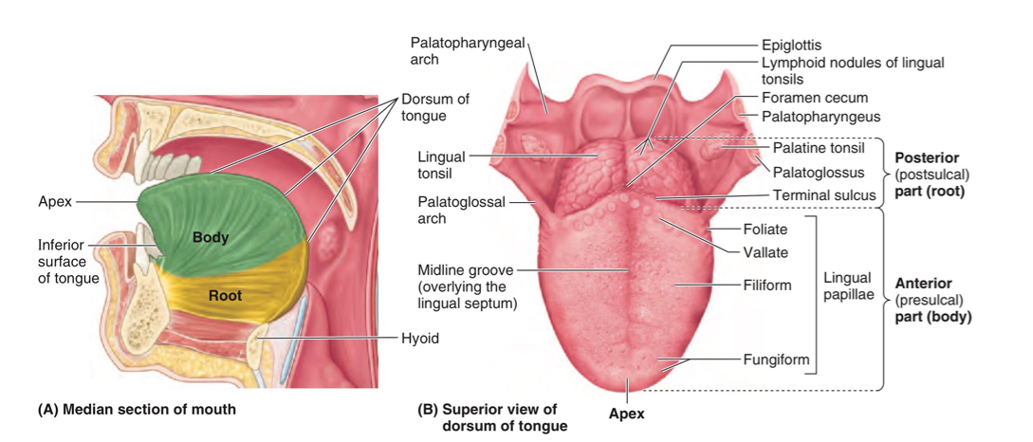
- The base of the tongue is the most posterior part of the organ. It is populated by numerous lymphoid aggregates known as the lingual tonsils along with foliate papillae along the posterolateral surface.

DORSUM OF THE TONGUE
It is convex in all the directions and divided by a faint V-shaped groove called the Sulcus Terminale.
- Oral part or papillary part
It is placed on the floor of the mouth. The margins are free and in contact with gums and teeth. Each margin shows a 4-5 vertical folds called Foliate Papillae.
Surfaces
A) superior surface: has a median furrow and is covered with papillae.
B) inferior surface: covered with smooth mucous membranes which’s hows a median fold called Frenulum Linguae. On either side of the frenulum, there is a prominence made by Deep Lingulal Veins. It also has a folds called Plica Fimbriata which is directed forwards and medically towards the tip of the tongue.
- Pharyngeal part or lymphoid part
It lies behind the palatoglossal arches and the sulcus terminalis. It’s mucous membRane has no papillae but has many lymphoid follicles which collectively form the lingual Tonsils.

It’s posterior surface is called the base of the tongue and it forms the anterior wall of the oropharnx.
- Posterior part
It is connected to epiglottis by 3 folds of mucous membrane, they are right, median and left Glossoepioglottic Folds.
On either side of median fold there is a depression called Vallecula.

MUSCLES OF THE TONGUE
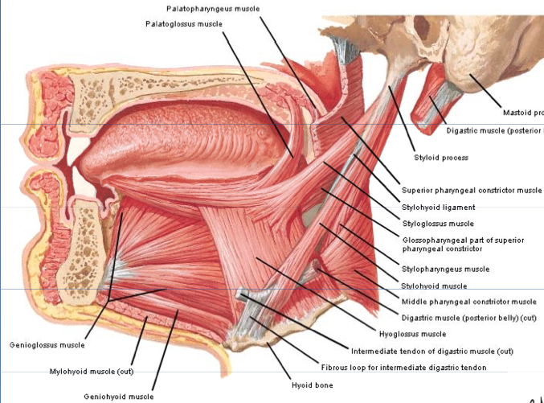
The middle fibrous septum Divides the tongue into the right and left halves.
Each half contains:
Intrinsic Muscles- The intrinsic tongue muscles are responsible for adjusting the shape and orientationof the organ. It is made up of four paired muscles
which occupy the upper part and attached to submucous fibrous layer.
They alter the shape of the tongue
1. Superior longitudinal muscle - retracts and broadens tongue, elevates apex of tongue
2. Inferior Longitudinal Muscle- retracts and broadens tongue, lowers apex of tongue
3. Transverse muscle- narrows and elongates the tongue
4. Vertical muscle- broadens and elongates the tongue

Extrinsic muscles- While the shape of the tongue is determined by the intrinsic muscles of the tongue, movement of the organ within (and out of) the oral cavity is dependent on the extrinsic tongue muscles. There are four pairs of extrinsic muscles, which can be viewed as those arising from above the tongue, and those that originate from below the tongue.
1. Genioglossus- depresses and protrudes tongue (bilateral contraction); deviates tongue contralaterally (unilateral contraction)
2. Hyoglossus- depresses and retracts tongue
3. Styloglossus - retracts and elevates lateral aspects of tongue
4. Palatoglossus - elevates root of tongue, constricts isthmus of fauces

VASCULATURE AND INNERVATION

Arterial supply
Lingual artery- supplies the tongue and floor of the mouth. The lingual artery originates from the external carotid artery in the neck and it passes between the hyoglossus and genioglossus muscles of the tongue.
The lingual artery mainly gives three branches within the tongue namely:
Dorsal lingual artery
Deep lingual artery
Sublingual artery

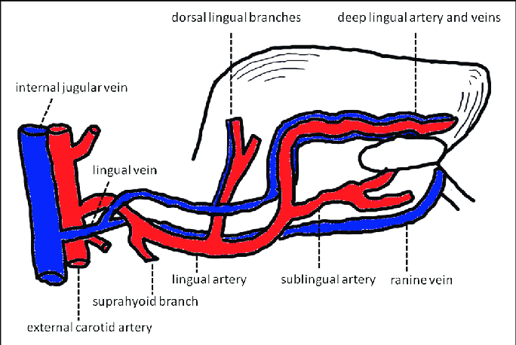
Secondary supply to the tongue by the tonsils branch of the facial artery and ascending pharyngeal branch of the external carotid artery.

Venous drainage
Drained by the dorsal lingual vein and deep lingual veins

Lymphatics
Apical vessels drain into the submental nodes
Marginal vessels drain into the submandibular nodes
Basal vessels drain into the Deep cervical nodes

INNERVATION
INNERVATION is complex and consists of three different supplies
1. Motor supply
2. General sensory supply
3. Special sensory supply
MOTOR SUPPLY: all extrinsic and intrinsic muscles are supplied by the hypoglossal nerve (CN XII) except the palatoglossus muscle which is supplied by the vagus nerve (CN X)
SENSORY SUPPLY: general sensory innervation is by three nerves
- Lingual nerve ; the anterior 2/3rd of tongue
- Glossopharyngeal nerve ; posterior 1/3rd of tongue
- Vagus nerve ; posterior most part of tongue
SPECIAL SENSORY SUPPLY: supplied by 3 nerves
- Chorda tympani (facial) ; taste sensation of the anterior 2/3rd
- Glossopharyngeal (CN IX) ; taste sensation of the posterior 1/3rd of tongue
- Vagus nerve ( CN X) ; taste sensation of the posterior most part of tongue

CLINICAL ASPECTS
1. Paralysis of the genioglossus ; tendency of tongue to fall posteriorly, obstructing the airway
2. Injury to the hypoglossal nerve; paralysis and eventual atrophy of affected side of tongue.
3. Sublingual absorption of drugs; quick absorption of a drug through deep lingual veins.
4. Glossopharyngeal Neuralgia; sharp shooting pain in the posterior 1/3rd of tongue
5. A particular pharyngeal arch defect, known as Pierre Robin Syndrome, causes glossoptosis among other symptoms. This particular defect causes the tongue to be displaced posteriorly and may cause airway obstruction or apnea.
6. Glossitis; inflammation of the tongue. This condition causes the tongue to swell in size, change in color, and develop a different appearance on the surface.

QUESTION 2 - write an essay on air sinuses
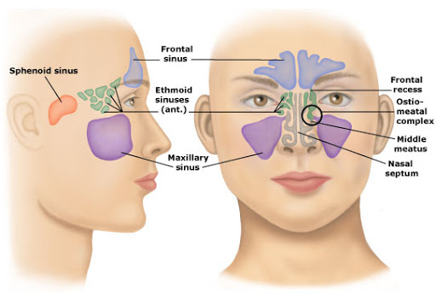
The paranasal sinuses are air cavities that help circulate the air that is breathed in and out of the respiratory system. They are situated around the nasal cavity and they are all paired and sometimes symmetrical, while always being bilateral. There are four different pairs of sinuses and they are called the:
- maxillary sinuses
- frontal sinuses
- sphenoidal sinuses
- ethmoidal sinuses

MAXILLARY SINUS
This sinus is also known as the antrum of highmore. This is the largest of all paranasal sinuses and it lies just under the cheek area. It is shaped like a pyramid.

Superior wall - bony orbit
Inferior wall - alveolar bone of the maxilla
Medial wall - nasal cavity
Lateral and anterior walls - cheekbones
Posterior wall - pterygopalatine fossa, infratemporal fossa
Innervation - anterior superior alveolar, middle superior, posterior superior nerves (branches of the maxillary nerve)
Vascularization - anterior superior alveolar, middle superior alveolar, posterior superior alveolar arteries (branches of the maxillary artery)

FRONTAL SINUS
this sinus shows the maximum variation, it is shaped more or less like an L. Its posterior wall is related to the anterior cranial fossa.
Its floor is formed by the upper part of orbit. Drains into the anterior part of middle meat us via the frontonasal duct. Develops very later in life and becomes fully developed only by the age of 9.

Anterior wall - forehead and superciliary arches
Superior and posterior walls - anterior cranial fossa
Inferior wall - bony orbit
Medial wall - contralateral sinus
Innervation - supraorbital nerve, supratrochlear nerve (branches of the ophthalmic nerve)
Vascularization - anterior ethmoidal, supraorbital, supratrocheal arteries (branches of the ophthalmic artery)

ETHMOIDAL SINUS
It is composed of complex bony labyrinth with thin walls. There may be 6-10 ethmoidal cells present in adults.
Superior wall - anterior cranial fossa, frontal bone
Lateral wall - bony orbit
Medial wall - nasal cavity
Innervation - anterior and posterior ethmoidal nerves (branches of the nasociliary nerve)
Vascularization - anterior and posterior ethmoidal arteries (branches of the ophthalmic artery)

SPHENOIDAL SINUS
This sinus is located in the skull base at the junction of the anterior and middle cranial fossa.
This sinus varies in size and may be asymmetric. This sinus drains into the superior meatus.

Anterior wall - nasal cavity
Superior wall - hypophyseal fossa
Inferior wall - nasopharynx and pterygoid canal
Innervation - posterior ethmoidal nerve (branch of the nasociliary nerve)
Vascularization - posterior ethmoidal, posterior lateral nasal arteries (branches of the ophthalmic artery)
Applied anatomy
Sinusitis; sinusitis is an inflammation or swelling of the tissues lining the sinuses. Healthy sinuses are filled with air but when they become blocked and filled with fluid, germs can grow can grow and cause an infection. This can be seen when someone has the common cold.

