OKPODU JESSICA
18/ENG07/010
PETROLEUM ENGINEERING
AFE 202 PROJECT/ASSIGNMENT

PREPARE A BUSINESS PLAN ON AN AGRICULTURAL ENTERPRISE:

EXECUTIVE SUMMARY
Farm ville is an existing farm dedicated to the production of environmental products. This is formed by a limited corporation located at agegbe, Osun state, Nigeria. Farm ville is working hard to become a lager and leading producer of environmental products such as fertilizers, crop supplements etc for this environmental plants.

KEYS TO SUCCESS
- Implementation of strict financial controls in the business by having controls, production and efficiency will be maximized.
- Never ending pursuit for the industry concentration.
- Recognition and implementation of customer satisfaction 100%.

PRODUCTS
Farm ville is a 8 acre farm that concentrates on the development and experiment of environmental products. These products are been tested on plants and with a successful work the plants and results will be sold for a variable price.
These fertilizers are been demanded widely in the market economy for plant system boosters.

MARKET
Farm ville has three distinct customers:
- Supplement companies
- Other nurseries to resell and experiment on this fertilizers
- The market industry
A statistic recovery says that fertilizers are about a quarter century old.

OBJECTIVES
The farm ville has identified several objectives for the business:
- Become a leading supplier of environmental products for the development and fertilizing industry.
- Reach the point of sustainable profitability
- Make a good living out of it.

MISSION
If farm villes mission is to become the leading provider of environmental products to the development and fertilizing industry. This will be accomplished by providing quality fertilizers at fair prices while exceeding customer's expectations. We carry out our mission in dollars ($) so as to know the income and outcome on the stock market. This is essential because dollars is higher than Naira (₦) and when converted is a GREATER INCOME!

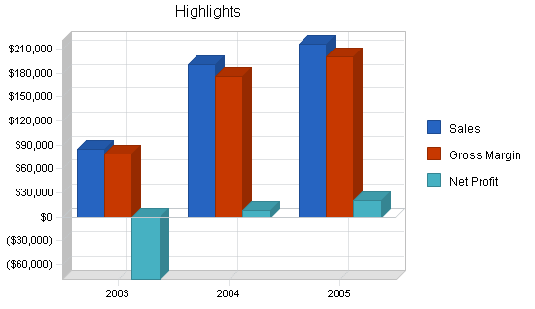
TARGET MARKET SEGMENT STRATEGY
Farm ville has chosen the three market segments based on the consistent demand for fertilizers. While there are other potential customers, they are smaller, less consistent in terms of demand, and more difficult to reach. The supplement companies, processors, and to a smaller degree the nurseries are attractive customers due to their consistent demand and typical long-term contract needs. There is significant value to these customers for a grower to consistently offer the same high level of active fertilizers in each plant and to be able to meet the needs of large volume, long duration contracts.

INDUSTRY ANALYSIS
The fertilizers growing market is typically concentrated market in several regions around Nigeria which have optimum growing conditions. At times, we send some of these our resources abroad to enhance growth in the economy. So some fertilizers are been shipped from abroad for a better perspective.

GOALS
- Grow high quality specialty fertilizers at wholesale and retail markets
- Production methods are economically feasible.

PROFIT
- The revenue of the fertilizers
- Cost of the fertilizers been sold at high services.
- Gross margin
MANAGEMENT TEAM
Board of directors lead by the co-owner of the business and other co-related. Utilizing all their skills to bring this business to success. Each person has its own operation to carry-out efficiently.

FINANCIAL PLAN
To finance growth and full-time production, purchasing about a loan of $100,000 worth of equipment for long-term assets.

