NAME: NNAMAH ONYINYE
MAT NO: 18/ENG08/011
DEPT: BIOMEDICAL ENGINEERING
COURSE TITLE: FOOD AND HEALTH AWERNESS
COURSE CODE: AFE 202

Question: Prepare a business plan for a chosen agricultural enterprise, following the guideline in the note.

Chapter 1: Executive summary and brief description of the project

This business plan examines the feasibility of and indeed economic viability of the development of a 500hectares of maize plantation by the Nnamah corn farming enterprise. Maize, also known as corn, is one of the farm produce that gives an incredible return on investment, as one seed of planted maize could return more than 500 kernels of corn come harvest season.

Short maize varieties may be grown at higher plant populations. The minimum plant population for maize is 36,000 plants per ha. A seed rate of about 25 kg/ha is required.10 kg is enough to plant 1 acre and 5 kg for half an acre.A farmer needs to wait about 3 months between harvest and planting time. Therefore from the farm we are expected to cultivate about just 5000 kernels of corn and not less than 2.5 million kernels of the same maize in less than 120 days.

Maize as a cereal crop is high yielding, easy to process and readily digested. It is a versatile crop that grows across a range of agro ecological zones.Maize has the highest world average yield per hectare among cereals. Maize has its significance as a source of a large number of industrial products besides its uses as human food and animal feed.

Maize remains a key food crop in Africa, Latin America and Asia where it is primarily used as human food; in developed countries though, maize is one of the most important raw materials for animal feed production and biofuels.

Maize also forms the basis for the production for most animal feeds in Nigeria. Livestock farmers will probably be unable to rear his livestock without maize. The production of meat, eggs and dairy products (like milk and yoghurt) would be difficult without maize, which is a hugely important ingredient in animal feed.

The purpose of this business plan is to provide a blueprint for near term and long term goals.
The business plan will be utilized as a tool to gauge how well the farm is doing in the future
compared to their initial goals and keep them on target. The business plan is also a tool for
lenders, explaining the need for initial financing, the source and use of funds, and debt repayment capabilities

Objectives

The purpose of this business plan is to provide a blueprint for near term and long term goals.
The business plan will be utilized as a tool to gauge how well the farm is doing in the future
compared to their initial goals and keep them on target. The business plan is also a tool for
lenders, explaining the need for initial financing, the source and use of funds, and debt repayment capabilities

The Nnamah corn farming enterprise objective is to raise the best tasting and finest quality grains of maize in our local government community .
The farming methods which will be applied is expected to leave smaller carbon footprint while simultaneously improving the health of its customers and it’s local community.

Chapter 2: Sponsorship and Management
The Project Sponsors of the farm are the owners Mr and Mrs Nnamah with help of a Commercial loan from banks and sponsors. Mr and Mrs Nnamah will put in about $30,000 of their personal earnings into the business and partnership with Fidelity bank limited to get an additional commercial loan of $15,000
Also, the Olufemi Ajala Agricultural Enterprise will be providing the materials and workers needed in the farm as a shareholder.

MANAGEMENT:
The management consist of the share holders and members of the cooperative who have stake in the survival and profitability of the business and also the Managing Directors responsible for coordination.
The Nnamah corn farming enterprise will be majorly operated by Mr and Mrs Nnamah.
Mr Nnamah as the Chief managing director will perform all office and accounting functions such as calculating the initial
garden costs, seed costs and planting times.
Mr Nnamah’s Major management duties are:
- creation of a detailed planting guide and building a living soil.
- organic farming methods which will be used with absence of chemical pesticides/fertilizers.
- Growing methods which be used in the farm including crop rotation, planting cover crops.

Mrs Nnamah as a co-owner and also a managing director will be responsible for overseeing all the activities of the workers in the farm and giving account on the progress of their produce during a course of time.

Workers from the Olufemi Ajala enterprise will be hired to be responsible for planting and cultivation and harvesting of plants.

Chapter 3: Market and Sales
There are three major markets for maize and its allied products in Nigeria.

Corn as Human Consumption:
Unlike in developed countries where a major portion of maize produced is used for animal feed or biofuel, maize is a significant part of diets in Africa in general and Nigeria in particular.

The demand for maize as human nourishment will increase in tandem with Nigeria’s population growth so experts say. There will therefore also be a higher demand for corn (maize)This market currently accounts for about 50 per cent of the Nigerian corn demand.

Corn as Animal Feed:
Corn is a favorite raw material for animal feeds, mainly because it is cheaper than many of the other feed alternatives and yet provides the required nutritional content for livestock. As a result, about 35 percent of corn produced in Nigeria is used in animal feed production.

Maize for Industrial Consumption:
It is estimated that about 15 per cent of Nigeria’s current maize produce goes for industrial use, due to its high starch content. The starch obtained from maize is processed into several additives, agents and ingredients such as sorbic acid, sorbitol, dextrine, and lactic acid.
These are used in the manufacture of common household items such as cosmetics, ink, medicines and wall paint

SALES
Nigerian Maize is traded both locally and internationally with a considerable percentage filtering into Niger, Chad, Mali, Benin Republic and some other countries in the West African subregion. Locally, white and yellow maize are sold almost in all markets in Nigeria with the commanding markets for the commodity being Dawanau market in Kano, Dandume and Jibia market in Katsina, Giwa Market in Kaduna,Shinkafi and Talata Mafara in Zamfara, Bodija in Ibadan, Ose Market at Onitsha and Mile 12 Market in Lagos.

Subjectively, The Nnamah corn farming enterprise will have side attractions in their farm produce which will differentiate their products from the other corn farming enterprise in the country and in turn escalate sales.

The Nnamah corn farming enterprise will provide
services exceeding expectations by offering farm to door delivery service for customer orders, Delivery of corn farm produce to markets in nearby environs for sales and also unbelievable whole sale and retail prices. They will utilize a fair price for a fair value.
They will incorporate product differentiation to stand apart from the
competition.
By doing all this subsequently the Nnamah corn farming enterprise will rise above their competition and make a gross amount of sales.

Competition Analysis
The competition of corn produce in Nigeria is majorly between the Northern part.
The leaders in this crop production are Niger, Taraba, Kaduna, Adamawa, and Plateau states

Tariff and Import Restriction
Restrictions on food importation and agricultural equipments will favour the project.

Market Potential
There is strong demand for Maize in Nigeria and Africa at large.It is primarily used as human food; maize is one of the most important raw materials for animal feed production.
Maize also forms the basis for the production for most animal feeds in Nigeria. Livestock farmers will probably be unable to rear his livestock without maize. The production of meat, eggs and dairy products (like milk and yoghurt) would be difficult without maize, which is a hugely important ingredient in animal feed.

Profitability
Weather, environmental factors such as temperature, sunlight, water, soil conditions, pests, diseases, price fluctuations and other risks could affect yield and profitability. Technical based solutions would be employed in order to reduce the possibility of these hindering factors and maximize profit.

Chapter 4: Technical feasibility, Resources and Environment
The project for production of corn is technically feasible. The equipments needed are readily available and our workers have reasonable knowledge on how to handle them
They include residue spreading, possible use of tillage implements, planter operation, and adjustments in the harvesting system.

Resources
Resources such as fertilizer and pesticides/insecticides and needed to facilitate the growth of corn
Our warm, high rainfall climate greatly increases potential nitrogen loss through denitrification and leaching, compared to drier and colder climates, particularly in heavier, clay soils. Thus, we can improve seasonal availability by applying nitrogen fertilizer at specific times according to corn need.

Pesticides are important. They help farmers grow more food on less land by protecting crops from pests, diseases and weeds as well as raising productivity per hectare.

Environment
The primary seedling limitations of corn farming are wet soils and cool soil temperature. Wet soil promotes compaction while planting, particularly around the seed furrow, which will restrict root development. Soil temperature regulates germination rate, so cool temperatures can greatly hinder stand success and plant growth uniformity, both of which are paramount to high corn productivity. The Nnamah corn farming enterprise is likely to use a soil temperature at a 2-inch soil depth at least 55 degrees F or 50 degrees F at a 6-inch soil depth.

Chapter 5: Government support and regulation
The Nnamah corn farming enterprise supports foreign exchange and import reduction conservation of government. It creates economic opportunities, market access, improved income for farmers and support food security objective of government. The project will benefit from government intervention fund in the agriculture sector and the favorable policy of zero duty for agricultural and equipment import. Restriction of forex for all food products will also widen market opportunity. This project helps improve the economy of the country, it also serves as a sourced employment and human empowerment. It encourages the export activities of the country especially when it comes to agricultural produce like Maize. This project also tends to confirm with the objectives of the government.

Chapter 6: Timelines of Projects
The project will be completed between 6 months due to the raining season.
A farmer needs to wait about 3 to 4 months between harvest and planting time. Therefore from the farm we are expected to cultivate about just 5000 kernels of corn and not less than 2.5 million kernels of the same maize in less than 120 days.
Corn planted in cold, wet soil is unlikely to germinate. Corn grows best in air temperatures from 60° to 95°F. Corn can take from 60 to 100 days to reach harvest depending upon variety and the amount of heat during the growing season.

ESTIMATED COST AND REVENUE:
FIXED COST:

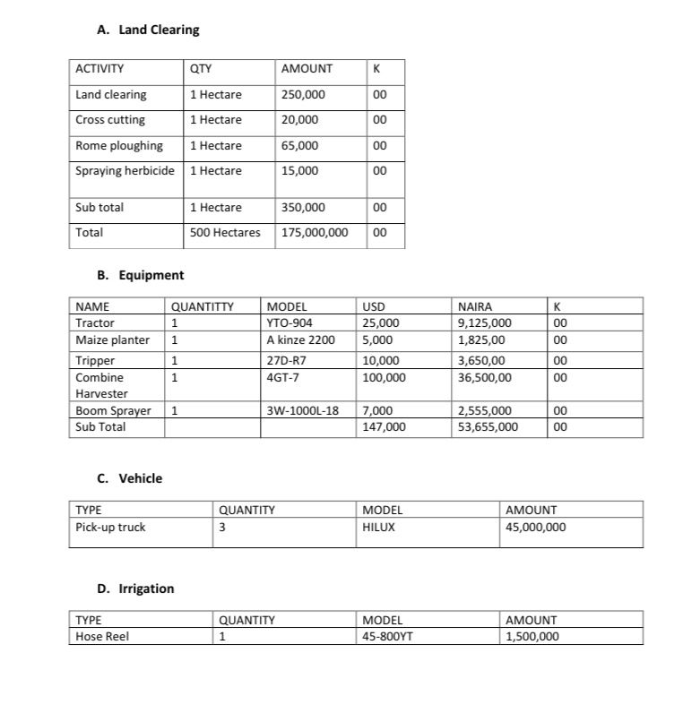

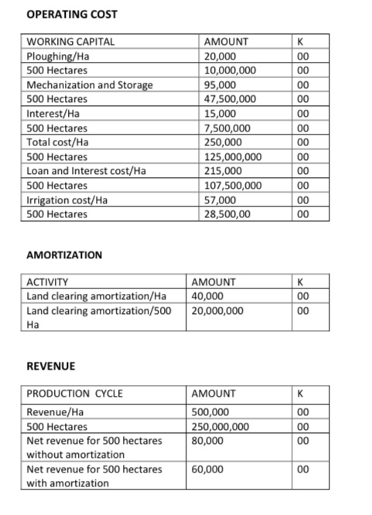

Chapter 8: Funding Mechanism

The farm land is provided by funds from the owners of the enterprise and shareholders. Any funding that is not from the purse of the owners, is gotten through commercial loans sourced by the owners at a reasonable interest percentage.

Chapter 9: Conclusion
In conclusion The Nnamah corn farming enterprise project is Technically feasible and Commercially viable. It is therefore recommended for funding.

