SALAMI ABDULHAFEEZ TEMITOPE
15/ENG04/054
ELECTRICAL/ELECTRONICS ENGINEERING

Question 1
- Working principle of 3G

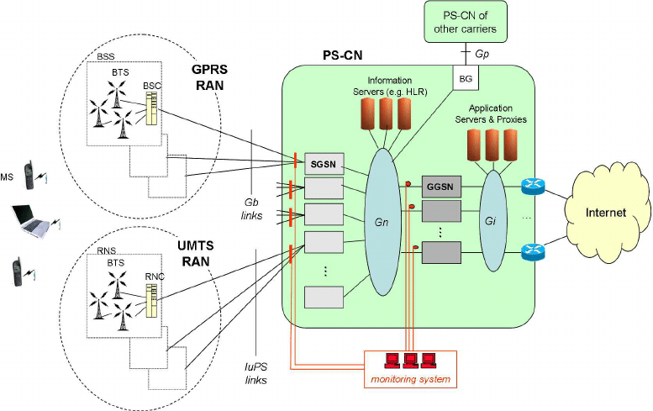
Fig1: working principle of 3G

The architecture of 3G has a term known as UMTS. UMTS is an acronym for universal mobile telecommunications systems. This standard is used worldwide picking up from the previous 2G GSM module generation systems. The data technology uses a network of phone towers to pass signals, ensuring a stable and relatively fast connection over long distances. 3G is a cell phone network protocol. Just like the voice calls, the 3G internet is transported along the Mobile phone network to the compliant mobile phones. Just like you can move while talking on a mobile phone, the 3G internet is designed to connect from cell to cell on a mobile network. 3G offers speeds that are several times faster or higher than any of its predecessors, including the short-lived 2.5G network which offered internet connectivity. 3G speeds are high enough to allow for audio and video streaming. They’ve been shown to be perfectly adequate for remote collaboration tools, such as Unified Communications, while offering clear and responsive voice clarity across the line. Typically, the 3G technology is intended for Smartphones, these feature increased bandwidth and transfer rates to accommodate Web-based applications and phone-based audio and video files.
The UMTS architecture used in 3G makes use of WCDMA technology with its technology similar to CDMA networks. UMTS makes use of certain components which helps it architecture. These components include; User Equipment, UMTS Terrestrial Radio Access Network, Core Network.
Each of these components have sub components and parts which they play in the systems architecture.
The user equipment contains the functions needed to access UMTS services. It contains the Mobile Equipment (which is used to connect the UMTS user with the parts of UMTS system via the radio interface) and the UMTS Subscriber Identity Module (which is a smartcard which contains the subscriber identity, authentication algorithms and architectures etc.
The second components which is the UMTS Terrestrial Radio Access Network which handles cell-level mobility. Its handling function is related to mobility. It consists of both base stations and network controllers
The third component is known as the core network which is shared with GSM and GPRS. Its functions consist of intersystem handover, network gateways, location management, etc.

The advantage of 3G data technology includes;
- Higher bandwidths
- Good for data intensive applications.
- Applications that are more data intensive can be developed and used
- Customers can use all the facilities at the same time.
- Wireless broadband
- Faster data rates

The disadvantages of 3G data technology includes
- Due to the use of the DTH & the 3G technology, everyone will use this multi-purpose services to avoid time loss and keeping records for different service providers. So, the traditional cable business will badly have affected by implementing this new technology.
- Power consumptions is higher
- Requires 3G compatible handsets

- Working principle of 4G
4G stands for fourth generation of network. It is an integration of various technologies including GSM, CDMA, GPRS, Wireless LAN etc. This works much in the same way as 3G, simply faster. 4G allows you to access broadband style speeds with high-speed download and upload packets, but this is, however, affected by location. 4G is essentially a highly advanced radio system. 4G is entirely IP based, which means it uses internet protocols even for voice data. It works through your device communicating with a base station. Base stations are technical speak for the masts and These mast relays data from your device to the internet and back again. 4G also features reduced latency. The Technologies used in 4G data technology are smart antennas for multiple input and multiple output, IPv6, VoIP, OFDM and Software defined radio (SDR) Systems. These 4G technologies have specific functions which helps in the efficiency of the data technology.
The smart antennas are basically transmit/receive antennas. The ipv6 technology is used to support a large number of wireless enable devices. It enables a number of application with better multicast and is used for route optimization. The VoIP basically allows only packet to be transferred eliminating complexity of 2 protocols over the same circuit. The OFDM is currently used as Wi-Max and WiFi. The SDR is just basically a form of open wireless architecture.

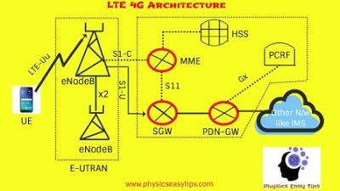
Fig 2: working principle of 4G

The image above shows the working principle of the 4G network with each of the component performing a specific task to ensure the data technology performs at its best.
The MME is an acronym for Mobility Management Entity which is used for Paging, Authentication, Handover and Selection of Serving Gateway. The SGW is an acronym for Serving gateway and It is used to Routing and Forwarding user data packet. The PDN-GW is an acronym for Packet Data Network Gateway and It is used for user equipment (UE) IP allocation. The HSS is an acronym for Home Subscriber Server and It is a user Database used for service subscriber, user identification and addressing. The PCRF is an acronym for Policy and Charging Rule Function and It is used in providing quality of service and charging. The encode B is an acronym for evolved Node B and it used as radio resources management and radio bearer control.

The advantages of 4G includes;
- Extremely high voice quality
- Higher bandwidth
- High spectral efficiency
- Very low latency.
- Simple protocol architecture.
- Efficient multicast/broadcast.

The disadvantages of 4G includes;
- Higher data prices for consumers.
- It is very expensive and hard to implement.
- Complex hardware.
- Power usage is more.

(c) working principle of 5G

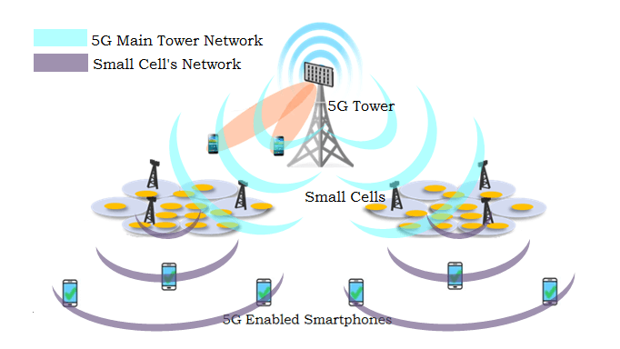
Fig 3: working principle of 5g

As earlier stated, 5G stand for fifth generation data technology and it is a significant advancement in today’s technology. 5G makes use of 4G frequency spectrum operating at higher data rates compared to the 4G and also makes use of the millimeter waves. This 5g provides even lower latency at around 1ns which is lower than what is offered by the 4g and 3g. it has an improved data speed and higher uplink and downlink speeds. Like other cellular networks, 5G networks use a system of cell sites that divide their territory into sectors and send encoded data through radio waves. Each cell site must be connected to a network backbone, whether through a wired or wireless backhaul connection. 5G networks use a type of encoding called OFDM, which is similar to the encoding that 4G LTE uses. The air interface is designed for much lower latency and greater flexibility than LTE, though. With the same airwaves as 4G, the 5G radio system can get about 30 percent better speeds thanks to more efficient encoding. While most 4G channels are 20MHz, bonded together into up to 140MHz at a time, 5G channels can be up to 100MHz, with Verizon using as much as 800MHz at a time. That's a much broader highway, but it also requires larger, clear blocks of airwaves than were available for 4G. There are two major components of the 5g which includes the core network and the radio access network.
The radio access network consists of small cells, towers, masts etc. the small cells being a major feature in the 5g at the new millimeter wave frequency where the connection range is short. Small cells are portable miniature base stations that require minimal power to operate and can be placed every 250 meters or so throughout cities. To prevent signals from being dropped, carriers could install thousands of these stations in a city to form a dense network that acts like a relay team, receiving signals from other base stations and sending data to users at any location. 5g also makes use of the MIMO interface.

The advantages of 5g includes;
- Greater bandwidth
- Newer technologies may become available o 5g networks
- Reduced latency
- High peak data speeds

The disadvantages of 5g includes;
- Network coverage
- Radio frequency may become a problem
- 5G network Technology will take more time for security and privacy issues.

Question 2
The differences between 2g,3g,4g and 5g includes;

Technology | 2G | 3G | 4G | 5G
Requirements | No official requirements  Digital technology | ITU MIT-2000 required  144 kbps mobile, 384 kbps pedestrian, 2mbps indoors. | ITU IMT advanced requirements includes ability to operate in up to 40 MHz radio channels and with high spectral speeds | At least I GB/s or more data rates to support ultra-high definition video and virtual reality applications
Data bandwidths | 14.4kbps to 384 kbps | 2 mbps | 2 mbps to 1Gbps | 1Gbps and higher
Core network | PSTN packet network | Packet network | All IP network | Flatter IP network and 5g network interfacing
Service | Digital voice and packetized data | Integrated high quality video and audio | Dynamic information access, HD streaming. | Dynamic information access, HD streaming. Global roaming
Multiple access | TDMA  CDMA | CDMA | CDMA | CDMA&BDMA
Frequency | 850-1900MHZ | 1.6-2.5 GHZ | 2-8GHZ | 24-80GHZ
Standards | GSM, GPRS, EDGE | WCDMA, CDMA 2000 | All access convergence including OFMDA, MC-CDMA, network- LMPS | CDMA, BDMA

Question 3

No, there is no practical nor reasonable theoretical relationship between 5g and the corona virus. There is no figurative and literal correlation between these two things. This baseless rumor is only as a result of the ignorance of humans and in my opinion as a means to both amuse the ones spreading the rumors and as also a means to rattle the world. Most people fail to release that just like the sun, 5g is a non- ionizing radiation which means it causes little or no significance to the deterioration of the cells in the body and this does not still justify its correlation with the 5G.
Some certain practical operations claim that the 5g causes radiation and this radiation somehow enters the blood stream and mutates with the cells which causes covid-19. This is both incorrect and laughable and also somewhat irritating to both read and comment on. People tend to not research and read up on the world and go ahead with various trends and rumors which is somewhat sad.
We do hope that in time to come humans would prefer to read and research rather than take the words from people who are bent on misleading the masses

