Name: Oyedeji Al’amin Oyedapo
Matric No.: 15/ENG04/050
Department: Electrical/Electronics Engineering

- Working Principles of 3G, 4G and 5G Networks.

- 3G Technology
It was 3G technology that paved the way for the smartphones and tablets that we use today to stay connected. 3G provides a stable and relatively fast mobile connection. But what is 3G technology, and how does it work?
3G data technology uses a network of phone towers to pass signals, ensuring a stable and relatively fast connection over long distances. The tower nearest to the user’s mobile phone passes data to it. While it may not sound complex, 3G technology was revolutionary at the time it was released.
UMTS (Universal Mobile Telecommunications System):
UMTS, short for Universal Mobile Telecommunications System, is a 3G networking standard used throughout much of the world as an upgrade to existing GSM module.
Some Features of UMTS Include:
- UMTS makes use of WCDMA, a technology that shares much with CDMA networks used throughout the world, though it is not compatible with them.
- Base level UMTS networks are generally capable of downlink speeds as 384 kbps.
- The UMTS architecture takes advantage of the existing GSM and GPRS networks which serve as a core network in UMTS infrastructure.
The UMTS is made up of 3 main components:
a) User Equipment:
It is assigned to a single user and contains all the functions needed to access UMTS services. It contains: – Mobile Equipment (ME) : It is a radio terminal which is used to connect the UMTS subscriber with the fixed part of UMTS system via the radio interface Uu.
– UMTS Subscriber Identity Module (USIM): A smartcard which contains the subscriber identity, authentication algorithms, encryption keys etc.
b) UMTS Terrestrial Radio Access Network (UTRAN):
It handles cell-level mobility. It is a system of base station and controller handling function related to mobility. It contains:

1. Nodes B (Base Stations):
• It converts the data between Uu radio interface and the Iub interface connecting a Node B with the RNC.
• It performs physical level processing such as channel coding, data interleaving, rate matching, modulation etc.
2. Radio Network Controllers (RNC):
• RNC’s controls and manages radio resources to Node B.
• RNC performs the data-link layer processing and participates in handover operations.
• RNC is considered a single access point of UTRAN for the core network.
• It’s connected to a single MSC/VLR to route circuit-switched traffic and to a single SGSN to route packet switched traffic.
c) Core Network (CN):
The core network is shared with GSM and GPRS. The CN contains functions for intersystem handover, gateways to other networks and performs location management. It contains:
- Home Location Register (HLR)
- Mobile Station Controller / Visitor Location Register (MSC/VLR).
- Gateway MSC: Connect UMTS to external circuit switch n/w (e.g PSTN)
- Serving GPRS Support Node (SGSN): It serves the Packet-switched traffic.
- Gateway GPRS Support Node (GGSN): Connects UMTS to external packet switched. (e.g. Internet)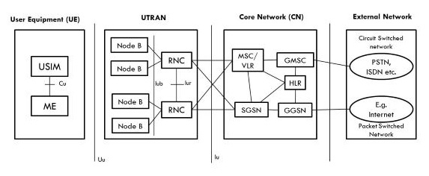

Advantages of 3G :
- Faster data rates.
- Support multimedia applications such as video and photography.
- Value added services like mobile television, GPS, video call and video conference.
- High speed mobile internet access.
- Increased capacity.
Disadvantages of 3G:
- Requires 3G compatible handsets.
- The cost of upgrading to 3G device is expensive.
- Power consumption is high.
- 3G requires closer base stations which is expensive.

- 4G Technology:
4G stands for fourth generation cellular system and is an evaluation of 3G to meet the forecasted rising demand. It is an integration of various technologies including GSM,CDMA,GPRS,IMT-2000 ,Wireless LAN. Data rate in 4G system will range from 20 to 100 Mbps.
Features:
- Fully IP based Mobile System.
- It supports interactive multimedia, voice, streaming video, internet and other broadband service.
- It has better spectrum efficiency.
- It supports Ad-hoc and multi hop network.
4G Architecture
- Figure shows Generic Mobile Communication architecture.
- 4G network is an integration of all heterogeneous wireless access networks such as Ad-hoc, cellular, hotspot and satellite radio component.
- Technologies used in 4 G are smart antennas for multiple input and multiple output (MIMO), IPv6, VoIP, OFDM and Software defined radio (SDR) System.
Smart Antennas:
- Smart Antennas are Transmitting and receiving antennas.
- It does not require increase power and additional frequency.
IPV6 Technology:
- 4G uses IPV6 Technology in order to support a large number of wireless enable devices.
- It enables a number of application with better multicast, security and route optimization capabilities.
VoIP:
- It stands for Voice over IP.
- It allows only packet to be transferred eliminating complexity of 2 protocols over the same circuit.
OFDM:
- OFDM stands for Orthogonal Frequency Division Multiplexing.
- It is currently used as WiMax and WiFi.
SDR:
- SDR stands for Software Defined Radio.
- It is the form of open wireless architecture.
Advantages:
- It provides better spectral efficiency.
- It has high speed, high capacity and low cost per bit.
Disadvantage:
- Battery usage is more.
- Hard to implement.
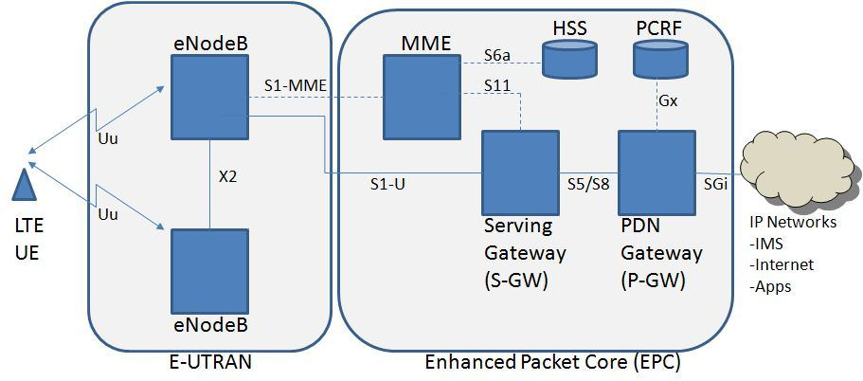
MME- Mobility Management Entity
It is used for Paging ,Authentication, Handover and Selection of Serving Gateway
SGW- Serving gateway
It is used to Routing and Forwarding user data packet.
PDN-GW Packet Data Network Gateway
It is used for user equipment (UE) IP allocation
HSS -Home Subscriber Server
It is a user Database used for service subscriber, user identification and addressing
PCRF -Policy and Charging Rule Function
It provide quality of service and charging
eNode B-evolved Node B
It is used as radio resources management and radio bearer control.

Advantages of 4G:
- Quickly download files over a wireless network
- Extremely high voice quality
- Easily access Internet, IM, social networks, streaming media, video calling
- Higher bandwidth
- 4G is 10 times faster than 3G
Disadvantages of 4G:
- New frequencies means new components in cell towers.
- Higher data prices for consumers
- Consumer is forced to buy a new device to support the 4G
- It is impossible to make your current equipment compatible with the 4G network.

- 5G Technology:
5G is the fifth generation of cellular networks, and it is expected to be one of the fastest wireless technologies ever created. 5G wireless technology is meant to deliver higher multi-Gbps peak data speeds, ultra low latency, more reliability, massive network capacity, increased availability, and a more uniform user experience to more users. Higher performance and improved efficiency empower new user experiences and connects new industries.
Like 4G LTE, 5G is also OFDM-based (Orthogonal frequency-division multiplexing) and will operate based on the same mobile networking principles. However, the new 5G NR (New Radio) air interface will further enhance OFDM to deliver a much higher degree of flexibility and scalability.
5G will not only deliver faster, better mobile broadband services compared to 4G LTE, but it will also expand into new service areas, such as mission-critical communications and connecting the massive IoT. This is enabled by many new 5G NR air interface design techniques, such as a new self-contained TDD subframe design.

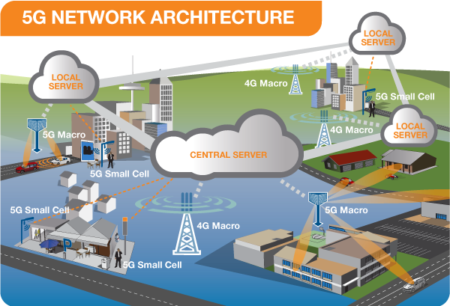

ADVANTAGES OF 5G
- High resolution and bi-directional large bandwidth shaping.
- Technology to gather all networks on one platform.
- More effective and efficient.
- Technology to facilitate subscriber supervision tools for the quick action.

DISADVANTAGES OF 5G
- 5G is more costly compared to other Mobile Network Technology because many technical/ official engineers are required to install and maintain it.
- The risk of overcrowding the frequency range of the 5G wireless spectrum is greater as more devices are connected to one channel.
- 5G network Technology will take more time for security and privacy issues.
- Coverage indoor distance up to 2 meters and 300 meters outdoors can be achieved due to greater losses at higher frequencies as 5Gmm wave influences from such losses (rain losses, attenuation due to rain, etc.).

Question 2: In tabular form, establish adequate differences between 2G, 3G, 4G and 5G.

Technology | 2G | 3G | 4G | 5G
Requirements | No official requirements | ITU’s, IMT-2000 required. 144kbps mobile, 384 kbps pedestrian, 2Mbps indoors. | ITU’s, IMT Advanced requirement include ability to operate in up to 40MHz radio channel. | At least 1GB/s or more data rates to support ultra-high definition video and virtual reality.
Data Bandwidth | 14.4Kbps to 384kbps | 2Mbps | 2Mbps to 1 Gbps | 1Gbps and higher (as demand)
Core Network | PSTN Packet Network | Packet Network | All IP Network | Flatter IP Network and 5G network interfacing
Service | Digital voice, Higher capacity, packetized data | Integrated high quality audio, video, data. | Dynamic Information access, wear-able devices, HD streaming, global roaming. | Dynamic information access, wear-able devices, HD streaming; any demand of users; global roaming smoothly.
Standards | GSM, GPRS, EDGE, etc. | WCDMA  CDMA 2000 | All access convergence including: OFMDA, MC-CDMA etc. | CDMA  BDMA
Multiple Access | TDMA  CDMA | CDMA | CDMA | CDMA  BDMA
Starts from | 1990 | 2001 | 2010 | 2015
Switching | Circuit Packet | Circuit Packet | Packet | All Packet
Frequency | 850-1900MHz | 1.6-2.5GHz | 2-8GHz
Question 3

  - No, there is no correlation between 5G and Corona virus.

  - 5G is the latest development in wireless technology. 5G is poised to change humanity in a very big way, and infact may be the single biggest revolution in human culture since the global adoption of the internet. This is because 5G technology will allow information transfer rates as high as a stunning 20gigabytes per second, which is faster than most wired connections.

But with this new technology, come fear of the public sector and how people are opposing the rollout of 5G technology on the grounds that it is dangerous to human health and could even be linked to the spread of the corona virus disease reason being the very high frequency that the technology uses to transmit data. The truth is 5G radio waves aren’t powerful enough to damage the cells in your body alone or transmit a virus. Much like 4G or 3G before it, the radio waves used in 5G are non-ionizing radiation. These are on the opposite end of the electromagnetic spectrum to ionizing radiation sources like X-rays, gamma rays, and ultraviolet rays.

None of the conspiracy theories that try to link 5G and the coronavirus even make sense. The virus is spreading in countries without access to 5G, the frequencies from 5G can’t harm your body, and COVID-19 is caused by a contagious virus that is in no way related to electromagnetic waves. Even the general correlation between 5G and COVID-19 doesn’t stand up to scrutiny: they’re both global phenomena happening at roughly the same time, but as soon as you look at specific countries, the correlation falls apart.

