NAME: INEGBEDION IKPEHOSA ANGEL
MATRIC NUMBER: 18/MHS01/185
DEPARTMENT: MEDICINE AND SURGERY
COURSE: EMBRYOLOGY
ASSIGNMENTs

- Discuss ovulation

OVULATION
This is the release of mature secondary oocyte from the ovarian follicle.
There is an abrupt increase in the luteinizing hormone that causes;
- Primary oocyte to compete meiosis
- The follicle enter the preovulatory mature vesicular stage.
Meiosis II begins and the secondary oocyte is arrested approximately 3 hours before ovulation at metaphase II
In the meantime, at the surface of the ovary, an avascular stigma occurs at the apex so for the oocyte to be released, two events will occur caused by the luteinizing hormone surge.
Increase in collagenase enzyme breaking down the collagen fibers surrounding the ovary
Increase in production of prostaglandin which helps in muscular contraction in the ovary walls.
The cells of the cumulus oophorus will float out with the secondary oocyte during ovulation then the cumulus oophorus will arrange themselves around the zona pellucida to form the corona radiate.
Ovulation is triggered by a surge in luteinizing hormone
It usually follows the luteinizing hormone peak 12 to 24 hours.
Clinical correlates
During ovulation, some women experience an abdominal plan called mittelschmerz or middle pain because it mormaly occurs near the middle of menstrual cycle.
Mittelschmerz pain may be used as symptomsof ovulation;
Other signs are
- Increase surge for sex
- Tenderness of breast
- Swollen vagina
- Changes in cervical mucus
Anovulation: is failure to ovulate due to low concentration of gonadotrophin.
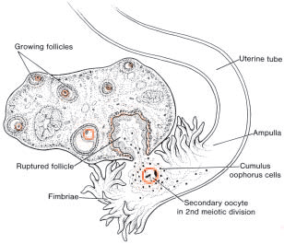
2 Differentiate between meiosis I and meiosis II
Meiosis 1 | Meiosis II
Prophase 1  Three major events takes place during this stage:  - Synapsis: homologous chromosomes align themselves in pairs.  - Crossing over: interchange of the chromatin segments.  - Chiasma formation: the x shape that forms during the crossing over. | Prophase II  Three events do not take place: no synapsis, no crossing over and no chiasma formation.  The spindle fiber also resolves
Metaphase I  Alignment of the 46 homologous duplicated chromosomes equator. | Metaphase II  Alignment of 23 duplicated chromosomes at the equator.
Anaphase I  Separation of 46 homologous duplicated chromosomes but centromere does not split | Anaphase II  Separation of duplicated chromosome and centromere splits
Telophase I  Formation of two secondary gametocytes 23 duplicated chromosome 2N | Telophase II  Formation of four gametocyte 23, 1N
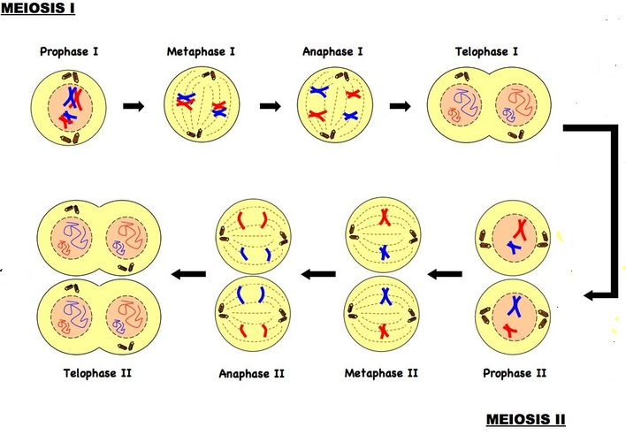
3 discuss the stages involved in fertilization
Fertilization
This is the union of sperm and oocyte, it takes approximately 24 hours which includes;
- Passage of sperm through corona radiate: for this to occur, the sperm must be capacitated
- Penetration of zona pellucida: the acrosome will bind to the zona glycoprotein on the zona pellucida then acrosin will be released to allow the sperm penetrate the zona pellucida.
When the sperm comes in contact with the oocyte surface, lysosomal enzymes are released from the cortical granules lining the plasma membrane of the oocyte then they will send message back to the region of the zona pellucida: close the binding site and block polyspermy.
- Fusion of plasma membrane of sperm and oocyte: the head and tail of the sperm will enter the cytoplasm of the oocyte leaving the plasma membrane behind.
- Completion of the second meiotic division: as soon as the sperm enters the region of the oocyte, 2nd meiotic division is completed and second polar body is formed, the nucleus becomes a pronucleus.
- Formation of male pronucleus: the tail will degenerate while the nucleus of the sperm enlarges to form a pronucleus.
Formation of zygote: since the zygote has 2 haploid pronuclei called an ootid, they will fuse to single diploid aggregation of chromosome then the ootid becomes a zygote.
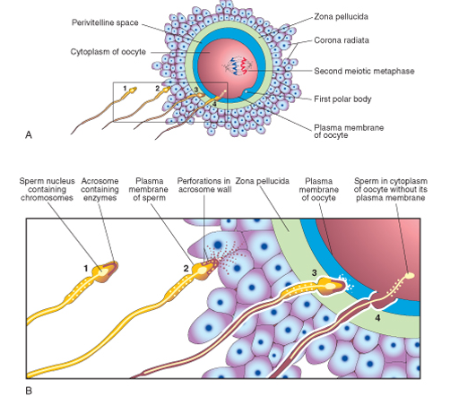

4 differentiate between monozygotic twins and dizygotic twins.
Monozygotic twins | Dizygotic twins
- They are formed from a single zygote | They are formed from two zygotes
- Incidence is more common | Incidence is less common
- They are genetically identical | They are not identical
- They are of the same sex | They are of the same or different sex
- They share a common chorionic and amniotic sac with one placenta | They do not share a common chorionic and amniotic sac and one placenta
- They are often called conjoined twins | They are not seen as conjoined twins

