EMBRYOLOGY ASSIGNMENT.
QUESTIONS.
- DISSCUSS OVULATION

ANSWER
This is the release of an oocyte from the ovarian follicle
In a few days before ovulation, under the influence of FSH and LH, the secondary follicle grows rapidly to a diameter of about 25 mm to become mature vesicular/ mature secondary or Graafian follicle
Coincident with final development of the vesicular follicle, there is an abrupt increase in LH that causes;
the primary oocyte to complete meiosis I
and the follicle to enter the preovulatory mature vesicular stage
Meiosis II is also initiated, but the secondary oocyte is arrested in metaphase approximately 3 hours before ovulation
In the meantime, the surface of the ovary begins to bulge locally, and at the apex, an avascular spot, the stigma, appears

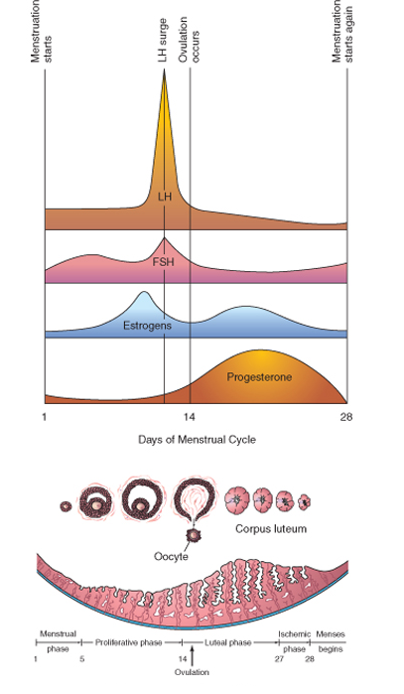
For the oocyte to be released, 2 events occur which are caused by LH surge:
- It increases collagenase activity, resulting in digestion of collagen fibers (connective tissue) surrounding the follicle

- Prostaglandin levels also increase in response to the LH surge and cause local muscular contractions in the ovarian wall

Those contractions extrude the oocyte, which together with its surrounding follicular (granulosa) cells from the region of the cumulus oophorus,
This causes ovulation in which oocyte floats out of the ovary
Some of the cumulus oophorus cells then rearrange themselves around the zona pellucida to form the corona radiata

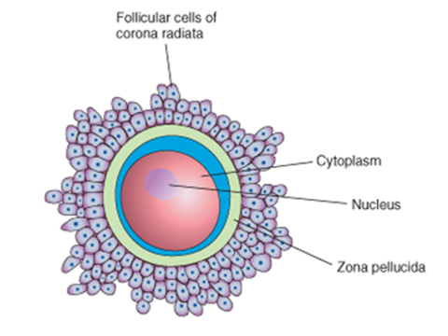
CLINICAL CORRELATES INCLUDE;
- During ovulation, some women feel a variable amount of abdominal pain called mittelschmer also known as middle pain because it normally occurs near the middle of the menstrual cycle
- In these cases, ovulation results in slight bleeding into the peritoneal cavity, which results in sudden constant pain in the lower abdomen.
- Mittelschmerz may be used as a symptom of ovulation, but there are better symptoms, such as the slight drop in basal body temperature
- Some women fail to ovulate, this is called anovulation, because of a low concentration of gonadotropins
- In these cases, administration of an agent to stimulate gonadotropin release and hence ovulation can be employed
- Although such drugs are effective, they often produce multiple ovulations, so that the risk of multiple pregnancies is 10 times higher in these women than in the general population

QUESTION 2
DIFFERENTIATE BETWEEN MEIOSIS 1 AND MEIOSIS 2.

ANSWER.

DIFFERENCES

MEIOSIS 1 MEIOSIS 2
Starts as diploid; ends as haploid | Starts as haploid; ends as haploid
Reductive division | Equational division
Homologous chromosome pairs separate | Sister chromatids separate
Crossing over happens | Crossing over does not happen
Complicated division process | Simple division process
Long duration | Short duration
Preceded by S-phase and G-phase | Preceded only by G-phase
Sister chromatids in prophase have convergent arms | Sister chromatids in prophase have divergent arms
Equatorial plane is centered | Equatorial plane is rotated 90°
Prophase split into 5 sub-phases | Prophase does not have sub-phases
Ends with 2 daughter cells | Ends with 4 daughter cells

QUESTION 3
DISCUSS THE STAGES INVOLVED IN FERTILIZATION.
- Fertilization
- The usual site of fertilization is the ampulla of the uterine tube
- The fertilization process takes approximately 24 hours
- It is a sequence of coordinated events which include the following stages

I Passage of a sperm through the corona radiata:
- For sperms to pass through the corona radiata, they must have been capacitated (removal of the glycoprotein coat and seminal plasma proteins from the plasma membrane that overlies the acrosomal region of the spermatozoa)
- Penetration of the zona pellucida:
- The zona is a glycoprotein shell surrounding the egg that facilitates and maintains sperm binding and induces the acrosome reaction
- The intact acrosome of the sperm binds with a zona glycoprotein (ZP3/ zona protein 3) on the zona pellucida
- Release of acrosomal enzymes (acrosin) allows sperm to penetrate the zona pellucida, thereby coming in contact with the plasma membrane of the oocyte
- As soon as the head of a sperm comes in contact with the oocyte surface, the permeability of the zona pellucida changes
- When a sperm comes in contact with the oocyte surface, lysosomal enzymes are released from cortical granules lining the plasma membrane of the oocyte
- In turn, these enzymes alter properties of the zona pellucida to :
- prevent sperm penetration and
- inactivate binding sites for spermatozoa on the zona pellicida surface
- only one sperm seems to be able to penetrate the oocyte
III. Fusion of plasma membranes of the oocyte and sperm
- The plasma or cell membranes of the oocyte and sperm fuse and break down at the area of fusion
- The head and tail of the sperm enter the cytoplasm of the oocyte, but the sperm's plasma membrane remains behind
IV. Completion of the second meiotic division of oocyte and formation of female pronucleus
- Penetration of the oocyte by a sperm activates the oocyte into completing the second meiotic division and forming a mature oocyte and a second polar body
- The nucleus of the mature ovum/oocyte is now called the female pronucleus
- Formation of the male pronucleus
- Within the cytoplasm of the oocyte, the nucleus of the sperm enlarges to form the male pronucleus and the tail of the sperm degenerates
Note
- Since all sperm mitochondria degenerate, all mitochondria within the zygote are of maternal origin (i.e., all mitochondrial DNA is of maternal origin)
- Morphologically, the male and female pronuclei are indistinguishable
- The oocyte now contains 2 pronuclei, each having haploid number of chromosomes(23)
- The oocyte containing two haploid pronuclei is called an ootid
- The 2 pronuclei fuse into a single diploid aggregation of chromosomes, the ootid becomes a zygote
- The chromosomes in the zygote become arranged on a cleavage spindle in preparation for cleavage of the zygote
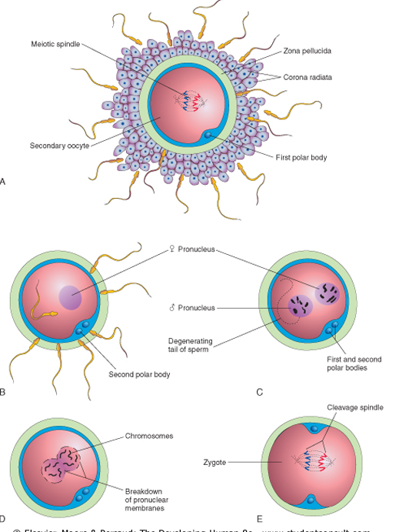

QUESTION 4
DIFFERENTIATE BETWEEN MONOZYGOTIC TWINS AND DIZYGOTIC TWINS
ANSWER.
DIZYGOTIC TWINS MONOZYGOTIC TWINS
 | Two different eggs fertilized by two different sperm cells | The splitting of the same fertilized egg into two
 | Like any other sibling; not identical. | Nearly identical
 | Usually different | Always the same
 | Varies by country. About 6 in 1,000 in Japan, up to over 20 per 1,000 in some parts of Africa. Two-thirds of all twins in the world are fraternal. | Uniform around the world; about 3 in 1,000. Only one-third of all twins in the world are identical.
 | Gender May be different | Always the same
 | Causes include Hereditary predisposition, certain fertility drugs, IVF | Not known
 | As similar as any other sibling | Extremely similar, although may not be exactly identical due to environmental factors
 | Develop separate sacs in utero. | May be contained in one sac in utero.
 | Low risk of twin to twin transfusion syndrome | Higher risk compared with fraternal twins

