NAME: AKINGBOLA OLUWAFIKAYOMI ANNE
MATRIC NO: 18/MHS01/054
COLLEGE: MEDICINE AND HEALTH SCIENCES
DEPARTMENT: MBBS
EMBROYOLOGY ASSIGNMENT
Discuss the second week of development
Three major events take place during this week; (8-14)
- Completion of implantation
- The formation of a bilaminar germ disc
- Development of extra embryonic structures- chorionic cavity, amnion, amniotic cavity, umbilical cord, connecting stalk
Day 8
The blastocyst is partially embedded in the endometrium. The syncytiotrophoblast will continue to erode the endometrium, eroding the blood vessels and capillaries in the endometrium. The cells of the cytotrophoblast will continue to divide and migrate into the region of the syncytiotrophoblast. The inner cell mass the embryoblast differentiates into 2 cells;
- The cuboidal cells- hypoblast
- The columnar cells -epiblast
The cells of the epiblast that are adjacent to the cells of the cytotrophoblast are called amnioblast. The epiblast surrounds a cavity called the amniotic cavity. The epiblast and the hypoblast give rise to the bilaminar germ disk. The endometrium adjacent to the implantation site is the edematous.

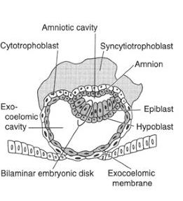
Day 9
The blastocyst is deeply embedded in the endometrium. Cells of the syncytiotrophoblast continue to erode the endometrium and cytotrophoblast will continue to divide and migrate into the region of the syncytiotrophoblast. The surface epithelium is closed by a coagulum called fibrin. Vacuoles appear in the region of the syncytiotrophoblast and enlarge to form lacunae. This stage of the trophoblast development is known as the lacunar stage. Cells of the hypoblast adjacent to the cytotrophoblast form a thin membrane called exocoelomic / Heuser’s membrane. The cavity lines the inner surface of the cytotrophoblast. The membrane has a cavity called the exocoelomic membrane/ Heuser’s membrane/primary yolk sac/ primary umbilical cord.

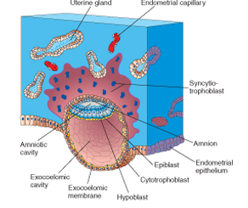

Day 11-12
- The blastocyst is completely embedded in the endometrium. The syncytiotrophoblast continues to erode the endometrium and cells of the cytotrophoblast continue to divide and migrate into the region of the syncytiotrophoblast. The blastocyst now has a slight protrusion into the lumen of the uterus. The ruptured endometrial capillaries are called sinusoids. The lacunae then begin to communicate with the sinusoids and the maternal blood enters the lacunar system. The communication of the eroded endometrial capillaries with the lacunae establishes the primordial uteroplacental circulation. When maternal blood flows into the lacunae, oxygen and nutritive substances are available to embryo. A new population of cells appears between the inner surface of the cytotrophoblast and outer surface of the exocoelomic cavity. These cells which are derived from the yolk sac form the extraembryonic mesoderm. Soon, large cavities develop in the extraembryonic mesoderm to form extraembryonic cavity or extraembryonic coelom. The space surrounds the primitive yolk sac and amniotic cavity, except where the germ disc is connected to the trophoblast by the connecting stalk (which develops into the umbilical cord). The embryonic mesoderm lining the cytotrophoblast and amnion is called extraembryonic somatic mesoderm. The one lining the yolk sac is known as the extraembryonic splanchnic mesoderm. As the conceptus implants, the endometrial connective tissue cells undergo a transformation, called decidual reaction
- During this transformation, the cells of the endometrium swell because of the accumulation of glycogen and lipid in their cytoplasm and they are known as decidual cells.
- The primary function of the decidual reaction is to provide nutrition for the early embryo and an immunologically privileged site for the conceptus.

Day 13

The surface defect in the endometrium has been completely covered by the surface epithelium. Occasionally bleeding occurs at the implantation sites as a result of increased blood flow into the lacunar spaces. Cells of the cytotrophoblast proliferate locally into the syncytiotrophoblast, forming cellular columns surrounded by syncytium. Cellular columns with the syncytial covering known as primary villi. The primary yolk sac becomes smaller in size and it is known as the secondary yolk sac. A portion of the exocoelomic cavity is pinched off to form the exocoelomic cyst. It is pinched off to allow formation of the secondary yolk sac. The exocoelomic cavity enlarges to form the chorionic cavity. The extraembryonic cavity lining the inside of the cytotrophoblast is then known as chorionic plate. The only place where this is absent is the connecting stalk which becomes the umbilical cord.

Clinical correlate
The syncytiotrophoblast produces a hormone called the Human Gonadotropin hormone which enters the maternal blood via lacunae and keeps corpus luteum secreting estrogens and progesterone. hCG can be detected in maternal blood or urine as early as day 10 of pregnant and is the basis for pregnancy tests.

See diagrams on the next page.

