NAME: Barnabas Oluwatobi
MATRIC NO: 18/MHS06/021
DEPARTMENT: Medical Laboratory Science
COURSE: AFE 202
AGRICULTURE PLAN ON FISH CULTIVATION
Fish cultivating or pisciculture includes bringing fish economically up in tanks or walled in areas, for example, fish lakes, as a rule for nourishment. It is the chief type of aquaculture, while different techniques may fall under mariculture. An office that discharges adolescent fish into the wild for recreational angling or to enhance an animal categories' normal numbers is by and large alluded to as a fish incubation facility. Around the world, the most significant fish species delivered in fish cultivating are carp, tilapia, salmon, and catfish.

Request is expanding for fish and fish protein, which has brought about across the board overfishing in wild fisheries. China gives 62% of the world's cultivated fish. Starting at 2016, over half of fish was delivered by aquaculture. Cultivating meat eating fish, for example, salmon, doesn't generally decrease pressure on wild fisheries. Meat eating cultivated fish are normally taken care of fishmeal and fish oil extricated from wild scrounge fish. The 2008 worldwide returns for fish cultivating recorded by the FAO totaled 33.8 million tons worth about $US 60 billion. The expense of information sources per unit of fish weight is higher than in broad cultivating, particularly in light of the significant expense of fish feed. Higher protein-level necessities are an outcome of the higher feed proficiency of oceanic creatures (higher feed transformation proportion [FCR], that is, kg of feed per kg of creature delivered). Fish, for example, salmon have a FCR around 1.1 kg of feed per kg of salmon, though chickens are in the 2.5 kg of feed per kg of chicken range. Fish don't utilize vitality to keep warm, killing a few sugars and fats in the eating regimen, required to give this vitality.

Some fish farms have different caging systems but first what are fish cages used for;
Fish cages are placed in lakes, bayous, ponds, rivers, or oceans to contain and protect fish until they can be harvested.The method is also called OFF SHORE CULTIVATION when the cages are placed in the sea. They can be constructed of a wide variety of components. Fish are stocked in cages, artificially fed, and harvested when they reach market size.
Classifications of Aquaculture:

Aquaculture utilizes neighborhood photosynthetic creation (broad) or fish that are taken care of with outer nourishment supply (concentrated).

BROAD/EXTENSIVE AQUACULTURE; Growth is constrained by accessible nourishment, generally Zooplankton benefiting from pelagic green growth or benthic creatures, for example, scavangers and mollusks. Tilapia channel feed straightforwardly on phytoplankton, which makes higher creation conceivable. Photosynthetic creation can be expanded by preparing lake water with counterfeit compost blends, for example, potash, phosphorus, nitrogen, and small scale components.

CONCENTRATED/INTENSIVE AQUACULTURE; In these sorts of frameworks fish creation per unit of surface can be expanded voluntarily, as long as adequate oxygen, new water and nourishment are given. Due to the prerequisite of adequate new water, a gigantic water refinement framework must be coordinated in the fish ranch. One approach to accomplish this is to consolidate hydroponic agriculture and water treatment. The special case to this standard are confines which are put in a waterway or ocean, which supplements the fish crop with adequate oxygenated water.

Achievability STUDY/REPORT FOR FISHERY/FISH FARMING

This field-tested strategy looks at the attainability of the advantages of fish cultivating specifically zones. The lake will be sufficiently large to contain various measure of fishes for the utilization and conveyance of fishes to showcase merchants and different buyers. There is appeal of fish in the network these days. This business will affect significantly and emphatically on different fish merchants and improve the pay of different fish ranchers. The name of the Organization is DOPERTY FISHING INDUSTRIES.

TYPES OF CAGING SYSTEM
1. COPPER-ALLOY NETS

Copper composites have become significant netting materials in aquaculture. Copper composites are antimicrobial which implies they crush microorganisms, infections, organisms, green growth, and different organisms. The obstruction of life form development on copper amalgam nets additionally gives a cleaner and more advantageous condition for cultivated fish to develop.

2. WATER SYSTEM DITCH AND POND SYSTEM;

These utilization water system dump or ranch lakes to raise fish. The fundamental prerequisite is to have a jettison or lake that holds water, conceivably with an over the ground water system framework, numerous water system frameworks utilize covered channels with headers. Utilizing this strategy, water allocations can be put away in lakes or trench, generally fixed with bentonite earth.

3. COMPOSITE FISH CULTURE;

The composite fish culture framework is an innovation created in India by the Indian Council of Agricultural Research during the 1970s. In this framework, of both neighborhood and imported fish, a mix of five or six fish species is utilized in a solitary fish lake. These species are chosen with the goal that they don't vie for nourishment among them by having various kinds of nourishment natural surroundings. Therefore, the nourishment accessible in all the pieces of the lake is utilized. Fish utilized in this framework incorporate catla and silver carp which are surface feeders, rohu, a section feeder, and mrigal and basic carp, which are scavengers.

BUSINESS EVALUATION OF FARM
This evaluation is based on fishes i.e tilapias and catfishes. .evaluation would be based on 5%normal loss i.e the process of taking care of young fry’s, its possible to loose 5%of the fishes due to sickness. Therefore if we start with 1000 tilapias its possible to loose 50fishes at the process of rearing them, while if we start with 400 catfishes, its possible to loose 20 fishes to disease at the process of rearing them.

SPONSORSHIP: This business is sponsored by Pastor The federal Bank of Agriculture (BOA). They iate using this business idea as an opportunity to engage talented fish farmers and to help the society at large. They are also handling and promoting a small scale business in Kogi State. DOPERTY FISHING Industries will be responsible for the management of the projects.

THE EXECUTIVES
The administration will involve explicitly hand-picked experienced individuals to deal with the business. The best point of this administration is to give reasonable choices and right strategies that will empower the business to run adequately. I, BARNABAS OLUWATOBI will be answerable for the everyday administration for agreeable business.

MARKET AND SALES:

MARKET ORIENTATION: Domestic, South-South, South-West, Nigeria MARKET SHARE: 5% nichie advertise in the south-south, Nigeria

PRODUCT: Canned Fish, Fish skin, Fish Oil, and numerous others

RIVALRY ANALYSIS:

The waterfront government conditions of Nigeria are Ogun, Lagos, Ondo, Edo, Delta, Bayelsa, Rivers, Akwa Ibom, and Cross Rivers States, found in the southern piece of the nation. The significance of the fisheries area to people and the economy of many created and creating nations can't be overemphasized. It is striking that fish gives over 60.0% of the world's inventory of protein, particularly in creating nations. Its significance could be felt legitimately and in a roundabout way among country and urban occupants in Nigeria.

MARKET POTENTIAL:

The market open door for fish cultivating in Nigeria is gigantic. Nigerians devour almost 2 million tons of fish for each year, and the nation's developing populace guarantees request will keep on blasting. Request far exceeds current national creation, making it important to import fish from everywhere throughout the world.

BENEFITS

Physical, substance, natural, climate and ecological factors, for example, temperature, daylight, water, air, size of the lake, assortments of fish feed, sicknesses, cost

variances and different dangers for example intrusion of hooligans to the lakes to take the fishes. Specialized, logical and money related based arrangements will be utilized to fence against these variables to defend benefit. Looking out for the lake by security work forces and topping off of the water in the lake to guarantee compelling creation.

SPECIALIZED ASSISTANCE; This association has specialized help from the FAO. They furnish specialized aptitude to manage protection, the board, strategies,

financial matters, industry and results of our fishery assets. This business has hounded a profound establishment and we have at our backs working connected at the hip with us the RIVERS STATE GOVERNMENT. The administration will likewise contribute to our transportation of our merchandise all through the state and to different enterprises.

MECHANISMS: Pastor dokinta will give us a freed shrubbery and a lake from about 70ft long, 35ft width and 4-5 ft of water dept. Minister Belemina Obunge will likewise give different confining frameworks and fish feed for the association. The administration will likewise give some cultivating actualizes and furthermore a few types of gear for the advancement of the task.

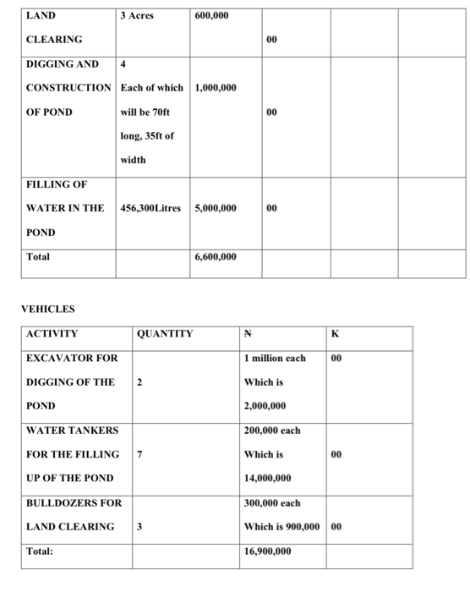
ESTIMATED PROJECT COSTS AND REVENUE FIXED COST
UNDERTAKING KING TIMELINE:

The undertaking will be finished inside 2 and a half years ideally between October, 2019 to March 2022 on the grounds that land clearing is for the most part done in the dry season and furthermore the burrowing of the lake and the purchasing of youthful fishes. Youthful fishes develop to their real size in around 1-2 years.

IMPLENTATION/MONITORING: I, OLUWATOBI , guaranteed the real spending plan was being observed to show that the real outcome mirrors the normal outcome as contained in the diagram venture plan . a control component was remembered for the implantation intend to guarantee reasonability of the venture at unequaled.

END/CONCLUSION :

My Project is doable and monetarily suitable. It is thusly suggested for financing so usage can happen.

