Aliu Kudirat Oshione
17/MHS01/054
Medicine and Surgery 300level
Gross Anatomy of Head and Neck
Question 1: Write an essay on the cavernous sinus
Introduction
The cavernous sinus is a paired dural venous sinus located within the cranial cavity. It is divided by septa into small ‘caves’ – from which it gets its name. Each cavernous sinus has a close anatomical relationship with several key structures in the head, and is arguably the most clinically important venous sinus.The dural venous sinuses are channels between the two layers of dura mater which are responsible for the venous drainage of the brain, skull, orbit and internal ear.
Anatomical Location and Borders of Cavernous Sinus
The cavernous sinuses are located within the middle cranial fossa, on either side of the sella turcica of the sphenoid bone (which contains the pituitary gland). They are enclosed by the endosteal and meningeal layers of the dura mater. The cavernous sinus has the following borders:
- Anterior – superior orbital fissure.
- Posterior – petrous part of the temporal bone.
- Medial – body of the sphenoid bone.
- Lateral – meningeal layer of the dura mater running from the roof to the floor of the middle cranial fossa.
- Roof – meningeal layer of the dura mater that attaches to the anterior and middle clinoid processes of the sphenoid bone.
- Floor – endosteal layer of dura mater that overlies the base of the greater wing of the sphenoid bone.
Contents of Cavernous Sinus
Several important structures pass through the cavernous sinus to enter the orbit. The can be sub-classified by whether they travel through the sinus itself, or through its lateral wall:
•Structures that pass travels through the cavernous sinus include: Abducens nerve (CN VI), Carotid plexus (post-ganglionic sympathetic nerve fibres) and internal carotid artery (cavernous portion).
•Structures that passe through lateral wall of the cavernous sinus include: Oculomotor nerve (CN III), Trochlear nerve (CN IV), Ophthalmic (V1) and maxillary (V2) branches of the trigeminal nerve.
The cavernous sinus is the only site in the body where an artery (internal carotid) passes completely through a venous structure. This is thought to allow for heat exchange between the warm arterial blood and cooler venous circulation.
Dural Venous Sinus System
Each cavernous sinus receives venous drainage from:
- Ophthalmic veins (superior and inferior) – these veins enter the cavernous sinus via the superior orbital fissure.
- Central vein of the retina – it drains into the superior ophthalmic vein, or directly into the cavernous sinus.
- Sphenoparietal sinus – which empties into the anterior aspect of the cavernous sinus.
- Superficial middle cerebral vein – it contributes to the venous drainage of the cerebrum.
- Pterygoid plexus – which is located within the infratemporal fossa.
It is important to note that the superior ophthalmic vein forms an anastomosis with the facial vein. Therefore, the ophthalmic veins represent a potential route by which infection can spread from an extracranial to an intracranial site.
The cavernous sinuses empty into the superior and inferior petrosal sinuses, and ultimately, into the internal jugular vein. The left and right cavernous sinuses are connected in the midline by the anterior and posterior intercavernous sinuses. They travel through the sella turcica of the sphenoid bone.

Clinical Significance of Cavernous Sinus
- Cavernous sinus thrombosis (CST): This refers to the formation of a clot within the cavernous sinus.This most common cause of CST is infection; which typically spreads from an extracranial location such as the orbit, paranasal sinuses, or the ‘danger zone’ of the face. Infection is able to spread in this manner due to the anastomosis between the facial vein and superior ophthalmic veins.Common clinical features include headache, unilateral periorbital oedema, proptosis (eye bulging), photophobia and cranial nerve palsies. The abducens nerve (CN VI) is most commonly affected.Treatment is typically with antibiotic therapy. Where the cause is infection, thrombosis of the cavernous sinus can rapidly progress to meningitis.
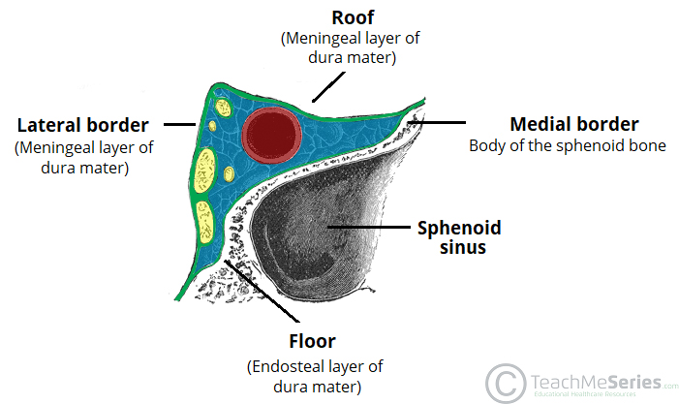
Figure: Right Corona Sinus

Question 2: Discuss the walls of the nose
Introduction
The nose is the part of the respiratory tract superior to the hard palate. It contains the peripheral organ of smell
Composition
It is made up of: the external nose and nasal cavity.
Functions of the Nose
- olfaction (smelling)
- respiration (breathing)
- filtration of dust
- humidification of inspired air
- Reception and elimination of secretions from the paranasal sinuses and nasolacrimal ducts.
Nasal Cavities
The nasal cavity is divided into right and left halves by the nasal septum. It is entered anteriorly through the nares. It opens posteriorly into the nasopharynx through the choanae.
Boundaries or Walls of the Nasal Cavity
The nasal cavity has a:
- roof
- floor
- medial wall
- lateral wall
•The roof is a curved and narrow, except at its posterior end and it is divided into 3 parts: the frontonasal, ethmoidal and sphenoidal. They are named from the bones forming each part.
•The floor is wider than the roof and is formed by the: palatine processes of the maxilla and horizontal plates of the palatine bone.
•The medial wall is formed by the nasal septum
•The lateral walls are irregular owing to three bony plates, the nasal conchae, which project inferiorly, somewhat like louvers.
Features on the lateral wall of the nasal cavity
- There is the presence of nasal conchae and they curve inferomedially
- The nasal conchae include;
- Superior nasal concha
- middle nasal concha
- inferior nasal concha
- The conchae or turbinates of many mammals (especially running mammals and those existing in extreme environments) are highly convoluted, scroll-like structures that offer a vast surface area for heat exchange
Underneath each choncha in both humans with simple nasal conchae and animals with complex turbinates is a recess or meatus (passages in the nasal cavity).The nasal cavity is thus divided into 5 passages:
i) A posterosuperiorly placed sphenoethmoidal recess
•3 laterally located nasal meatus:
ii) Superior nasal meatus
iii) Middle nasal meatus
iv) Inferior nasal meatus
v) And a medially placed common nasal meatus into which the four lateral passages open.
The inferior concha
This is the longest and broadest and is formed by an independent bone (of the same name, inferior concha) covered by a mucous membrane that contains large vascular spaces that can enlarge to control the caliber of the nasal cavity.
When infected or irritated, the mucosa may swell rapidly, blocking the nasal passages on that side.
The arterial supply of Walls of theNose
The arterial supply of the medial and lateral walls of the nasal cavity is from five sources:
- Anterior ethmoidal artery (from the ophthalmic artery)
- Posterior ethmoidal artery (from the ophthalmic artery)
- Sphenopalatine artery (from the maxillary artery)
- Greater palatine artery (from the maxillary artery)
- Septal branch of the superior labial artery (from the facial artery)
Venous drainage
A rich submucosal venous plexus deep to the nasal mucosa drains into the sphenopalatine, facial, and ophthalmic veins
Innervation
- olfactory nerve
- branches of the ophthalmic [V₁] which include the anterior and posterior ethmoidal nerves
- maxillary [V₂] nerves which include;
•posterior superior lateral nasal nerves
•posterior superior medial nasal nerves
• nasopalatine nerve
•posterior inferior nasal nerves
