AJEYOMI PEACE JESULAYOMI
18/MHS01/046 MEDICINEAND SURGERY
200L
EMBRYOLOGY
- Discuss Ovulation
Ovulation is the release of a mature secondary oocyte from the ovarian follicle. It is one of the cyclic changes that occurs during the ovarian cycle. In a few days before ovulation, under the influence of follicle stimulating hormone and luteinizing hormone, the secondary follicle grows to about a diameter of approximately 25mm or more to become a mature vesicular/mature secondary/graafian follicle.
Coincident with final development of the vesicular follicle, there is an abrupt increase in LH (LH surge) that causes;
- The primary oocyte to complete meiosis I to form secondary oocyte and 1st polar body
- And the follicle to enter the preovulatory mature vesicular stage. Meiosis II is also initiated, but the secondary oocyte is arrested in metaphase II approximately 3 hours before ovulation by cytostatic factor.
In the meantime, the surface of the ovary begins to bulge locally, and at the apex, an avascular spot, the stigma, appears. Only at 1 oocyte is released monthly.
For the oocyte to be released, 2 events occur which are caused by LH surge:
- it increases collagenase activity, resulting in digestion of collagen fibers (connective tissue) surrounding the follicle
- Prostaglandin levels also increase in response to the LH surge and cause local muscular contractions in the ovarian wall
Those contractions extrude the oocyte, which together with its surrounding follicular cells from the region of the cumulus oophorus, this causes ovulation in which oocyte floats out of the ovary. Some of the cumulus oophorus cells then rearrange themselves around the zona pellucida to form the corona radiata. Ovulation is triggered by an abrupt increase of LH production. Ovulation usually follows the LH peak by 12 to 24 hours. The LH surge, elicited by the high estrogen level in the blood, appears to cause the stigma to balloon out, forming a vesicle.
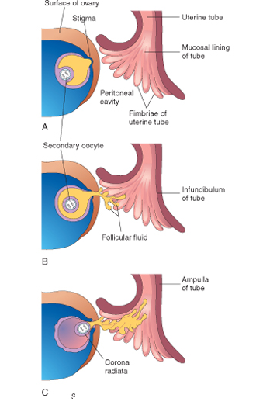Image showing how stigma appears and oocyte is released from ovary.

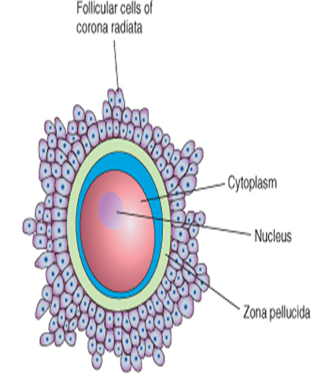Image showing mature secondary oocyte with corona radiata around it.

Clinical Significance
- During ovulation, some women feel a variable amount of abdominal pain called Mittelschmerz also known as middle pain because it normally occurs near the middle of the menstrual cycle
- In these cases, ovulation results in slight bleeding into the peritoneal cavity, which results in sudden constant pain in the lower abdomen.
- Mittelschmerz may be used as a symptom of ovulation, but there are better symptoms, such as the slight drop in basal body temperature. Before ovulation, basal temperature is consistent but as one gets close to ovulation, there will be a decline followed by a sharp increase in the temperature showing that ovulation has just occurred.
- Other signs include;
1. Changes in cervical mucus: when one is not ovulating, cervical mucus appears sticky, creamy, or maybe absent. But as ovulation approaches, it becomes waterier, abundant and takes up an egg white looking appearance, and can stretch up to an inch or more between the fingers.
2. There will be an increase in libido or urge for sex.
3. The breast become tender
4. The vulva/ vagina swells

Some women fail to ovulate, this is called anovulation, because of a low concentration of gonadotropins, in these cases, administration of an agent to stimulate gonadotropin release and hence ovulation can be employed. Although such drugs are effective, they often produce multiple ovulations, so that the risk of multiple pregnancies is 10 times higher in these women than in the general population. Use of ovulation prediction kits help to detect the LH surge which occurs approximately 12-36 hours before ovulation.
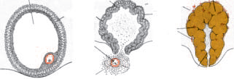
- Preovulatory follicle B. Ovulation C. Corpus Luteum

- Differentiate between meiosis I and meiosis II
BASIS | MEIOSIS I | MEIOSIS II
Separation | Sister chromatids don’t separate | Sister chromatids separate
Events of prophase | Synapsis, crossing over and chiasma formation occurs | Synapsis, crossing over and chiasma formation doesn’t occurs
Production | Two haploid daughter cells are formed from the diploid parent | Four haploid daughter cells are formed from the haploid parent
Chromosome number involved | It involves 46 homologous duplicated chromosomes | It involves 23 duplicated chromosomes
Phases involved | It involves prophase I, metaphase I, anaphase I, and telophase I | It involves prophase II, metaphase II, anaphase II, and telophase II
Duration | It is longer | It is shorter
Chromosomes produced | It produces individual chromosomes in the daughter nuclei | It produces sister chromosomes in daughter nuclei
Alignment | 46 homologous duplicated chromosomes align at the equatorial plate | 23 duplicated chromosomes align at the equatorial plate
Disjunction at anaphase | 46 homologous duplicated chromosomes separate to the opposite ends | 23 duplicated chromosomes separate to the opposite ends
Direction of arm | In prophase I, sister chromatids have convergent arms | In prophase II, sister chromatids have divergent arms

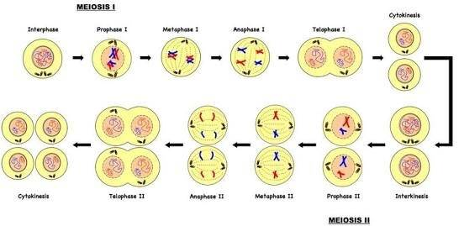
- Discuss stages involved in fertilization
Fertilization is the union of the sperm and egg to form a zygote. It is the first event that occurs in 1st week of development. The usual site of fertilization is the ampulla. Fertilization takes approximately 24 hours. It is a sequences of coordinated events which involve 5 steps;
- Passage of sperm through the corona radiata: for sperms to pass through the corona radiata, they must undergo capacitation. Capacitation is the removal of the glycoprotein coat and seminal plasma proteins from the plasma membrane that overlies the acrosomal region of the spermatozoa. Only capacitated sperms can freely pass through the corona radiata.
- Penetration through zona pellucida: The zona pellucida is an acellular, amorphous, glycoprotein shell surrounding the oocyte that facilitates and maintains sperm binding and induces the acrosome reaction. The intact acrosome of the sperm binds with a zona glycoprotein (ZP3/ zona protein 3) on the zona pellucida. Release of acrosomal enzymes (acrosin) allows sperm to penetrate the zona pellucida, thereby coming in contact with the plasma membrane of the oocyte. As soon as the head of a sperm comes in contact with the oocyte surface, the permeability of the zona pellucida changes.
When a sperm comes in contact with the oocyte surface, lysosomal enzymes are released from cortical granules lining the plasma membrane of the oocyte. In turn, these enzymes alter properties of the zona pellucida to prevent sperm penetration and inactivate binding sites for spermatozoa on the zona pellucida surface and blocks polyspermy. Only one sperm seems to be able to penetrate the oocyte
- Fusion of plasma membranes of the oocyte and sperm: The plasma membranes of the oocyte and sperm fuse and break down at the area of fusion. The head and tail of the sperm enter the cytoplasm of the oocyte, leaving behind the plasma membrane of the sperm.
- Completion of the second meiotic division of oocyte and formation of female pronucleus: As soon as the sperm enters the cytoplasm of the oocyte, second meiotic division is completed, forming a mature oocyte and a second polar body. The nucleus of the mature oocyte is now called the female pronucleus.
- Formation of the male pronucleus: Within the cytoplasm of the oocyte, the nucleus of the sperm enlarges to form the male pronucleus and the tail of the sperm degenerates.
Since all sperm mitochondria degenerate, all mitochondria within the zygote are of maternal origin (i.e., all mitochondrial DNA is of maternal origin). Morphologically, the male and female pronuclei are indistinguishable. The oocyte now contains 2 pronuclei, each having haploid number of chromosomes (23). The oocyte containing two haploid pronuclei fuse and is called an ootid
- Formation of zygote: The 2 pronuclei fuse into a single diploid aggregation of chromosomes, the ootid becomes a zygote. The chromosomes in the zygote become arranged on a cleavage spindle in preparation for cleavage of the zygote.

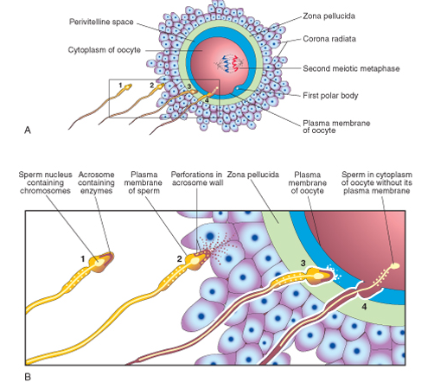 | 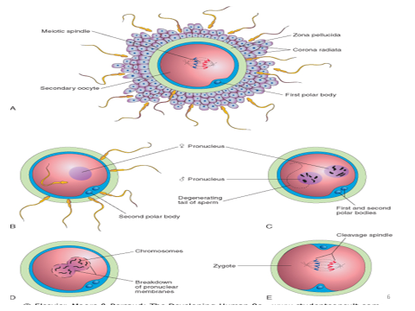

- Differentiate between monozygotic and dizygotic twins
MONOZYGOTIC TWIN | DIZYGOTIC TWIN
It is formed from a single zygote | It forms from two zygotes
Incidence rate is higher | Incidence rate is lower
Twins are genetically identical | Twins are not genetically identical
Resemblance is similar | Resemblance is just like siblings resemblance
They are mostly diamniotic, monochorionic, with a single placenta | Mostly two amnions, Two chorions and two placentas
They are often called conjoined twins | Not seen as conjoined twins
They are also known as identical twins | They are also called fraternal twins

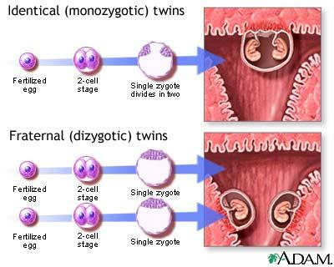 |  | 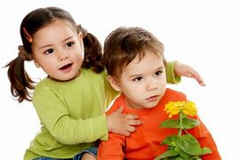
Monozygotic twins Dizygotic twins
Clinical correlates: Conjoint twins is a condition seen in monozygotic twins when the inner cell mass doesn’t completely split. The 2 fetuses are joined by a salt bridge. It could be craniophagus, thoracophagus, cephalothoracophagus or pygophagus.

