NAME: EGBURHE OGHENEOCHUKO JEFFREY

MATRIC NUMBER:18/ENG02/035

DEPARTMENT: Computer Engineering

COURSE: Afe 202

PLAN OUTLINE
- Executive Summary
- Company Summary
- Products
- Market Analysis Summary
- Strategy And Implementation Summary
- Management Summary
- Financial plan

Executive Summary
Botanical Bounty is an existing farm dedicated to the production of botanical perennials. Botanical Bounty has been formed as an Oregon-based Limited Liability Corp. (L.L.C.) located outside of Albany, Oregon. Botanical Bounty is working hard to become a leading producer of botanical plants for the natural supplement industry as well as plant nurseries. By leveraging a well thought out business plan executed by a skilled management team, Botanical Bounty will generate over $216,000 in year three sales.
Keys to Success
Botanical Bounty has identified three keys that will be instrumental in their success. The first is the implementation of strict financial controls. By having the proper controls, production efficiency will be maximized. The second key will be the never ending pursuit for the industry's highest concentration levels of botanical ingredients in each plant. The third key is the recognition and implementation of the philosophy that 100% customer satisfaction is required to ensure a profitable business. Profits are a by product of satisfying customers, not the other way around.
Products
Botanical Bounty is a 10 acre farm that concentrates on the growing of botanical medicinals. Botanical Bounty has chosen five plant species that have significant market demand as well being well suited for growth in the Willamette River Valley. Botanical Bounty will feature: Echinacea - an immune system booster; Ginseng - a source of energy; St John's Wort - for mild depression; Skullcap- for inflammation; and Ginger - a stomach soother.
Market
Botanical Bounty has three distinct customers: supplement companies, processors of botanicals for supplement companies, and nurseries that resell the plants. The first two customers purchase the plants for use in their products which they ultimately sell to the end consumer. The market for natural supplements is quite exciting. Surveys show that over 158 million consumers (over 55% of U.S. population) use dietary supplements. An estimated 115.3 million consumers buy vitamins and minerals for themselves, and 55.8 million purchase them for other members of their family, including children. Consumer surveys consistently find that nearly half of all Americans now use herbs - a statistic that is particularly remarkable when we realize that today's herbal products industry is just over a quarter century old.
Management Team
Botanical Bounty will be lead by the husband and wife team of David and Sue Nealon. David brings a wealth of business and project management skills to the company. While working at Yahoo!, David was responsible for the successful launch and market lead capture of Yahoo!s driving directions section. Utilizing these skills, David will be responsible for the business operations of the farm. Sue, with a background of plant biology will be the driving force of the operation, growing the highest active ingredient content plants in the country. Additionally, because of her wealth of knowledge, she will be the leader of the sales department.
Financial Plan
Botanical Bounty began as a hobby for David and Sue two years ago. Over the last two years they have worked out all of the bugs related to production. Additionally, they are now quite hungry to succeed, creating one of the premier botanical perennial farms in the country. To finance our growth and full-time production, we need to purchase $35,000 worth of new equipment as long-term assets. To that end, we are seeking a $100,000 10-year loan. Sales forecasts conservatively indicate that $190,000 revenue will be generated in year two, rising to $216,000 the following year.

1.1 Objectives
The Botanical Bounty has identified several objectives for the business:
- Become a leading supplier of botanical perennials for the health/vitamin industry.
- Reach the point of sustainable profitability.
- Enjoy work while making a good living.

1.2 Mission
It is Botanical Bounty's mission to become the leading provider of botanical perennials to the health/vitamin industry. This will be accomplished by providing quality plants at fair prices while exceeding customer's expectations.

1.3 Keys to Success
Botanical Bounty will adhere to three keys that will be instrumental in its success:
- Strict financial controls.
- The never ending pursuit of the highest concentration of botanicals in every plant.
- Ensuring that all customer's needs are met and they are satisfied with the purchased products.
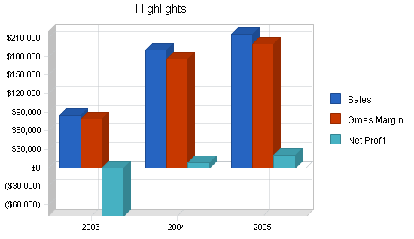

Company Summary
Botanical Bounty is an Oregon based perennial farm that grows a variety of botanical medicinal perennials. The company has been formed as an Oregon L.L.C. The farm has been in existence for two years now, initially operating as a hobby as rather than a profit producing business.

2.1 Company History
Botanical Bounty has been in operation for two years. Initially it was started as a hobby where Susan could use her plant biology skills while covering some of the costs. The Nealon's were able to achieve this lifestyle due to a windfall that David received as a result of exercised stock options. After the second year, the Nealon's decided that although they had the money to live on for many years, it would be irresponsible to needlessly spend it so they got serious about the business and made a concerted effort to become profitable.
Botanical Bounty has chosen the Willamette River Valley as an ideal place to grow perennials. Botanical Bounty has 10 acres of land which they use for production. During several of the winter months, production is moved into their green house for propagation. Botanical Bounty employs a drip irrigation system for all of the plants.
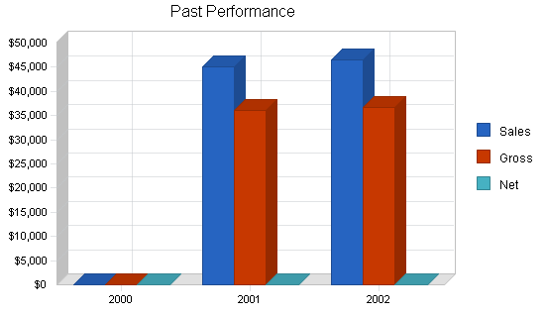

Company Ownership
Botanical Bounty is an Oregon L.L.C. owned by David and Susan Nealon. The L.L.C. business formation has been chosen as a strategic way to shield the Nealons from personal liability.

Products
Botanical Bounty offers a range of botanical perennials (plants where the root structure remains, allowing the plant to regrow every year). Botanical perennials were chosen for two main reasons. The first is the medicinal value that they offer, therefore the plants have a positive contribution to society by improving people's health. The second reason is that the market for medicinal herbs is a very strong industry with excellent growth, ensuring demand for their plants. Botanical Bounty will offer the following excellent:
Echinacea
Echinacea was used extensively by Native Americans and the early settlers also adopted its use. It has been used for years in alternative medicine to support the immune system, and to purify the blood, especially during season changes and during the cold and flu season. Scientific studies have confirmed the presence of natural chemicals, echinacosides, which increase white blood cell activity.
Ginseng
Ginseng stimulates and increases endocrine activity in the body. Promotes a mild increase in metabolic activity and relaxes heart and artery movements. Stimulates the medulla centers and relaxes the central nervous system.
Skullcap
Skullcap is a powerful medicinal herb, it is used in alternative medicine as an anti-inflammatory, abortifacient, antispasmodic, slightly astringent, emmenagogue, febrifuge, nervine, sedative and strongly tonic. Some valuable constituents found in the plant are scutellarin, catalpol, other volatile oils, bitter iridoids and tannins. Scientific studies are proving this to be a valuable plant in many areas for mental disorders. Skullcap is used in the treatment of a wide range of nervous conditions including epilepsy, insomnia, hysteria, anxiety, delirium tremens, withdrawal from barbiturates and tranquilizers.
Ginger
Ginger roots and dried herb are medicinal and edible, it has a spicy, hot, crispy, taste and can be eaten fresh in small quantities in salads, used as a relish, a condiment, or made into a sauce for meat, especially good on chicken, or used to make ginger candy. Widely used as an alternative medicine ginger contains the valuable constituent aristolochic acid, scientific study shows it to have anti-inflammatory, antiviral, antitumor activity, cures warts in some cases and is a broad-spectrum antibacterial and antifungal.
Botanical Bounty sells these excellent perennials in plant form for the botanicals to be extracted by their customers. Botanical Bounty concentrates on producing the healthiest plants which have the highest concentration of active botanicals.

Market Analysis Summary
Botanical Bounty has identified three main customer groups: supplement companies; botanical processors; and other nurseries. The customer segments are distinct enough to be able to target each one differently. The industry that Botanical Bounty produces for has been undergoing consolidation for several years now. Botanical Bounty will be able to serve the industry by leveraging their competitive edge of healthy, potent plants.

4.1 Market Segmentation
Botanical Bounty has identified three different target market segments which they will sell to:
Supplement Companies
This customer group manufactures botanical supplements for their own label products. The companies purchase the plants and extract the active ingredients and transform them into sellable products for their own brand. There are a handful of large companies that operate in this market space. Ten years ago there were many different ones but through consolidation the industry has grown in size but decreased in the number of different players.
Processors
These customers purchase the the plants, extract the botanicals and either sell the concentrated botanicals to the end producers or they themselves produce the supplement and sell the final product to other companies for their private label products. In essence they are the subcontractor for the supplement companies. These companies therefore are one layer within the manufacturing system and do not sell to the end consumer. They act as a supplier/processor for the retail brands.
Other Nurseries/Garden Centers
This customer group purchases the plants which they in turn sell at retail to the individual end consumer. The typical consumer is a health conscious individual who is interested in either extracting the botanical from the plant immediately or growing the plant in their own garden for future use.

Target Market Segment Strategy
Botanical Bounty has chosen the three market segments based on the consistent demand for botanical extracts. While there are other potential customers, they are smaller, less consistent in terms of demand, and more difficult to reach. The supplement companies, processors, and to a smaller degree the nurseries are attractive customers due to the their consistent demand and typical long-term contract needs. There is significant value to these customers for a grower to consistently offer the same high level of active botanicals in each plant and to be able to meet the needs of large volume, long duration contracts.

Industry Analysis
The botanical perennial growing market is typically concentrated in several regions around the U.S. which have optimum growing conditions. While there are a couple mega farms, on the whole, 78% of the U.S. production comes from growers with 5-20 acres of land. Approximately 23% of botanical extracts are grown abroad and imported into the United States. Reasons for botanical growth to occur overseas is typically based on the type of herb and its ability to grow better in the respective region.
The market for supplements is huge and growing:
U.S. Supplement Market
Surveys show that over 158 million consumers (over 55% of the U.S. population) use dietary supplements. An estimated 115.3 million consumers buy vitamins and minerals for themselves, and 55.8 million purchase them for other members of their family, including children. Consumer surveys consistently find that nearly half of all Americans now use herbs - a statistic that is particularly remarkable when we realize that today's herbal products industry is just over a quarter century old.
The basic reason cited for dietary supplement growth is the desire for self-care. Consumers use dietary supplement products to help them achieve their self-care goals that arise out of a sense of alienation from the established health care system. Results from a national survey conducted in 1999 by Men's Health magazine show that consumers use dietary supplements as a means of ensuring good health. They also use supplements for very specific medicinal purposes such as treating and preventing serious illnesses, colds, and the flu; increasing mental sharpness; and alleviating depression.
The consumer's desire for self-care and the widespread use of dietary supplements may cause problems for public health. An estimated 22.8 million consumers use herbal remedies instead of prescription medicine, and an estimated 19.6 million use them with a prescription product.
In the past, except for vitamin and mineral products, dietary supplements, particularly botanical products, were sold mainly to adults in health food stores. In contrast, now such products are available in supermarkets, other retail stores, and on the Internet, making these products readily accessible to children and other vulnerable populations. The Nutrition Business Journal estimated that in 1999, U.S. consumer sales of supplements over the Internet amounted to $142 million, almost three times the previous year's total of $48 million.
The five main channels of distribution are: consumer-direct (includes direct mail/catalog, direct from sales representatives, multi-level marketing, Internet & infomercial/direct from television); food, drug, mass-market stores, health and natural food stores, healthcare professionals and practitioners, others.

Competition and Buying Patterns
As mentioned previously, competition takes two forms, farms similar in size and production capacity to Botanical Bounty and megafarms. The similarly sized farms range in size from 5-30 acres. The number of different herbs grown varies from a handful to upwards of 50. The choice of plants grown is based on owner preference as well as location and the ability of the local growing conditions to support the different plants.
On the other end of spectrum is the megafarm. These farms have a similar range of species cultivated, however they differ greatly in production capacity. These farms are huge, typically not less than 100 acres, peaking at 300 acres. These growers however are few number.
The buying patterns of the different customers are typically based on these variables:
- Price
- Availability
- Ability to deliver consistently on long-term contracts
- Significant % of active ingredients
- Consistency.

Strategy and Implementation Summary
Botanical Bounty will leverage their competitive edge in order to gain significant market share. Their competitive edge is their ability to consistently produce plants with high active botanical percentages as well as a high ratio of healthy plants (sellable).
The marketing strategy will have the objective of raising awareness and visibility of their industry-leading percentages of active botanicals. The strategy will communicate the fact that Botanical Bounty's plants will yield a significantly higher amount of botanicals measured per plant.
The sales strategy, in addition to reinforcing the competitive edge, will seek to qualify leads by concentrating on Botanical Bounty's ability to perform reliably on long-term contracts, becoming a stable supplier to the larger companies that need a steady supply stream.

5.1 Competitive Edge
Botanical Bounty has a dual competitive edge:
Healthy Plants
The healthier the plant, the faster it will grow, the more botanicals that can be extracted from it. This means an increase in production efficiency due to a larger percentage of plants that are sellable. Other characteristics of healthy plants which are important on the production side is: lower pest counts, more established root structures, and high biomass.
High Concentration of Active Botanicals
This is beneficial to the purchaser because they are buying the plants precisely for the active botanicals. High concentration levels are valuable to Botanical Bounty because they increase the amount of botanicals produced per plant or per acre, increasing the production capacity of a given amount of land, thereby increasing their return on investment and increasing the attractiveness of Botanical Bounty's plants relative to the competition.

Marketing Strategy
The marketing strategy will be based on generating awareness and visibility of Botanical Bounty and their ability to produce the highest percentages of botanicals. The strategy will rely on several different forms of communication. The main form is participation in the numerous trade shows for the industry. The trade shows are where everyone from the industry gathers to meet and transact business. t is a wonderful place to network as well as learn about new developments in the industry. The second form of communication will be the use of advertisements. The main venues for advertisements will be industry trade magazines. The trade magazines are a well read source of information that buyers and sellers refer to for many different transactions.

Sales Strategy
Botanical Bounty's sales strategy efforts will focus on identifying qualified leads and turning them into paying customers. The main sales effort that Botanical Bounty will undertake is the reinforcement of the fact that Botanical Bounty's plants have the industry's highest percentage of botanicals. This will be quite appealing to the buyers as this is exactly what they want, more botanicals per plant. In addition to selling the buyers on Botanical Bounty's competitive edge of potent plants, there will be an emphasis on Botanical Bounty's ability to perform on long-term contracts.
Botanical Bounty recognizes that the transactions should not be thought of as individual sales, but as long-term relationships. This is a reasonable assumption based on the fact that the customers are in the business of utilizing botanicals, that they will continually have the need for the botanicals, and that it is far less expensive to establish a relationship with one vendor than to continually have to find new vendors that can meet their needs.

Sales Forecast
The sales forecast indicates that growth will be slow but steady. Growth will be slow because of the time and effort needed to develop the customers. Production is not the slowing element as Botanical Bounty has been in production for a couple of years. Granted they were not producing at the same level, or for that matter with the same goal of business efficiency, but nonetheless they will be able to reasonably raise production to meet the sales needs. During the wet months of the year, the forecast reflects a tapering of sales as production will fall during these months. There will however be some sales and production which will be moved inside to the greenhouses.
There are a few risks that could have a negative impact on sales. The first is weather. Plants are dependant on the weather. A poor growing season will have a serious effect on production. This risk is spread amongst all of the producers of the specific region meaning the weather risk is imposed on everyone, generally not a specific farmer. Another risk that could effect sales is some sort of pest that could unexpectedly negatively effect the crops. By planting multiple botanicals and choosing them based on their heartiness relative to the growing climate, Botanical Bounty is able to minimize these risks as much as possible.
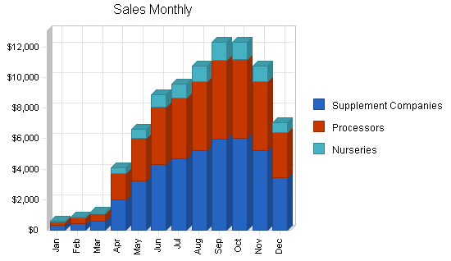

Management Summary
The Botanical Bounty management team is made up of the husband and wife team of David and Sue Nealon. David studied at Pomona College, a small liberal arts school in central California. David graduated with a dual major of Business and Philosophy. David worked at a bicycle shop for a year before joining Yahoo! as employee number 34. David was a Project Manager and was in charge some business development activities. His first "home run" was the development, launching, and management of Yahoo!'s driving directions service. David recognized the value of providing people with precise, custom driving directions.
Initially is was a daunting task to develop revenue for this service which the individual users did not pay for, but David was able to generate sufficient advertising dollars specifically for his service. David was ultimately responsible for the entire project, providing him with a wealth of project management and operations skills. After this direction service became the market leader for this niche, David moved on to other projects at Yahoo! David spent a total of four years at Yahoo! providing him with a wealth of experience.
Sue Derent Nealon is the biology/horticulture manager for Botanical Bounty. Sue studied at the University of Oregon, first receiving her undergraduate degree in biology and later her Master's in Plant Biology. Sue's Master's thesis was a dual thesis in plant fertility and herbal concentrations. The plant fertility topic was a study of different types of compost and the effects on fertility. The second topic explored the interrelationships of nutrients and temperature and the effect that they have on the plants' production of the respective botanicals. The topics of her thesis were chosen based on her desire to continue with her education professionally as a grower.
After school Sue moved down to California to work at one of the largest indoor growing operations in California. Wanting to be closer to her parents, the Sue and David moved to the Willamette River Valley in Oregon in pursuit of Sue's dream of running her own farm. For the first two years she ran the farm as a hobby, just figuring things out without a concern for profits. After several serious conversations, they decided to really make the farm a business.
Playing to their strengths Sue will manage the farming operations and sales, while David handles the business operations.

Personnel Plan
- David: Operations including vendor relations, accounting, and some growing responsibility.
- Sue: Head grower and sales. As head grower she is responsible for supervising, scheduling plant production, the cutting schedules, crop selection, growing schedules, fertilizer selection and application schedules, irrigation system development, and pest control. Because Sue has the technical knowledge regarding the plants and their industry leading botanical concentrations, she will be in charge of sales which will include qualifying leads as well as participating in the final negotiations and account management.
- Grower: Sue will have the assistance of a full-time grower in order to allow her to meet her sales responsibilities.
- Laborers: The laborer positions will be seasonal as there is more work required in the summer months, however, there will always be some laborers on staff throughout the year. Some of the responsibilities of the laborers are soil tilling, compost distribution, plant collections and trimming.

Financial Plan
The following sections will outline important financial information.

Break-even Analysis
The Break-even Analysis is shown below.
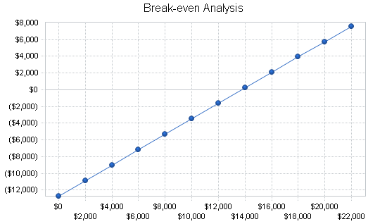

Projected Profit and Loss
The following table and charts show the Projected Profit and Loss.
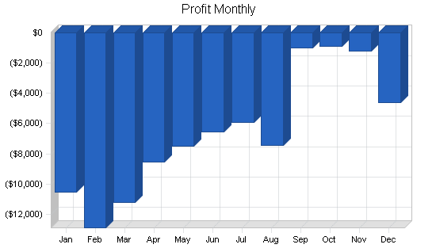
Conclusion
The project is technically feasible and commercially viable. It is therefore recommended for funding.

