ADEKANYE ITUNU OLUWADARA
17/MHS01/017
GROSS ANATOMY OF HEAD AND NECK
300L

QUESTIONS:
- Write an essay on the carvanous sinus
- Discuss the walls of the nose

Carvanous Sinus
The cavernous sinus is a paired dural venous sinus located within the cranial cavity. It is divided by septa into small ‘caves’- from which it gets its name.
Each cavernous sinus has a close anatomical relationship with several key structures in the head, and is arguably the most clinically important venous sinus.
Anatomical Location and Borders
The cavernous sinuses are located within the middle cranial fossa, on either side of the sella turcica of the sphenoid bone (which contains the pituitary gland). They are enclosed by the endosteal and meningeal layers of the dura mater.
The borders of the cavernous sinus are as follows:
- Anterior –superior orbital fissure
- Posterior –petrous part of temporal bone
- Medial –body of the sphenoid bone
- Lateral –meningeal layer of the dura mater running from the roof to the floor of the middle cranial fossa.
- Roof –meningeal layer of the dura mater that attaches to the anterior and middle clinoid processes of the sphenoid bone.
- Floor –endosteal layer of dura mater that overlies the base of the greater wing of the sphenoid bone.
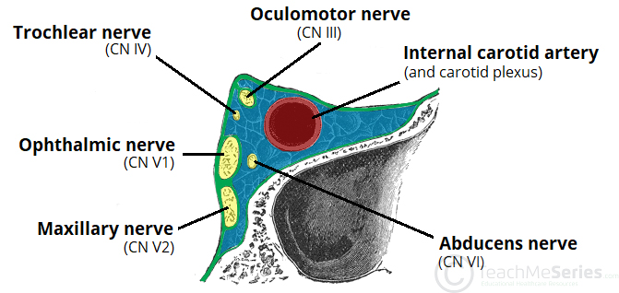
Contents
Several important structures pass through the cavernous sinus to enter the orbit. They can be subclassified by whether they travel through the sinus itself, or through its lateral wall:
Travels through cavernous sinus | Travels through lateral wall of cavernous sinus
- Abducens nerve (CN VI)  - Carotid plexus  - Internal carotid artery (cavernous portion) | - Oculomotor nerve (CN III)  - Trochlear nerve (CN IV)  - Ophthalmic (V1) and maxillary (V2) branches of the trigeminal nerve
The cavernous sinus is the only site in the body where an artery (internal carotid) passes completely through a venous structure. This is thought to allow for heat exchange between the warm arterial blood and cooler venous circulation.
Dural Venous Sinus System
Each cavernous sinus receives venous drainage from:
- Ophthalmic veins (superior and inferior) – these enter the cavernous sinus via the superior orbital fissure.
- Central vein of the retina – drains into the superior ophthalmic vein, or directly into the cavernous sinus.
- Sphenoparietal sinus – empties into the anterior aspect of the cavernous sinus.
- Superficial middle cerebral vein – contributes to the venous drainage of the cerebrum
- Pterygoid plexus – located within the infratemporal fossa.
The superior ophthalmic vein forms an anastomosis with the facial vein. Therefore, the ophthalmic veins represent a potential route by which infection can spread from an intracranial site. The cavernous sinuses empty into the superior and inferior petrosal sinuses, and ultimately, into the internal jugular vein. The left and right cavernous sinuses are connected in the midline by the anterior and posterior intercavernous sinuses. They travel through the sella turcica of the sphenoid bone.
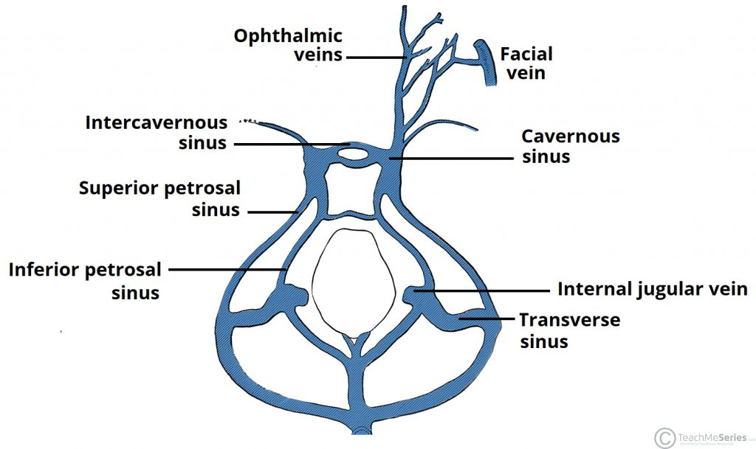
Clinical Significance
Cavernous sinus Thrombosis
Cavernous sinus thrombosis (CST) refers to the formation of a clot within the cavernous sinus. This most common cause of CST is infection; which typically spreads from an extracranial location such as the orbit, paranasal sinuses, or the danger zone of the face. Infection is able to spread in this manner due to the anastomosis between the facial vein and superior ophthalmic veins.
Common and clinical features include headache, unilateral periorbital oedema, proptosis (eye bulging), photophobia and cranial nerve palsies. The Abducens nerve (CN VI) is most commonly affected.
Treatment is typically with antibiotic therapy. Where the cause is infection, thrombosis of the cavernous sinus can rapidly progress to meningitis.

WALLS OF THE NOSE
The nose consists of 4 walls in the nasal cavity; the roof, the floor, medial wall, lateral wall.
- The roof of the nasal cavity is curved and narrow, except at its posterior end; the roof is divided into three parts (frontonasal, ethmoidal, and sphenoidal) that are named from the bones that form them.
- The floor of the nasal cavity, wider than the roof, is formed by the palatine process of the maxilla and the horizontal plate of the palatine bone.
- The medial wall of the nasal cavity is formed by the nasal septum.
- The lateral wall of the nasal cavity is irregular because of three scroll-shaped elevations—the nasal conchae—that project inferiorly like scrolls.
- The conchae curve inferomedially, each forming a roof for a groove, or meatus—a passage in the nasal cavity.
The nasal conchae (superior, middle, and inferior) divide the nasal cavity into four passages:
- Sphenoethmoidal recess
- Superior meatus
- Middle meatus
- Inferior meatus
The inferior concha is the longest and broadest and is covered by mucous membrane that contains large vascular spaces that can enlarge to control the calibre of the nasal cavity. When infected, the mucosa may swell rapidly, ‘‘blocking the nose.’’
The sphenoethmoidal recess, lying superoposterior to the superior concha, receives the opening of the sphenoidal sinus. The superior meatus is a narrow passage between the superior and middle nasal conchae into which the posterior ethmoidal sinuses open by one or more orifices. The long middle meatus is wider than the superior one. The anterosuperior par of this passage leads into a funnel-shaped opening, the ethmoidal infundibulum, through which it communicates with the frontal sinus. The passage that leads inferiorly from each frontal sinus to the infundibulum is the frontonasal duct. The semilunar hiatus is a semicircular groove into which the frontal sinus opens. The ethmoidal bulla a rounded elevation located superior to the hiatus—is visible when the middle concha is removed. The bulla is formed by middle ethmoidal cells that form the ethmoidal sinuses. The maxillary sinus also opens into the posterior end of the semilunar hiatus.
The inferior meatus is a horizontal passage inferiolateral to the inferior nasal concha. The nasolacrimal duct draining tears from the lacrimal sac opens into the anterior part of this meatus.

