Fapohunda Oluwatomi Oche
15/ENG04/025
Electrical/ Electronics Engineering
EEE 512 Assignment

Questions
1. (i) With the aid of a well labelled architectural diagram, provide detailed explain on the
working principle of 3G, 4G and 5G networks
(ii) Outline the advantage and disadvantages of 3G, 4G and 5G
2. In tabular form, establish adequate differences between 2G, 3G, 4G and 5G
3. Recently in Nigerian there has been a widespread of opinion that the advent of 5G
evolution will aid the spread of the corona virus which has become a pandemic all over the
world.
(i) Is there any correlation between 5G and Corona virus
(ii) Do you support the state, if yes or No, in not more than 500 words Justify your answer to
- and (ii)

Solution
- Working principle of the following networks:
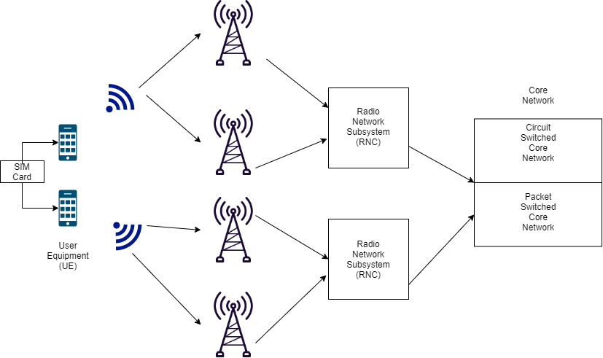
- 3G
Figure 1: 3G Architecture

A 3G network consists of three major elements which are the User Equipment (UE), the Radio Network Subsystem (RNC) and the Core Network. The UE communicates with the base station/nodes (cell towers) through air interface using a system called Wide Band Code Division Multiple Access (WCDMA). The means of data encryption and user identification in the UE is the USIM (known as the SIM card). Each operator has their own frequencies and the UE uses a specific bandwidth in the uplink and downlink connection to the base station. The base station relays the signal to the RNC using the IUB interface. The RNC handles a lot of base stations and this is what is actually being connected to the UE. The base station is just a relay. Information from the RNC is gathered at the core network which is divided into two major elements; the Circuit Switched Core Network and the Packet Switched Core Network. The Circuit Switched Core Network is essentially a mobile switching centre for handling calls, text messages and the current location of the user. It also has a gateway mobile switching centre for connecting to other service providers. There is a register called the Home Location Register which stores all the customers on the network and a C interface is used to connect this register with the mobile switching centre. The Packet Switched Core Network is used to handle data services requests.

- 4G
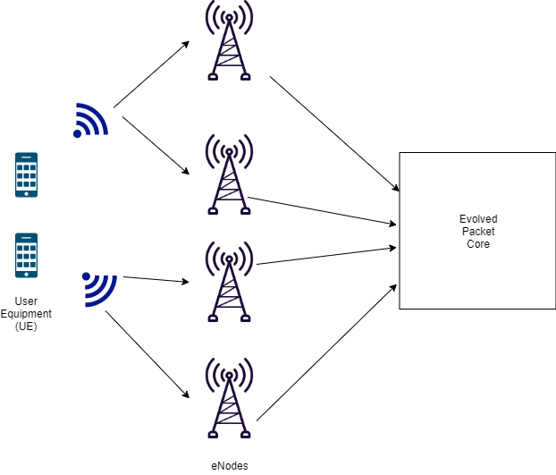
Figure 2: 4G Architecture

The architecture in 4G is similar to 3G with the exception of using one core instead of the two used in 3G (Circuit Switched and Packet Switched Core Network). Also, 4G does not use a central controller RNC to control the network and for switching. Instead it utilizes eNode (ebase stations) and is just an interconnection of evolved base stations without a centralized controller. eNodes consist of two elements; Remote Control Radio Unit (RRU) and Baseband Units (BBU). The RRU consists of the antenna and is used for modulation and demodulation of all signals transmitted and received on the air interface. BBU consists of digital modules which processes the signals from RRU and acts as an interface to the core network. The 4G network is autonomous as it does not require a central controller. The eNodes interface with the core network using an S1 interface. The core network handles both data and voice services.

- 5G
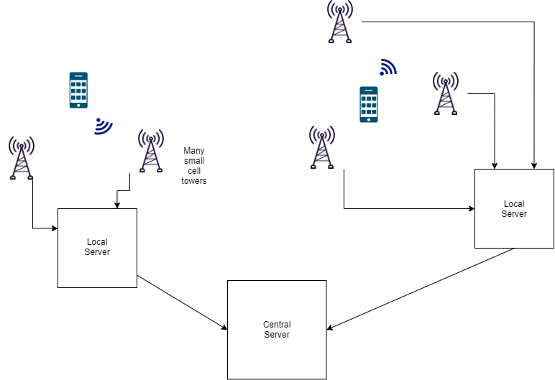
Figure 3: 5G Architecture

5G network architecture illustrating 5G and 4G working together, with central and local servers providing faster content to users and low latency applications. A mobile network has two main components, the ‘Radio Access Network’ and the ‘Core Network’. The Radio Access Network - consists of various types of facilities including small cells, towers, masts and dedicated in-building and home systems that connect mobile users and wireless devices to the main core network. Small cells will be a major feature of 5G networks particularly at the new millimetre wave (mmWave) frequencies where the connection range is very short. To provide a continuous connection, small cells will be distributed in clusters depending on where users require connection which will complement the macro network that provides wide-area coverage. The Core Network - is the mobile exchange and data network that manages all of the mobile voice, data and internet connections.

Advantages of 3G
- Easier to implement than 4G or 5G
- It can cover longer distances than 4G or 5G

Disadvantages of 3G
- It uses two core networks. Which means service operators have to maintain two core networks
- Really slow as it only has a bandwidth of 384 Kbps

Advantages of 4G
- High bandwidth: it can handle up more than 1 Gb per second (compared to 3G)
- It has higher data rates transfer speeds than 3G

Disadvantages of 4G
- Harder to implement than 3G
- Struggle to adopt it for use in voice calls

Advantages of 5G
- High bandwidth: it can handle up more than 5 Gb per second (compared to 4G)
- Low latency: it has a response time of 1milisecond
- Dense connections: in a given square kilometre 5G can connect 10 times more devices than 4G is capable of doing.
- Frequencies: it uses a higher band of frequencies from 3KHz to 300GHz which can carry data with more speed and a higher performance
- 5G uses 90% less energy than 4G

Disadvantages of 5G
- Higher frequencies can carry data fast but not far so it requires a lot of small cell towers (nodes)
- Trees, walls, rain and buildings can block data transmission. So, a direct line of sight is needed
- Not many mobile devices have the chipset to enable 5G

- Differences between 3G, 4G and 5G
Technologies | 3G | 4G | 5G
Data Rate | 384 Kbps | 1 Gbps | 5 Gbps
Latency | 100–500 ms | < 100 ms | 1 ms
Service | Audio and video data | High quality streaming services | All upcoming technologies such as IoT and self-driving cars supported
Frequency | 1.6 - 2.5 GHz | 2 – 8 Ghz | 3 – 300 GHz
Technology | CDMA, UMTS, EDGE | LTE, Wi-Fi | WWWW
Bandwidth | 100MHz | 100MHz | 1000x BW per unit area
Core Network | Packet and Circuit Switched | All IP network | Flatter IP network and 5G Network Interfacing (5G-NI)

- 5G and Corona virus
- There is no correlation between 5G and corona virus
- No, I do not support the statement

Justification
Fear of new technology is nothing new, it is deep rooted in the history of human beings and is not completely unwarranted. In the United States and Europe, radioactive products from the 1920s through the 1940s including toothpaste, hair cream, cosmetics and even suppositories were sold to the ignorant masses supporting the idea that it was beneficial to use these products. It did not take long before people got a rude awakening to the tune of cancer and other deadly skin diseases. Hence, there is a cringing fear in people anytime anything that involves radiation is being postulated which unfortunately, includes communication technologies such as 5G. The idea that links corona virus and 5G started from an American holistic doctor called Thomas Cowan. He appeared in a video which went viral on social media in which he attempted to correlate corona virus and 5G technology. He is currently on probation in his place of work at California. These false concepts were further spread by American singer, songwriter, vocal arranger and actress Keri Hilson with her millions of followers on social media. First of all, to discredit this notion, there are two types of radiation; ionizing and non-ionizing radiation. Ionizing radiation knocks electrons from atoms in our bodies and seriously damages the molecular structure of cells in the body, examples include x-rays and nuclear materials. Non ionizing radiation does not cause harm to the body, and a good example is the 5G frequency. Next on the agenda, even if we speculate about the amount of radiation we receive, scientists have tested variations of the radiations we receive by 5G communications extensively on smaller animals like rats which are more likely to be affected and found it does not affect them in any way. The small cell towers mounted around the cities are under strict regulations as to where they are positioned. Also, 5G antennas consume 90% less energy than 4G antennas which mean they produce less radiation. It is evident 5G does not cause corona virus as corona virus is spreading in locations that do not have 5G such as Italy and Nigeria. Furthermore, South Korea and some parts of the US had 5G eight months before Wuhan had it. After all the tests being carried out by scientists everyday if there was a valid correlation between corona virus and 5G then companies involved will be buried in lawsuits. It is disrespectful to the healthcare workers and scientists on the frontlines fighting the corona virus to spread these fallacies without proper research and there are many research papers being produced everyday which demystify this false notion.

