Name: Iroegbu Ugochi Miriam
Matric. number: 17/mhs01/164
Department: Medicine and Surgery
Course:Head and Neck
- Write an essay on the carvanous sinus
The carvenus sinuses are large venous sinuses
about 2cm long and 1cm .They are located on each side of the sella turcica
and the body of the sphenoid bone.Each sinus extends from the superior orbital fissure and anteriorly to the apex of the petrous part of the temporal bone posteriorly.
Boundaries:
Roof: the sinus lies in a space between the periosteum of
the body of the sphenoid bone and a fold of dura mater. The roof is attached to
the anterior and posterior clinoid processes of the sphenoid bone.
Floor: the floor is a narrow strip of endosteum along the
base of the greater wing of the sphenoid bone.
Lateral wall: is formed by the uncus i.e medial part of the
temporal lobe of the brain.
Medial wall: formed by
the endosteum of the body of sphenoid with a layer of dura occluding it
from the pituitary fossa
Posterior wall: formed by the inner layer of dura which
covers the posterior cranial fossa and passes upward to join the roof and
cerebral peduncle
Anterior wall: formed by the ophthalmic veins as they enter
from the orbit.
Communication: the superior and inferior ophthalmic veins
drain into the cavernous and also the superficial middle cerebral vein and
sphenoparietal sinus drain into the sinus. There is communication between the
sinuses through the intercavernous sinuses, which pass anterior and posterior
to the pituitary stalk.
The cavernous sinus drains into the superior and inferior
petrosal sinuses and the pterygoid plexus.
Content: inside each sinus is the internal carotid artery
with the sympathetic plexus and the abducent nerve (CNVI)
The lateral wall of each sinus contains, from superior to
inferior, the following:
.
The oculomotor nerve (CNIII)
The trochlear nerve (CNIV)
The ophthalmic division of the trigeminal nerve
.
The maxillary division of the trigeminal nerve

Several important structures pass through the cavernous sinus to enter the orbit. The can be sub-classified by whether they travel through the sinus itself, or through its lateral wall:
Travels through the carvenous sinus | Travels through lateral wall of carvenous sinus
Abducens nerve(CN VI) | Oculomotor nerve (CN III)
Carotid plexus (post ganglionic sympathetic nerve fibres) | Trochlear nerve (CN IV)
Internal carotid artery ( carvernous portion) | Ophthalamic(v1) and maxillary (v2) branches of the trigerminal nerve

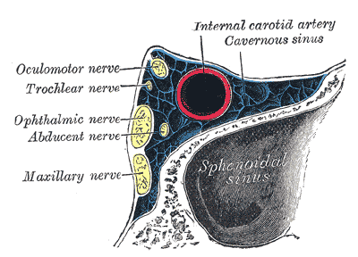.

2. Discuss the walls of the nose

Lateral wall: The lateral wall of the nasal cavity is a region of the nasopharynx essential for humidifying and filtering the air we breathe in nasally. Here we can find a structure called agger nasi. The agger nasi is also referred to as the ‘nasoturbinal concha’ or ‘nasal ridge.’ It can be described as a small mound or ridge found in the lateral side of the nasal cavity. The structure is located midway along the anterior aspect of the middle nasal concha. An abnormally enlarged form may restrict the drainage of the frontal sinus by obstructing the frontal recess area.
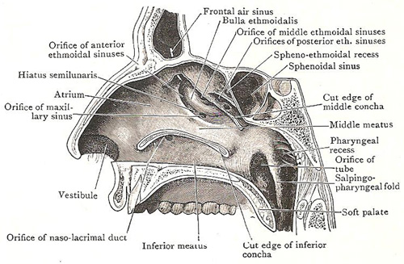
Medial wall: this is oriented vertically in medial saggittal plane and separates right and left saggital plane of nasal cavities. The The medial wall, nasal wall, or base of maxillary sinus presents, in the disarticulated bone, a large, irregular aperture, communicating with the nasal cavity. In the articulated skull this aperture is much reduced in size by the following bones:
- the uncinate process of the ethmoid above,
- the ethmoidal process of the inferior nasal concha below,
- the vertical part of the palatine behind,
- and a small part of the lacrimal above and in front.
The sinus communicates through an opening into the semilunar hiatus on the lateral nasal wall.

