Aliu Kudirat Oshione
17/MHS01/054
Medicine and Surgery 300lvl
Head and Neck Assignment
Question 1: Discuss the anatomy of the tongue and comment on its applied anatomy
The tongue is a unique flexible muscular organ located in the oral cavity that not only facilitates the perception of gustatory stimuli but also plays important roles in mastication and deglutition. Additionally, the tongue is an integral component of the speech pathway, as it helps with articulation.
The tongue has the following parts:
- The root of the tongue: It is the part of the tongue that rests on the floor of the mouth. It is usually defined as the posterior third of the tongue
- The body of the tongue: It is the anterior two thirds of the tongue
- The apex (tip) of the tongue: It is the anterior end of the body which rests against the incisor teeth. The body and the apex of the tongue are extremely mobile.
- The dorsum (dorsal surface) of the tongue: It is the posterosuperior surface which is located partly in the oral cavity and partly in the oropharynx.The dorsum is characterized by a V-shaped groove called the terminal sulcus or groove which divides the dorsum of the tongue into the anterior (oral) part in the oral cavity proper and the posterior (pharyngeal) part in the oropharynx
The margin of the tongue is related on each side to the lingual gingivae and lateral teeth. The mucous membrane on the anterior part of the tongue is rough because of the presence of numerous small lingual papillae which includes:
- Vallate papillae: Large and flat topped, they lie directly anterior to the terminal sulcus and are arranged in a V-shaped row.
- Foliate papillae: Small lateral folds of the lingual mucosa. They are poorly developed in humans.
- Filiform papillae: Long and numerous, they contain afferent nerve endings that are sensitive to touch.
- Fungiform papillae: Mushroom shaped pink or red spots, they are scattered among the filiform papillae but are most numerous at the apex and margins of the tongue.
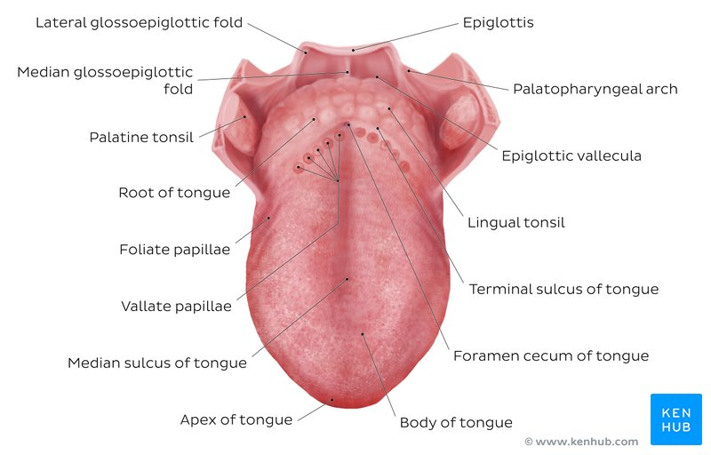
The vallate, foliate, and most of the fungiform papillae contain taste receptors in the taste buds.There are four basic taste sensations:
- Sweetness is detected at the apex
- saltiness at the anterolateral margins
- sourness at the posterolateral margins
- bitterness at the posterior part of the tongue
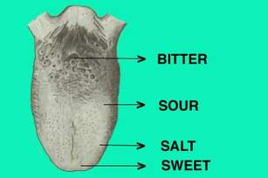
Muscles of the Tongue
The tongue is essentially a mass of muscles that is mostly covered by mucous membrane.Extrinsic muscles alter the position of the tongue while intrinsic muscles alter its shape. The four intrinsic and four extrinsic muscles in each half of the tongue are separated by a median fibrous lingual septum, which merges posteriorly with the lingual aponeurosis.
Extrinsic muscles of the tongue include: genioglossus, Hyoglossus, styloglossus and palatoglossus. They originate outside the tongue and attach to it and mainly move the tongue but they can alter its shape too.
Intrinsic muscles of the tongue include: superior longitudinal muscle, inferior longitudinal muscle, transverse muscle and vertical muscles. They have their attachments entirely within the tongue and are not attached to bone.
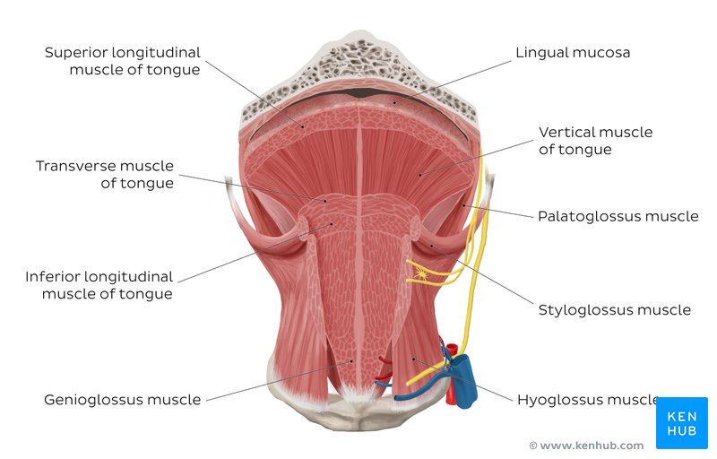
Vasculature of the Tongue
Arterial Supply
The arteries of the tongue are derived from the lingual artery, which arises from the external carotid artery. On entering the tongue, the lingual artery passes deep to the hyoglossus muscle and give rise to the:
- The dorsal lingual arteries supply the posterior part (root),
- The deep lingual arteries supply the anterior part,
- The deep lingual arteries communicate with each other near the apex of the tongue,
- The dorsal lingual arteries are prevented from communicating by the lingual septum.
Venous Drainage
The veins of the tongue are the dorsal lingual veins, which accompany the lingual artery. The deep lingual veins, which begin at the apex of the tongue, run posteriorly beside the lingual frenulum to join the sublingual vein. The sublingual veins in elderly people are often varicose (enlarged and tortuous). All these lingual veins terminate, directly or indirectly, in the internal jugular vein.
Lymphatic Drainage
Lymph from the tongue takes four routes:
- Lymph from the posterior third drains into the superior deep cervical lymph nodes
- Lymph from the medial part of the anterior two thirds drains directly to the inferior deep cervical lymph nodes
- Lymph from the lateral parts of the anterior two thirds drains to the submandibular lymph nodes
- The apex and frenulum drain to the submental lymph nodes.
The posterior third and the medial part of the anterior two thirds drain bilaterally.
Innervation of the Tongue
•Motor innervation: All muscles of the tongue, except the palatoglossus, receive motor innervation from the hypoglossal nerve.
•Sensory innervation: The anterior two thirds of the tongue are supplied by:
- the lingual nerve (CN V₃) for general sensation
- the chorda tympani, a branch of the facial nerve (CN VII) transferring nerve fibers to the lingual nerve, for taste
The posterior third of the tongue and the vallate papillae are supplied by:
- the lingual branch of the glossopharyngeal nerve (CN IX) for both general sensation and taste
- Another contribution is made by the internal laryngeal branch of the vagus (CN X) for general sensation and taste.
Applied Anatomy
Lingual Carcinoma
- A lingual carcinoma in the posterior part of the tongue metastasizes to the superior deep cervical lymph nodes on both sides, whereas a tumor in the anterior part usually does not metastasize to the inferior deep cervical lymph nodes until late in the disease.
- Because these nodes are closely related to the IJV, metastases from the tongue may be widely distributed through the submental and submandibular regions and along the IJVs in the neck.
Frenectomy
- An overly large lingual frenulum (tongue-tie/ ankyloglossa) interferes with tongue movements and may affect speech
- In unusual cases, a frenectomy (cutting the frenulum) in infants may be necessary to free the tongue for normal movement and speech
Thyroglossal Duct Cyst
- A cystic remnant of the thyroglossal duct, associated with development of the thyroid gland, may be found in the root of the tongue and be connected to a sinus that opens at the foramen cecum
- Surgical excision of the cyst may be necessary
- Most thyroglossal duct cysts are in the neck, close or just inferior to the body of the hyoid bone

Question 2: Write an essay on the air sinuses
The paranasal sinuses are air-filled extensions of the respiratory part of the nasal cavity. There are four paired sinuses, named according to the bone in which they are located; maxillary, frontal, sphenoid and ethmoid. The function of the sinuses is not clear. It is thought that they may contribute to the humidifying of the inspired air. They also reduce the weight of the skull.
Sinuses are formed in childhood by the nasal cavity eroding into surrounding bone. As they are outgrowths of the nasal cavity, they all drain back into it – openings to the paranasal sinuses are found on the roof and lateral walls of the nasal cavity. The inner surface is lined by a respiratory mucosa.
The air sinuses are:
- Frontal Sinuses: These are the most superior in location, found under the forehead. The frontal sinuses are variable in size, but always triangular-shaped. They drain into the nasal cavity via the frontonasal duct, which opens out at the hiatus semilunaris on the lateral wall.
- Sphenoid Sinuses: The sphenoid sinuses also lie relatively superiorly, at the level of the spheno-ethmodial recess. They are found more posteriorly, and are related superiorly and laterally to the cranial cavity. The sphenoid sinuses drain out onto the roof of the nasal cavity. The relationships of this sinus are of clinical importance – the pituitary gland can be surgically accessed via passing through the nasal roof, into the sphenoid sinus and through the sphenoid bone.
- Ethmoidal Sinuses: There are three ethmoidal sinuses; anterior, middle and posterior. They empty into the nasal cavity at different places:
•Anterior – Hiatus semilunaris
•Middle – Ethmoid bulla
•Posterior – Superior meatus
- Maxillary Sinuses: The largest of the sinuses. It is located laterally and slightly inferiorly to the nasal cavities. It drains into the nasal cavity at the hiatus semilunaris, underneath the frontal sinus opening. This is a potential pathway for spread of infection – fluid draining from the frontal sinus can enter the maxillary sinus.
Clinical Relevance: Sinusitis
As the paranasal sinuses are continuous with the nasal cavity, an upper respiratory tract infection can spread to the sinuses. Infection of the sinuses causes inflammation (particularly pain and swelling) of the mucosa, and is known as sinusitis. If more than one sinus is affected, it is called pansinusitis.
The maxillary nerve supplies both the maxillary sinus and maxillary teeth, and so inflammation of that sinus can present with toothache.

