**NAME : MARK MUKORO. OGHENEBRUME**

**MATRIC NO : 14/ENG06/018**

**ASSIGNMENT TITLE : ASSIGNMENT 1**

**COURSE TITLE : PRODUCT DESIGN**

**COURSE CODE : MEE 510**

1. **PRODUCT/PROJECT DESIGN**

Development of a Mobile Air Conditioning System

1. **MATERIAL SELECTION**

This is an assemblage project which involves different pre-existing components. These components serve as the materials. The main material classes like metals, polymers, ceramics are used for the components but the design and manufacturing of these components are beyond this project scope. Therefore, the components selected are hereby discussed as the materials selection. The various components include

* + 1. Compressor
    2. Receiver drier
    3. Condenser
    4. Evaporator
    5. cooling fan
    6. The AC Blower Motor
    7. Expansion valve

1. **FACTORS CONSIDERED IN CHOOSING THE MATERIALS**
   * 1. **Compressor**  : The most important dimensioning component of the air conditioner was found to be the compressor, since it determines the capacity and the final acceptable diameter of the air conditioner. The compressor constitutes the base of the air conditioner, and works as an engine for the refrigerant circulation in the tubes through the condenser and the evaporator. According to compressor manufacturers, it is hard to install inverter controllers in portable air conditioners since the controller dissipate a lot of heat that is unwanted in a small, compact unit. Forthese reasons, in this work, 1h.P inverter compressor was selected. This is illustrated in figure 1 below



Figure 1: The compressor

* + 1. **Receiver Drier** : Air conditioning systems utilize a receiver drier to extract moisture from the system. The receiver drier is used on ac systems which make use of on expansion valve to control refrigerant flow and is located on the high-pressure side of the system, between compressor and the condenser. The receiver drier stores a portion of the system’s refrigerant and contains a moisture absorbing substance to remove any moisture the system may become contaminated.



Figure 2 : The receiver drier

* + 1. **Condenser :** The compressor of the car generates compressed gas and sends it along to the top of the condenser, where the gas begin to cool. The gas continues to cool and condense as it makes it way through the serpentine-like coil arrangements, before exiting the bottom of the condenser as a high-pressure liquid. Figure 3 shows a condenser



Figure 3: The Condenser

* + 1. **Evaporator :** The ac evaporator serves in multiple capacities, but its function is to absorb heat which may have built up on a hot day inside your car’s interior. The evaporator contains cold Freon gas. The cold Freon gas passes through the evaporator and makes the evaporator very cold. The ac blower fan is located behind the evaporator and blows air across it and that cold air travels through the dash duct work and out the vents.



Figure 4 : An evaporator

* + 1. **Condenser fan :** The ac condenser fan’s job is to assist in cooling the hot compressed gasses supplied by the compressor as they pass through the condenser. The function of the condenser fan, is also to supply additional cooling to the vehicle’s radiator located just behind the condenser. In the event the condenser fan is not operating as intended, or has ceased to function at all, your system will not operate efficiently. Air flow over the condenser and engine radiator is essential.
    2. **The AC Blower Motor :** The ac blower motor works in conjunction with the evaporator to remove heat and cool your vehicle interior. It is usually located underneath the dash and connected to ducting where it pulls-in the warm air from the interior and pushes it across the cool coils and fins of the evaporator and send the cold air back to the car’s interior. Figure 5 shows the AC blower motor



Figure 5: The A.C Blower motor

* + 1. **Expansion valves :** Expansion valves regulate the amount of liquid refrigerant flowing from the condenser to the evaporator based upon the evaporator pressure. A thermal expansion valve will include a temperature sensor and meters the amount of refrigerant flowing into the evaporator.



Figure 6: The expansion valve

In the new air conditioner design, an axial fan was the appropriate evaporator fan choice, since it lets the air in from underneath and exhausts it upwards. Furthermore, the natural shape of an axial fan in combination with the placement uses the cylindrical air conditioner shape optimally. The condenser fan in the new design is of radial type since it was desired to imbibe air from underneath and exhaust it from the air conditioner in a radial direction. As the condenser fan is placed with its axis vertically, it uses the cylindrical shape of the air conditioner in an efficient way.

1. **Deign specification**

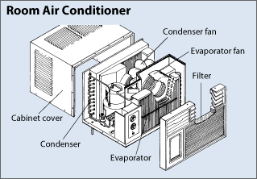

**Figure 7 : Design Specification of the final Assemblage**

1. **Design Drawing**

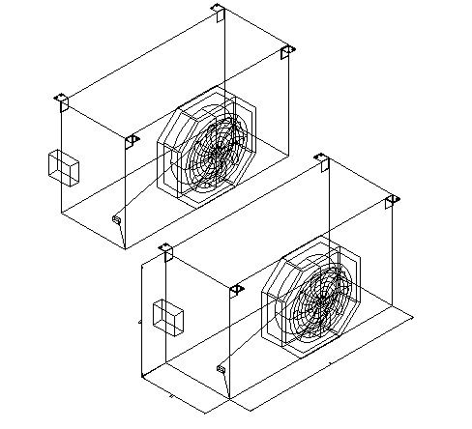

**Figure 8 : Design Drawing of the Condenser**

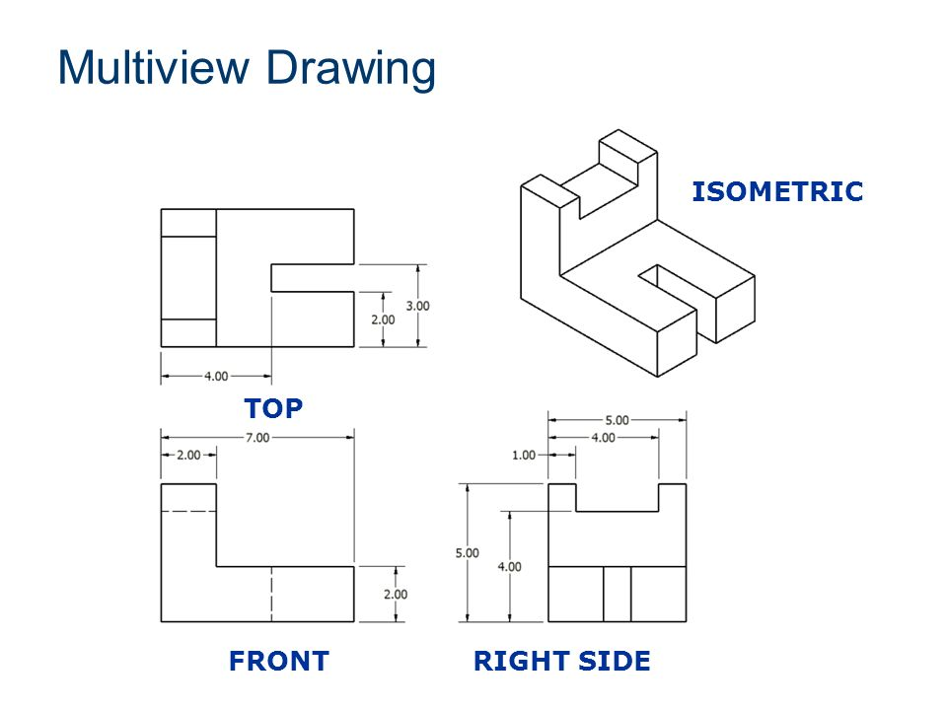

**Figure 9 : The Multi view Drawing of the final assemblage**

1. **BEME**

The BEME of the project is shown in Table 1

Table 1 : Bill of Engineering Measurement and Evaluation (BEME)

|  |  |  |  |
| --- | --- | --- | --- |
| S/N | ITEM | QUANTITY | RATE (₦) |
|  | I H.P compressor | 1 | 45,000 |
|  | Condenser | 1 | 45,000 |
|  | Evaporator | 1 | 40,000 |
|  | Outside cover (Steel) | 1 | 15,500 |
|  | Miscellaneous | 1 | 20,500 |
|  | VAT | 1 | 5,000 |
|  | Roller | 2 | 4,000 |
|  | Paint | 1 | 5000 |
|  | **Total** |  | 180,000 |

1. **Design Calculation**

**Heat Balance**

Heat is defined as the energy exchange between two bodies caused by a temperature difference. The denotation of the expression “energy exchange” emphasizes the essentiality of the first law of thermodynamics, which is the theory behind the air conditioner technology.

$$∆U = Q – W$$

∆U = Change in internal energy of the syatem

Q = heat added to the system

W = Work done on the system

The law states that the energy in a system can change into different forms, but the total amount of energy can never decrease or increase but will always remain constant. By other means, the energy is always conserved, but can be transformed into different stages, for instance thermal, kinetic or chemical energy.

The heat added to an air conditioner system in the form of hot air flow, Qc , flows through a heat exchanger where it cools down, Qh . In order to lower the temperature of the air, heat needs to be removed from it.

Heat transfer can occur primarily through conduction or convection. Conduction occurs in solid or stagnant media and describes the heat transfer in a material not moving. Convection occurs when heat transfer takes place through a flowing medium. Both of these two phenomena represent the basic theory behind the air conditioner technology.

## 

## Capacity Calculation: Using a small room of 3m × 3m × 3m high is to be air conditioned by the design mobile AC given the following dimension

Table 2: The Capacity Calculation Table

|  |  |  |  |  |  |
| --- | --- | --- | --- | --- | --- |
| Source | Heat transfer  coefficient(U)  W/m2K | Area (A) m2 | Temp.diff(0C ) | Sensible heat gain $= UA∆T$ |  |
| North wall (with doors) | 1.3 | $$2(3×3)-2 ×1.5 =15$$ | 10 | $$1.3×15×10=195$$ |  |
| South wall (with window) | 1.3 | $$2(3× 3 ) - 1×4 = 14$$ | 10 | $$1.3×14×10=282$$ |  |
| Roof | 1.2 | $$3× 3= 9$$ | 10 | $$1.2×9×10=108$$ |  |
| Floor | 1.5 | 3 $×$ 3= 9 | 10 | $$1.5× 9×10 = 135$$ |  |
| Doors(2 nos.) in north wall | 1.3 | $$2×1.5 = 3$$ | 10 | $$1.3× 3×10= 39$$ |  |
| Windows  South wall(4 no | 1.5 | $$1 ×4 = 4$$ | 10 | $$1.5 ×4×10 = 60$$ |  |
|  |  |  |  | 719W | 0.719 $KW$ |

1. **Design Process/Manufacturing**

Generally, the mechanical design process was applied on the project. A schematic picture of the method is shown in Figure 10



**Figure 10:** The Mechanical Design Process

The project was initiated with a product discovery. This was followed by a project planning where an overall project outline will be made with problem description, objectives and scope. A product definition was made where a comprehensive investigation of the existing products will take place in order to define the functions, requirements and product challenges. The product definition phase was followed by a conceptual design phase, known in this project as the general concept. In this phase, sketching was made in order to come up with the general design outline of the product. Simultaneously, a general assembly for the main inner components will be made.

When the general design is established, a product development of the new design will be made. In this phase, the features and inner components of the air conditioner will be further explored and developed in order to match the new concept. In order to develop a realistic assembly and feasible components, literature will be studied focusing on the specific component and interviews with relevant experts will be held. In the final stage, product support, final ideas for the product’s maintenance and handling will be presented. In order to finalize and assess the result, analysis of the result will be made in the end in order to assess important aspects of the new product concept.

## Inner Components

The main inner components were identified as the compressor, the heat exchangers consisting of the evaporator and the condenser, the correlated fans and the electronics box and can be recognized in Figure 3.2 and Figure 3.3. All of them are mounted on a rectangular base. The base and inner structure are divided into two levels, where the upper one includes the evaporator, the evaporator fan and the electronics box, while the lower one includes the condenser, the condenser fan and the compressor.



**Figure 11 :** The inner front of the portable unit with the main components

The inner structure also incorporates a water drainage system in order for the unit to be self-evaporative. The self-evaporative system uses the condense water to cool down the condenser in order for the unit to be more efficient. This also reduces the amount of condense water that needs to be drained from the unit. In order for the condense water to be distributed over the condenser, the structure includes paths for the water to drain in along with a splashing fan in the bottom, splashing up water on the condenser.



**Figure 11 :** The inner back of the portable unit with the main components

THE FINAL MOBILE AC DEVELOPED

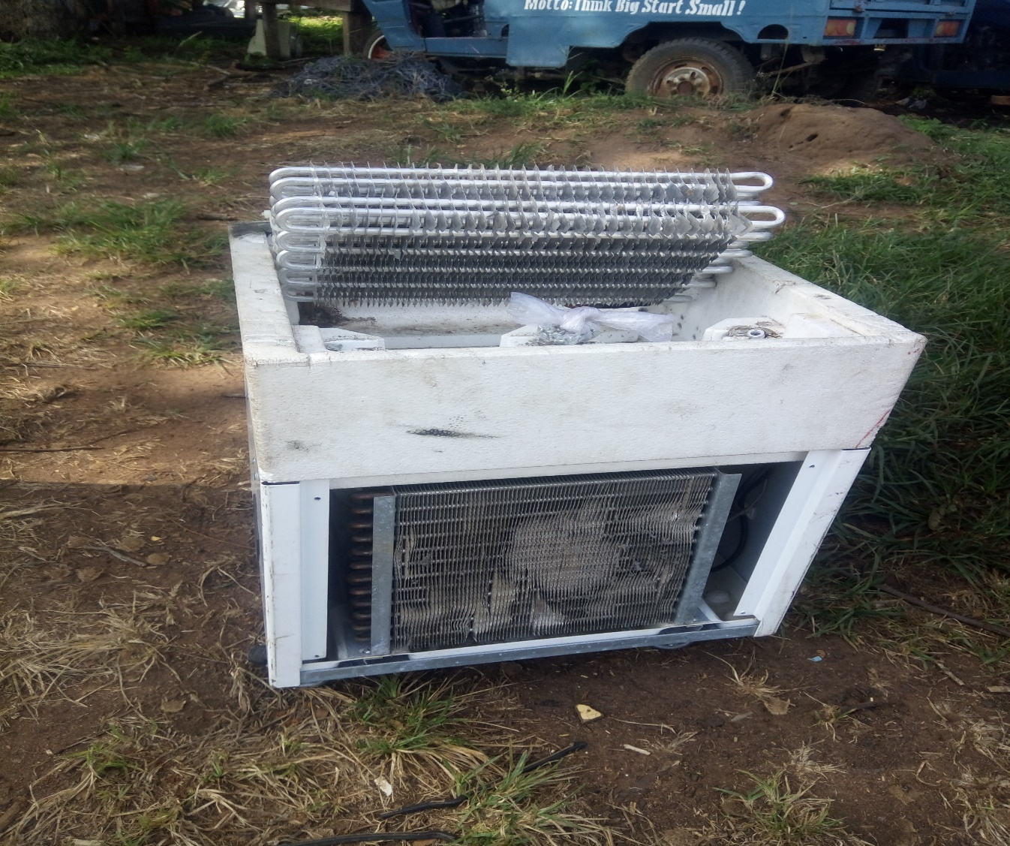

Figure 12: The interior of the air conditioning system

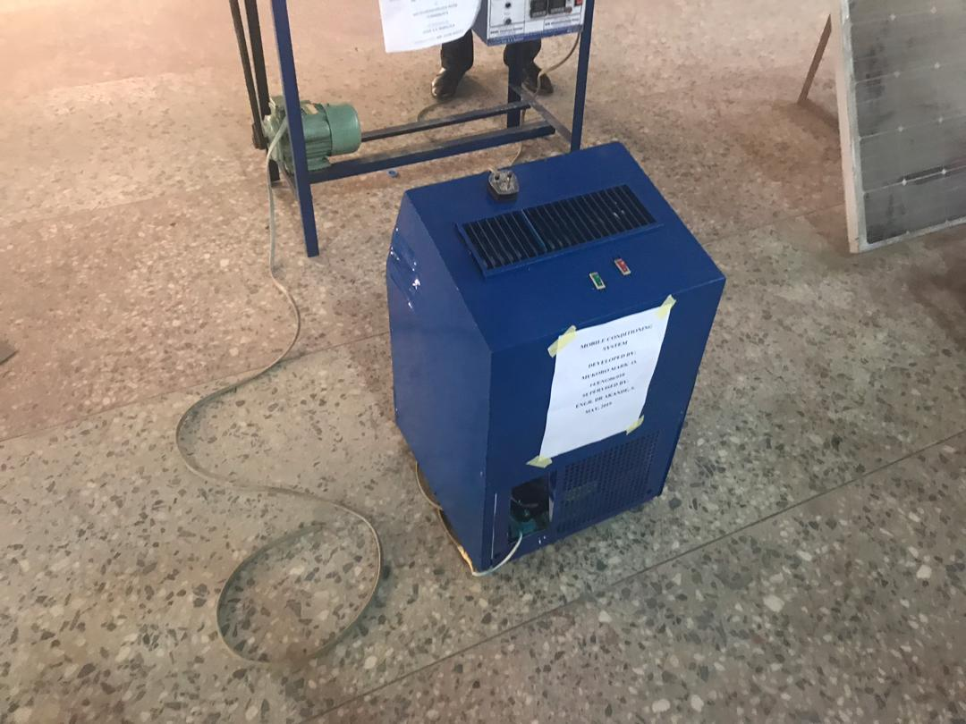

Figure 13: The complete mobile air conditioning system