MBA CHIAMAKA ABALI
18/MHS01/209
MHS/MBBS
GENERAL EMBRYOLOGY 1
ASSIGNMENT
1. DISCUSS OVULATION
Ovulation is the release of an oocyte from the ovarian follicle. Before ovulation, the secondary oocyte and some cells of the cumulus oophorus, detach from the interior of the distended follicle. Around the middle of the ovarian cycle, the ovarian follicle under the influence of Follicle Stimulating Hormone(FSH) and Luteinizing Hormone(LH), undergoes a sudden growth spurt producing a cystic swelling or bulge on the surface of the ovary. A small avascular spot, the stigma, soon appears on this swelling. The secondary follicle grows rapidly to a diameter of about 25mm to become mature vesicular/ mature secondary or Graafian follicle.
Ovulation is triggered by a surge of LH production. Ovulation usually follows the LH peak by 12 to 24 hours. The LH surge, elicited by the high estrogen level in the blood, appears to cause the stigma to balloon out, forming a vesicle. The stigma soon ruptures expelling the secondary oocyte with the follicular fluid. Expulsion of the oocyte is the result of intrafollicular pressure, and possibly by contraction of smooth muscles in the theca externa(sheath) owing to stimulation by prostaglandins.
- CLINICAL CORRELATES
During ovulation, some women feel a variable amount of abdominal pain called mittelschmer also known as middle pain because it normally occurs near the the middle of the menstrual cycle. In these cases, ovulation results in slight bleeding into the peritoneal cavity, which results in sudden constant pain in the lower abdomen. Mittelschmer may be used as a symptom of ovulation.
Some women fail to ovulate, this is called anovulation because of a low concentration of gonadotropins. In this case administration of an agent to stimulate gonadotropin release and hence ovulation can be employed.
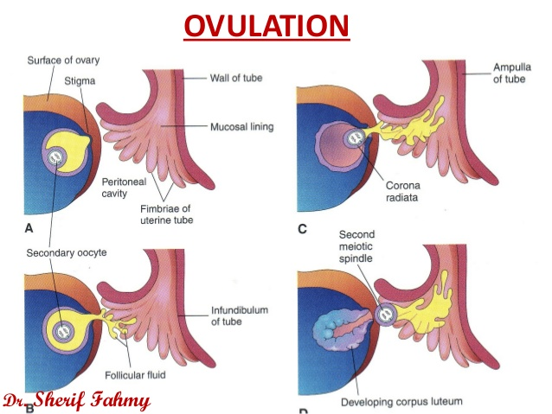

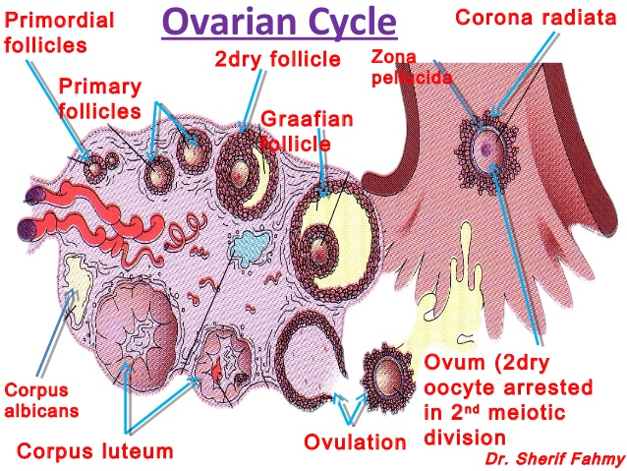

2. DIFFERENTIATE BETWEEN MEIOSIS 1 AND MEIOSIS 2
 | MEIOSIS 1 | MEIOSIS 2
DEFINITION | Meiosis 1 is division that reduces the ploidy level from 4n to 2n i.e. Reduction | Meiosis 2 is a division that divides the remaining set of chromosomes from 2n to n i.e. Division.
TYPE OF CELL | Diploid cell | Haploid cell
NUMBER OF CHROMOSOMES | 46 Homologus Duplicated | 23 Duplicated Chromsomes
DURATION | Longer | Shorter
GENETIC RECOMBINATION | Occurs | Does not occur
NATURE | Heterotypic | Homotypic
PROPHASE | Follows a long interphase | Follows Telophase 1
 | Synapsis is present | Synapsis is absent
 | Crossing over is present | Crossing over is absent
 | Chiasma formation is absent | Chiasma formation is absent
METAPHASE(ALIGNMENT) | Tetrads are arranged at the metaphase of the equator | Single chromosomes are arranged at the metaphase equator
 | Microtubules of one pole are attached to kinetochores of one of the two chromosomes facing to the same pole | Microtubules are attached to kinetochores of the centromere on either side of a single chromosome
 | Single chromosomes move towards opposing poles at anaphase 1 | One pair of sister chromatids move towards the opposing poles at anaphase 2
 | The metaphase plate is arranged in equidistant to the opposing poles | The metaphase plate rotates 90 degrees compared to metaphase 1
ANAPHASE(SEPARATION/DISJUNCTION) | Two spindle fibers are attached to the centromere of each chromosome in the homologous pair | Two spindle fibers are attached to the same centromere of a single chromosome
 | Homologous chromosomes are separated | Sister chromatids are separated
 | Centromeres of each chromosome in the homologous pair remains the same and does not split | Two sister chromatids are separated by splitting of the centromere
 | Not similar to the anaphase of the mitosis | Similar to the anaphase of the mitosis
TELOPHASE | Telophase 1 is a stage of meiosis 1 where the complete movement of separated homologous chromosomes to the opposite poles of the cells occurs | Telophase 2 is a stage of meiosis 2 where the complete movement of separated sister chromatids to the opposite poles of the cell occurs
 | Each daughter nuclei consists of a single set of chromosomes of the species | Each daughter nuclei consists of a single set of sister chromatids from each chromosome of the species
 | At the end of telophase 1, 2 secondary gametocytes/daughter cells are formed(23 duplicated chromosomes) 2N | At the end of telophase 2, 4 secondary gametocytes/daughter cells are formed(23 single stranded chromosomes) 1N

3.DISCUSS THE STAGES INVOLVED IN FERTILIZATION
Fertilization is the union of the male and female gametes i.e. the sperm and the oocyte to form a zygote. It takes place in the ampulla of the uterine tube and it is usually lasts approximately 24 hours.
Fertiliazation is a sequence of arranged events which include the following stages:
- Passage Of The Sperm Through The Corona Radiata: For sperms to pass through the corona radiata, they must have been capacitated i.e. removal of the glycoprotein coat and seminal plasma proteins from the plasma membrane that overlies the acrosomal region of the spermatozoa because only c apacitated sperms can pass freely through the corona radiata.
Dispersal of the follicular cells of the corona radiata surrounding the oocyte and zona pellucida appears to result mainly from the action of the enzyme hyaluronidase released from the acrosome of the sperm but the evidence of this is not umequivocal. Tubal mucosal enzymes also appear to assist the dispersal. Movements of the tail of the sperm are also important in its penetration of the corona radiata.
- Penetration Of The Zona Pellucida: Passage of a sperm through the zona pellucida is the important phase in the initiation of fertilization. The zona is a glycoprotein shell surrounding the egg that facilitates and maintains sperm binding and induces the acrosome reaction. Formation of a pathway also results from the action of enzymes released from the acrosome. The enzymes esterase, acrosin, and neuraminidase appear to cause lysis (dissolution or loosening) of the zona pellucida, thereby forming a path for the sperm to enter the oocyte. The most important of these enzymes is acrosin, a proteolytic enzyme. Once the sperm penetrates the zona pellucida, a zona reaction, a change in the properties of the zona pellucida, occurs that makes it impermeable to other sperms. The composition of this extracellular glycoprotein coat changes after fertilization. The zona reaction is believed to result from action of lysosomal enzymes released by cortical granules near the plasma membrane of the oocyte. The contents of these granules, which are released by cortical granules near plasma membrane of the oocyte. The contents of these granules which are released into the perivitelline space, also cause changes in the plasma membrane that make it impermeable to other sperms.
In turn, these enzymes alter properties of the zona pellucida to prevent sperm penetration and inactivate binding sites for spermatozoa on the zona pellucida surface.
- Fusion Of Plasma Membrane Of The Oocyte And Sperm: The plasma or cell membranes of the oocyte and sperm fuse and break down in the area of fusion. The head and tail of sperm enter the cytoplasm of the oocyte, but the sperm's plasma membrane remains behind.
- Completion Of The Second Meiotic Division Of Oocyte And Formation Of Female Pronucleus: Penetration of the oocyte by a sperm activates the oocyte into completing the second meiotic division and forming a mature oocyte and a second polar body. Following decondensation of the maternal chromosomes, the nucleus of the the mature oocyte becomes the female pronucleus.
- Formation Of The Male Pronucleus: Within the cytoplasm of the oocyte ,the nucleus of the sperm enlarges to form the male pronucleus and the tail of the sperm degenerates. Morphologically, the male and female pronuclei are indistinguishable. During growth of the pronuclei, they replicate their DNA-1n(haploid),2 c(two chromatids). The oocyte containing the two haploid pronuclei is called an ootid, the nearly mature oocyte after the first meiotic divisions have been completed.
- The 2 Pronuclei Fuse Into A Single Diploid Aggregation Of Chromosomes, The Ootid Becomes A Zygote: The chromosomes in the zygote becomes arranged on a cleavage spindle in preparation for the zygote. The zygote is genetically unique because half of its chromosome came from the mother and half from the father. The zygote contains a new combination of chromosomes that is different from those in the cells of either of the parents.

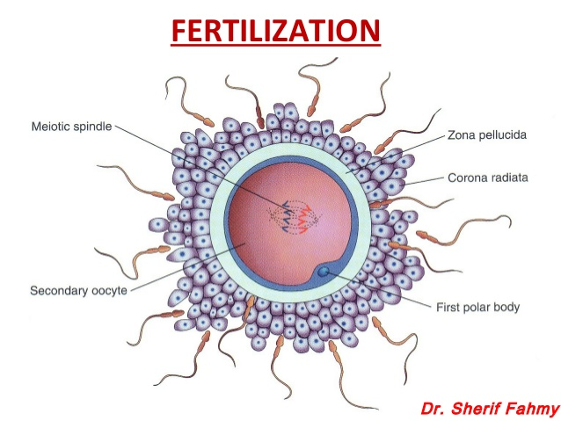

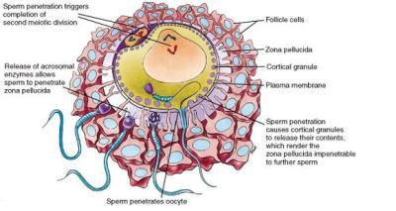

4. DIFFERENTIATE BETWEEN MONOZYGOTIC TWINS AND DIZYGOTIC TWINS
 | MONOZYGOTIC TWINS | DIZYGOTIC TWINS
DEFINITION | Developed through a singular embryo splitting into two. | Developed through two independent but simultaneous fertilization events.
CAUSE | The cause is currently unknown | Either through In Vitro Fertilization, a hereditary predisposition, or the use of certain fertility drugs.
NAME USAGE | They are known as identical twins | They are known as fraternal twins
GENETIC CODE | Monozygotic twins are genetically identical | Dizygotic twins are genetically similar as the case wouls be with any non-identical sibling
GENDER | Always the same gender | Can be different gender
BLOOD TYPE | Have the same blood type | Have different blood type
PHYSICAL APPEARANCE | Extremely similar,if not identical appearance, but can be affected by environmental factors | Similar appearance as would be expected with any other non-identical siblings
LIKELIHOOD OF CONCEPTION | Uniform chance of conceiving a monozygote twin worldwide | The chance of conceiving a dizygotic twin varies from country to country and population around the world
WORLWIDE POPULATION | One-third of all twins worldwide are monozygotic | Two-thirds of all twins worldwide are dizygotic
HEREDITARY | Not Hereditary | Hereditary
TWIN TYPE(INSIDE THE UTERUS) | Either,Mono-Di, Di-Di, or Mono-Mono twins | Di-Di twins only
TWIN-TI-TWIN TRANSFUSION SYNDROME(TTS) RISK | There is a high TTS risk in monozygotic twins | There is much lower TTS risk in dizygotic twins

