Oghene-Karo Ifoto
17/mhs01/149
Medicine and surgery

Gross anatomy of the head and neck

QUESTION 1 - form an essay on the cavernous sinus
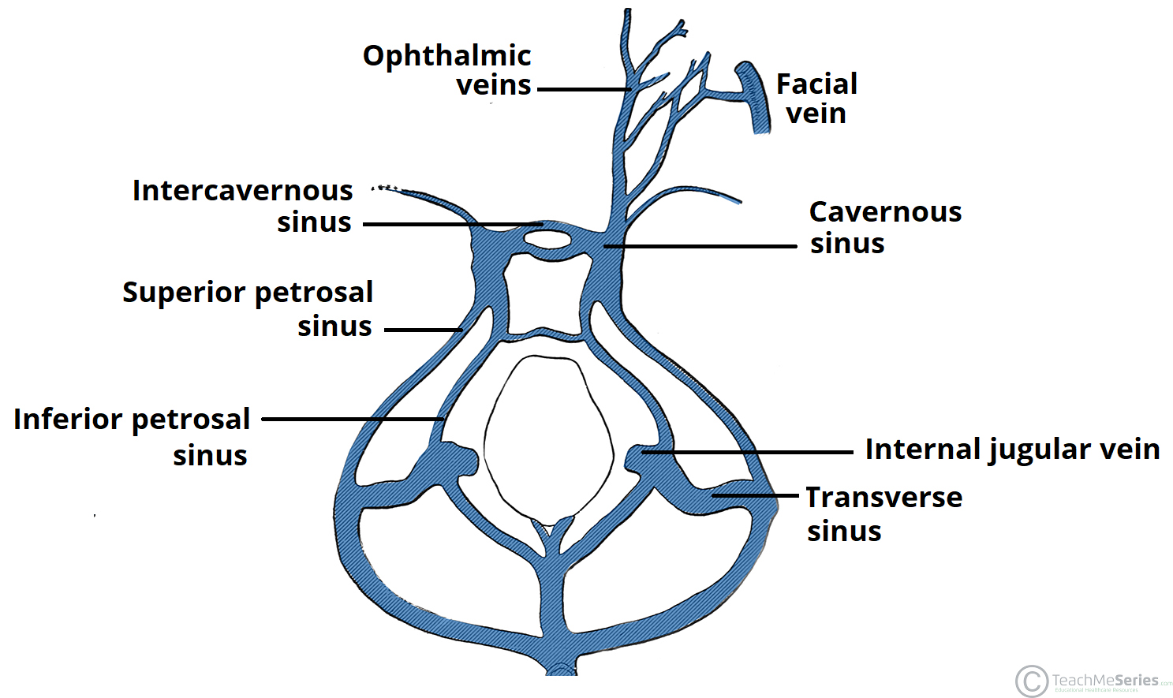
Introduction and location
The cavernous sinuses are one of several drainage pathways for the brain that sits in the middle cranial fossa on each side of the sella turcica.
It extends from the superior orbital fissure anteriorly to the apex of the temporal bone posteriorly.
Communications of the cavernous sinus
The cavernous sinus receives drainage from the ;
1. Cerebral veins
2. Superior and inferior ophthalmic veins from the orbit
3. Emissary veins (from the pterygoid venous plexus in the infratemporal fossa)
In addition to receiving venous drainage from the brain, it also receives tributaries from parts of the face.
The left and right cavernous sinuses communicate by through the anterior and posterior intercavernous sinuses. The cavernous sinus drains to the superior and inferior petrosal sinuses, which then join the sigmoid sinus.
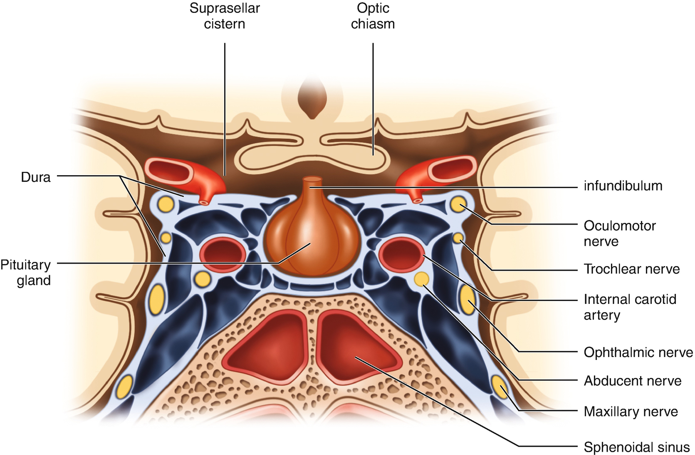
Structures passing through the cavernous sinus

The cavernous sinus is of great clinical importance because of the structures passing through them;
Structures passing through the sinus include;
-the internal carotid artery
-the abducens nerve (CN VI)

Structures passing through the lateral walls of the sinus include the;
- Oculomotor nerve (CN III)
- Trochlear nerve (CN IV)
- Trigeminal nerve; ophthalmic division (CN V1)
- Trigeminal nerve; maxillary division (CN V2)

Relations of the cavernous sinus
Medial to the sinus is the lateral wall of the pituitary fossa with the pituitary gland, the sphenoid bone and air sinus
Lateral to the cavernous sinus is Medial part of temporal lobe
Superior to the cavernous sinus is the internal carotid artery
Posterosuperior to the cavernous sinus is the uncus of the temporal lobe

Applied anatomy
1.Carotid-cavernous fistula; head trauma can lead to the rupture of the cavernous part of the carotid artery And this would cause a carotid-cavernous fistula. This can cause pulsating exophthalmus because the venous pressure would increase and this would cause the blood in the ophthalmic veins to flow in the wrong direction

2.Cavernous Sinus thrombosis; infection can spread easily especially from the danger area that is the triangle surrounding the nasal labial area of the face. Infection from this area can lead to a thrombosis which would reach the cavernous sinus and cause blockage. This can lead to further damage or injury of the structures passing through the cavernous sinus. E.g internal strabismus if cranial VI was damaged, double vision when looking downward if CN IV was damaged and ophthalmoplegia.

QUESTION 2 - walls of the nose

The nasal cavity is made up of a floor, a roof, a medial wall and a lateral wall.

- THE FLOOR
The floor of the nasal cavity is composed of ;
- The palatine process of the maxilla making up the anterior 3/4th
- The horizontal process of the palatine bone making up the posterior 1/4th

- THE ROOF
The roof of the nasal cavity is composed of ;
- An anterior slope made up of the nasal bone
- A posterior slope made up of the body of sphenoid
- A middle horizontal bone made up of cribriform plate of the ethmoid bone through which the olfactory nerves pass through.

- THE MEDIAL WALL aka the NASAL SEPTUM
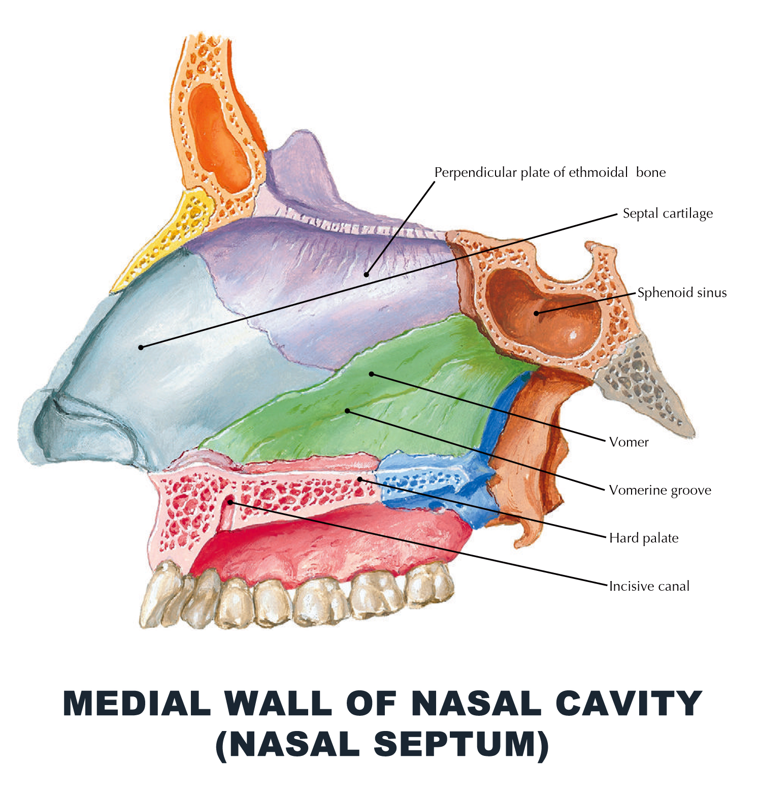
The medial wall is made up of cartilage and the septum proper
The septum proper constitutes;
- Septal cartilage
- The perpendicular plate of the ethmoid postero-superiorly
- The vomer postero-inferiorly
These articulate ate with the following bones to complete the septum
- superiorly; the nasal bone, the frontal bone and the rostrum of the sphenoid
- inferiorly with the nasal crest of the maxilla, the anterior nasal spine of the maxilla and the palatine bone.
The osteocartilaginous framework of the septum proper is covered with nasal mucous membrane.

THE BLOOD SUPPLY
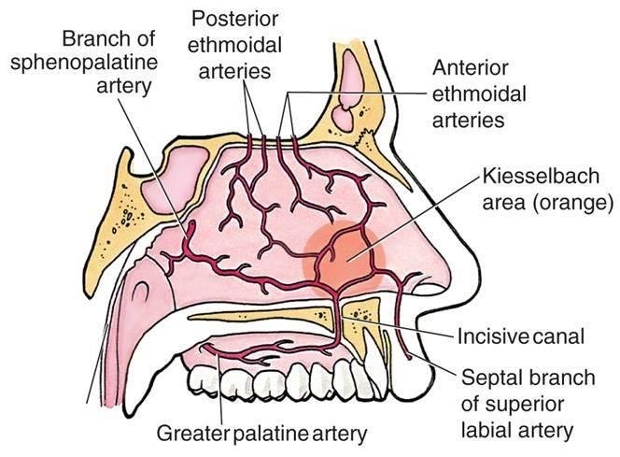
- little’s area; septal branches from of the superior labial artery, the greater palatine artery, anterior ethmoidal artery, the posterior ethmoidal artery and the sphenopalatine artery form an anastamosis at an area just above the vestibule called the Kiesselbach’s plexus.
- Woodruff’s area; there is a venous plexus located at the posterior wall of the nasal septum

INNERVATION
ANTERIOR SUPPLY; the anterior nasal septum is supplied by an anterior ethmoidal branch from the nasociliary nerve and a small area above the vestibule is supplied by the anterior superior alveolar nerve.
POSTERIOR SUPPLY; the posterior nasal septum is supplied by the nasopalatine nerve and it also receives a branch from the nerve to to the pterygoid canal.

LYMPHATIC DRAINAGE
Drains a anteriorly to the submandibular lymph nodes.
And posteriorly to the retropharyngeal and anterior deep cervical lymph nodes.

4. THE LATERAL WALL
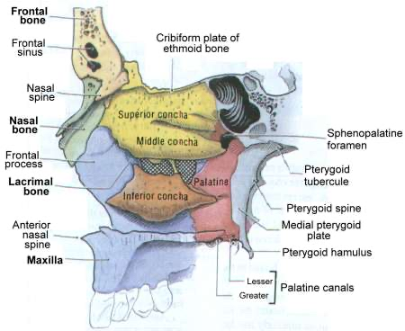
it’s made up of ;
-Medial part of the maxilla
-Ethmoid bone
-Nasal bone
-Ascending part of the maxilla
-Inferior nasal concha
-Medial pterygoid plate
-Perpendicular plate of the palatine bone

The lateral wall has projections called concha; they are long and narrow curled projections that protrudes into the breathing passage of the nose to interrupt air flow in order to increase its contact with the blood blood vessels that line the nasal cavity.
The conchae;
The superior conchae; part of the ethmoid
The middle conchae; part of the ethmoid
The inferior conchae; a whole separate bone
And sometimes the presence of a fourth conchae called the concha suprema

Below and lateral to each conchae is a corresponding meatus;
The inferior meatus; the nacsolacrimal duct opens into its anterior part.
The middle meatus; the frontal, maxillary and anterior ethmoidal sinus open into this. It constitutes the bulla ethmoidalis, the hiatus semilunaris, and the infundibulum .
The superior meatus; the posterior ethmoidal sinus opens into it.
The sphenoethmoidal recess; a triangular fossa that lies above the superior meatus. The Sphenoidal sinus opens into it.

