NAME: VALERIE N. AMINIA-JUMBO
MATRIC NO: 17/MHS01/059
COURSE TITLE: GROSS ANATOMY OF THE HEAD AND NECK
COURSE CODE: ANA 301

- Write an essay on the carvenous sinus

The cavernous sinus is a paired dural venous sinus located within the cranial cavity. It is divided by septa into small ‘caves’ – from which it gets its name. Each cavernous sinus has a close anatomical relationship with several key structures in the head, and is arguably the most clinically important venous sinus. The dural venous sinuses are channels between the two layers of dura mater which are responsible for the venous drainage of the brain, skull, orbit and internal ear.

Anatomical Location and Borders
The cavernous sinuses are located within the middle cranial fossa, on either side of the sella turcica of the sphenoid bone (which contains the pituitary gland). They are enclosed by the endosteal and meningeal layers of the dura mater.The borders of the cavernous sinus are as follows:
- Anterior – superior orbital fissure.
- Posterior – petrous part of the temporal bone.
- Medial – body of the sphenoid bone.
- Lateral – meningeal layer of the dura mater running from the roof to the floor of the middle cranial fossa.
- Roof – meningeal layer of the dura mater that attaches to the anterior and middle clinoid processes of the sphenoid bone.
- Floor – endosteal layer of dura mater that overlies the base of the greater wing of the sphenoid bone.
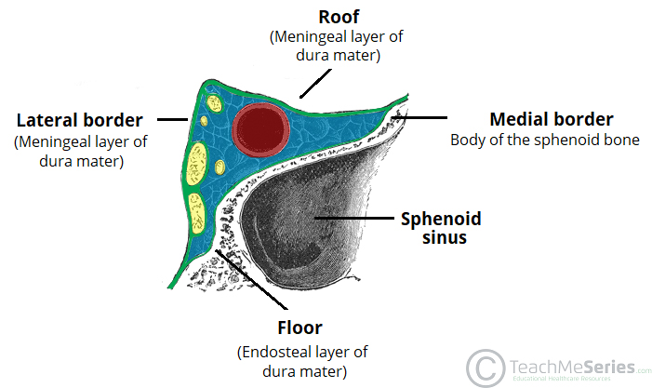
Several important structures pass through the cavernous sinus to enter the orbit. The can be sub-classified by whether they travel through the sinus itself, or through its lateral wall:
Travels through cavernous sinus: | Travels through lateral wall of cavernous sinus:
- Abducens nerve (CN VI)  - Carotid plexus (post-ganglionic sympathetic nerve fibres)  - Internal carotid artery (cavernous portion) | - Oculomotor nerve (CN III)  - Trochlear nerve (CN IV)  - Ophthalmic (V1) and maxillary (V2) branches of the trigeminal nerve

The cavernous sinus is the only site in the body where an artery (internal carotid) passes completely through a venous structure. This is thought to allow for heat exchange between the warm arterial blood and cooler venous circulation.

Dural Venous Sinus System
Each cavernous sinus receives venous drainage from:
- Ophthalmic veins (superior and inferior) – these enter the cavernous sinus via the superior orbital fissure.
- Central vein of the retina – drains into the superior ophthalmic vein, or directly into the cavernous sinus.
- Sphenoparietal sinus – empties into the anterior aspect of the cavernous sinus.
- Superficial middle cerebral vein – contributes to the venous drainage of the cerebrum
- Pterygoid plexus – located within the infratemporal fossa.
It is important to note that the superior ophthalmic vein forms an anastomosis with the facial vein. Therefore, the ophthalmic veins represent a potential route by which infection can spread from an extracranial to an intracranial site.
The cavernous sinuses empty into the superior and inferior petrosal sinuses, and ultimately, into the internal jugular vein. The left and right cavernous sinuses are connected in the midline by the anterior and posterior intercavernous sinuses. They travel through the sella turcica of the sphenoid bone.

Clinical Significance - Cavernous Sinus Thrombosis
Cavernous sinus thrombosis (CST) refers to the formation of a clot within the cavernous sinus.
This most common cause of CST is infection; which typically spreads from an extracranial location such as the orbit, paranasal sinuses, or the ‘danger zone’ of the face. Infection is able to spread in this manner due to the anastomosis between the facial vein and superior ophthalmic veins.
Common clinical features include headache, unilateral periorbital oedema, proptosis (eye bulging), photophobia and cranial nerve palsies. The abducens nerve (CN VI) is most commonly affected.
Treatment is typically with antibiotic therapy. Where the cause is infection, thrombosis of the cavernous sinus can rapidly progress to meningitis.

- DISCUSS THE WALLS OF THE NOSE
The nasal cavity is divided into two lateral compartments separated down the middle by the nasal septum. The nasal cavity communicates anteriorly through the nostrils and posteriorly with the nasopharynx through openings called choanae. The nasal cavities and septum are lined with a mucous membrane and are richly vascularized by branches of the maxillary, facial, and ophthalmic arteries. The nasal cavity receives innervation via branches of the olfactory [cranial nerve (CN) I], ophthalmic (CN V-1), and maxillary nerves (CN V-2).

Boundaries of the Nasal Cavity
The nasal cavity is bordered by the following structures
- Roof. Formed by the nasal, frontal, sphenoid, and ethmoid bones (cribriform foramina, which transmits CN I for smell).
- Floor. Formed by the maxilla and the palatine bones. The incisive foramen transmits branches of the sphenopalatine artery and the nasopalatine nerve for general sensation from the nasal cavity and palate.
- Medial wall (nasal septum). Formed by the perpendicular plate of the ethmoid bone, the vomer bone, and the septal cartilage.
- Lateral wall. Formed by the superior, middle and inferior nasal conchae. In addition, the maxillary, sphenoid, and palatine bones contribute to the lateral wall. The lateral wall contains the following openings:
  - Sphenoethmoidal recess. The space between the superior nasal concha and the sphenoid bone, with openings from the sphenoid sinus.
  - Superior meatus. The space inferior to the superior nasal concha, with openings from the posterior ethmoidal air cells.
  - Middle meatus. The space inferior to the middle nasal concha, with openings for the frontal sinus via the nasofrontal duct, the middle ethmoidal air cells on the ethmoidal bulla, and the anterior ethmoidal air cells and maxillary sinus in the hiatus semilunaris.
  - Inferior meatus. The space inferior to the inferior nasal concha, with an opening for the nasolacrimal duct, which drains tears from the eye into the nasal cavity.
  - Sphenopalatine foramen. An opening posterior to the middle nasal concha receives the nasopalatine nerve and the sphenopalatine artery from the pterygopalatine fossa into the nasal cavity.

